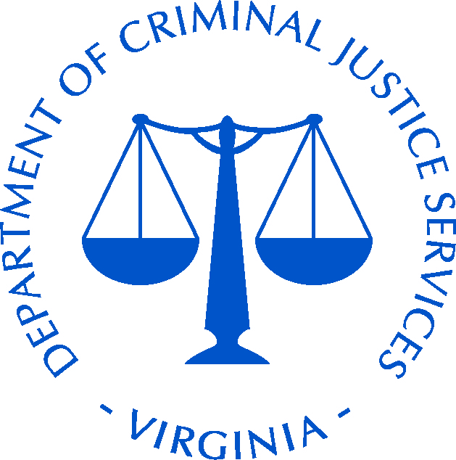
Virginia Department of Criminal Justice Services
2016 INTERSECTIONS OF VIOLENCE CONFERENCE
April 12-14, 2017 • Norfolk Marriott Waterside Hotel • Norfolk, Virginia

SCHOLARSHIP APPLICATION

Eligibility (Law Enforcement, Child Advocates and Child Welfare Workers)

Thank you for your interest in attending the 2017 Intersections of Violence Conference. Please fill out the following form for consideration of a scholarship for the upcoming conference. Scholarships are limited and not all applicants will be able to receive one. Due to the limited number of scholarships there will be only one scholarship awarded per organization

SECTION A: Applicant Information
This section will provide additional information about you, the applicant.
1. Name of Applicant:
2. Applicant’s Position:
3. Applicant’s Organization:
4. Street Address:
City: |  |  |  |  |  |  |  |  |  |  | State: |  |  |  | Zip Code:
5. Phone: |  |  |  |  |  |  |  |  |  |  | Fax:
Email:
6. Type of Organization:
 |  | Law Enforcement
 |  | Department of Social Services
 |  | Child Advocacy Agency
Special Dietary Needs: ________________________________________
SECTION B: Assistance Requested (check all that apply)
 | Registration Fee (please do not register yourself – DCJS will register you and waive your fee)
Please indicate which sessions you will attend:
 | Lodging April 11, 2017 |  |  |  |  |  |  |  |  |  |  | Lodging April 13, 2017
 | Lodging April 12, 2017

SECTION C: Supervisor/Agency Head Attestation
This section ensures that your supervisor or organization head supports your attendance at the training event.
I agree to support the attendance of my employee to attend this training. I acknowledge that should a scholarship be awarded, the employee will be permitted to attend.
_________________________________________ ________________________________
Signature of Supervisor Date
_______________________________________________________________________________
Printed Name of Supervisor
_______________________________________________________________________________
Title of Supervisor
_______________________________________________________________________________
Name of Agency or Organization
_______________________ ___________________________________________________
Phone Number Email Address
Please return the completed form to Melissa Roberson:
Email: melissa.roberson@dcjs.virginia.gov • Phone: (804) 225-3456 • Fax: (804) 786-3414

