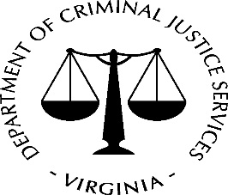 DCJS Subrecipient Single Audit Certification Form
Your organization has been identified as having been awarded Federal funds, as a subrecipient of the Virginia Dept of Criminal Justice Services (DCJS), during the Agency’s fiscal year ending June 30, 2018.
Title 2 U.S. Code of Federal Regulations Part 200, Uniform Administrative Requirements, Cost Principles, and Audit Requirements for Federal Awards (“Uniform Guidance”) requires DCJS to monitor subrecipients to which we pass-through Federal grant funding.
Effective with fiscal years beginning on or after December 26, 2014, the Uniform Guidance requires all recipients of Federal funds to have a Single Audit conducted when total Federal award expenditures are $750,000 or more during a fiscal year. Subpart F—Audit Requirements
This threshold includes Federal award expenditures from all sources, not just from DCJS. For this reason, the certification form should be completed by a financial official in your organization who has access to grant records for your entire organization.
Your assistance is needed in completing and returning this form to DCJS by ________.
Subrecipient Name: _____________________________________________________________
FIN: __________________________________________________________________________
Did your organization expend $750,000 or more in total Federal awards in fiscal year 2018?
YES *A Single Audit is required. Expected completion date is ___________________
NO
Other **Financial review by CPA under $750,000
*If the answer is YES above, your organization must submit a copy of your Single Audit reporting package to the Federal Audit Clearinghouse (FAC) within the earlier of 30 calendar days after receipt of the auditor's report(s), or nine months after the end of the audit period. In addition, if the audit disclosed audit findings that relate to the award(s) provided by DCJS, your organization must also submit the audit report package to DCJS along with a corrective action plan to address those findings.
**If other please send DCJS a copy of the audited or reviewed financial statements.
I certify that, to the best of my knowledge, the above information is correct:
Name: Title: ________________________________
Date: ________________________________E-mail: ____________________________________
Please return this form via e-mail to ______________

