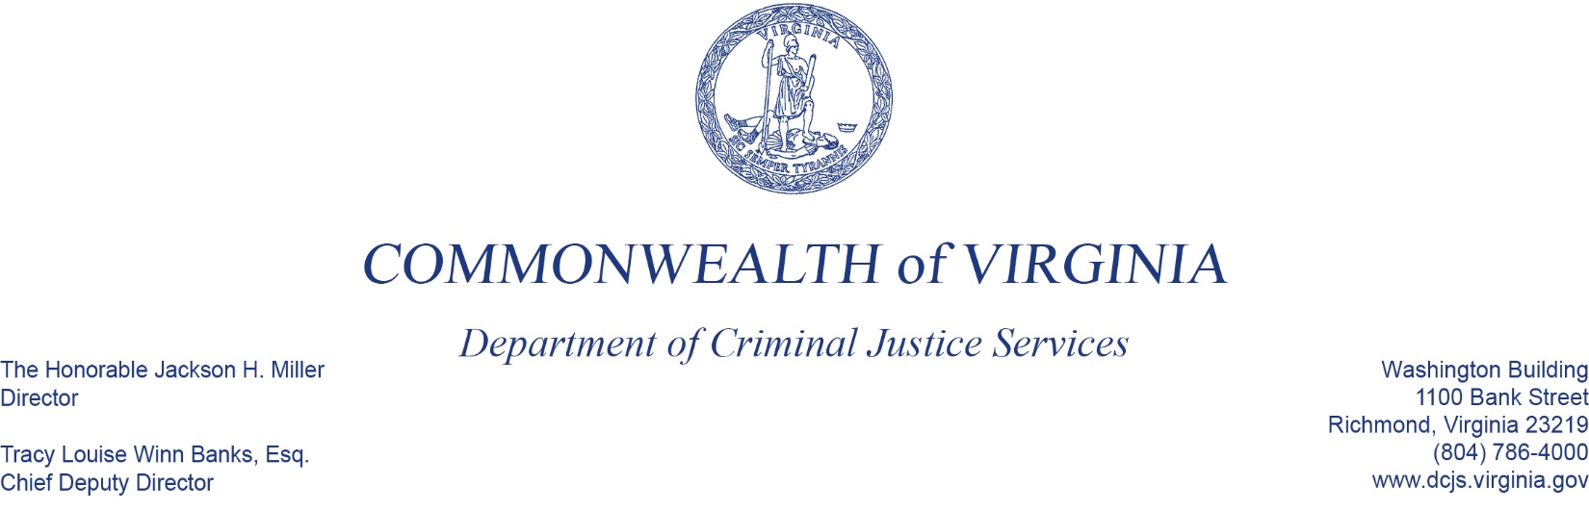**Criminal Justice Services Board   
Grants Committee Meeting**

November 25, 2024

|  |  |  |
| --- | --- | --- |
| ***Members Present***  Ed Macon (Proxy for Karl Hade), Vice Chair  Officer Bennie Evans, Jr.  Timothy Coyne (Proxy for Maria Jankowski)  Sheriff Brian Hieatt | ***Members Absent***  Chief Craig Branch, Chair  Russell “Rusty” McGuire  Ebony Clark |  |
|  |  |  |

1. Call to Order

Vice Chair Ed Maconcalled the meeting to order at 11:20 AM

1. Roll Call

Mr. Macon asked Wendy Lohr Hopp to conduct the Roll Call. Wendy stated there was a quorum with four members present. Maria Jankowski provided Tim Coyne as proxy. All members joined the meeting by electronic communication.

1. Introductions/ Opening Comments

Mr. Macon officially welcomed guests and any agency dignitaries.

1. Approval of Minutes from Last Meeting

Mr. Macon called for corrections, deletions, and/or additions to the minutes from the September 19, 2024 meeting. A motion was made by Sheriff Brian Hieatt to approve the minutes and was seconded by Mr. Tim Coyne.

1. **Grant Review**
   1. **Sexual Assault Service Program – Victim Services, Andi Martin**

|  |  |
| --- | --- |
| |  | | --- | | The purpose of the Sexual Assault Services Program (SASP) is to support the establishment, maintenance, and expansion of rape crisis centers and other nongovernmental or tribal programs and projects to assist individuals who have been victimized by sexual assault, without regard to the age of the individual (34 U.S.C. §12511(b)(2)(B)). SASP funding originates from the U.S. Department of Justice’s Office on Violence Against Women.  This Calendar Year (CY) 2025 funding opportunity is a continuation funding opportunity from CY 2024 awards. These are 12-month grants, with the possibility of one additional year of continuation funding for CY 2026 if funding is available. Applicants were asked to submit requests level to, or under, their CY 2024 awards. DCJS **received 30 applications with requests totaling $970,586**.  All **30 applications are recommended for funding at the amounts requested**, as all amounts are level to, or under, their CY 2024 awards.  In summary, DCJS staff **request approval to fund 30 projects** for the 12-month period (1/1/2025–12/31/2025), **totaling $970,586**, using federal SASP funds designated for this purpose. |   A motion was made by Sheriff Brian Hieatt, seconded by Mr. Tim Coyne. The motion passed by majority vote. There were no recusals are noted. |
|  |

* 1. **Jail Based Substance Use Treatment Grant Program – Adult Justice Programs, Jennifer MacArthur**

|  |  |  |  |  |  |
| --- | --- | --- | --- | --- | --- |
| |  | | --- | | The purpose of the Jail-Based Substance Use Disorder (SUD) Treatment and Transitions Grant Program is to increase access to substance use disorder treatment and transitional services for individuals incarcerated in local and regional jails in Virginia. Funded programs may include medication assisted treatment therapies, addiction recovery and other substance use disorder services, reentry and transitional support, or a combination of these services. This program is currently funded by the 2024 Appropriation Act, which includes $2,000,000 from the Commonwealth Opioid Abatement and Remediation Fund.  This is a new funding opportunity that will provide three calendar years of funding; January 1, 2025 – December 31, 2027. DCJS **received 14 applications with requests totaling $1,791,825**. **Staff is recommending funding for 10 applications in the amount of $1,301,514.**  Staff is **not recommending funding for four applications totaling $490,311. Three applications are not recommended due to program ineligibility**. **One application is not recommended due to unreasonable costs and insufficient justification** as to how the funding would enhance the existing treatment program.  In summary, DCJS staff **request approval to fund ten projects** for the three-calendar year period (1/1/2025–12/31/2027), **totaling $1,301,514**, using state special funds designated for this purpose. | |  | | A motion was made by Sheriff Brian Hieatt, seconded by Mr. Tim Coyne. The motion passed by majority vote. There were no recusals are noted. | |  | | |

* 1. **Operation Ceasefire Grant Program – Office of Safer Communities and Youth Services, Greg Hopkins**

|  |  |  |  |  |  |
| --- | --- | --- | --- | --- | --- |
| |  | | --- | | The purpose of the Operation Ceasefire Grant Program (OCGP) is to support the implementation of strategies that will result in reducing violent crime within the Commonwealth while implementing effective and sustainable solutions to intercept and eliminate local cycles of violence. The purpose of this OCGP solicitation is to support continuation of local law enforcement and prosecution programs funded under the 2023 Operation Ceasefire Grant Program Funding Opportunity.  DCJS **received four applications with requests totaling $799,223**. After grant review, DCJS **recommends approval of all four Ceasefire continuation grants totaling $799,223**. The amount of funding that DCJS anticipated being available for this solicitation was $800,000.  In summary, DCJS staff **request approval to fund four grant applications** for the 24-month period 1/1/2025-12/31/2026, **totaling $799,223**, using state funds allocated for this purpose. | |  | | A motion was made by Sheriff Brian Hieatt, seconded by Officer Bennie Evans. The motion passed by majority vote. There were no recusals are noted. | |  | | |

* 1. **Combatting Hate Crimes Grant Program – Division of Public Safety Training and Virginia Center for School and Campus Safety, Tracy Matthews**

|  |  |  |  |  |  |
| --- | --- | --- | --- | --- | --- |
| |  | | --- | | The purpose of the Combatting Hate Crimes Grant Program is to minimize bias-motivated incidents by providing funding that supports institutions and/or nonprofit organizations within a locality that may be at risk for targeted, bias-motivated violence based on race, religious conviction, color, gender, disability, gender identity, sexual orientation, or national origin. State general funds in the amount of $3.5 million are available for distribution.  DCJS received **13 applications with requests totaling $1,612,314**. For FY2025**, staff is recommending funding of seven applications in the amount of $668,622.**  The grant period for this award is from January 1, 2025 – December 31, 2025.  Staff is **not recommending funding for six applications totaling $744,220** due to requests for ineligible equipment or failure to provide a clear, justifiable connection to the purpose of the Hate Crimes Grant Program.  In summary, DCJS staff **request approval to fund seven awards,** **totaling $668,622**, for the 12-month period (1/1/2025–12/31-2025), using state general funds designated for this purpose. | |  | | A motion was made by Sheriff Brian Hieatt, seconded by Mr. Tim Coyne. The motion passed by majority vote. There were no recusals are noted. | |  | | |

1. Old Business

No Old Business was bought forth at this meeting.

1. New Business

No New Business was bought forth at this meeting.

1. Public Comment

No Public Comment was bought forth at this meeting.

1. Announcements

Vice Chair Ed Macon announced that the next Grants Committee meeting will be held February 27, 2025.

1. Adjourn

The meeting adjourned at 11:42 am.

**Recusals**

None provided.