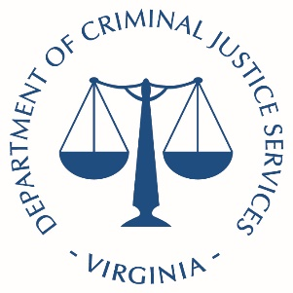
Commonwealth of Virginia Information
Virginia Department of Criminal Justice Services

Safer Communities Grant Program
QUARTERLY NARRATIVE REPORT
_____________________________________________________________________________________
Grant Number:
Program Name:
Name of the Person Completing the Report
Contact Information (phone & email):
Reporting Period

 | Quarter 1 (July 1-September 30) |  | Quarter 2 (October 1-December 31)
 | Quarter 3 (January 1- March 31) |  | Quarter 4 (April 1-June 30)

INFORMATION & INSTRUCTIONS:
• This form seeks narrative information about your FVIP Grant Program project during the preceding
quarter.
• This form is to be completed and uploaded to the Virginia Department of Criminal Justice Services
(DCJS) Online Grants Management System (OGMS).
• Complete this form for the quarterly reporting period marked above.
Project Description:
Row | FY 1st QTR | FY 2nd QTR | FY 3rd QTR | FY 4th QTR | YTD
A) Number of Youth Carried Over from the Previous Quarter
B) Number of New Admissions
C) Number of Youth Who Received Pre-Test Evaluation
D) Number of Youth Completed the Program Requirements
E) Number of Youth Who Exhibited an Improvement In Social Competencies.
F) Number of Youth Who Received Post Test Evaluation

G) Number of Schools Where Activities Have Taken Place?
H) Number of Families Participated In Programing?
I) Number Of Youth Exposed/Participated In Pro-Social Skilled Activities
Total:

Goals and Progress
A. Describe progress made toward project goals/objectives:

B. What outputs did the project have during the reporting period as a result of the grant funding (i.e. Number of youth served, number of training hours provided to staff, etc.):

C. Describe any significant program activities during the reporting period (i.e., graduation ceremonies, media event/coverage, news articles, etc).:

