Grade: Five | Lesson: 5 | Topic: Alcohol Awareness
Virginia Standards of Learning | Health  5.1i, 5.1j, 5.2i, 5.2j
Virginia School Counseling Standards | DeM1:  5-6a, 5-6b
Materials Needed | - Chart paper and markers  - Case study handout
Learning Objectives | - Examine the legal consequences concerning underage alcohol use.  - Identify the effects of alcohol on the brain and body.  - Discuss reasons for alcohol misuse and abuse.  - Problem-solve various scenarios regarding underage use of alcohol.
I DO  Learning-Ready Reminders  Content | Introduce yourself.  Build a positive relationship with the students by sharing a fun fact about yourself. (For example: Your favorite ice cream flavor, your favorite food, or your favorite color.) Next, use the Learning-Ready Visuals and define the classroom expectations for when you visit. Say, “We will learn a lot about safety, responsibility, and respect within our school and community! When we are learning, we must be learning-ready! When we are learning-ready, we will:  - Respect personal space - Be aware of your surroundings, respect others’ space, and stay in your own area.  - Use volume control - Use indoor voices and be mindful of noise levels.  - Show active listening - Eyes and ears open! Ready to participate!  - Have sharp minds - Be prepared to problem solve, ask questions, and contribute to the lesson.”  Introduce alcohol use and abuse awareness.  Ask students “Why do you think people consume alcohol?” Sample responses may include the following:  - “Many adults began to drink when they were younger and for all the wrong reasons.  - Their friends drink alcohol.  - They saw an advertisement making alcoholic beverages seem like fun.  - They saw it happening on TV or in movies which made it seem acceptable.  - A child could see an adult drinking an alcoholic beverage and want to be like that person.  - They may not have known all we know now about the negative effects of alcohol.  - They drink it to try to relax.  - They drink it to try to escape their problems.  - Now they can’t stop because they’re addicted.”  Share these facts about alcohol, “Alcohol is a depressant drug that slows the body's processes. It is the oldest and most abused drug in the world.  There are predictable, though varying, physical effects on everyone who drinks alcohol. It is this drug, and is the intoxicating ingredient in wine, beer, vodka, rum, cough medicines, some mouthwashes, and more."  “Factors that can influence the effects of alcohol on a person include the following:  - Presence of food in the stomach  - Use of carbonated beverages  - Concentration of alcohol  - Amount of alcohol intake  - Body weight  - Age  - Previous drinking experience  - Presence of other drugs in the system  - General health of the individual"  “Effects of alcohol on different organs include the following:  - Heart  - Loses normal rhythms  - Weakens the strength of muscle contractions  - May cause the heart to enlarge or cause heart failure in advanced stages of alcoholism  - Stomach  - Alcohol has no nutritional value  - Irritates the stomach lining  - Liver  - The organ that breaks down alcohol in the body. It does so at the rate of one ounce of pure alcohol per hour (equals 12 ounces of beer, 5 ounces of wine, or 1 1 /2 ounces of 86 proof whiskey). Whatever alcohol the liver cannot oxidize immediately continues to circulate throughout the body affecting the brain and other organs.  - There is no drug, food, or exercise that will increase the speed at which the liver can break down alcohol.  - Excessive use of alcohol can lead to permanent liver damage.  - The disease called fatty liver is caused when there is a high intake of alcohol and the liver neglects to break down fat.  - Hepatitis is the next stage of liver damage where there is inflammation of liver cells.  - Cirrhosis is the most severe, often fatal, form of liver disease. All functions of the liver begin to fail. The excess alcohol kills the cells and they are replaced by scar tissue. Liver failure causes the accumulation of toxic products that should have been broken down by the liver.  - Brain  - This is the organ most affected by the presence of alcohol. Alcohol arrives in the brain almost immediately upon consumption.  - The younger the person (underage) the more dangerous it can be for the brain.  - Examples: Large doses shrink the brain, interfere with brain development, block memory formation and learning, and affect higher brain functions such as judgment, learning, behavioral control, vision, coordination, and speech.”  Show a picture of the brain on slide 16 and discuss the different areas it affects. Give examples such as movement-walking. judgment- poor decisions, vision- being able to drive properly, etc.  Discuss the consequences of buying or using alcohol.  - “Age restrictions: In the United States, adults aged 21 and older can legally buy alcohol. For kids and teens, alcohol is off-limits due to its harmful effects.”  - “Driving Under the Influence (DUI): If someone is caught driving with alcohol in their system, they can face serious consequences. These include driver’s license suspension, fines, and even jail time. DUI laws are strict because alcohol impairs driving skills and puts everyone on the road at risk.  - Possession and purchase: Minors caught with alcohol can be fined or required to do community service. Convictions of offenses can stay on their record for years. Stores that sell alcohol to underage individuals can also face penalties.  - Social host liability: If a young person hosts a party where alcohol is served to other minors, they can be held responsible. Social host liability laws aim to prevent underage drinking at parties.  - School consequences: Schools take alcohol misuse seriously. Students caught with alcohol may face disciplinary actions, including suspension or expulsion.”  “If you know someone who is underage drinking, and you need advice talk to someone that will be supportive. Such as a school counselor, relative, doctor, favorite teacher, etc. Underage drinking is a choice! Most teens don't do it. It can compromise your future and the decisions that you make for your future. “
WE DO  Practice | Lead the small group alcohol consequences activity.  Gather students into small groups (three or four students per group). Explain they will be discussing the effects of underage alcohol use. Provide each group with chart paper or board and markers. Ask students to brainstorm and write down the potential consequences of underage drinking. Encourage them to think beyond physical health and consider social, emotional, and legal aspects. Have each group discuss their list of consequences. You can suggest the following discussion points:  - Health risks: Slowed brain development, liver damage, heart problems, and increased cancer risk.  - Social consequences: Poor decision-making, risky behavior, and impaired judgment.  - Legal issues: Fines, community service, and potential impact on future opportunities.  - Relationships: Strained friendships, family conflicts, and social isolation.  - Academic Challenges: Lower grades, absenteeism, and disrupted learning.
YOU DO  Practice  Check for Understanding  Conclusion | Introduce case studies activity.  Provide each group with a hypothetical scenario related to underage alcohol use from the case study handout. Ask them to discuss the potential consequences for the individual in the scenario. Encourage critical thinking and empathy. Have students document their group discussion on their handouts.  Have groups share strategies to prevent underage drinking. Discuss positive alternatives (e.g., sports, hobbies, volunteering, etc.) and ways to resist peer pressure. Emphasize the importance of open communication with parents and seeking help if needed.  Have each group present their findings to the class. Summarize key points on the board. Highlight the severity of consequences and the need for responsible choices. Have a brief class discussion about the impact of their choices on themselves and their community.  Ask students to reflect individually on what they’ve learned at the bottom of the case study handout.

Case Studies
Case 1: The Big Game It's Friday night, and the local 8th-grade school football team is playing their biggest rival game of the season. There's a big party after the game and everyone is talking about it. Some older kids mention that they are going to sneak in some alcohol. One student, a 5th grader named Ben who was invited to the party, is worried because he doesn't want to drink but doesn't want to be left out either.
Discussion questions:


- What should Ben do? Is it okay to go to a party where there will be alcohol?

- Are there other ways for Ben to have fun without feeling left out?

Case 2: Family Celebration It's a family celebration for a birthday or holiday. The adults are drinking wine or beer with dinner. A 5th grader named Maya is curious about what it tastes like. She sees her older cousin sneaking sips from their drinks throughout the night.
Discussion questions:

- Is it okay for Maya to try some of her cousin's drinks? What are some things Maya could ask for instead of alcohol?

- Why do some adults drink alcohol, and why can't kids?

Case 3: The Pressure to Perform David, a 5th grader, is in the school play. He's really nervous about his big solo performance. He overhears some older kids talking about how they use alcohol to calm their nerves before games or performances.
Discussion questions:

- Is this a good way to deal with nervousness? What are some healthy ways to deal with nervousness?

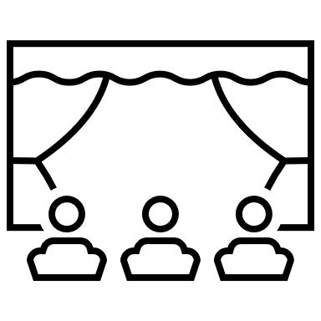

- How can David speak up and say no if someone offers him alcohol?
Case 4: The Mishap A 5th grader named Sarah is at a friend's house. They find a cabinet with alcohol and decide to try some just for fun. They end up not feeling well and get scared.

Discussion questions:

- What should Sarah and her friend do?

- Why is it important to tell an adult if you accidentally consume alcohol?

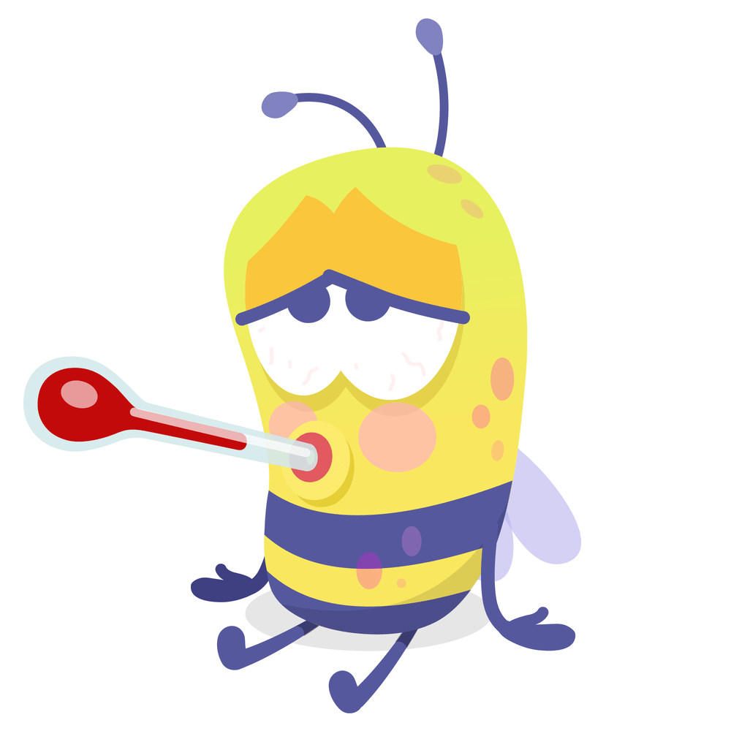
- What are the dangers of underage drinking?

Case 5: Misinformation and Marketing Alex is 11 and sees a lot of commercials and social media posts that make alcohol seem fun and exciting. He hears rumors from older kids that there are "health benefits" to certain types of alcohol.

Discussion questions:
- Where can Alex find accurate information about alcohol?

- How can advertising be misleading? What are some dangers of believing rumors about alcohol?




Case 6: Coping Mechanism A 5th grader named Lily is going through a tough time at home. Her parents are fighting a lot, and she feels stressed and anxious. She sees her older brother drinking alcohol and it seems to calm him down.
Discussion questions:
- What are some safer ways for Lily to cope with stress?

- How can Lily communicate her feelings? Who should she communicate them to?

