Grade: Five | Lesson: 6 | Topic: Nicotine Awareness
Virginia Standards of Learning | Health  5.1i, 5.1j, 5.2i, 5.2j
Virginia School Counseling Standards | DeM1: 5-6a, 5-6b
Materials Needed | - Chart paper  - Nicotine impact handout  - Paper  - Art supplies
Learning Objectives | - Examine the laws concerning tobacco use (past and present).  - Identify several consequences and effects of tobacco/nicotine on the brain and body.  - Explore additional consequences (environment, financial, etc.)  concerning smoked, smokeless, and vaping products.
I DO  Learning-Ready Reminders  Content | Introduce yourself.  Build a positive relationship with the students by sharing a fun fact about yourself. (For example: Your favorite ice cream flavor, your favorite food, or your favorite color.) Next, use the Learning-Ready Visuals and define the classroom expectations for when you visit. Say, “We will learn a lot about safety, responsibility, and respect within our school and community! When we are learning, we must be learning-ready! When we are learning-ready, we will:  - Respect personal space - Be aware of your surroundings, respect others’ space, and stay in your own area.  - Use volume control - Use indoor voices and be mindful of noise levels.  - Show active listening - Eyes and ears open! Ready to participate!  - Have sharp minds - Be prepared to problem solve, ask questions, and contribute to the lesson.”  Introduce nicotine products and their impact on human bodies.  Say, “Today we’ll be talking about nicotine, the drug you find in smoked tobacco like cigarettes, cigars, loose tobacco, or hookahs, smokeless tobacco like loose tobacco, mints, and strips, and e-cigarettes like vapes. All of these contain nicotine. Nicotine is what makes tobacco and e- cigarettes addictive. Nicotine is a powerful addictive stimulant to the brain and the central nervous system. Like alcohol, it initially stimulates, then has a depressant effect.”

Say, “Here are some vocabulary terms we are going to discuss.
- Central Nervous System (CNS): The central nervous system is like the control center of our body. It includes two important parts: the brain and the spinal cord.
  - Brain: This is where we think, learn, feel, and remember things. It’s like our super-smart computer!
  - Spinal cord: Imagine it as a long highway that carries messages between the brain and the rest of our body.
- Stimulant: A stimulant is like a turbo boost for our body and brain. It speeds things up! Examples of stimulants include caffeine (found in coffee and some sodas) and sugar (like when we eat candy). They can temporarily make us feel more awake and energetic.
- Depressant: A depressant is like a calm-down potion. It slows things down! Doctors sometimes use depressants to help people relax their muscles or feel less anxious. But if we take too much, it can make us feel sleepy, confused, and even stop us from breathing properly.”
Tell students, “Stimulants and depressants together can negatively interact with one another and lead to health issues. Nicotine products contain both.”

Share facts with the class about nicotine and addiction.
While going through slides point out the areas as you go along with the lesson indicating what parts of the body may be harmed by tobacco and nicotine use.

“Addiction is an uncontrollable urge to do something despite harmful consequences. Nicotine is just as addictive as heroin. It interferes with ordinary responsibilities such as work, family, or health. The user may not even be aware that their behavior is causing problems for themselves and others. Symptoms of withdrawal can include anxiety, nausea, and insomnia. Nicotine exposure during the teen years can limit brain growth and development leading to problems with attention and learning, and causing vulnerability to addiction.”

“Tobacco use narrows blood vessels, cutting down blood and oxygen flow. It raises blood pressure, which means the heart must work harder.”

“Burned tobacco and second-hand smoke contains more than 7,000 chemicals. Many are toxic and have been related to cancer. These chemicals make a toxic soup. And you breathe in this toxic soup when you breathe in cigarette smoke.”

“What is in tobacco products?
- Nicotine: this is an addictive drug.
- Insecticide
- Tar: like road paving and roofing materials.
- Methanol: used in rocket fuel.
- Acetone: found in nail polish remover.
- Ammonia: found in cleaners used to clean toilets.
- Carbon monoxide: found in car exhaust fumes.
- Arsenic: found in rat poison.
- Formaldehyde: found in embalming fluid.”

“Health issues and diseases related to tobacco use include:
- Chronic bronchitis
- Laryngitis
- Emphysema
- Heart disease
- Cancers
- Stained teeth and skin
- Wrinkled and dry skin
- Gum disease, tooth loss, and bad breath
- Use can cause some medications to not work or work properly.”

Introduce e-cigarette products.
These are battery-operated and deliver nicotine and other chemicals to the body. Some people believe the e-cigarette is a safer product than tobacco. Currently, there is no proof this is a safer product.
- E-cigs produce an aerosol (not pure water vapor) by heating liquid nicotine, flavoring, and other chemicals that combine to make the aerosol.
- These liquids also contain:
  - Flavoring that causes lung disease and injury when inhaled.
  - Ultra-fine particles that are inhaled deep into the lungs.

  - Heavy metals and other chemicals that can permanently lodge in the user's lungs.
- These products are regulated by the FDA and are not considered safe.
- Users inhale the aerosol into their lungs. Bystanders also inhale this aerosol when the user exhales into the air.
- These products are not FDA approved as a quit smoking aid.”

“Health issues and diseases caused by e-cigarettes:
- Lung disease and/or injury
- Respiratory problems- “popcorn lung” (caused by the chemical diacetyl)
- E-cig aerosol has metals and toxic chemicals known to cause cancer.
- Skin exposure to or ingestion of “e-juice” can cause seizures, brain injury, or vomiting."

“Legal consequences of tobacco/nicotine use may include:
- Fines: In many states, if someone under 18 is caught with tobacco or nicotine products, they can be fined.
- Community service: Young violators might have to do community service.
- Tobacco education programs: If caught with tobacco, some states require young people to attend special programs to learn about the dangers of smoking. These mandatory programs teach them why it’s important to stay away from tobacco outside of school.
- Loss of driver’s license: In some places, if you’re underage and caught with tobacco, your driver’s privileges might be taken away. It’s a way to remind everyone that tobacco is harmful.
- Official records: Getting a citation for using tobacco and nicotine products underage can result in this being documented on your personal official record.”

“There are also environmental consequences to tobacco use. Cigarettes are the most littered item on earth. Many e-cigarettes are single-use plastic pods. All those toxic chemicals and heavy metals contaminate our water and wildlife. The toxic exposure can poison fish, as well as animals who eat cigarette butts and garbage.”

“The cigarette filters, or “butts”, take years to biodegrade because they’re made of plastic fibers. Some studies have shown that after two years, only 38% of a cigarette butt was decomposed."

“There are also social, peer, and personal consequences to tobacco use. With all of this knowledge, why do you think people start or continue to use nicotine and tobacco products?” Ask students to talk to a peer or two about what they think. Possible student responses for why people use nicotine and tobacco products could include peer pressure, as a means to cope with stress, or because it is glamorized in movies or social media.
Parents who use it can normalize the use of any nicotine product.” Stress that many adults who smoke did not know all the effects when they started and are now addicted.

“What happens when a user stops? When a person quits smoking, the body begins to repair some of the damage caused by the smoking. “ Discuss ways in which people try to quit smoking such as medication and behavioral modification or therapy.

“Did you know there are financial impacts of tobacco use? The average cost of a pack of cigarettes is $6.36.” Help the students calculate the cost of smoking a pack a day by week, month, and year.

Note: Some students may be concerned about a loved one who uses tobacco or e-cigarettes and want to know how they can get the person to quit. Encourage students to be supportive, sensitive, and helpful around someone who is trying to quit smoking. Make sure they know the resources available in your community for tobacco cessation assistance.
WE DO  Practice | Activity  Divide students into small groups (three or four students per group). Provide each group with a silhouette of a human body from the handouts. Distribute markers or sticky notes to the groups. Instruct students to label different body parts on the silhouette where nicotine can affect them. Encourage them to consider both direct and indirect effects.  As they label, reemphasize the following points of impact on the body:  - “Brain: Nicotine stimulates the brain’s reward system, leading to addiction.

Check for Understanding  Conclusion | - Heart and blood vessels: Nicotine narrows blood vessels, increasing blood pressure and making the heart work harder.  - Lungs: Discuss the impact of smoking on lung health.  - Other organs: Mention other organs affected by nicotine exposure.”  Bring the groups together for a class discussion. Ask each group to share their labeled silhouettes and explain why they placed labels on specific areas. Discuss the consequences of nicotine use, including addiction, impaired brain development, and cardiovascular risks.  “Let’s create a public service announcement (PSA) on influencing others to not use nicotine or tobacco products.” Let students work independently or with a partner to create a PSA. Instruct students to include at least one area of negative impact of nicotine use that they  have learned about in their PSA.

Nicotine, Tobacco, and the Human Body
Identify the potential negative impacts of nicotine and tobaccos use on the body
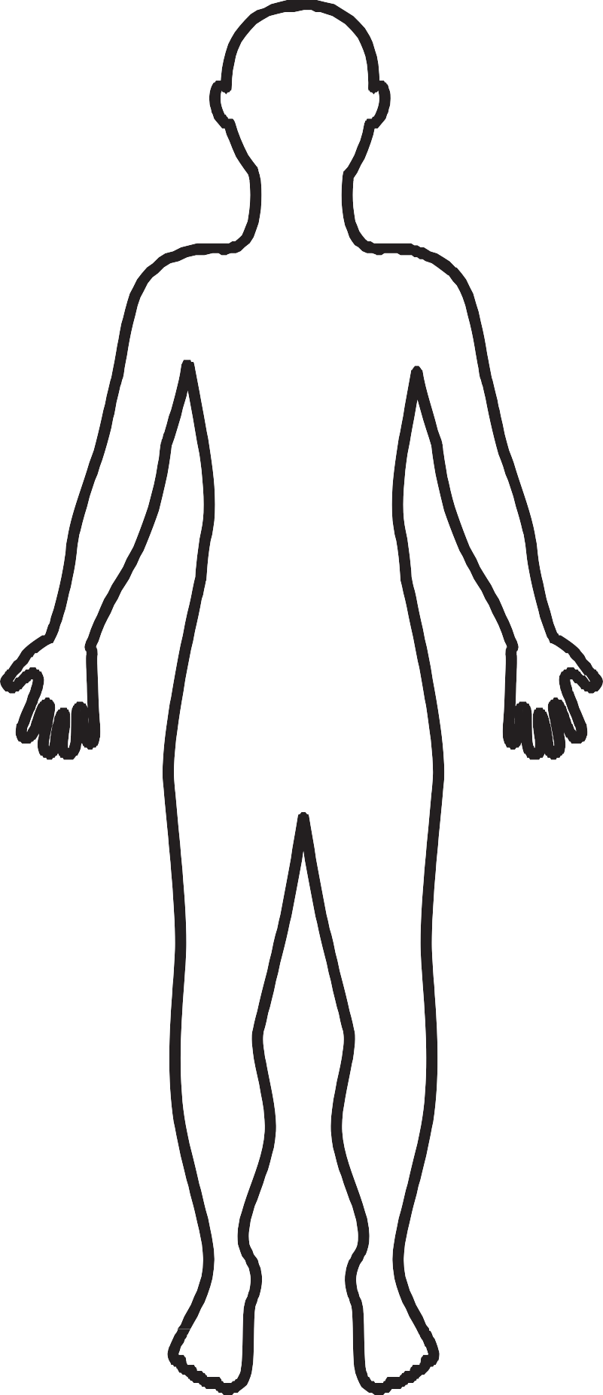

Name: Date:
Negative Impact of Nicotine and Tobacco Use
Legal Consequences

Environmental Consequences

Social, Peer, and Personal Consequences

Financial Consequences

