Grade: One | Lesson: 3 | Topic: Awareness/Safety at Home
Virginia Standards of Learning | English  1.2,1.3  Health  1.1, 1.2, 1.3
Virginia School  Counseling Standards | Kindergarten-Third Grade, Personal/Social Development
Materials Needed | - Lined paper  - Pens or pencils  - Word cards
Learning Objectives | - Define door, phone, and computer safety.  - Identify fire, guns, medicines, and other dangers.  - Role-play responses to potential dangers found in homes.  - Create safety plans.
I DO  Learning-Ready Reminders | Introduce yourself.  Build a positive relationship with the students by sharing a fun fact about yourself. (For example: your favorite ice cream flavor, your favorite food, or your favorite color, etc.) Next, use the Learning-Ready Visuals and define the classroom expectations for when you visit. Say, “We will learn a lot about safety, responsibility, and respect within our school and community! When we are learning, we must be learning-ready! When we are learning-ready, we will:  - Keep our bodies in our own space!  - Use our quiet voices!  - Keep our ears open!  - Have our brains ready!”  Review and introduce safety rules.  "We're going to discuss the importance of safety rules. Staying safe is crucial because it helps protect ourselves and those around us."  "When you're at home alone, there are essential safety tips to follow. Some of these will be new and some will be a reminder. Today we are going to focus on ways we can stay safe in our homes.  These safety tips include:  - Keep doors and windows closed and locked.

- Know how to call 911 in case of an emergency.
- Avoid the use of electrical appliances, knives, or matches.
- Never touch a gun.
- Don’t take medications without adult supervision.
- Follow online safety rules.
- Avoid computer use when parents are not at home."

Answer the telephone and door safely. "Now, let's understand how to safely answer the phone and door when you're home alone."

- Telephone safety: "Always remember, if the phone rings and you don't know who's calling, you don’t have to answer it. If you do answer the phone, don't let them know you're home alone. You can say, 'My parents can't come to the phone right now - may I take a message?' Just know that you're in charge of the phone, and if you ever feel uncomfortable, it's okay to hang up."

- Door safety: "When someone comes to the door, it's safest not to open it if they don't live with you. Always ask your parents before opening the door. It's best to stay inside unless you really need to go outside, and we will talk about how to be safe with your family in case of a fire."

Computer safety rules: "Another safety rule is to use the computer safely. Here are some important rules to remember:
- Don't share personal information such as your name, address, phone number, or school with anyone online.
- Only visit websites that your parents have approved.
- Don’t download or install anything without their permission.
- If you find anything online that makes you uncomfortable, tell a trusted adult.
- Never agree to meet someone you have met online without your parent's approval."

Gun safety rules: (Show word cards for rules.) "Guns should always be stored safely and out of reach of children. If you aren't sure if a gun is real or a toy, always treat it as a real gun. Do not touch it. Immediately find an adult. Guns should never be around kids without adult supervision.
- STOP: Do not touch the gun. Leave it exactly where it is.
- Don't touch: Even if it appears to be a toy, you must treat it as if it's real.
- Run away: Leave the area where the gun is located and go to a safe place where there is an adult.
- Tell a grown-up: As soon as you are in a safe location, inform them about the gun.

Safety rules about drugs, medicines, and household substances: "Now, let's talk about staying safe around dangerous household substances. It's really important to understand the safety rules when it comes to drugs, medicines, and other household substances."

“Why do we use drugs and medicines?
- To prevent disease
- To help when we're sick
- To stop pain
- To keep you healthy

Safety rules for medicine:
- Never taste, touch, or smell anything your parents don't give you.
- Never use medicine on your own. An adult will need to read and measure the medicine to make sure it is the correct amount and the correct type.
- Some medicines look like candy."

"Lastly, let's talk about who can give you medicine. Who can give you medicine?"
- Your parents or guardians
- A doctor or nurse
- The dentist
- A pharmacist

Fire safety rules:
Say, “Now let’s look at the rules that help us prevent fires and rules that will help keep us safe if there is a fire.”
- “Stay away from matches and lighters: Matches and lighters are tools for grown-ups. They are not toys! If you find them, tell a grown-up right away.
- Stop, drop, and roll: If your clothes ever catch on fire, remember to stop, drop to the ground, cover your face with your hands, and roll back and forth until the fire goes out.
- Get out and stay out: If you see a fire or hear a smoke alarm beep, get outside right away. Go to your family’s meeting place (like a tree or a lamppost) and wait there for everyone to gather.
- Tell a grown-up: Always tell a grown-up if you see or smell smoke, even if you’re not sure where it’s coming from. Grown-ups can call firefighters to help.
- Practice fire drills: Sometimes, families have fire drills to practice what to do if there’s a fire. When you hear the smoke alarm, follow your family’s plan to get outside fast and safely.
- Remember, firefighters are community helpers: Firefighters wear special clothes to keep them safe from fire. They are brave helpers who come to put out fires and keep us safe.”
WE DO  Practice | "Now, let's engage in a class discussion. Can someone tell me one way that we can stay safe in our homes?" or “Turn to the person beside you and tell them one way they can stay safe in their home."  Role-play real-life scenarios.  "Now, let's practice using these safety rules in real-life scenarios. We'll role-play activities where students take turns practicing how to be safe in pairs. As you participate, remember to apply the safety rules we learned about."  There is a stranger at the door: "You hear the doorbell ring, and when you check, you see a stranger outside. What should you do to stay safe?"  - Keep doors and windows closed and locked.  - Do not answer the door for anyone you don't know and find a grown-up.  - If you are home alone and they will not leave, call 911.  Online chatting: "You're home alone and receive a chat request from someone you don't know. You are on Roblox or playing a game, and someone that you do not know sends you a message. They say they are seven years old, and they want to be your friend. What should you do?"  - If you do not know them, do not respond.  - Do not share personal information.  - Exit the chat and disconnect from the computer immediately.  - Tell a trusted grown-up.  Gun safety at home: "You come across a gun in a place where it should not be, like a drawer in the living room. What should you do to stay safe?"  - STOP  - Don't touch it.  - Leave the area and run away.  - Tell a grown-up.  - Wait for help.  Medication safety at home: "You're home alone and you notice a bottle of pills that you don't recognize on the kitchen counter. What should you do to stay safe?"  - Don't touch it.  - Leave it alone.  - Tell a trusted grown-up.  Fire safety: “Let’s practice "Stop, Drop, and Roll" together. Imagine your clothes are on fire (but they’re not really). I’ll say the steps, and we’ll practice together”:  - (Demonstrate) "Stop!" (stand still)  - (Demonstrate) "Drop!" (kneel down)  - (Demonstrate) "Roll!" (roll back and forth)

YOU DO  Check for Understanding | Create a plan. (Distribute lined paper.)  "Now, it's time for you to create a safety plan. You can choose from scenarios we've discussed, such as 'What if you come across a gun?' or 'What if there's a fire?' or any other scenario. Write down the steps you should take to stay safe in that situation.”  Share about your safety plan.  "Once you've completed your safety plan, you will have an opportunity to share your plan with the class."

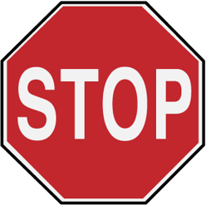
Stop!

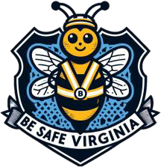

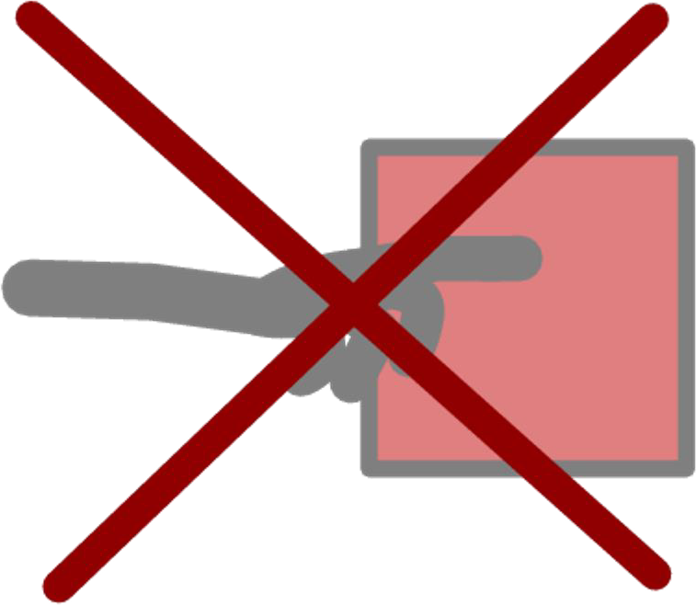
Don’t Touch!


Get Away!

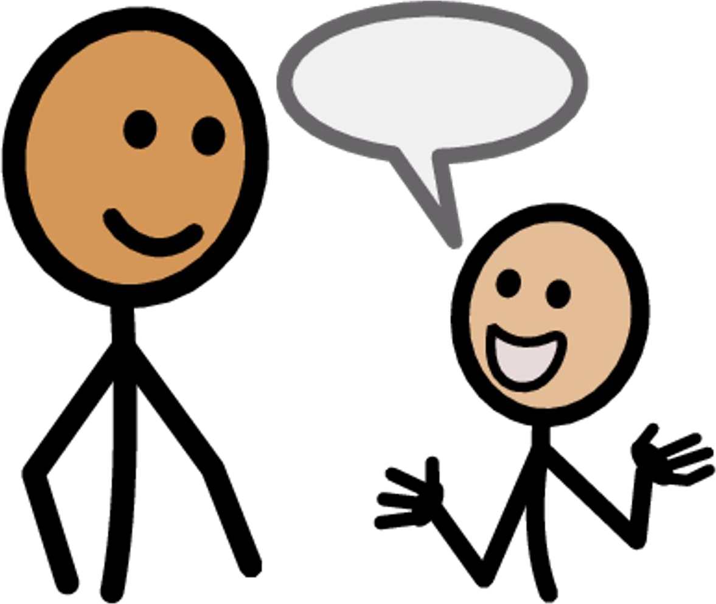
Tell an adult

