Grade: Four | Lesson: 2 | Topic: Digital Citizenship
Virginia Standards of Learning | Fourth Grade:  (3 – 5) DC A and B
Virginia School Counseling Standards | EP9
Materials Needed | - Crayons or markers  - Superhero handout  - “Dear Future Me” handout  - Book- The Technology Tail: A Digital Footprint Story by Julia Cook
Learning Objectives | - Identify ways to be a positive digital citizen.  - Solve real-life scenarios concerning digital use and safety.  - Recognize what cyberbullying is and develop ways to be respectful and responsible online.
I DO  Learning-Ready Reminders  Content | Introduce yourself.  Build a positive relationship with the students by sharing a fun fact about yourself. (For example: Your favorite ice cream flavor, your favorite food, or your favorite color.) Next, use the Learning-Ready Visuals and define the classroom expectations for when you visit. Say, “We will learn a lot about safety, responsibility, and respect within our school and community! When we are learning, we must be learning- ready! When we are learning-ready, we will:  - Respect personal space - Be aware of your surroundings, respect others’ space, and stay in your own area.  - Use volume control - Use indoor voices and be mindful of noise levels.  - Show active listening - Eyes and ears open! Ready to participate!  - Have sharp minds - Be prepared to problem solve, ask questions, and contribute to the lesson.”  Introduce what it means to be a responsible digital citizen.  Say “Today we're going on an adventure to explore what it means to be a responsible digital citizen. Just like we act respectfully in our community, we also need to act responsibly online.  Remember online safety isn't just about protecting yourself, but also about being mindful of others' feelings. Finally, imagine we're

all members of a digital community, where everyone deserves to feel welcome and respected."

Respect
Then say, “Imagine respect like a superpower! It's all about treating others the way you'd like to be treated, even if they're different from you. Here's how you can use this superpower:
- Kind words and actions: Think of how words and actions can make someone feel happy, sad, or angry. Choose words and actions that make people feel good, like using please and thank you, listening when others talk, and sharing.
- Treat others fairly: Everyone deserves to be treated nicely, no matter what. Don't make fun of someone or exclude them just because they're different. Remember, even superheroes respect villains!
- Take care of things: Respect isn't just about people, it's about places and things too! Treat your belongings, school property, and nature with care so everyone can enjoy them.
- Be kind online: Just like you wouldn't bully someone at school, don't say mean things in comments, messages, or games. Remember, people have feelings, even online!
- Think before you share: Would you share that picture or information if you were saying it out loud? Be careful about what you post about yourself and others.”

Responsibility
“Being responsible is like being a superhero's sidekick! It means taking charge and owning up to your actions. Here's how you can be a responsible sidekick:
- Do your part: Whether it's finishing your homework, cleaning your room, or taking care of a pet, being responsible means doing your tasks without needing reminders. Think of it as training for bigger responsibilities later!
- Make good choices: Even superheroes make mistakes, but
they learn from them! If you make a bad choice, apologize

and try to fix it. Being responsible means making choices that don't hurt yourself or others.
- Be accountable: If you mess up, own up to it! Lying or blaming others isn't cool. Responsible superheroes take responsibility for their actions, even when it's tough.
- Protect your information: Don't share your passwords or personal details with people you don't know online. It's like giving away your secret identity!
- Be careful about clicking links: Not everything online is safe. Ask a grown-up before clicking on links or downloading anything, just like you would ask before crossing the street.
- Think critically about what you see: Not everything you read online is true. Check with trusted sources like teachers, librarians, or websites you know before believing something.”

Have students share with their shoulder buddies about a time they were respectful or responsible in a digital setting.

Read the book: The Technology Tail: A Digital Footprint Story by Julia Cook.
WE DO  Practice | Have students work in small groups for these activities. Encourage them to discuss their different ideas amongst their group and give them the option to share aloud with the entire class.  Discussion: Digital dilemma game  "Okay, team! Get ready to solve some puzzles. Imagine you're playing a game online, and someone starts making fun of another player. What could you do to be a responsible digital citizen?" (Allow students to respond.) Discuss options like reporting the incident, speaking up kindly, or ignoring the negativity.  "Now, picture yourself receiving a message from someone you don't know who wants to meet up offline. Is that safe? What responsible steps could you take?" Guide students towards not meeting strangers online and reporting such messages to a trusted adult.

Activity: Create a digital superhero.
“This digital superhero is the ultimate upstander.” Use the “Digital Superhero” handout to have students create their own digital superheroes. Students will identify the respectful and respectful characteristics of their superhero and incorporate the guided questions into their final product. Say, "Time to channel your inner hero! Each of you will create a digital superhero who fights for justice online. What special powers would your superhero have to stop cyberbullying, spread kindness, and protect people's privacy.”

Provide drawing materials and brainstorm ideas together. "Once you're done, let's share our amazing superheroes! What challenges would they face, and how would they use their powers to make the online world a better place?" Choose a couple of
students to present their superheroes to the class and discuss.
YOU DO  Check for Understanding | Independent reflection: “Dear Future Me” letter  "Imagine sending a letter to yourself in the future, sharing your thoughts on being a responsible digital citizen. What are some
 | good online habits you want to keep up? What are some potential
 | risks you want to avoid?" Distribute the “Dear Future Me”
 | handout and encourage reflection. "Feel free to share your letters
 | with a trusted adult or keep them private, like a personal time
 | capsule for your future self."
Conclusion | "Today, we've explored so much about being responsible digital
 | citizens. Remember, it's all about using technology wisely,
 | respecting others, and being kind online."

NAME
DATE

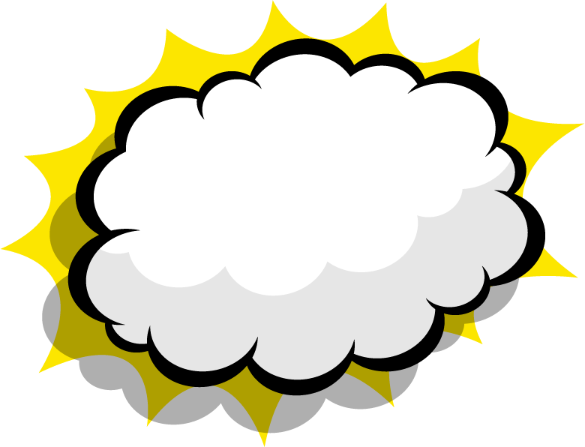
My Superhero
Draw your hero here
Your hero's superpowers



Your hero's name Your hero's features

Dear Future ME,

Sincerely,

