Grade: Four | Lesson: 5 | Topic: Peer Pressure
Virginia Standards of Learning | English  4.1, 4.2  Health:  4.1, 4.2, 4.3
Virginia School Counseling Standards
Materials Needed | - Whiteboard or chart paper  - Markers  - Scenario cards
Learning Objectives | - Define peer pressure.  - Explain how people influence others (for good and bad).  - Identify strategies for resisting negative influences.  - Discuss strategies to demonstrate responsibility and remorse for behavior.  - Apply these strategies to scenarios.
I DO  Learning-Ready Reminders  Content  Practice | Introduce yourself.  Build a positive relationship with the students by sharing a fun fact about yourself. (For example: Your favorite ice cream flavor, your favorite food, or your favorite color.) Next, use the Learning-Ready Visuals and define the classroom expectations for when you visit. Say, “We will learn a lot about safety, responsibility, and respect within our school and community! When we are learning, we must be learning-ready! When we are learning-ready, we will:  - Respect personal space - Be aware of your surroundings, respect others’ space, and stay in your own area.  - Use volume control - Use indoor voices and be mindful of noise levels.  - Show active listening - Eyes and ears open! Ready to participate!  - Have sharp minds - Be prepared to problem solve, ask questions, and contribute to the lesson.”  Introduce students to the concept of peer pressure.  "Today, we'll talk about something important called peer pressure. Can anyone tell me what they think peer pressure means?" (Allow students time to respond.)  Define peer pressure.  Say to the students, “Let's talk about peer pressure. Peer pressure is when people your age try to influence you to do something, whether good or bad. Sometimes, it's tempting to do what everyone else does, even if it's wrong. Let's discuss some examples to help us understand it better."  Explain how people influence others (for good and bad).  Use slides 9-12 of the presentation to provide examples of negative and positive peer pressure:  - Cheating on a test (negative peer pressure): Tell the students, "Imagine you're sitting in class, and your friends start passing notes, whispering, ‘Hey, let's copy each other's answers on the test.' They keep nudging you, saying, 'Come on, everyone else is doing it. It's not a big deal.' This is an example of negative peer pressure because they're trying to influence you to cheat, which is not the right thing to do."  - Encouraging healthy choices (positive peer pressure): Next say, "Now, think about a positive example. You're at lunch with your friends and bring a nutritious lunch from home. Your friends notice and say, 'Wow, that looks healthy! I should start bringing healthier lunches, too.' They encourage you to join the school's fitness club and they start to eat more fruit and vegetables. This is a positive example of peer pressure because your friends influence you to continue making healthier choices, which is good."  - Skipping school (negative peer pressure): "Now, consider another negative example. You're excited about attending school because you have a project presentation today. But your friends approach you and say, 'Hey, let's skip school and go to the mall instead. It'll be way more fun!' They insist, saying, 'Don't worry, nobody will even notice we're gone.' This is an example of negative peer pressure because they're trying to persuade you to skip school, which is irresponsible behavior."  - Volunteering for community service (positive peer pressure): Now tell the students, "Your classmates are organizing a community service project to clean up the local park. They invite you to join them, saying, 'We're making a difference in our community. It would be awesome if you could help, too!' They encourage you to participate by explaining how much fun it will be and how good it will feel to help others. This is a positive example because they're influencing you to do something helpful and responsible for your community."  Summarize by saying, “By discussing these examples, we can understand how people influence others both for good and bad, which helps us grasp the concept of peer pressure and its impact on decision-making.”  Identify strategies for resisting negative influences.  Next say, "Alright, class, we're going to do an activity now to help us understand positive and negative peer pressure better. I will share some scenarios on the board, and I want you to tell me if each one is an example of positive or negative peer pressure. Pay close attention to the situation and consider whether it's encouraging a good or bad choice. Ready? Let's get started." Use slides 13-16 to go through each scenario. Present each scenario one at a time. Allow students time to respond to each scenario.:  1. “Your friends want you to sneak into a movie theater without paying.”  2. “Your friends suggest hiking instead of playing video games indoors.”  3. “Your friends urge you to try smoking cigarettes behind the school building.”  4.” Your friends invite you to participate in a charity run to raise funds for a local animal shelter.”
WE DO  Practice  Check for understanding | Discuss strategies to demonstrate responsibility and remorse for behavior.  "Now, let's work together to develop strategies for resisting negative peer pressure. I'll write down your ideas on the board. Take a moment to think about what you could do when you feel pressured to do something you know is wrong. What are some things you can do when you feel pressured to do something you know is wrong? Remember, there are no wrong answers here, just ideas to help us make better choices." Allow students time to respond. Encourage participation from everyone in the class.  After discussion say, “Class, now that we've discussed strategies to resist negative peer pressure, let's dive deeper into what happens if we find ourselves in a situation where we've made a mistake. It's important to remember that everyone makes mistakes, but how we handle them afterward truly matters. So, let's talk about demonstrating responsibility and remorse for our behavior.” Identify these important strategies to remember:  1.” Say no firmly. It's okay to say no if you're uncomfortable with something. It's important to stand up for what you believe in.”  2. “Walk away. Sometimes, removing yourself from a tough situation is the best option. Taking a break can help you make better choices.  3. Find new friends who support your decisions. Surround yourself with friends who respect your choices and help you do the right thing.  4. Talk to a trusted adult. If you're unsure what to do, don't hesitate to talk to a grown-up you trust. They can provide guidance and support.  5. Take responsibility for your actions. When you make a mistake, own up to it. Don't blame others. For example, if you break something, apologize sincerely.  6. Apologize sincerely if you make a mistake. If you hurt someone, apologize and mean it. It's important to acknowledge the impact of our actions.  7. Make amends to those you may have harmed. If you do something wrong, try to fix it. Offer help or replace what was damaged, if possible.  8. Learn from your mistakes and strive to improve. Use your mistakes as opportunities for growth. Think about what you can do differently next time.  9. Reflect on the consequences of your actions. Consider how your choices affect yourself and others. Think before you act.  10. Seek guidance from positive role models. Don't be afraid to ask for help when needed. Positive role models, like teachers or parents, can offer valuable advice.”  “Now, let's discuss how we can demonstrate responsibility and remorse if we make mistakes. Can anyone share their thoughts on this? Remember, it's important to acknowledge our errors and take steps to make things right. Let's discuss how we can demonstrate responsibility and remorse for our behavior. When we make a mistake, it's important to take ownership of our actions and try to make things right. How do you think we can do that?" Write down each suggestion on the board as students share their ideas. Encourage discussion and elaboration on each strategy to ensure understanding. This activity helps students identify practical ways to resist negative influences and demonstrates responsibility by seeking help when needed. Encourage students to share their thoughts.  Examples of responses can be:  - Take responsibility: Admit your mistake without making excuses. Accept the consequences of your actions. Be honest with yourself and others about what happened.  - Show remorse: Apologize sincerely to those you may have hurt. Express empathy and understanding toward others' feelings. Reflect on the impact of your actions and express regret.  - Making amends: Take action to repair any damage caused by your behavior. Offer to help those affected by your actions in any way possible. Demonstrate through your actions that you are committed to making things right.  Follow up the discussion by saying, "It's important to remember that everyone makes mistakes, but how we handle them matters. By taking responsibility and showing remorse, we can learn and grow from our experiences."
YOU DO  Practice  Check for Understanding | Apply strategies to scenarios.  Pass out scenario cards and say, “Now, it's time to apply what you've learned. I'm going to hand out scenario cards to each of you. Read the scenario and decide what you would do in that situation. Then, we'll share our answers."  Scenarios:  1. “Your friends want you to skip homework and play video games instead.  2. Your classmates are teasing another student and want you to join in.  3. Your friends are pressuring you to try vaping.  4. Your friend asks you to cover for them while they break a school rule.”  "Who would like to share how they would handle their scenario? Remember, not only think about how to resist negative peer pressure but also how you could demonstrate responsibility and remorse if needed." Encourage students to share their responses and discuss how they incorporate strategies for responsibility and remorse.
Conclusion | "Today, we discussed peer pressure and how it can affect our choices. Remember, doing what you know is right is important, even if others disagree. Let's make smart choices, but if we make mistakes, let's take responsibility for our actions and demonstrate remorse. You did a fantastic job today, class!”

Scenario #1  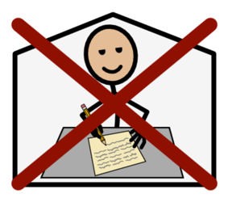  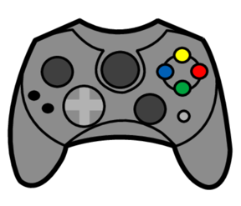 | Your friends want you to skip homework and play video games instead.
Scenario #2  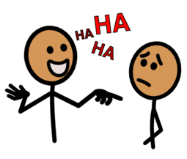 | Your classmates are teasing another student and want you to join in.

Scenario #3  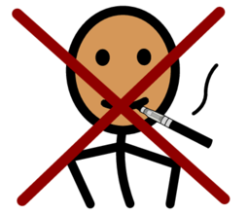 | Your friends are pressuring you to try vaping.
Scenario #4  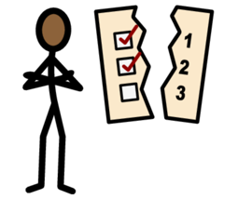 | Your friend asks you to cover up for them when they break a school rule.

