Grade:  Kindergarten | Lesson: 1 | Topic: Bus Safety
Virginia Standards | English
of Learning | K.1, K.2, K.3
 | Health
 | K.3
 | History
 | K.8, K.10
 | Mathematics
 | K.12
Virginia School  Counseling Standards | EP1, EP4, EP6
Materials Needed | - Model school bus and bus safety pledge.  - Bus driver/pedestrian definitions and game cards.  - Chart paper and marker or whiteboard/chalkboard.
Learning Objectives | - Define a pedestrian.  - Explain the purpose of a school bus and how to prepare to ride as a passenger.  - Define the job of a bus driver and their responsibility to be safe.  - Review and recall bus and pedestrian safety rules.  - Discuss and compare safe and unsafe behaviors in danger zones.
I DO | Introduce yourself.  Build a positive relationship with the students by sharing a fun fact about yourself. (For example: your favorite ice cream ﬂavor, your favorite food, or your favorite color, etc.) Next, use the Learning-Ready Visuals and deﬁne the classroom expectations for when you visit. Say, “We will learn a lot about safety, responsibility, and respect within our school and community! When we are learning, we must be learning- ready! When we are learning-ready, we will:  - Keep our bodies in our own space!  - Use our quiet voices!  - Keep our ears open!  - Have our brains ready!”  Introduce and discuss the vocabulary word "pedestrian” and discuss  the difference between a bus rider and a pedestrian.  Hold up the vocabulary card for a pedestrian and ask, “Who can tell me what you see in this picture?” (Allow students to call out what they see.)
Learning-Ready Reminders
Content

Check for Understanding | Define the word pedestrian. A pedestrian is a person who is walking, riding a scooter, or using a wheelchair to get around. Hold up the vocabulary card, providing a visual example of the definition. Have the students stand up and “be a pedestrian” with you as you walk around the room.  Play the game “Pedestrian or Non-Pedestrian”.  Hold up picture #1 (person in a car) and ask students to show a thumbs up or thumbs down. “Is this person a pedestrian or not a pedestrian?”  Continue to play the game through the stack of cards. Students will  recall the difference between a pedestrian and a non-pedestrian.  Introduce the school bus, describe why we ride the bus, and define  the job of a bus driver.  Hold up the school bus and ask, “How many of you rode this to get to school today? A school bus takes us to and from school.” (Next, show the vocabulary card for the school bus driver with a picture.) “A bus driver is the person responsible for driving the school bus and keeping us safe."  Next say, “We are going to play another thumbs up and thumbs down game. I am going to show you pictures and ask you questions. If the answer is yes, you are going to give me a thumbs up! If the answer is no, you will give me a thumbs down.”  - (Hold up the picture of a pedestrian.) “Is this person a pedestrian?” (If you are comfortable, you can ask “How do you know this person is a pedestrian?”.)  - (Hold up a picture of a teacher in the classroom.) “Is this person a bus driver?” (If you are comfortable, you can ask “How do you know this person is not a bus driver?”.)  - (Hold up a picture of a child in a car.) “Is this person a pedestrian?” (If you are comfortable, you can ask “How do you know this person is not a pedestrian?”.)  - (Hold up a picture of a bus driver) “Is this person a bus driver?” (If you are comfortable, you can ask “How do you know this  person is a bus driver?”.)
WE DO  Practice | Practice bus rules.  Next, tell the students, “I have a new song about being safe on the bus. We are going to learn the song and sing it together so we can be safe on the bus!” Use the PowerPoint to play the song called “School  Safety Bus Song”.

Check for Understanding | After the first round of singing, stop and say,  “Wow! You all did a wonderful job naming different parts of the bus and explaining the bus driver's job. I want to hear you sing the song again, all by yourselves!”  The students will sing “The Wheels on the Bus”, describing the various parts of the school and bus and explaining the role of the bus driver with minimal guidance.  Examine safety rules for pedestrians and riding the bus. Discuss and  compare safe and unsafe behaviors in danger zones.  Say, “I know you all are learning about pedestrian safety and riding the school bus safely.” Hold up a picture of a pedestrian and review asking, “Who can tell me what this picture is?”  Next, use the danger zone slide, and describe the bus danger zone. “The bus danger zone means:  - Stay three giant steps away from the side of the bus.  - Always keep five giant steps away from the front of the bus.  - Never go behind the bus or near the wheels.  - If you drop something near the bus, tell an adult and let them tell you what to do. Never pick it up without permission.  - Use the handrail when boarding or getting off the bus. Next, use the PowerPoint to read the short story, “We Can Ride the  Bus to School,” and say, “Let’s read this story about being safe on our way to school!”  Read the story, “We Can Ride the Bus to School!”
YOU DO | List safety rules.  After reading, say, “We heard a lot of great safety rules! I want us to create a list of safety rules together.” Use chart paper/whiteboard to record student responses to “We can be safe on the bus when we…”  After creating and reviewing the list, pass out the “Safety Bus Pledge” to the students. The students will apply their bus safety knowledge by creating a picture of themselves being safe when riding the bus to school. At the bottom of the page, the student will write their name  after the words “I can be safe on the bus.”
Conclusion | When students have completed their picture, they can share how they plan to be safe on the bus. You can close the lesson by saying, “Thank you for sharing your pledge with me today. I know you are going to be safe pedestrians and help the bus driver get you to and from school  safely."

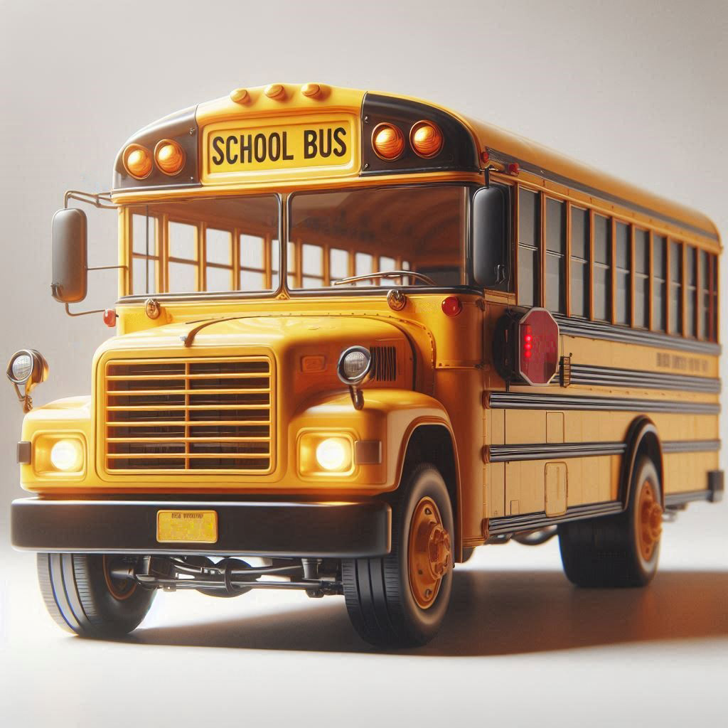
• •

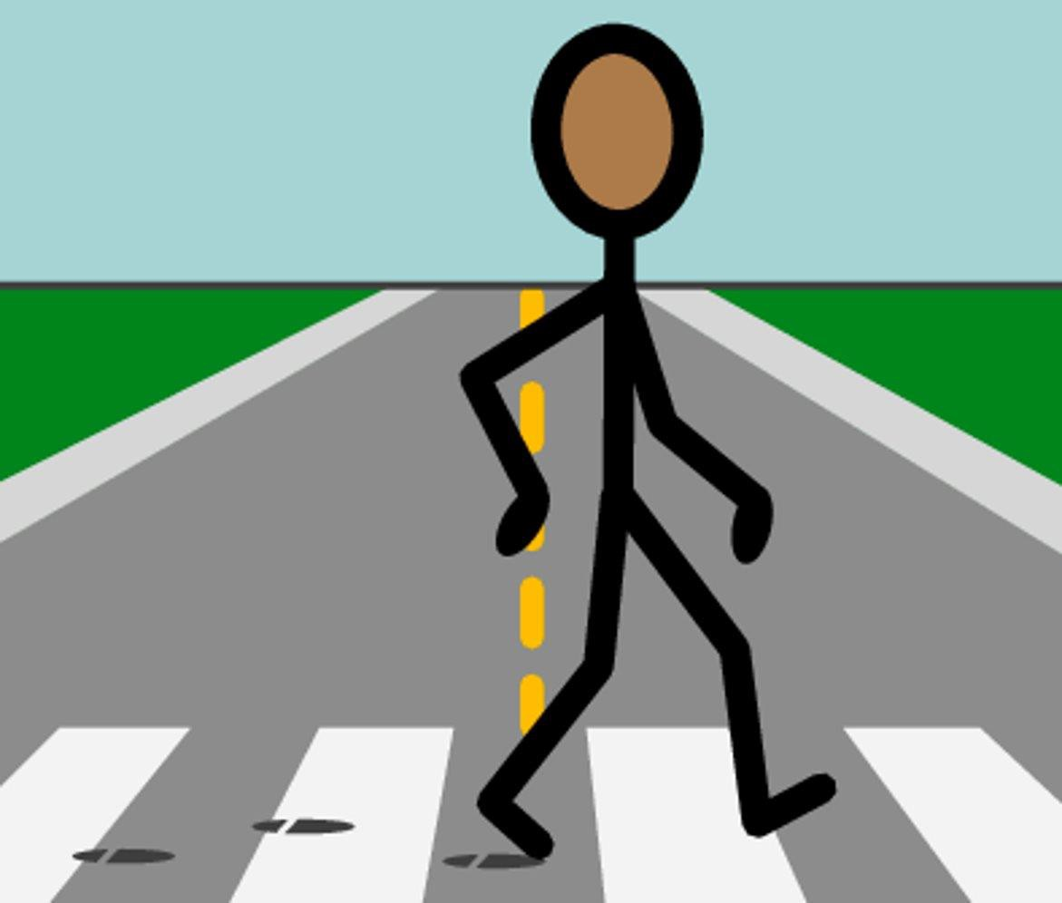
Pedestrian: pedestrian is a person who is walking, riding a scooter, or using a wheelchair to get around.

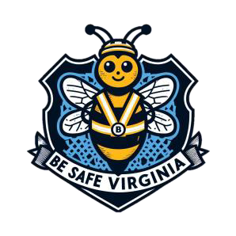
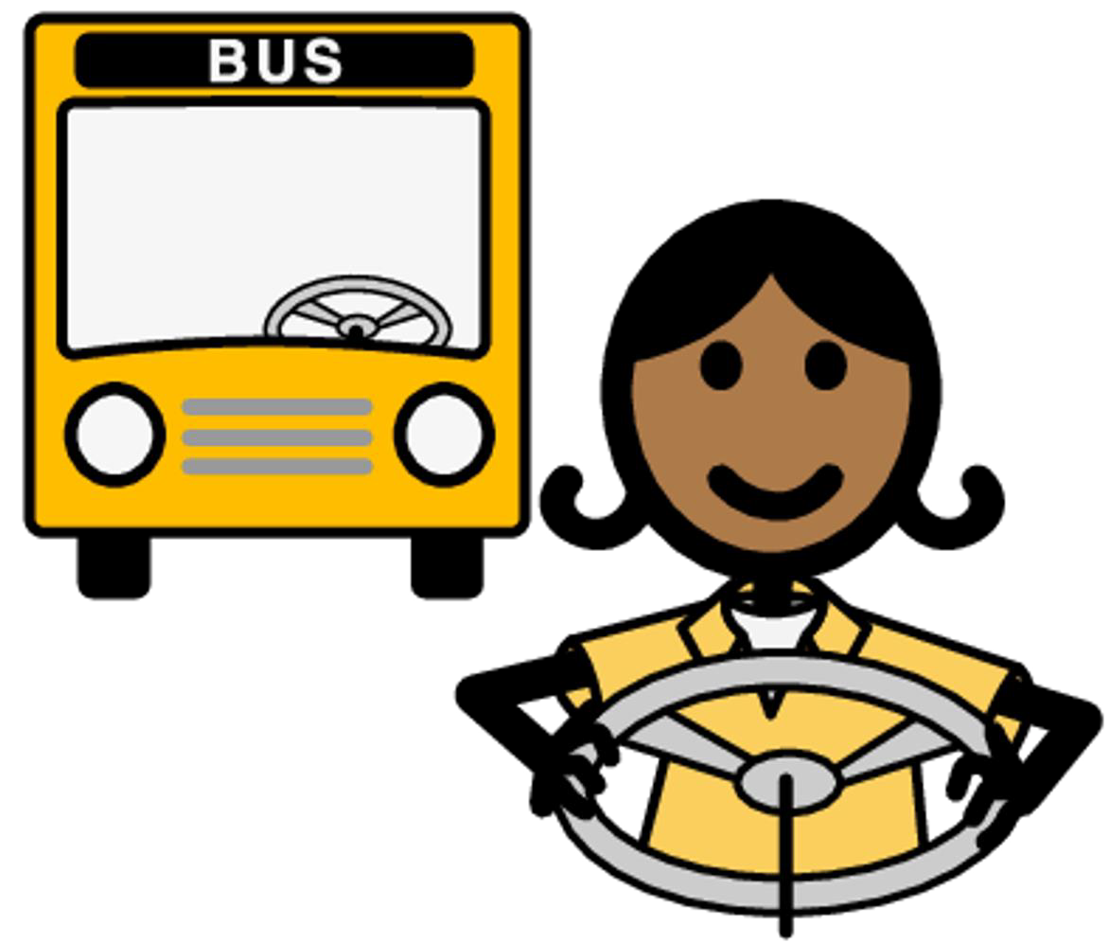
Bus Driver: A bus driver is the person responsible for driving the school bus and keeping us safe.

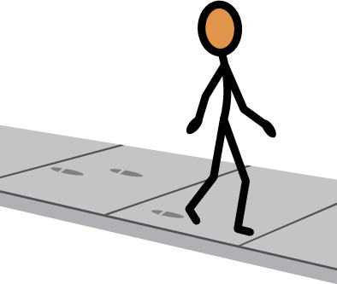
Is this person a pedestrian?




Is this person a bus driver?

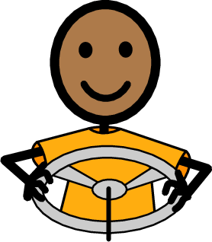
Is this person a pedestrian?

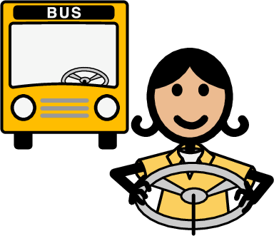
Is this person a bus driver?

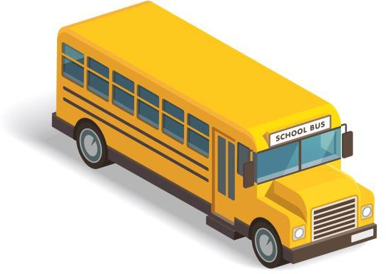
I can be safe on the bus!

My Safe Bus Ride Pledge

🖐 I promise to wait for the bus in a safe place, away from the road.

I will always listen to the bus driver because they know what’s best for a safe ride.

I will walk onto the bus calmly, find a seat quickly, and sit down.

🗣 I will use my inside voice, so I don’t distract the driver.

□ I'll keep my backpack on my lap or under the seat, not in the aisle.

● I won’t put my hands, arms, or head out of the windows.

- When getting off, I will wait for the bus to stop completely before standing.

Before crossing the street, I will always look left, right, then left again.

I'll be kind and respectful to everyone on the bus, because we all want a safe trip. If I see something unsafe, I'll tell the driver or a teacher.
I promise to follow these rules every time I ride the bus to make sure I, and everyone else, have a safe and happy journey.

🖋 (Student's Name) Date:
Let's keep our bus rides safe and fun!

My safety picture.

