Grade: Kindergarten | Lesson: 2 | Topic: Community Helpers Responsible for Safety
Virginia Standards of Learning | English  K.1, K.2, K.3  Health K.1, K.3  History  K.8, K.10, K.11  Mathematics K.6  Science  K.1, K.3
Virginia School Counseling Standards
Materials Needed | - Paper or cardstock  - Community Helpers and their tools cards (printed)  - Crayons, colored pencils, or markers
Learning Objectives: | - Define the role of a community helper.  - Define the role of a police officer.  - Identify community partners based on the tools/parts of their uniforms.  - Explain what to do if there's an emergency.  - Discuss what you should do if you see a gun.
I DO  Learning-Ready Reminders | Introduce yourself.  Build a positive relationship with the students by sharing a fun fact about yourself. (For example: your favorite ice cream flavor, your favorite food, or your favorite color, etc.) Next, use the Learning- Ready Visuals and define the classroom expectations for when you visit. Say, “We will learn a lot about safety, responsibility, and respect within our school and community! When we are learning, we must be learning-ready! When we are learning-ready, we will:  - Keep our bodies in our own space!  - Use our quiet voices!  - Keep our ears open!  - Have our brains ready!”  Note: If this lesson is not being taught by a police officer, reference the school SRO, or use a photograph of a police officer.

Tell the students, “Raise your hand if you know what my job is.” Say, “I am a police officer”. Ask the students to raise their hands and tell you what they think you do as a police officer. Call on students and allow them to answer.
Explain that a police officer is a community helper.
Say “Community helpers are people who have a job to help keep our friends and neighborhood safe in different ways. Police officers are community helpers who protect our community and ensure everyone follows the rules to keep our neighborhood and friends safe.” Tell the students that police officers also:
- Help people cross the street.
- Help people by directing traffic.
- Help lost children find their parents.
- Help people in accidents.
- Help those in trouble.
- Help catch people who have broken the law.
- And police officers do much more!
WE DO | Identify community partners based on the tools they use/parts of their uniform.  Say “Community helpers are people who have a job to help keep our friends and neighborhood safe in different ways. Every community helper has tools and a uniform that helps us recognize them if we need help and they also help them do their job.”  Tell them you are wearing a uniform that is blue (or brown) and a badge that helps them know you are a police officer.  Tell them you have tools to help you do your job such as a flashlight to help you see in dark places and a tourniquet to help someone that is bleeding.  Tell the students you have pictures of other community helpers and a tool each helper uses to do their job. “Let's see what other community helpers you all know.” Pass out a helper picture and tool picture to each student and tell them to hold their picture in their laps. Ask “Who has the ?” Let that student bring their helper picture up to see. Then ask, “Who has the tool the uses to help our neighborhood/friends?” Let that student bring their tool picture up to show. Ask the class “How does a help our neighborhood and friends?”

Respond with “Yes, a helps our neighborhood and friends by . A uses a to .”
Do this for each community helper. Collect the cards and briefly review the learning-ready rules to get the students' attention back in order to move on.
YOU DO | Explain what to do if there's an emergency.  Tell the students we learned about different community helpers and what tools they use to help our neighborhood and friends. We also learned about what a police officer does. Now we are going to learn something very important.  Tell students that an emergency is when something serious, dangerous, and unexpected has happened and help is needed. Ask the students if they know what to do if there's an emergency. Ask students to raise their hands and name examples of an emergency. Ask students to raise their hands and name examples of something that is not an emergency. Briefly discuss their answers for both.  Tell the students when there is an emergency, and no other adult is able to help, they can call 911 using a phone. Practice saying “9-1- 1” out loud as a class. (Be sure to stress what would constitute an emergency so that students will not randomly call 911.)  Tell the students that 911 sends the police. Talk about what will happen on the phone when you call 911:  - Someone will answer and say “911 what is your emergency?” Tell the students it is their job to stay calm and tell the person what is happening.  - “They will then ask you your location. It is safe to tell them your location if you call 911.”  Tell the students that 911 dispatchers are community helpers too and they help the police and community by following the rules which will keep them safe and out of trouble and using their brain to make smart choices.  Discuss what you should do if you see a gun.  Say, “We are going to learn an important rule together. I am going to teach you what to do when you see a gun. If you see a gun you:  - STOP: Do not go close to the gun.

- DON’T TOUCH: Never touch a gun if you see one.
- RUN AWAY: Get far away from the gun.
- TELL A GROWN-UP: Find an adult and tell them where you saw the gun. “
Ask the students why in between each step (Do you know why we stop? Do you know why we do not touch?)
Next, teach the students these hand moves to remember the steps. “Now we are going to learn hand moves to help us all remember these steps.” Model each step for the students by yourself first and then have the student join you. Repeat it together three times and then have the students do it one time independently:
- STOP: (Hold your hands and arms straight out.)
- DON’T TOUCH: (Cross your hands and arms over each other while shaking your head no.)
- RUN AWAY: (Use both thumbs out to motion back over your shoulders.)
- TELL A GROWN-UP: (Hold both hands cupped around your
mouth.)
Conclusion | Explain to the students that they will now create special "thank you” cards for community helpers. These cards will be a way for them to show appreciation for the important work that community helpers do.  Provide each student with a blank card or a piece of paper folded in half to create a card. Encourage them to use crayons, markers, or colored pencils to decorate the card. They can draw pictures of their favorite community helper or create a “thank you” message.  Discuss community helpers.  Have a brief discussion with the students as they’re creating their cards about the different community helpers they learned about in the lesson. Ask questions like:  - "Who is your favorite community helper?"  - "What does a police officer/teacher/firefighter/doctor do to help our community?"  - "Why are community helpers important?"

Teacher Key: Community helpers - tools
- Firefighter - water hose
  - A firefighter helps keep our neighborhood and friends safe by putting out fires and saving people when there is an accident. Firefighters use a water hose to put out fires.
- Bus drivers - bus
  - A bus driver helps keep our neighborhood and friends safe by driving them to different places like school, the store, and home. The bus driver uses the bus to take a lot of people at one time
- Teachers - pencils
  - Teachers help our neighborhood and friends by helping students learn and grow. Teacher use pencils at school to teach students how to write
- Doctor - Stethoscope
  - Doctors help keep our neighborhood and friends safe by making sure everyone’s body is healthy. Doctors use a stethoscope to check your heart
- Crossing guard - stop sign or whistle
  - Crossing guards help keep our neighborhood and friends safe by helping people and cars cross the street. Crossing guards use whistles and stop signs to warn people when it is and isn’t safe
- Chef- Spatula
  - Chefs help our neighborhood and friends by making healthy food for people to eat. Chefs use spatulas as a tool to cook
- Children - Brain
  - Children help our neighborhood and friends by following the rules and being kind to others. You use your brain as a tool to make smart choices!
- Police officer - dog
  - Police officers help our neighborhood and friends by ensuring everyone is safe and following the law. Some police officers use a dog to find lost items or people by smelling.

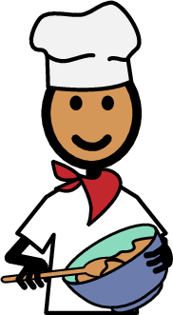

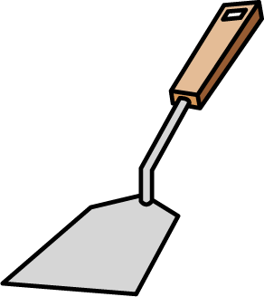

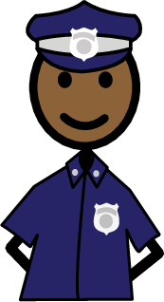

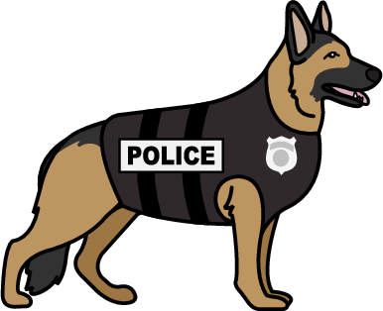

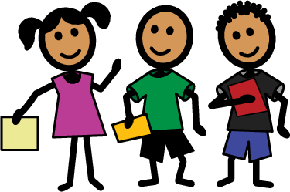

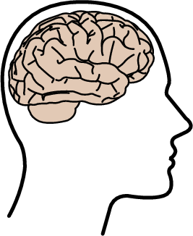

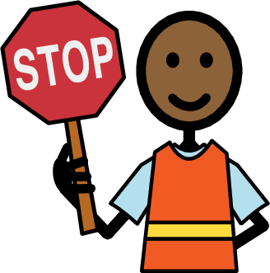

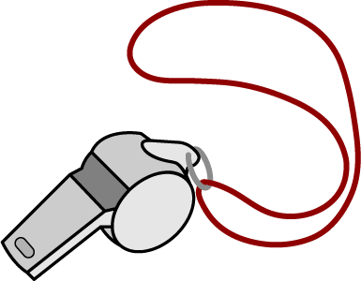

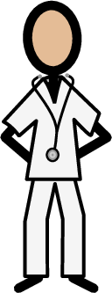

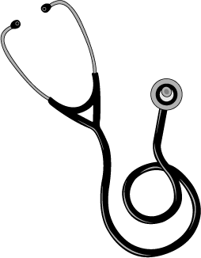

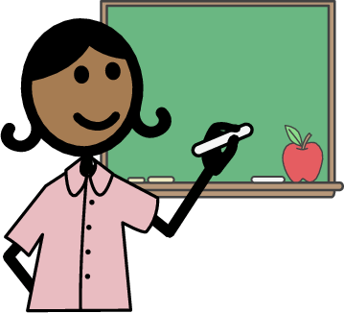

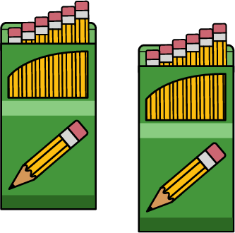

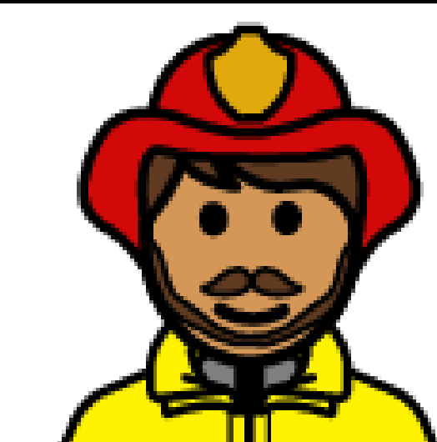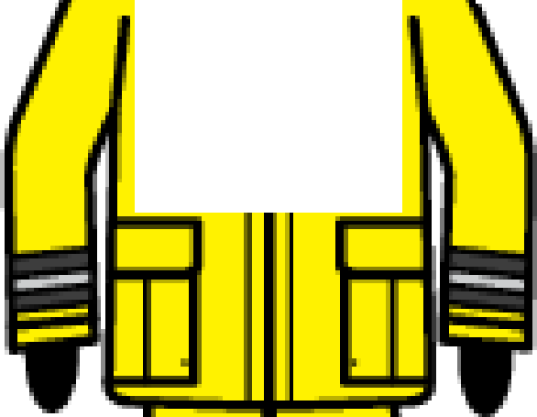

B B

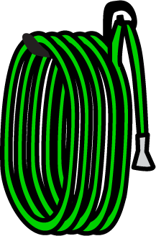

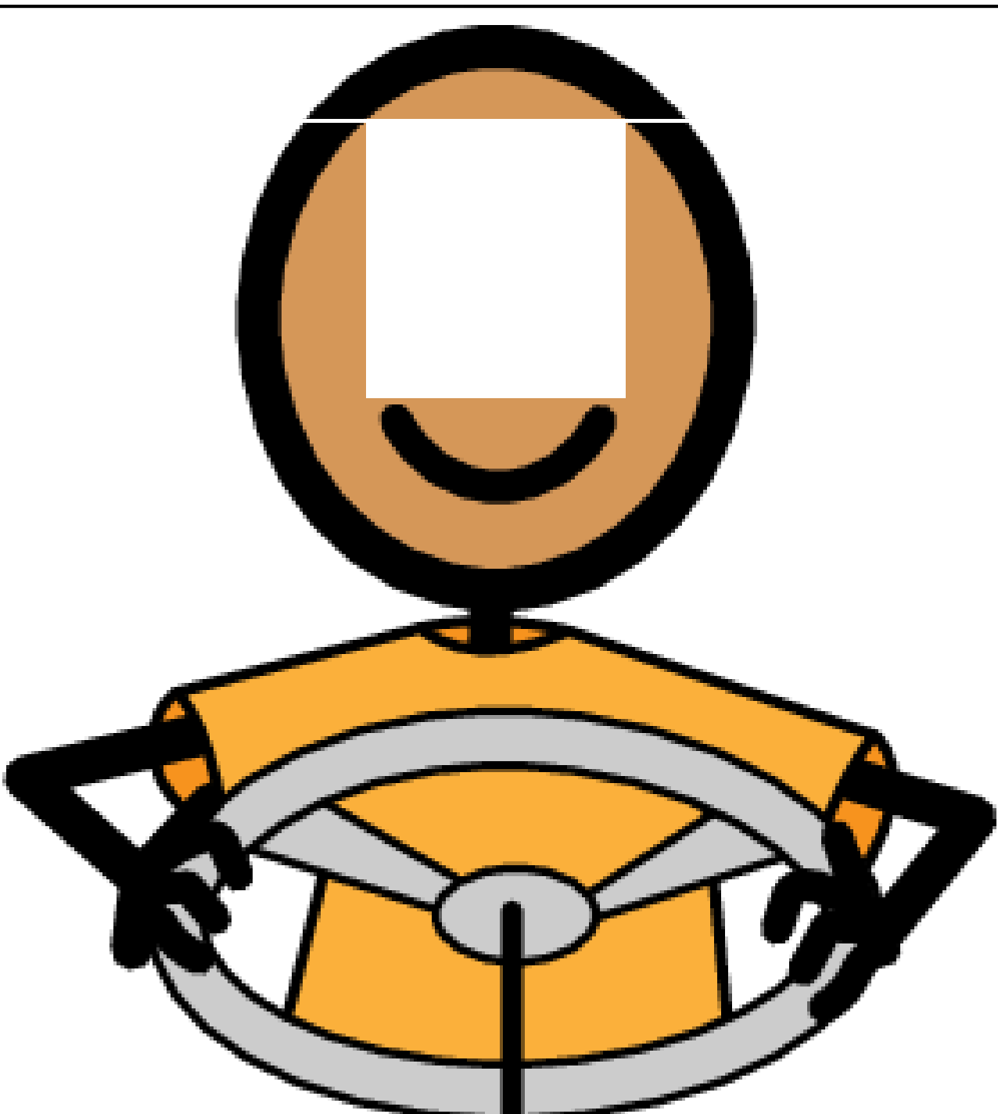
• •



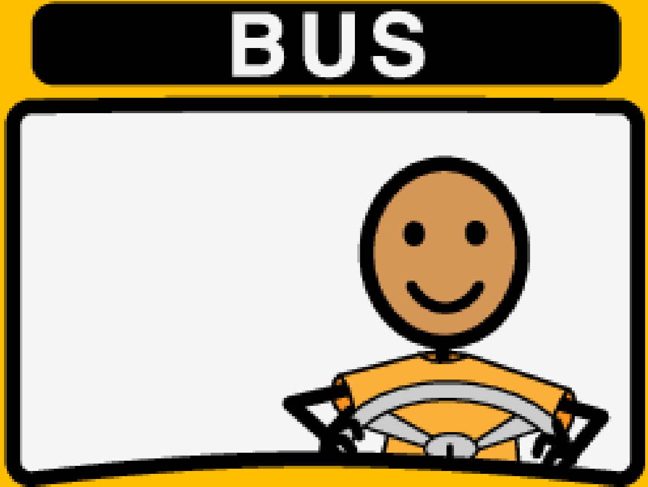
0--0

