Grade: Kindergarten | Lesson: 5 | Topic: Following Rules/  Respecting Authority
Virginia Standards of Learning | English  K.1, K.2, K.3  Health K.1, K.3  History K.10  Mathematics K.PS.1  Science  K.1
Virginia School Counseling Standards | Kindergarten-Third Grade, Personal/Social Development  EA1  EP1
Materials Needed | - Book- How Do Dinosaurs Stay Safe? by Jane Yolen  - Chart paper or whiteboard and markers  - Class pledge handout
Learning Objectives | - Define the words authority and rules.  - Explain the role of rules and how they keep us safe.  - Identify persons with authority.  - Define how they are responsible for safety.
I DO  Learning-Ready Reminders | Introduce yourself.  Build a positive relationship with the students by sharing a fun fact about yourself. (For example: your favorite ice cream ﬂavor, your favorite food, or your favorite color, etc.) Next, use the Learning-Ready Visuals and deﬁne the classroom expectations for when you visit. Say, “We will learn a lot about safety, responsibility, and respect within our school and community!  When we are learning, we must be learning-ready! When we are  learning-ready, we will:  - Keep our bodies in our own space!  - Use our quiet voices!  - Keep our ears open!  - Have our brains ready!”  Discuss the role of rules and explain how they keep us and others safe.  Introduce the concept of rules by saying, "I know that in your classroom community, you are responsible! I can see that you are responsible because you all show me that you are learning ready each time I come for a visit! How do you know how to be  responsible?"

Content

Check for Understanding
(Allow students to call out what they know.)

Refer to the Learning-Ready Visuals and explain, "These are the learning rules we follow when I visit. You know how to be responsible because you have learned these learning-ready rules. What does the word rule mean?" (Allow students to call out what they know and provide a wait time of 20-30 seconds for students to process the question if needed.)

When students have ﬁnished, hold up the vocabulary card providing a visual example of the word and deﬁne the word, Rule. “A rule describes something that we need to do.”

Read the book How Do Dinosaurs Stay Safe by Jane Yolen.
Say, “Today, we are going to read a book about how to follow the
rules and why it is important to follow the rules.”

After reading, ask, “Why is it important to follow the rules?” (Allow students to call what they know), then repeat, “We follow the rules to stay safe.” Demonstrate the importance of following the rules by modeling we have rules:
- To keep us safe (have students hug themselves).
- To help us make good choices (students point to their heads).
- To help us be responsible (students give thumbs up and
sit up tall).

Play the thumbs up/thumbs down game.
Are they following a rule or not following a rule? Tell the students, “I will show you pictures of different rules. If you see the person following the rule, you will give me a thumbs up. If the person is not following the rule, you will give me a thumbs down!” Use the visual examples in the PowerPoint (following a rule, not following a rule).

Identify persons with authority and their responsibility for safety.
After the students are finished, ask. “Who makes the rules in your classroom?” (Allow response time.) “Who makes the rules in your house?” (Allow response time.) Next, explain that the people who make the rules and make sure that we follow them are people in authority. Hold up vocabulary cards for authority

to define the word: “A person in authority is a person who is in charge and is responsible for keeping us safe.”
Show pictures of people who can be in an authority position.
- Parent
- Teacher
- Police officer
WE DO  Practice  Conclusion | Then, using chart paper or the whiteboard, have the students create a list of other people who can be in a position of authority. Examples include:  - Coach  - Bus driver  - Principal  - Firefighter  - Doctor  - Grandparent  - Babysitter/older sibling  When students have completed the list remind them that it is important to listen to those people because they help keep us safe and help us learn!  Review the importance of rules and following rules by saying, “I know that we have great rule followers in this classroom! Let’s practice our actions of why rules are important one more time!”  - To keep us safe (have students hug themselves).  - To help us make good choices (students point to their heads).  - To help us be responsible (students give thumbs up and  sit up tall).  Thank the students for participating.

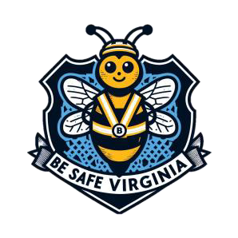
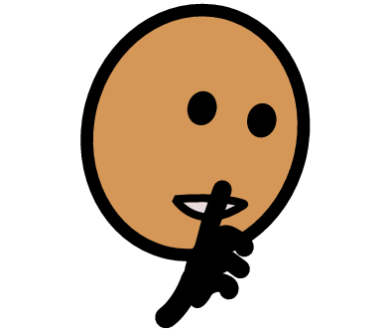
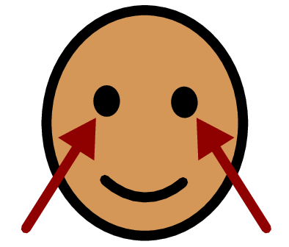
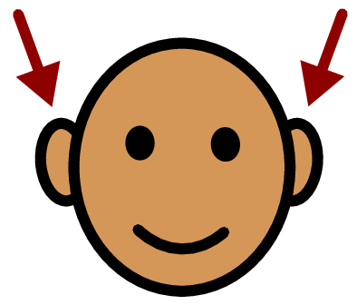

Rule: A Rule describes something that we need to do.
For example:
- Use your quiet voice
- Use your listening ears
- Look at the teacher

