Grade: Kindergarten | Lesson: 6 | Topic: Seatbelt Safety
Virginia Standards of | English
Learning | K.1, K.2, K.3
 | Health
 | K.3
 | History
 | K.8, K.10
 | Mathematics
 | K.12
Virginia School Counseling Standards
Materials Needed | - Book- I’m Safe! In the Car by Wendy Gordon  - “Buckle Up” coloring sheet  - Crayons or markers for students
Learning Objectives | - Discuss the rules concerning safety belt usage.  - Explain how to use a safety belt properly.  - Review other vehicle safety tips.  - Understand the importance for passengers to wear safety belts.
I DO | Introduce yourself.  Build a positive relationship with the students by sharing a fun fact about yourself. (For example: your favorite ice cream flavor, your favorite food, or your favorite color, etc.) Next, use the Learning- Ready Visuals and define the classroom expectations for when you visit. Say, “We will learn a lot about safety, responsibility, and respect within our school and community! When we are learning, we must be learning-ready! When we are learning-ready, we will:  - Keep our bodies in our own space!  - Use our quiet voices!  - Keep our ears open!  - Have our brains ready!”  Identify general safety precautions and actions to stay safe and healthy.  Begin by asking students to name some things they do each day to stay safe and healthy. Encourages students to identify who teaches them about these things and who can help when needed. List some potential examples on the board. Show the examples (PowerPoint  slides 8 -11):
Learning-Ready
Reminders
Content

- Brush your teeth.
- Get a good night's sleep.
- Look both ways before crossing the street.
- Listen to our teachers and parents.
- Follow the directions or rules.
“Great job! These are all great ways to stay safe! Today, I will be talking about how we stay safe when we ride in a vehicle.”Display pictures of different vehicles (slide 13) and ask if anyone knows what they are.
Ask students, “What rules do we follow in a car that help keep us safe?” After giving the students the opportunity to share their ideas, use the examples below to highlight the rules:
- Always wear your seatbelt.
- Stay seated.
- Listen to the grown-ups.
- Keep your hands and feet inside the car.
- Don’t play with any car controls.
- Don’t throw things.
- Ask for what you need.
WE DO  Practice | Explain, "Remember these rules! We will come back to them later. Now, I want to focus on the first rule, to always wear your seatbelt. We are going to practice buckling up and checking our seatbelts today.” Show the seatbelt (on slide 25) and say, “Seatbelts protect us and keep us safe. We will start by learning what we need to do to fasten and check our seatbelt."  Learn the rules for buckling up.  “We always wear our seatbelts when in the car. Step 1: Fasten seatbelt.  Step 2: Straighten the straps.  Step 3: Check the straps and buckle.”  Model how to buckle up each of the types of seatbelts, straighten, and check the straps.  Recite the seatbelt poem.  “Where's your seatbelt, where's your seatbelt; Here is mine, here is mine, Around my hips and chest, around my hips and chest  Where is yours, where is yours?”  Next, have the class echo the poem line by line together and pretend to fasten their seatbelts. (Use a bus or vehicle if available  for practice.)

Check for Understanding | Engage students in a discussion about when they should wear a safety belt, showing picture examples. Have them use the response cards (yes/no) for students to answer questions like:  - “Do you need to wear them when you’re just going a short distance?”  - “Do you need to wear them when the driver is a really good driver?”  - “Do you need to wear them if you’re sitting in the back?”
YOU DO  Practice | Read I’m Safe! In the Car by Wendy Gordon  Have the students complete the activity in the book I’m Safe! In the  Car by Wendy Gordon to reinforce the importance of staying safe in vehicles.
Conclusion  Check for Understanding | Have students complete the “Buckle Up” coloring sheet. “You all have done such a great job with showing me that you  know how to stay safe while riding in a vehicle. Can you all give me a thumbs up if you know how to fasten your seatbelt? What about checking the straps?” (Slide 25)  After getting thumbs up from the students, have students gesture with their hands fastening their imaginary safety belts and checking  the straps to make sure they are secure.

YES

YES
YES

YES

NO NO

NO NO

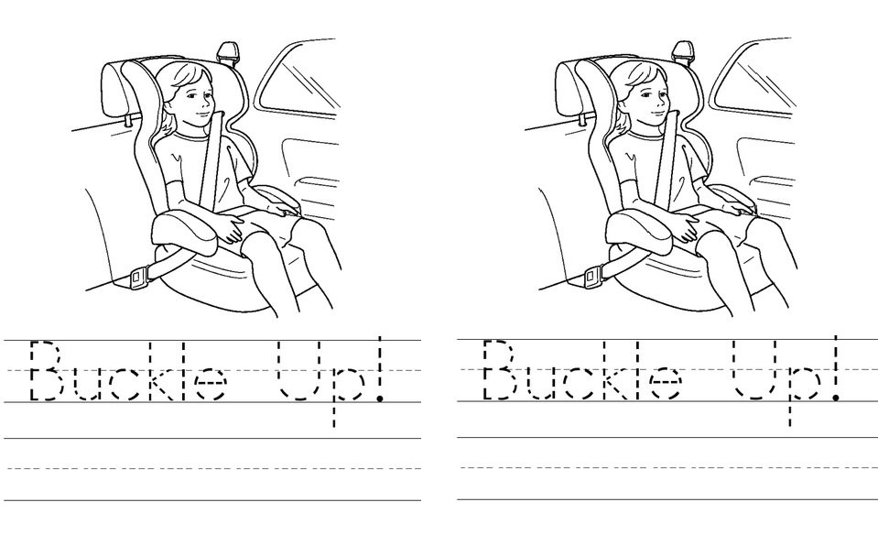

REMINDER: Virginia Law requires all children to be properly secured in a car seat or booster seat until at least age 8.

REMINDER: Virginia Law requires all children to be properly secured in a car seat or booster seat until at least age 8.

