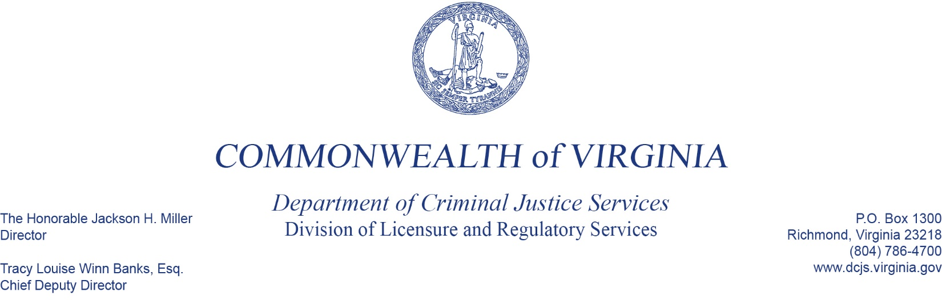

May 16, 2024

Private Security Services Advisory Board Appointment Notice

The Criminal Justice Services Board (CJSB) is seeking individuals interested in serving on the Private Security Services Advisory Board (PSSAB). The PSSAB is an advisory board to the CJSB on matters related to private security services, special conservators of the peace, bail bondsmen, and bail enforcement agents. Appointment to the PSSAB requires commitment to four meetings per year and representation of your industry’s perspective on training and regulatory matters. Individuals appointed to the PSSAB are required to file annual financial disclosure statements pursuant to the Virginia Conflict of Interests Act (see *Virginia Code* § 2.2-3114) and complete conflict of interests training every two years.

Pursuant to *Virginia Code* § 9.1-143, the CJSB is authorized to appoint members of the PSSAB. The following position is eligible for appointment **Effective November 1, 2024**:

* 1-Law Enforcement Representative

Eligible individuals must submit a resume and a cover letter that identifies their **DCJS ID/business number and represented industry.** Letters of reference or other supporting documentation may be included**. If you or your business has had any administrative action or sanctions taken by DCJS, please address those circumstances in your cover letter.**

The CJSB’s Nomination and Appointment Committee will make recommendations to the CJSB and only consider individuals submitting a complete package by **June 6, 2024**.

For additional information about the PSSAB, please feel free to contact other representatives or visit the DCJS website at http://www.dcjs.virginia.gov/about-dcjs/boards-committees.

Please submit letters and documentation to: Department of Criminal Justice Services

P.O. Box 1300

Richmond, Virginia 23218

Attention: Brenda Cardoza or Email:[brenda.cardoza@dcjs.virginia.gov](mailto:brenda.cardoza@dcjs.virginia.gov)