Grade: Pre-  Kindergarten | Lesson: 2 | Topic: Playground Safety  Rules
Virginia Early Learning Development Standards | APL4.1.  Managing actions and behaviors HPD4.2.  Adopting safe behaviors
Materials Needed | - My Playground Safety Pledge  - We Can Be Safe on the Playground! - (included in slideshow)
Learning Objectives | - Identify playground equipment.  - Identify playground safety rules.  - Apply playground safety rules.
I DO  Introduction/ Relationship Building  Learning-Ready Reminders  Content | Introduce yourself.  Build a positive relationship with the students by sharing a fun fact about yourself. (For example: Your favorite ice-cream flavor, your favorite food, or your favorite color) Next, use the Learning Ready Visuals and define the classroom expectations for when you visit.  Say, “We will learn a lot about safety, responsibility, and respect within our school and community! When we are learning, we must be learning-ready! When we are learning-ready, we will:  - Keep our bodies in our own space!  - Use our quiet voices!  - Keep our ears open!  - Have our brains ready!”  Identify playground equipment.  Say, “Today, we are going to talk about being safe when we are outside on the playground. Just like we follow our rules in the classroom to keep us safe, it is important for us to follow the rules in the playground to keep us safe!”  Say, “Raise your hand if you have ever been on a playground. What do you find on a playground?” And then show the picture to have them name the pieces of equipment.  Allow students to call out different pieces of equipment that they see. After students respond, say, “I see different playground equipment.  I see a slide to go down. I see swings to swing on. I see a climbing wall to climb on! I have a story we will read about being on the playground!”

Check for Understanding | Read the story, We Can Be Safe on the Playground!  Identify playground safety rules.  After reading, it says, “We know that being safe on the playground is important! In our story, we saw many ways to be safe on the playground. Let us review the playground safety rules!”  Use the slide labeled Playground Safety Rules to read and review each of the rules. (This is found on slide number 16.)  To check for understanding, have the students turn to their shoulder partner (the person beside them) and tell their partner the answer to the question. Ask the following questions:  “What do we do when we go down the slide?” “How do we climb up the ladders?”  “How do we use the swings?”  “What happens when we are finished on the playground?”
WE DO  Practice | Apply playground safety rules.  Next, say, “Wow, you are all showing me that you know your playground safety rules! We will play a game called Safe on the Playground or Not Safe on the Playground. I will show you a picture, and if the student is safe on the playground, you will give me a thumbs up in the air. If the student is not safe on the playground, you will give me a big thumbs down!”  Use the slide deck to play “Safe on the Playground or Not Safe on the Playground.” (These are slides 17-22.)
YOU DO | Apply playground safety rules.  After the game, pass out the handout “My Playground Safety Pledge” and say, “You all know so much about being safe on the playground. You have a special piece of paper that says, “My Playground Safety Pledge.” That means you will ensure that you will be safe on the playground. I want you to color or circle your favorite thing to do on the playground and then write your name on the paper.”

Conclusion | After students have completed the pledge, say, “Give yourself a high five; you all did such a great job learning about playground safety today! Before I leave, let us review the playground rules one last time!”  Review the playground rules together.

Our Playground Safety Pledge
1. We use our hands to hold on when climbing and swinging.

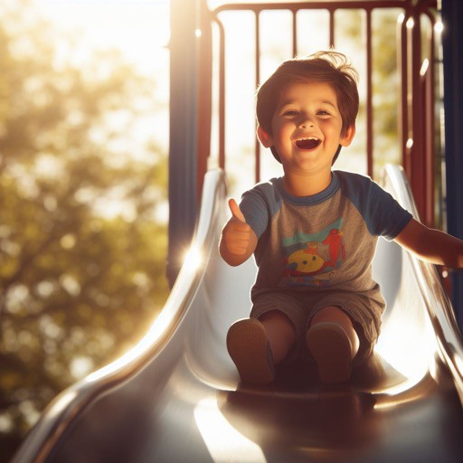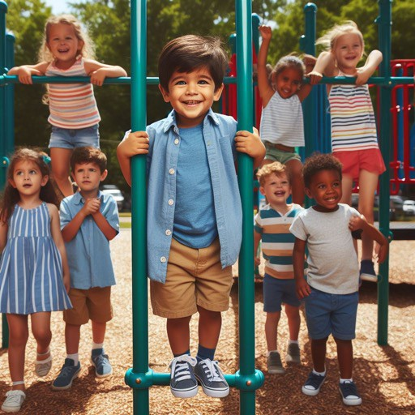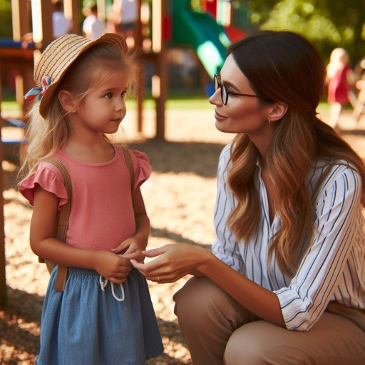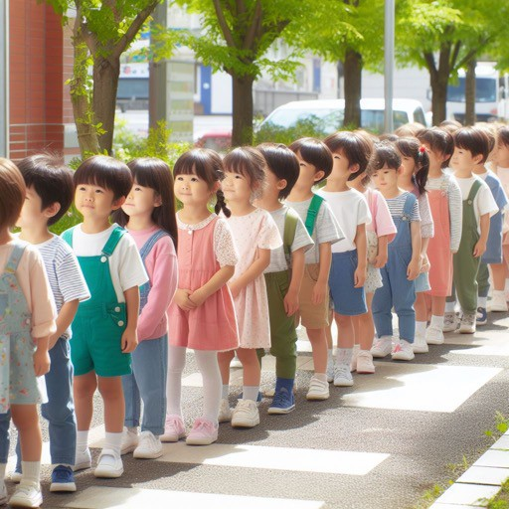
2. We go down the slide with our feet first.
3. We take turns.
4. We get a teacher when we need help.
5. We line up to go back inside.

My Name

