Grade: Two | Lesson: 3 | Topic: Respect for  Authority
Virginia Standards of Learning | English:  1.1, 1.2,1.3,1.4  Health:  1.1, 1.2,1.3  History:  1.1, 1.10,1.13
Virginia School Counseling Standards | Kindergarten-Third Grade  EP1  EP4
Materials Needed | - BINGO cards  - Chart paper and markers  - Rule and law pictures  - Tape  - Vocabulary card defining authority  - “I Can be Respectful” handout  - Rules and Responsibilities by Louise Spilisbury or the book Why Do We Need Rules and Laws by Jessica Pegis
Learning Objectives | - Define authority.  - List people who hold authority to enforce rules.  - List professionals who have the authority to enforce laws.  - Compare and contrast a rule and a law.  - List and practice respectful ways to interact with people and professionals who hold positions of authority.
I DO | Introduce yourself.  Build a positive relationship with the students by sharing a fun fact about yourself. (For example: your favorite ice cream flavor, your favorite food, or your favorite color, etc.) Next, use the Learning-Ready Visuals and define the classroom expectations for when you visit. Say, “We will learn a lot about safety, responsibility, and respect within our school and community! When we are learning, we must be learning-ready! When we are learning-ready, we will:  - Keep our bodies in our own space!  - Use our quiet voices!  - Keep our ears open!  - Have our brains ready!” Define authority.  Start by engaging the students by asking, "Do you know what the word  authority means?" Hold up a vocabulary card that explains authority as  someone who makes and can enforce rules or laws.

Check for Understanding | List people who hold authority to enforce rules.  Next, tell the students, “I am going to show you some pictures of different people. These people are called authority figures because they have the authority to enforce rules.” Show pictures of authority figures, like a teacher, and a parent. Hold up picture 1, Say, “Let us look at this picture. This is a picture of a parent or guardian. A parent or guardian makes rules in your home and helps you follow them. They are a person of authority who helps you follow rules.”  List professional(s) who have the authority to enforce laws.  Say, “This person in a police uniform is a police officer. They have the authority to enforce laws and keep us safe, just like they have the authority to enforce laws.”  Next, using chart paper, have students create a brainstorm of authority figures. When students have completed the activity say, “Now that we have learned about authority and how different people have the power to make sure rules and laws are followed, let us dive deeper into this. We are going to talk about the differences between rules and laws. Think about your classroom. Who can tell me about your rules in the classroom?” (Allow students to call out answers.)  Compare and contrast a rule and a law.  Next say, “You all have listed your classroom rules. A rule is a guideline set by a specific group or place (like a school rule). A rule is different from a law because a law is a rule set by the government that everyone in the country must follow. Certain areas, like a town or a state, have their own laws too! Let us read a book about the difference between rules and laws! Read the book, Rules and Responsibilities by Louise Spilisbury or the book, Why Do We Need Rules and Laws by Jessica Pegis.  After reading, to check for understanding say, “Now we are going to see if we can tell the difference between a rule and law by sorting these pictures I have with me. Who can tell me what the difference between a rule and law is, again?”  Use a piece of chart paper and draw a line down the middle. On one side, write the word rules, on the other side, write the word laws. Pass out rule and law pictures to students. (If you do not have enough pictures for everyone, have the classroom teacher assist in pairing students together. It is ok to have more than one of the same pictures on the chart paper.) Call students to come up and tape their picture on the chart paper under  the correct category.

WE DO  Practice  Check for Understanding | List and practice respectful ways to interact with people and professionals who hold positions of authority.  Next, explain to the students that they will be playing a game called, “Respectful Role-Play BINGO". Tell them that the game will help them learn about respectful interactions with people in authority.  Tell the students that each space will be filled with a respectful action they can take when interacting with an authority figure. For example, “Your teacher asks you a question in class. What should you do to show respect?”  Distribute "BINGO" cards to each student.  Read one scenario slide at a time. For each scenario, ask the students to think about and discuss the respectful action they would take in that situation. For example:  - Scenario 1: “Raise your hand and wait to be called on.”  - Scenario 2: “Set the table without complaining.”  - Scenario 3: “Listen to what the police officer says and follow instructions.”  When a student has a match on their card to the respectful action described in the scenario, they can place a sticker or make a mark on that space. The goal is to get three in a row (horizontally, vertically, or diagonally) on their card.  To check for understanding, after a few scenarios have been called out, discuss with the students what they have learned about respectful interactions with authority figures. Encourage them to share out loud the  respectful actions they marked on their cards.
YOU DO  Practice | Next, say “I will be presenting scenarios involving interactions with authority figures. Some scenarios will show respectful interactions, while others will show disrespectful interactions. You are going to identify by giving me a thumbs up if it is respectful, and thumbs down if it is disrespectful. After we identify the disrespectful scenario, we are going to discuss what could change to make it respectful. For example, if your teacher asks a question and you shout out the answers, is that respectful or not respectful?” Allow students to show you thumbs down. Next ask, “What would make that a respectful interaction?”  One by one, present the scenarios to the students (slides 29-35). Example scenarios:

Check for Understanding | - (Respectful): "Your teacher asks you a question, and you raise your hand to answer politely."  - (Disrespectful): "Your teacher asks you a question, and you shout out an answer without raising your hand."  After each scenario, ask the students whether the scenario was respectful  or disrespectful by showing a thumbs up or thumbs down. Encourage them to provide reasons for their choice. Discuss their responses briefly.
Conclusion | To close the activity, pass out the paper labeled, “I Can be Respectful” and have students write and/or draw one way that they are going to be  respectful the rest of the week.

Authority: A person who makes and can enforce rules or laws.

Police Officer Principal

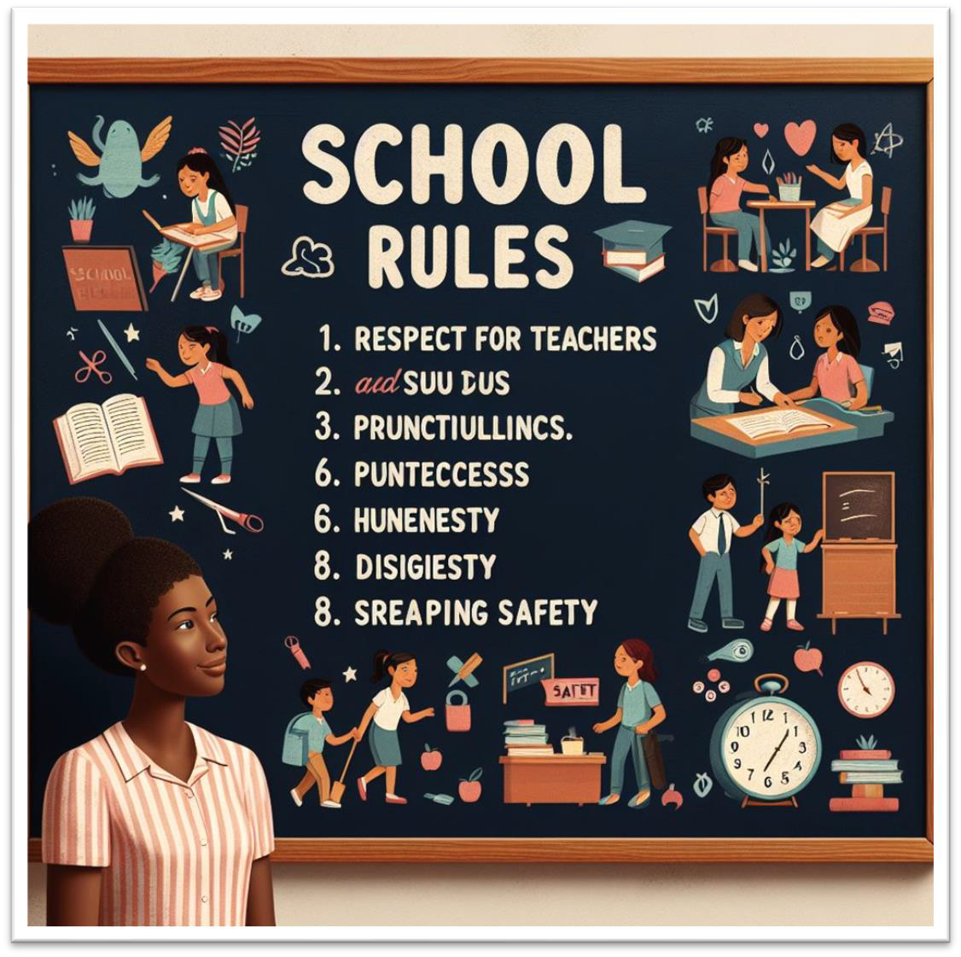

Rule: A guideline set by a specific group or place (like a school rule).
- Respect others
- Raise your hand
- Be kind
- Help others
- Be on time
- Be prepared

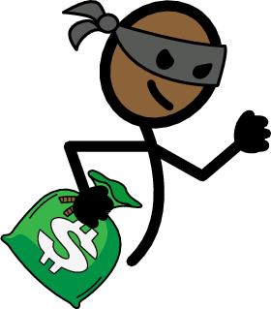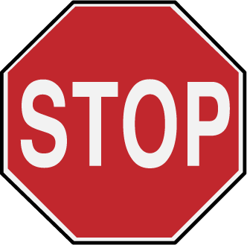

Law: A rule set by the government that everyone in the country must follow

BINGO
 |  | 
 | Free Space | 
 |  | 

BINGO
 |  | 
 | Free Space

BINGO
Free Space

BINGO
Free Space

BINGO
Free Space

BINGO
Free Space

I can be respectful!
Write and/or draw one way that you are going be respectful the rest of the week.

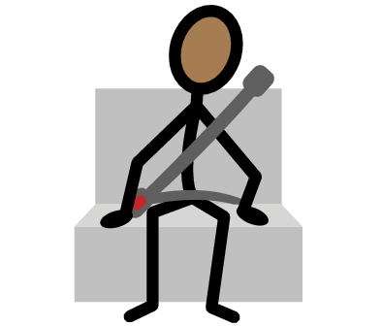
Wear a seatbelt.



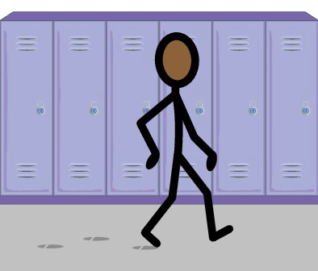
Walk in the hallway.

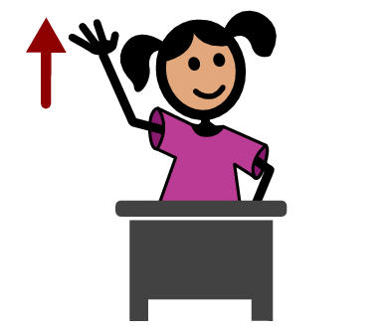
Raise your hand.

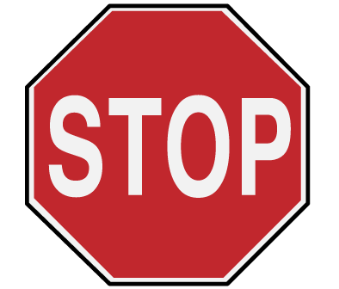
Stop at a stop sign.

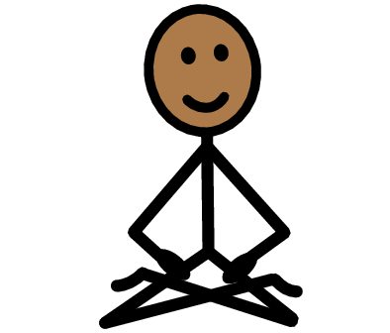
Keep our bodies in our space.

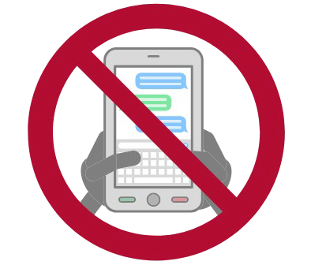
No texting while driving.

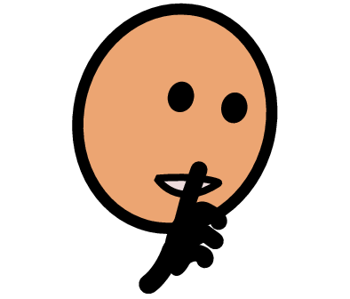
Use our quiet voices.

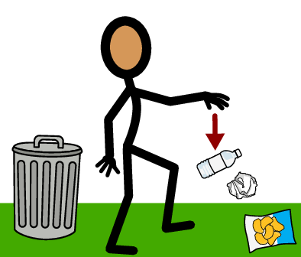
No littering.

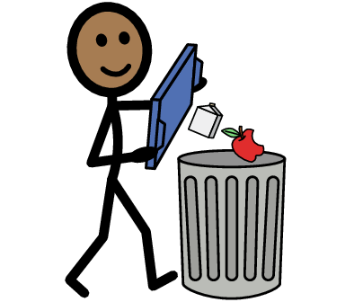
Be respectful and keep your area clean.

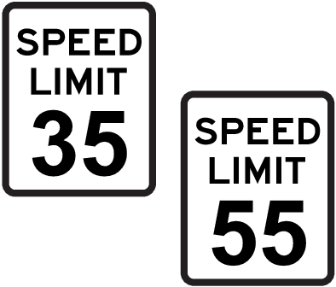
Follow the speed limits.

