Grade: Three | Lesson: 1 | Topic: Community Emergency Preparedness
Virginia Standards of Learning | English  3.1, 3.2  Health  3.1, 3.2, 3.3  Mathematics  3.14
Virginia School Counseling Standards | Kindergarten-Third Grade  EP1  EP4
Materials Needed | - “Emergency Make a Plan” handout
Learning Objectives | - Define types of emergencies and match them to appropriate emergency response workers.  - Define and list weather-related emergencies.  - Create a plan for weather-related emergencies.
I DO  Learning-Ready Reminders  Content | Introduce yourself.  Build a positive relationship with the students by sharing a fun fact about yourself. (For example: Your favorite ice cream flavor, your favorite food, or your favorite color.) Next, use the Learning-Ready Visuals and define the classroom expectations for when you visit. Say, “We will learn a lot about safety, responsibility, and respect within our school and community! When we are learning, we must be learning-ready! When we are learning-ready, we will:  - Respect personal space - Be aware of your surroundings, respect others’ space, and stay in your own area.  - Use volume control - Use indoor voices and be mindful of noise levels.  - Show active listening - Eyes and ears open! Ready to participate!  - Have sharp minds - Be prepared to problem solve, ask questions, and contribute to the lesson.”  Tell the students “Today we are going to learn about what to do in an emergency. Can someone tell me what an emergency is?” Let students raise their hands and call on them to respond. Tell the students, “An emergency is when something serious, dangerous, and unexpected has happened and help is needed immediately.”  Ask the students “Who do you call when you need someone to come help you?” (Allow students time to respond.)  Next say, “Yes, it is necessary to call 911 when you need someone to come to you to help. Today we are going to talk about weather-related emergencies and what you can do to protect yourself during those types of emergencies.”  Tell the students “I am going to show you a picture of a weather-related emergency and your job is to tell me what it is and what happens during this type of emergency.” Examples:  - Thunderstorms: Thunderstorms can bring lightning and lots of rain, thunder, wind, and hail.  - Tornado: A tornado is a spinning column of air. Tornadoes have strong winds that can cause a lot of damage to things in their paths. These signs may help you know that a tornado is coming - dark or green-colored sky, funnel cloud, loud train-like sound, or hail.  - Hurricane: A hurricane is a big storm that forms over the ocean. It has a spiral shape and can travel a long way before it reaches land. A hurricane can cause lots of damage with strong winds and heavy rain when it hits land. The ocean water can rise with large waves that flood the coast.  - Flooding: Water that covers land that is normally dry. Flood waters can destroy houses and buildings. Floods can also contaminate drinking water and lead to diseases.  - Home fires or forest fires: Fire is fast and hot, and the smoke makes the sky dark. Most fires can be prevented!  Explain to the students that it is important to be informed and that there are two weather terms that everyone needs to be familiar with.  - Weather watch means there is a risk of bad weather happening.  - Weather warning means that bad weather is already occurring.  Tell the students “We can know what to expect by watching the weather on TV, listening to the radio, checking the weather on our online devices, or asking an adult.”
WE DO  Practice  YOU DO  Practice | “Let’s practice understanding the weather forecast. I am going to tell you a weather forecast, and you will explain to me what it means.”  Show the PowerPoint (slides 23-27) or read the scenarios and ask students what these forecasts mean:  - A tornado watch at 3:00 pm.  - Hurricane warning in Allentown.  - Flood watch in Clifford City tomorrow at 5:00 pm until 2:00 am.  - Tornado warning- take shelter until 7:00 pm.  - Thunderstorm and hail warning in Stevens City.  Tell the students “Now that you know how to understand the weather, we are going to talk about what to do in these situations to keep yourself safe.”  “At school:  - Listen to the adults- it is your teacher's job to keep you safe and know all the safety procedures at school.  - Stay calm and follow directions.  - Pay attention to drills and take them seriously.  At home:  - Listen to adults.  - Stay calm and follow directions.  - Talk with an adult at home about what to do when there is a weather-related emergency at home. Every home is built differently, so it is important to have a plan for what to do in your own home.  - Have a plan with your parents for if you are ever home alone.”  - “Have plans for any other homes you spend a lot of time at like your grandparents’ house or the babysitter.”  Know how to respond.  Explain to the students that “When we stay calm during these emergencies, we can then respond to them with the appropriate safety precautions.”  9-1-1 is used for emergencies when we need police or fire and rescue. During a 9-1-1 call, the dispatcher will answer the phone and ask “What is your emergency? “  You should  - Speak clearly and don’t use head nodding that they can’t see.  - Know your name, address, and phone number.  - Stay on the phone until the dispatcher tells you to hang up.  Tell the students, “We will review each weather-related emergency again, and discuss what you can do to keep yourselves safe.”  Have students get into different groups. Give each group an emergency scenario and explain to the students that they will role-play or discuss what to do during each scenario.  Practice using PowerPoint slides 32-43. For slide 32, have students pretend to call 9-1-1. For Slide 34, have students get into the tornado position. For Slides 35-43 have students shout out the steps for staying safe during a fire and then give them time to practice “Stop Drop and Roll”.
Check for Understanding

Practice

Conclusion | Tell the students “Remember, an emergency is when something serious, dangerous, and unexpected has happened and help is needed immediately.”  Explain to the students again that “At school it is important to listen to your teacher and teachers know all the safety plans to keep you safe. At home it is important that everyone has a safety plan that everyone who lives in the home knows.”  Tell the students “I have a job for you to go home and make a plan with your family.” Pass out the “Make A Plan” handout for the students to go over with their families.

Name: __________________
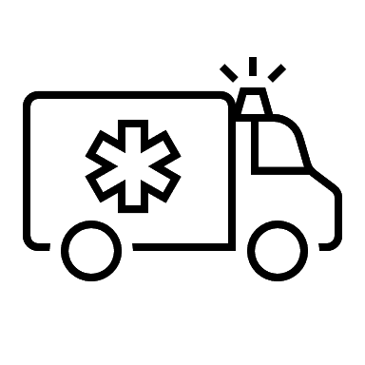
Our Household Emergency Plan
Family Information:
Our Address Is:

____________________________________________________________________________________________________________________________________________________________
Members of our Household: Phone Number (if they have one):

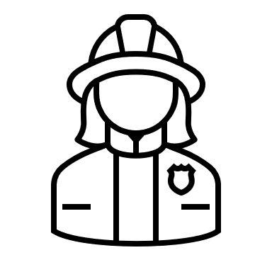
Emergency Numbers:
For emergency services call 9-1-1

Poison Control Number: ______________________________________________________

Doctor’s Name and Number: ______________________________________________________

Dentist’s Name and Number ______________________________________________________

Emergency Contact Name and Number: _____________________________________________

Fire Plan:
Ways out of the house:

1.____________________________________________________________________________

______________________________________________________________________________

2. ____________________________________________________________________________

______________________________________________________________________________

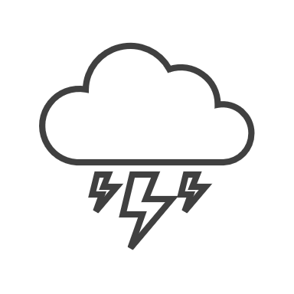
Meeting Place: _________________________________________________________________

Storm Plan:
Storm Safe Space in the House: ____________________________________________________

Meeting Place: _________________________________________________________________

Other Important Household/Medical Information:

________________________________________________________________________________________________________________________________________________________________________________________________________________________________________________________________________________________________________________________
______________________________________________________________________________
