Grade: Three | Lesson: 2 | Topic: Digital  Decision Making
Virginia Standards of | C.S.
Learning | 3.10, 3.15, 3.16
Virginia School Counseling  Standards | Kindergarten-Third Grade  EP1 EP4
Materials Needed | - Book- The Little Cyber Engineer by Amber DeVilbiss  - Decision-making handout  - “That’s Private” handout  - Crayons or markers  - Common Sense Education pledge video
Learning Objectives | - List safety rules in digital environments.  - Evaluate digital risks in various scenarios.  - Recognize what cyberbullying is.  - Develop ways to become an upstander online.  - Demonstrate the decision-making process in digital spaces.
I DO  Introduction/ Relationship Building | Introduce yourself.  Build a positive relationship with the students by sharing a fun fact about yourself. (For example: Your favorite ice cream flavor, your favorite food, or your favorite color.) Next, use the Learning-Ready Visuals and define the classroom expectations for when you visit. Say, “We will learn a lot about safety, responsibility, and respect within our school and community! When we are learning, we must be learning-ready! When we are learning-ready, we will:  - Respect personal space - Be aware of your surroundings, respect others’ space, and stay in your own area.  - Use volume control - Use indoor voices and be mindful of noise levels.  - Show active listening - Eyes and ears open! Ready to participate!  - Have sharp minds - Be prepared to problem solve, ask questions, and contribute to the lesson.”  Become a digital decision maker.  Mastering the decision-making process: Equip your students with tools to make mindful choices. Introduce a five-step framework:  - Stop and think: Avoid impulsive decisions.  - Explore the options: Do not settle for the first choice. Brainstorm other possibilities.
Learning-Ready Reminders
Content

- Gather information: Find knowledge from trusted sources to make informed choices.
- Imagine the future: Think about how each choice will make you feel in the long run.
- Consider the consequences: Analyze the potential outcomes for yourself and others.

Connecting online and offline worlds.
Internet choices: Bridge the gap to online environments by asking, "What decisions do you make on the internet/online?" Generate a list of activities like shopping, playing games, connecting with friends, and reading. Then, explore internet access: who uses it, who has devices at home, and who knows how to use cell phones. Discuss
what it means to "go online" and who they play with when gaming.

Compare positive and negative consequences.
Weighing the outcomes: Introduce the concept of consequences, both positive and negative, for online and offline decisions. Ask, "What are some negative consequences that could happen from a bad decision?" Discuss potential outcomes like struggling in school, getting hurt, losing trust, and the permanence of online actions.
Contrast these with positive consequences like academic success, strong friendships, self-esteem, and a positive online footprint.

“A consequence is like a natural result of your actions, kind of like an echo! Just like clapping your hands makes a sound, your choices
online and offline can also have effects, both good and bad. Good choices can lead to good consequences: If you're kind online, you might make new friends and feel good about yourself. That's like planting a happy seed and watching it grow into a friendly flower!”

“Not-so-good choices can lead to not-so-good consequences: If you share too much information online, it might be like leaving your favorite toy outside, it could be hard to get back.”

Identify ways in which students can protect their personal information.
“Never reveal details like your name, address, or phone number. Keep your passwords secure and share them only with trusted adults. Always log off, avoid leaving accounts open on shared devices.”
Why do good choices matter?
Building a brighter future: Conclude by emphasizing the significance of making good choices: "Why do I want you to make good choices

Check for Understanding | and decisions?" Explain that your goal is to help them reach their dreams and protect them from harm, both online and offline.  Read out loud.  Read the book The Little Cyber Engineer by Amber DeVilbiss. This book will provide opportunities for discussion around how internet security works.
WE DO  Practice  Check for Understanding | Role-play internet decision-making.  Navigating the Digital Maze: For these roleplaying activities, form small groups of students and have them create some space where they can collaborate and discuss. This is also an opportunity to incorporate a little bit of movement into the lesson. Consider the  areas of the classroom where students can congregate, have space to move, and still contribute to the roleplay. Each group will get one scenario for which they will complete the handout. Use the example scenarios (PowerPoint slides 24-27), or ones of your own. Have each group share their sheets after completing them.  Before students begin the first roleplaying scenario, have them get acclimated to the group by giving them this initial prompt:  Celebrating good choices: Reinforce the importance of good decisions by asking, "Think about a time you made a good decision on the internet." Encourage students to share stories where they  navigated potentially risky situations, highlighting the steps they took in their decision-making process.  Afterward, have the students complete the graphic organizer for one of the scenarios and determine the course of action using the five- step decision-making process.  Scenario 1: Cyberbullying Blues  “Your phone dings when you receive a message from someone in your class. It contains an embarrassing picture of another classmate. What do you do? Use your decision-making steps:  - Stop and think: Take a deep breath and resist the urge to react impulsively.  - Explore the Options: Consider all your choices. You could:  - Ignore it: This might work if the picture isn't widely circulated.  - Talk to the person who sent it: Explain why sharing the picture is wrong and ask them to delete it.

- Report it to a trusted adult: This could be a teacher, parent, or school counselor.
- Support the victim: Reach out to the classmate in the picture and offer your support.
- What else could you do?
- Gather information: Think about the potential consequences of each option. How might your actions affect the victim, the sender, and yourself?
- Imagine the future: Consider the long-term impact of your decision. How would you feel about yourself and your actions later?
- Consider the consequences: Will your decision hurt anyone? Will it violate anyone's privacy? Is there a risk of the picture spreading further?”

Discussion.
Elaborate on the different options and their potential outcomes. Encourage students to consider the feelings and privacy of everyone involved. Emphasize the importance of reporting cyberbullying to a trusted adult. Discuss how adults can help support the victim and
address the situation effectively.

Scenario 2: Sharing with Caution
“You’re playing a cool online game with one of your friends. They ask you to send them a picture of yourself so they can see what you look like. What do you do? Use your decision-making steps:
  - Stop and Think: Take a moment to consider the potential risks of sharing your picture. Is it safe to give out personal information to someone you've never met in person?
  - Explore the Options: You could:
    - Say no politely: Explain that you're not comfortable sharing personal information like pictures with people you don't know in real life.
    - Talk to a trusted adult: If you're unsure or feel pressured, seek advice from a parent, teacher, or counselor.
    - Use privacy settings: Remember you can adjust privacy settings on online platforms to control who can see your information.
  - Gather information: Think about the potential consequences of each option. How might sharing your picture impact your personal safety and privacy?

- Imagine the future: Consider how you would feel if your picture was used in a way you didn't intend. Could it cause embarrassment or harm?
- Consider the consequences: Will your decision potentially
violate your own privacy or someone else's? Is there a risk of online predators using your information?”

Discussion.
Elaborate to the class on the importance of online privacy and protecting personal information. Encourage students to be cautious about sharing their personal details with strangers online, even if
they seem friendly. Emphasize the importance of talking to trusted adults if they feel pressured or uncomfortable in any online situation.

Scenario 3: Free Game Download
“You're browsing the internet when you see an ad for a free game download. This seems too good to be true, but you really want the game. What do you do?” Follow the decision-making steps, guiding students to consider the risks of online scams. Discuss how to identify suspicious websites and protect their personal information. “Remember, making good digital citizenship decisions involves critical thinking, communication skills, and awareness of online risks.”

Have students transition back to their individual workspaces for the final activities.
YOU DO  Conclusion | Complete the handout “That’s Private” from Common Sense Education.  In this handout, students will identify which information is private and should not be shared openly online.  Also, students will complete a drawing and explanation of things that are okay to share online. Have students pledge to always be a good digital citizen. Remind students of the decision-making process. Close the lesson with this song on digital citizenship!  https://commonsense.org/education/videos/we-the-digital-citizens


- Stop and Think:
Making Decisions


What decision did you make?



- Explore the Options:

- Gather Information:

- Imagine the Future

- Consider the Consequences:

GRADE 3: THAT'S PRIVATE!
NAME
DATE

Keep It Private!

Part I Directions :
Draw an X through the sections that ask for private information. Then complete the rest of the form.
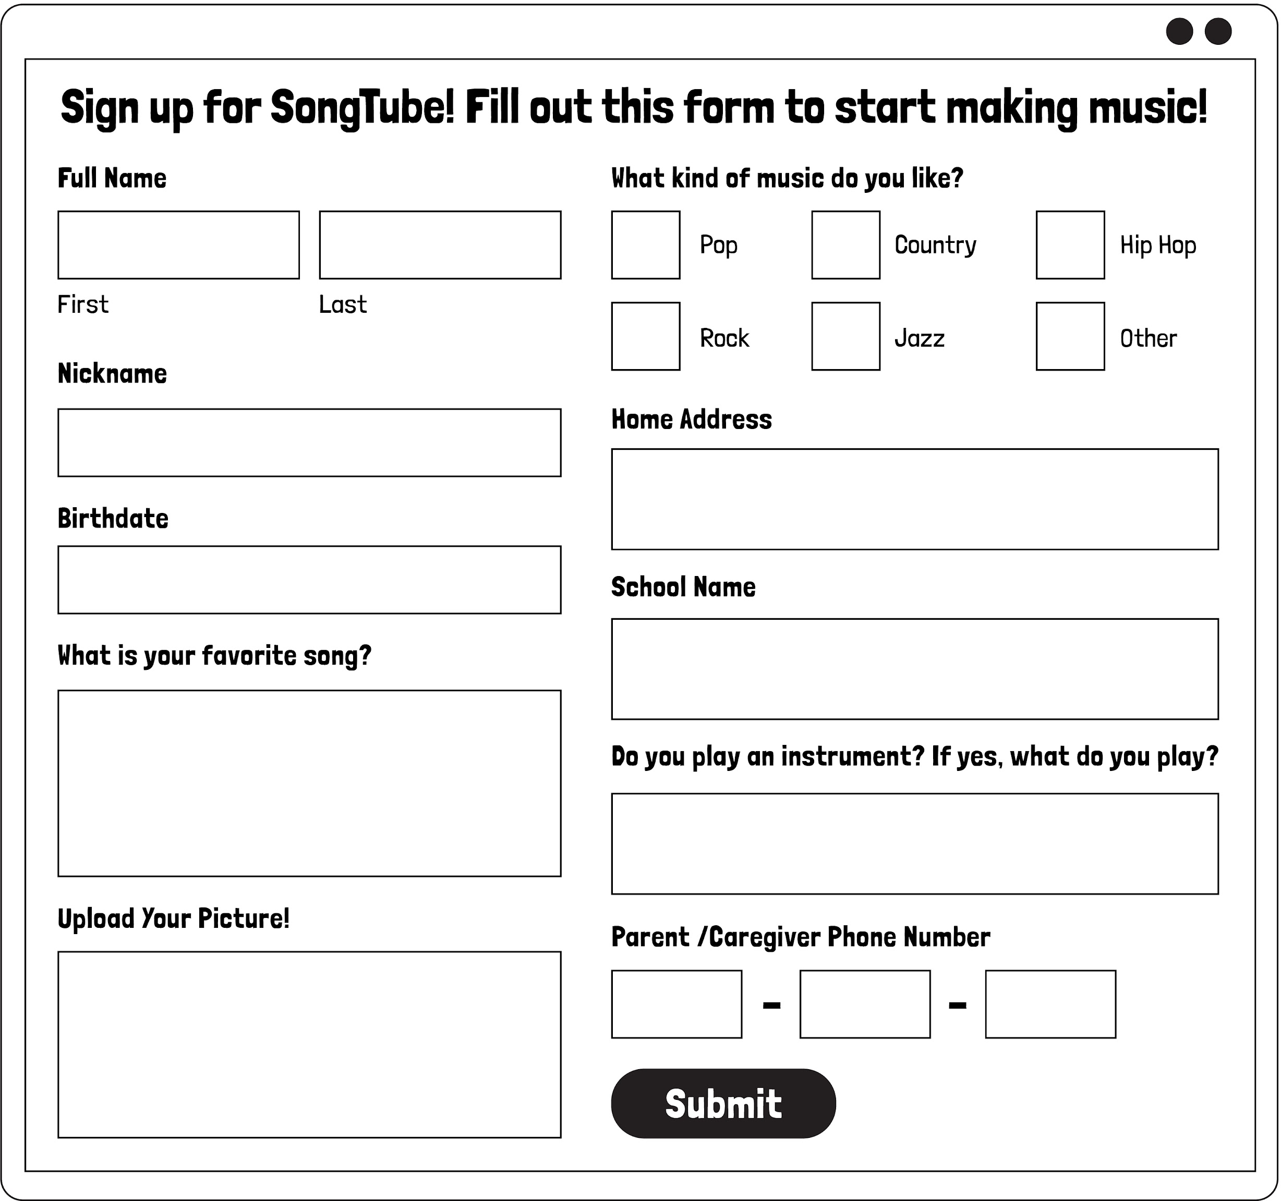
Paus e & Think Moment

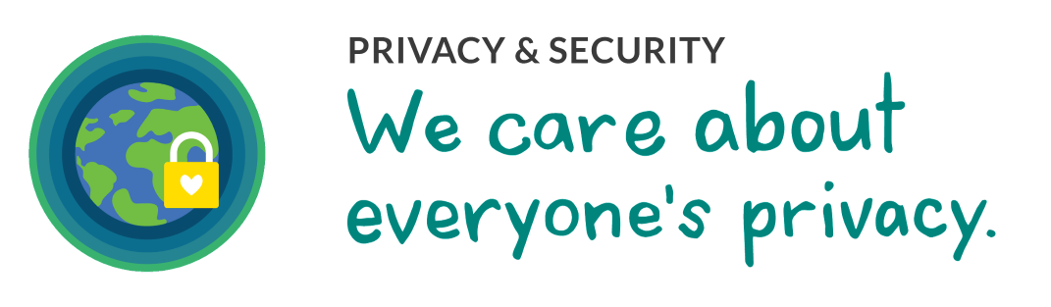

commonsense.org/education
1
Shareable with attribution for noncommercial use. Remixing is permitted.

GRADE 3: THAT'S PRIVATE!
NAME
DATE

Keep It Private!

What is an example of something that is OK to share online? Draw about it.
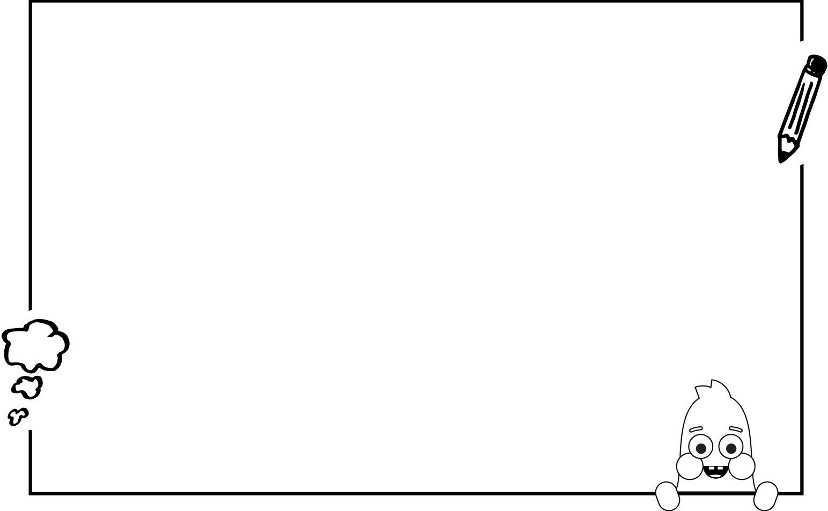
Explain why it is important to not share private information online.

commonsense.org/education
2
Shareable with attribution for noncommercial use. Remixing is permitted.

