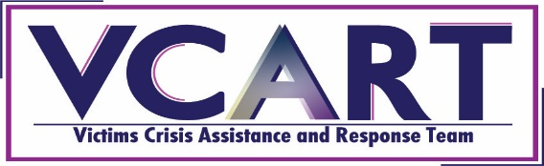
Application Form for the Basic Victims Crisis assistance and Response Team Training
August 24-26, 2022
Full Name:
Agency/Organization:
Title:
Mailing Address:
City:
State:
Zip:
Your Locality (City and/or County):
Work Email Address:
Personal Email Address:
Telephone (Daytime):
Telephone (Evening):
Telephone (Mobile):
Have you received the NOVA Crisis Response Team training within the past 5 years? ____Yes ____ No
Why would you like to be a part of the Virginia Victims Crisis Assistance and Response Team? _______________________________________________________________________________________________________________________________________________________________________________________________________________________________________________________________________________________________________________________________________________________________________________________________________________________________________________________________________________________________________________________________________________________________________________________________________________________________________________
Crisis Response teams respond to a wide variety of criminal, mass casualty events that effect many different people and/or communities. What skills and/or experience do you possess that would assist you in being a good crisis responder? (Examples: speak a second language, cultural and/or religious experience or knowledge, professional experience (military, law enforcement, teacher, counselor, etc.), school or organizational affiliations, etc.)
____________________________________________________________________________________________________________________________________________________________________________________________________________________________________________________________________________________________________________________________________________________________________
_____ Will you be applying for a scholarship for lodging? (Priority will be given to applicants that are current or former law enforcement officer, school or campus personnel, and/or those from Region 2, 3, 6 or 7, though anyone may apply. Applicant must also live more than 50 miles from the training site).
If applying for a scholarship, please provide an explanation of financial hardship that would require a lodging scholarship to attend the training. ________________________________________________________________________________________________________________________________________________________________________________________________________________________________________________________________________________________________________________________________________________________________________________________________________________________________________________________________________________________________________________________________________________________________________________________________________________________________________________________________________________________________________________________________________
Which region are you located in? (See map attached)
Region 1 Region 2 Region 3 Region 4 Region 5 Region 6 Region 7
Please complete this form and return by July 18, 2022 via email to Julia.fuller-wilson@dcjs.virginia.gov.

For more information, contact:
Julia Fuller-Wilson, State Victims Crisis Assistance and Response Team Coordinator, Department of Criminal Justice Services
julia.fuller-wilson@dcjs.virginia.gov or 804-371-0386

