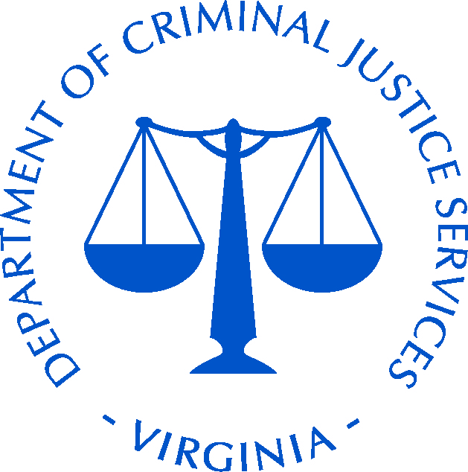
2017 Campus Safety and Violence Prevention Forum
Renaissance Portsmouth-Norfolk Hotel, Portsmouth, Virginia
March 7 – 8, 2017

AGENDA

TUESDAY, March 7, 2017

8:00 AM – 8:30 AM Welcome
Teresa Gooch, Division Director, Law Enforcement and Security Services,
Virginia Department of Criminal Justice Services
Francine Ecker, Director, Virginia Department of Criminal Justice Services (invited)
Brian Moran, Secretary of Public Safety and Homeland Security
Dave McCoy, Chief, University of Richmond

Presentation of Colors
Portsmouth Police Department Honor Guard

Singing of National Anthem
Second Lieutenant Deuntay T. Diggs, Stafford County Sheriff’s Office

8:30 AM – 10:30 AM Isla Vista Mass Murder Case Study
Commander Kelly Moore, Lt. Kevin Huddle, and Sgt. Joe Schmidt, Santa Barbara County Sheriff’s Department

Lead investigators will share a case study of an active shooter targeting students of the University of California, Santa Barbara and throughout the town of Isla Vista.

10:30 AM – 10:45 AM Break

10:45 AM – 11:45 AM Preventing Violent Extremism
Kathleen Bouzis, National Counter Terrorism Center

This presentation is designed to help communities and law enforcement understand violent extremist recruitment tactics and explores ways to collectively prevent and address these public safety threats at the local level. The Community Awareness Briefing (CAB) uses a series of case studies to illustrate the radicalization and recruitment process to which youth in our communities have fallen prey.

11:45 AM – 12:00 PM Fear2Freedom
Rosemary Trible, Fear2Freedom

A Survivor speaks as a "Voice for the Voiceless" empowering students to "Be the Change." This short session will feature the 4-minute trailer for the Emmy Award winning film entitled “Be the Change” and will provide information about the upcoming breakout session. Fear2Freedom can provide resources needed to foster a culture of intervention, prevention and awareness and begin a positive conversation with students that empowers and encourages them to “Be the Change” and combat assault on college campuses.

12:00 PM – 1:00 PM Lunch

WORKSHOPS (90 minute sessions)

1:15 PM – 2:45 PM

- Isla Vista Mass Murder, a closer look
Commander Kelly Moore, Lt. Kevin Huddle, and Sgt. Joe Schmidt, Santa Barbara County Sheriff’s Department

A closer look at elements of the investigation, such as resources for initial response, crime scene security, Intel analysis, fire/medic response and staging, demobilization, and long term investigative strategies.

- Alcohol Facilitated Sexual Assaults
Nancy Oglesby and Mike Milnor, Justice 3D

This session is focused on the campus environment. It discusses how to investigate these cases and why there are additional things that need to be documented and proven when a prosecutor is dealing with a physical helplessness case as opposed to one where alcohol/drugs are not at play. It will deal with the blackout/passout defenses that are often presented at trial and how to combat that. We touch on trauma-informed interviewing and also discuss amnesty issues for the victim and that barrier to reporting.

- Exploring the Intersections: Experiences of Violence and Diverse LGBTQ+ Identities
Stacie Vecchietti, Virginia Anti-Violence Project

During this session, we will explore basic LGBTQ+ terminology and engage in individual and group work to explore the unique considerations and barriers of diverse LGBTQ+ individuals that experience sexual/dating violence and/or stalking in a college/university context. Additionally, the group will explore how to best expand campus capacity to serve and work with LGBTQ+ survivors of violence and strategize next steps.

- Clery Act: The Requirements of the Violence Against Women Act and Intersections with Title IX
Adrienne Murray, D. Stafford and Associates
All public and private institutions of higher education who receive federal financial aid are required to comply with two major federal laws that create complex and cumbersome compliance requirements: Title IX of the Education Amendments of 1972 (“Title IX”) and the Jeanne Clery Disclosure of Campus Security Policy and Campus Crime Statistics Act (“Clery Act”). On October 20, 2014, the Department of Education published final regulations for the Clery Act as amended by the Violence Against Women Reauthorization Act of 2013 (“VAWA”), specifically, in Title III, Section 304 of VAWA. As a result of the changes to the Clery Act, institutions now have more significant and intricate requirements with regard to compliance, especially as it relates to policies, procedures and reporting requirements pertaining to sexual assault. This workshop will examine the general requirements of both laws, as well as note the significant intersections that exist between the Clery Act and Title IX as a result of the recent amendments. The workshop will also draw on relevant Department of Education guidance and advise institutions on practical steps they need to take now in order to meet compliance requirements.

- Suicide Prevention in the College Environment
Amy Hart, Suicide Prevention and Intervention Specialist

This session will focus on the importance of needing proper procedures and protocols for the safety of the student (off campus and residential), campus and caregivers; who needs to be trained and why; the types of trainings that can be offered; and resources available.

- Fear2Freedom
Rosemary Trible, Fear2Freedom

Fear2Freedom has launched a Sexual Assault Programming and Resources Tool Kit to assist college and university administrators in their Title IX training and education requirements. The focus of the Toolkit is to empower students to become a tangible part of the solution and change the cultural understanding on this issue. Central to the Programming & Resource Toolkit is this 30-minute, Emmy-Award winning, educational film. The film highlights national statistics, university leadership, student survivors, and the commitment needed to bring honor and respect to the college campus while preserving the dignity of each student. Students will be challenged to recognize the impact of sexual assault and will hear the courageous journey of healing from survivors. This session will provide an opportunity to view this film along with guidance on utilizing the resource tool kit.

2:45 PM – 3:00 PM Break

WORKSHOPS (90 minute sessions)

3:00 PM – 4:30 PM
- Building Local Countering Violent Extremism (CVE) Programs
Kathleen Bouzis, Jane McGuire, National Counter Terrorism Center and Ashley Riggs, Federal Bureau of Investigation

This session is designed to discuss how to start a local CVE program. Topics that will be covered include how to partner with local communities, key program components, and lessons learned from previous CVE programs across the country.

- Campus Sexual Assaults: The Unique Challenges
Nancy Oglesby and Mike Milnor, Justice 3D

This session focuses on doing a correct investigation and is geared mainly for campus law enforcement. It is not intended to be a primer on the Title IX, Clery laws as much as the challenges that can be presented when dealing with a sexual assault in a campus environment. It covers an overview of trauma-informed interviewing but mainly focuses on corroborating the assault, time concerns with witnesses, scene documentation, etc.

- Exploring the Intersections: Experiences of Violence and Diverse LGBTQ+ Identities
Stacie Vecchietti, Virginia Anti-Violence Project

During this session, we will explore basic LGBTQ+ terminology and engage in individual and group work to explore the unique considerations and barriers of diverse LGBTQ+ individuals that experience sexual/dating violence and/or stalking in a college/university context. Additionally, the group will explore how to best expand campus capacity to serve and work with LGBTQ+ survivors of violence and strategize next steps.

- Do we need to hire an external investigator or adjudicator?
Jennifer Hammat, George Mason University
Peter Lake, Center for Excellence in Higher Education Law and Policy, Stetson University College of Law

Imagine a Title IX incident occurring on your campus similar in scale to the Penn State scandal. Or, your campus community is deeply divided over a Title IX situation where there is an onslaught of media coverage. There are some Title IX-related incidents that are so complex, so large in scope, and have such a huge potential impact on the campus culture that an external investigator, and even adjudicator, may need to be called in. Title IX experts Peter Lake and Julian Williams examine when it is appropriate, advisable and/or necessary to engage an external investigator.

- Suicide Prevention in the College Environment
Amy Hart, Suicide Prevention and Intervention Specialist

This session will focus on the importance of needing proper procedures and protocols for the safety of the student (off campus and residential), campus and caregivers; who needs to be trained and why; the types of trainings that can be offered; and resources available.

- The Future of Campus Safety: Community Prevention and Connecting the Dots
Rick Shaw, Awareity

“The Final Report and Findings of the Safe School Initiative” by the Secret Service found in over 80% of the campus shootings, other people knew about the attack before it took place. The Final Report also found in over 90% of the attacks, there was evidence of the attacker’s concerning behavior prior to the attack, and this is just one of several reports with similar findings.

Countless hours of research, from hundreds of complex campus and community issues/incidents, exposes dangerous gaps on campuses (Students, Faculty, Administration, TATs, Security, HR, Legal, etc.), dangerous gaps within community resources (Law Enforcement, Mental Health, Health Care, Schools, Religious Orgs, etc.), and dangerous gaps within Social Media communities. However, the research also shows how these gaps can be closed, you just need to know how and be equipped to connect the dots within your community.

Through this extensive research, the 6 Essential Steps to Preventing incidents, lawsuits (Title IX), and tragedies have been revealed. Past and current post-event reports continue to reveal why so many colleges are failing to achieve all 6 Essential Steps to Preventing and end up in costly response and reaction mode so often. This session will provide the hard data that will help your campus make immediate and long-term improvements…because 99.9% of your campus and community prefer preventing vs. responding, and the data offers you a choice to invest in connecting the dots to save lives, reputations, and bottom lines… or continuing to respond.

WEDNESDAY, March 8, 2017

8:30 AM – 10:00 AM Balancing the Needs of the Victim, Criminal Justice System, and the Media in High Profile Cases
Tim Longo, Policing Matters, LLC

10:00 AM – 10:15 AM Break

10:15 AM – 11:45 AM Victim Blaming and Retaliation; the Second Rape
Anne Munch, Anne Munch Consulting Inc.

We live in a culture that professes to understand how sexual assault and rape are easily among the worst crimes that can be committed against a human and yet victims of these crimes routinely experience blame and backlash from people within this very same culture. This backlash can range from disbelieving comments from trusted friends to outright threats or actions against the victim including the publication of “revenge pornography”. This session will explore the underlying dynamics at play when community members including peers, jurors and complete strangers blame victims for crimes committed against them. We will consider the tension that community members face when presented with the “two sided coin” that depicts victim blaming on one side and offender accountability on the other as we challenge our reluctance to hold sex offenders accountable for their crimes.
11:45 AM – 12:45 PM Lunch

12:45 PM – 2:15 PM Understanding Victimology, Predation, and Serial Offending in Higher Ed: Identifying Vulnerable Campus Populations
Adrienne Murray, D. Stafford and Associates

The U.S. Department of Justice (2013) released findings demonstrating that 1 in 5 women will be sexually assaulted before she graduates college. Who is vulnerable to campus sexual assault and why? Who perpetrates sexual misconduct on campus and how do we identify these perpetrators? What is consent and how is incapacitation leveraged by offenders to continue perpetrating on campus without detection? This workshop will focus on victimology and predation on campus, the “Sexual Assault Sequence”, the grooming behavior of campus sexual predators, and the role of campus rape culture in insulating offenders and allowing them to continue operating in a target-rich environment. It will offer practitioners—including campus and local law enforcement officers, prosecutors, and campus administrators—guidance on the do’s and don’ts of conducting effective criminal and civil rights (Title IX) investigations.

2:15 PM – 2:30 PM Break

2:30 PM – 4:00 PM The Future of Title IX Compliance Under Our New Administration
Peter Lake, Center for Excellence in Higher Education Law and Policy, Stetson University College of Law

In the closing phase of President Obama’s administration, OCR ramped up its enforcement efforts. What are the critical takeaways from recent OCR investigations? How have recent VAWA amendments impacted Title IX enforcement and compliance efforts? Will Congress continue to add new statutory requirements? What can we expect in the transition to a new U.S. president? What will this all mean under the Trump administration, which has a different vision for Title IX enforcement? Join us to discuss Title IX compliance in transition.

