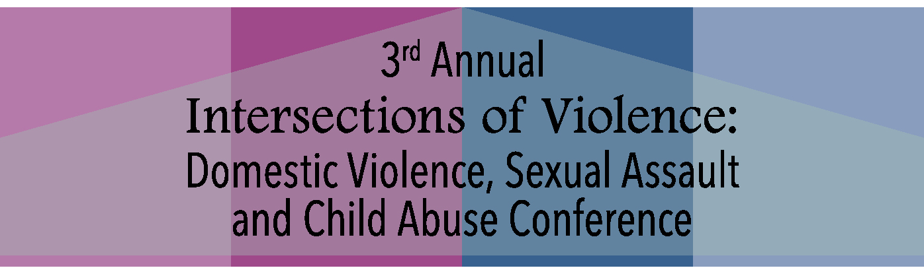
Presenter Bios

Dr. Gail Stern, Co-Founder and Chief Visionary Officer, Catharsis Productions

Dr. Gail Stern is the co-founder of Catharsis Productions and co-author of the non-stranger rape prevention program Sex Signals, which is presented over a thousand times each year to civilian college and military audiences around the world.
Dr. Stern has served as a subject matter expert for each branch of the U.S. Military, the DOD Sexual Assault Prevention and Response Office, and the White House. She participated in the development and delivery of the Air Force – Wide Bystander Intervention Training (BIT) program and was responsible for the development of the BIT Women’s Module; she also co-designed and delivered the accompanying Train-the-Trainer program from 2007-2010. Dr. Stern co-developed a 20- hour peer education curriculum and training program on sexual assault and harassment prevention for the U.S. Naval Academy at Annapolis.
In her previous career, Dr. Stern served as the National Law Enforcement Training Coordinator for the Anti-Defamation League from 1999-2003 and was a member of the Federal Law Enforcement Training Center Hate/Bias Crime Training Cadre (U.S. Department of the Treasury); the State and Local Anti-Terrorism Training Program; and, the U.S. Department of Justice Hate Crime Training Cadres. She focused training law enforcement officers on domestic extremist group investigation in both the U.S. and Canada.
Adam Foss, Founder and Executive Director, Prosecutor Impact
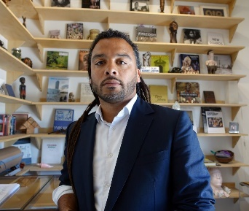
Adam J. Foss is a former Assistant District Attorney in the Juvenile Division of the Suffolk County District Attorney’s Office (SCDAO) in Boston, MA, and a fierce advocate for criminal justice reform and the importance of the role of the prosecutor in ending mass incarceration. Mr. Foss believes that the profession of prosecution is ripe for reinvention requiring better incentives and more measurable metrics for success beyond, simply, “cases won” leading him to found Prosecutor Impact - a non-profit developing training and curriculum for prosecutors to reframe their role in the criminal justice system. During his eight years as a prosecutor, Mr. Foss collaborated with the courts and the community to develop programming that continues to have a positive impact on the neighborhoods he prosecuted in. One example of these efforts is the Roxbury CHOICE program, an initiative Mr. Foss co-founded, to turn probation from a punitive sentence into a beneficial relationship with the court, the probation department, and the District Attorney’s Office. He is also the founder of the SCDAO Reading Program, a program he started, to bridge the achievement gap of area elementary school students. Before leaving the District Attorney’s Office, Mr. Foss was a critical piece of the foundation of the first juvenile diversion program in Suffolk County, keeping young people out of the cradle to prison pipeline. Most recently, Mr. Foss appeared in the critically-acclaimed CNN feature-length documentary “American Jail.” The Mandela Foundation recognized Mr. Foss as the 2017 Nelson Mandela Changemaker of the Year. Fast Company named him one of the Most Creative People in Business of 2017. The NAACP awarded Mr. Foss with the 2017 Roy Wilkins Next Generation Leader Award. The Root named Mr. Foss one of the 100 most influential black Americans of 2016.He was named Graduate of the Last Decade by his alma mater, Suffolk University Law School and is a visiting senior fellow at Harvard Law School. He sits on the boards of Restore Justice California and of the Pretrial Justice Institute. He also is a fellow at the Open Society Foundation Leadership in Government initiative as well as a Director’s Fellow in the world renown MIT Media Lab. In February of 2016, Mr. Foss delivered a TED talk that has already eclipsed 2 million views. In 2015, he was voted one of the country’s 40 most up-and-coming lawyers by National Law Journal and in 2013, the Massachusetts Bar Association voted him Prosecutor of the Year. In both his professional and personal capacities, Mr. Foss volunteers much of his time to the community he works in. Follow him: Twitter/IG: @adamjohnfoss and @prosecutorimpct or https://prosecutorimpact.com

Marty Parker, Supervisory Special Agent, Federal Bureau of Investigation (FBI)
Marty Parker has been a Special Agent with the FBI for 20 years. She has worked Crimes against Children violations, including child abductions, child sex tourism and human trafficking cases, in Oakland, California for almost her entire career. SSA Parker now coordinates the FBI’s Child Abduction Rapid Deployment Team (CARD) out of FBI Headquarters. SSA Parker has also been a field coordinator for the FBI’s Behavioral Analysis Unit (BAU) and has provided instruction on Active Shooters, Child Abductions, and Human Trafficking, among others.

Tiffany Turner, Director, Blacktivism-The Collective
Tiffany Turner is a passionate educator, trainer and presenter around multiple intersecting social justice issues that impact Black communities. Her work has been intense and vast across various issues of health, public health, education, arts and entertainment; her areas of expertise include Violence in the Black Community, Race Equity, Violence Against Women, Engaging Black Men and Boys, Infant & Maternal Health, HIV & AIDS, Adjudicated Youth, Educational Equity, Animal Abuse, Bullying, School to Prison Pipeline, Healthcare Reform & Access, Technology & the Digital Divide, Returning Citizens, Domestic & Teen Dating Violence, Sexual Assault, Human Trafficking and Stalking.
She holds a BA in Communications and a minor in African-American studies from George Mason University; as well as a Certificate in Community Health Leadership from Morehouse School of Medicine. She is also a certified Domestic Violence Advocate and Human Rights Liaison in the District of Columbia.
A proven leader with remarkable dedication, she is driven to experience new things, people, and opportunities and lives by her desire and determination to enhance and positively impact the lives of others! After serving as a long term consultant (six years) to the DC Coalition Against Domestic Violence, she moved into the role of the Program Director for Ujima– The National Center on Violence Against Women in the Black Community, a project that serves as a culturally specific resource center. She was the lead in building out this project from conception to inception. While there, Tiffany focused on developing its communication platforms, training, education, outreach and policy advocacy around domestic violence, sexual violence and community violence in the Black community. Her work covered the entire US and the territories of Puerto Rico and The US Virgin Islands.
She has now embarked upon the next chapter and natural phase in her journey as she launches Blacktivism: The Collective: The National Center for Peace and Prosperity in Black Communities, which will have a focus on the entire community.
Lastly, she is very proud of her roles as mother, wife, daughter, pet-parent, friend, mentor, mentee and Blacktivist.

Charles “Chuck” Slemp III, Commonwealth’s Attorney for Wise County & the City of Norton
C.H. "Chuck" Slemp, III was elected Commonwealth's Attorney for Wise County & the City of Norton on November 3, 2015. As Commonwealth's Attorney, Chuck manages an office of nine attorneys while working with State and local law enforcement officers and the citizens of Wise and Norton in order to prosecute those who choose to break the law. Prior to his service as Commonwealth's Attorney, Slemp served as Commissioner of Accounts for Wise County & the City of Norton, where we supervised the financial activities of court-appointed fiduciaries, and as General Receiver for the Circuit Court of Wise County, managing public funds in excess of $1.5 million. Additionally, he practiced criminal, domestic relations law, and estate administration in Southwestern Virginia and Northeast Tennessee. He is a graduate of the University of Virginia's College at Wise with a bachelor's degree in Business Administration. He holds a Master's Degree from Regent University School of Government in Law & Public Policy and a Juris Doctor from Regent University School of Law. He completed postgraduate study at Oxford University Hertford College in the United Kingdom.
Prior to his service as Commonwealths Attorney, Slemp served in a variety of roles to promote well-being of children, specifically children in foster care. He was appointed by the Governor of Virginia to the Virginia Commission on Youth, a standing bi-partisan legislative commission of the General Assembly which, by mandate, provides a legislative forum in which complex issues related to youth and their families may be explored and resolved. He served on the statewide steering committee for "Virginia Adopts: Campaign for 1,000," an effort to promote foster care adoption in Virginia. Further, Slemp represented the Commonwealth of Virginia at the National Conference of State Legislatures Children & Families Program Three Branch Institute on Children's Wellbeing. In addition to prosecuting serious crimes, Commonwealth's Attorney Slemp has created various initiatives designed to create greater efficiencies in the criminal justice system and promote public safety in Southwest Virginia.
In 2016, Slemp launched the "Courts to Classrooms" program, which provides educational experiences for area students. In 2017, Slemp created the "Southwest Virginia Joint Senior Abuse Task Force" to address crimes against senior citizens and the "Wise Works" program to provide alternative sentencing options for low-risk offenders. Addressing the region's substance abuse crisis, protecting seniors from financial exploitation, and safeguarding children from abuse & neglect remains among his top priorities. Slemp represents the Ninth Congressional District on the Virginia Commonwealth's Attorneys Services Council and is a member of the Virginia Trial Lawyer's Association Virginia Criminal Justice Conference. He also serves on the Board of Directors for Norton Community Hospital

Bonnie Price DNP, RN, SANE-A, SANE-P, AFN-BC, Administrative Director of Community Health Advocacy, Bon Secours Richmond Forensic Nursing Services
Dr. Price has been a nurse since 1984 and is the Administrative Director of Community Health Advocacy for Bon Secours in Richmond, Virginia. Bonnie’s focus areas include human trafficking, substance use disorders, workplace violence and the forensic nursing program, which Bonnie cofounded in 1993. Dr. Price has participated on numerous community boards and committees as a forensic nurse liaison. She speaks locally and nationally on clinical forensic issues and served as coeditor for the first edition of the Core Curriculum in Forensic Nursing. Dr. Price served two terms as a board member of the International Association of Forensic Nurses. She is also a member of the Virginia Chapter of the International Association of Forensic Nurses. In 2014, Dr. Price was honored with the International Association of Forensic Nurses highest award, the Virginia A. Lynch Pioneer Award in Forensic Nursing, and she was recognized with the 2018 YWCA Richmond Outstanding Women Award in Health and Science.

Sara Jennings, DNP, RN, SANE-A, SANE-P, AFN-BC, Manager, Bon Secours Richmond Forensic Nursing Services
Dr. Jennings has worked as a Forensic Nurse since 2006. She is the Manager of the Bon Secours Forensic Nursing Program in Richmond, VA. Dr. Jennings has participated on numerous community boards and committees as a forensic nurse liaison. She speaks locally and nationally on clinical forensic issues and served as editor of the Scope and Standards of Forensic Nursing. Dr. Jennings served two terms as a board member of the International Association of Forensic Nurses and is currently the IAFN President. She is also a member of the Virginia Chapter of the International Association of Forensic Nurses and has served as President and Secretary.

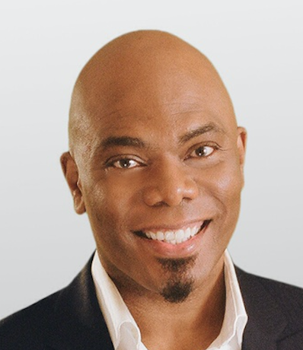
M.E. Hart, JD, CEO & Co-founder, Hart Learning Group, LLC
M.E. Hart, J.D. is author of Thriver’s Quest: Healing life’s traumas to bring out your best. His book offers insights, inspiration, and poetry drawn from his healing journey as a survivor of many adverse childhood experiences. Hart’s diverse background includes serving as Legal Advisor and Educator at the DC Office of Human Rights during the initial outbreak of AIDS; acting at the famed Arena Stage as a member of their repertory company; creating multimedia as an Attorney Producer for the Federal Judicial Center; and writing award-winning scripts for a children’s TV series. He stood with 200 male survivors of sexual abuse in the final season of the Oprah Winfrey Show – an experience that motivated him to share his healing story with the Bristlecone Project at 1in6.org. He is a certified executive coach and accomplished facilitator, and has conducted learning events for Fortune 500 companies across the US, and in Belgium, Moscow, Ukraine and other interesting parts of the world.

In April Hart joined Gov. Ralph Northam and members of the Virginia’s Department of Criminal Justice Services in recognizing Victims’ Rights Week. Hart is the founder of Hart Learning Group LLC, where he leads a team that helps organizations create inclusive, respectful, and innovative cultures

Victor Vieth, Director, Education and Research, Zero Abuse Project
Victor Vieth has trained thousands of child-protection professionals from all 50 states, two U.S. Territories, and 17 countries on numerous topics pertaining to child abuse investigations, prosecutions and prevention. Victor gained national recognition for his work in addressing child abuse in small communities as a prosecutor in rural Minnesota, and has been named to the President’s Honor Roll of the American Professional Society on the Abuse of Children. In 2012, Victor was awarded the Pro Humanitate Award from the North American Resource Center for Child Welfare
Victor is the Director of Education and Research of the Zero Abuse Project, a 501©(3) public charity based in St Paul, MN, committed to education, training, and survivor support in order to eradicate child sex abuse and remedy its resulting harms. He is the 2018 President of the Academy on Violence & Abuse, and founder of the National Child Protection Training Center. With NCPTC and its partners, Victor has been instrumental in implementing 22 state and international forensic interview training programs and dozens of undergraduate and graduate programs on child maltreatment.
Mr. Vieth graduated magna cum laude from WSU and earned his Juris Doctor from Hamline University School of Law (HUSL). In 2017, Victor earned an MA in theology from Wartburg Seminary. Mr. Vieth has published countless articles related to the investigation, prosecution and prevention of child abuse and neglect. He is author of Unto the Third Generation, a bold initiative that outlines the necessary steps we must all take to eliminate child abuse in America in three generations, and On This Rock: A Call to Center the Christian Response to Child Abuse on the Life and Works of Jesus (Wiff & Stock 2018).

Denise Purgold, LCSW, Lead Therapist, Adoptive Family Preservation, United Methodist Family Services (UMFS)
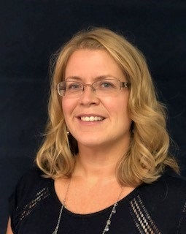
Denise Purgold, LCSW is the Lead Therapist with Adoptive Family Preservation (AFP) at UMFS, where she has worked since 2002. AFP is a regionalized project, funded by the Virginia Department of Social Services which provides free services to adoptive families in Virginia to support permanency and child/family well-being. Denise provides trauma informed and adoption competent clinical services to families in the central, eastern and piedmont regions of Virginia including: individual and family therapy, consultation, assessment, psychoeducation and training. Denise specializes in helping families work through adoption, attachment, trauma, parent child relationship, birth family and grief and loss issues. Denise received her BS in Psychology from Virginia Tech in 1992 and her Master of Social Work from Virginia Commonwealth University in 1997. Denise obtained her LCSW in 2003 and is a member of ATTACh and the Attachment and Trauma Network. Denise has worked in child welfare since 2002 and served as a Resource Parent Trainer, Treatment Foster Care Supervisor and Special Needs Adoption Supervisor at UMFS prior to moving into her role with AFP in 2009.
Denise is also a member of the Greater Richmond Trauma Informed Community Network (GRTICN) and serves as a trainer for the training committee. The TICN is comprised of professionals who are committed to practicing and advocating for trauma-informed care for children and families within the child welfare system in the City of Richmond and surrounding counties.
Denise is an adjunct faculty member for the School of Social Work at Virginia Commonwealth University, and also provides group therapy for children dealing with grief and loss issues through Full Circle Grief Center in Richmond, VA.

LaShaun Dozier, Adoption Therapist, The Adoptive Family Preservation (AFP) Project

LaSaun received her Bachelor’s degree in Social Work in December of 2005 from the University of Alabama. She received her Master’s in Mental Health Counseling in September of 2012 from Capella University, Minneapolis, MN. LaSaun has worked in the Human Services field for over 14 years. She enjoys the work of serving others and walking them through the sometimes arduous journey to wholeness and wellness.
LaSaun is a Resident in Counseling pursuing her credentials as a Licensed Professional Counselor (LPC.) She is employed at UMFS in Virginia Beach, VA as an Adoption Therapist with the Adoptive Family Preservation (AFP) project.

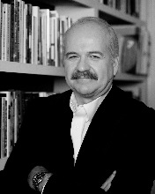
Mark Wynn (retired), Owner, Wynn Consulting
Twenty-one year member of the Nashville Metropolitan Police Department – Served as Lieutenant to the Domestic Violence Division – member of the Special Weapons and Tactics (SWAT) Team for fifteen years. A key creator of the largest police domestic violence investigative unit in the United States. A national trainer to police executives, patrol officers, training officers, prosecutors, judges, legislators, social service providers, healthcare professionals and victim advocates in all fifty states for over thirty years. An international lecturer at police academies in Australia, Canada, Germany, England, Northern Ireland, Russia, the Republic of Mauritius, the Republic of Georgia, the Federated States of Micronesia, China, the Islands of the Bahamas, Brazil, Turkey, Cyprus and Singapore. He is a survivor, enabling him to teach both effectively and passionately. In short, Mark is devoted to ending family violence as a police officer, detective, educator, program supervisor and now consultant and advisor.

Monique Williams, M.A., Educator and Consultant, Beginnings Family Enrichment, LLC.
Monique Williams, MA, has developed and facilitated numerous trainings and workshops on trauma-informed practice for the Virginia Department of Education, Department of Criminal Justice Services, Department of Corrections, and local agencies that serve youth in foster care, residential care, and early childhood education. She offers consulting to schools, public and private agencies, and nonprofits to strengthen youth and family engagement at all levels of service. Her experience in the field of mental health has greatly impacted the services provided to youth and families involved in multiple systems. She has provided expertise within the State Office of Children and Family Services at the Virginia Department of Behavioral Health and Developmental Services (DBHDS) and has served on a national demonstration project funded by the Office of Victims of Crime that focused on the identification and coordination of care for children, youth, and transitioning young adults who have been victimized by a broad spectrum of crimes and other traumatic violent events. As a Training Faculty with the Virginia Sexual and Domestic Violence Action Alliance Training Institute, Ms. Williams is often requested to facilitate trainings, workshops, and webinars centered on adverse childhood experiences and trauma, resiliency, intergenerational violence and historical trauma, and services to support communities of color. Ms. Williams is a licensed Special Education Teacher and provides private community-based child and family services in areas of parenting education for teens and adults, therapeutic mentoring, and academic tutoring for GED candidates. She also provides personal and professional development coaching focused on helping overworked and overwhelmed professionals to regain balance in their lives and career.

Kelsey McKay, Consultant, McKay Training and Consulting
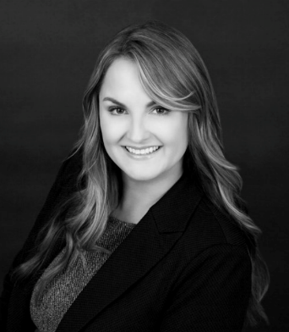
Kelsey McKay is a highly recognized national expert on the topic of asphyxiation and interpersonal violence. She was child abuse and domestic violence prosecutor in Travis County, Texas for 12-years exclusively prosecuting strangulation related crimes for half that time. She now trains and consults nationally to implement sustainable protocols and help strengthen how communities collaborate, investigate, treat and prosecute strangulation and in cases ranging from intimate partner violence and sexual assault to child abuse and homicide. She is the President & CEO of RESPOND Against Violence, a non-profit organization. She serves on multiple faculties, advisory boards and committees.

Koube Ngaaje, Executive Director, District Alliance for Safe Housing, Inc. (DASH)
Koube Ngaaje is the Executive Director for the District Alliance for Safe Housing, Inc (DASH). Founded in 2006, DASH is the largest safe housing program for survivors of domestic abuse and sexual violence in Washington, DC. DASH works to ensure access to safe and sustainable housing for all survivors of domestic and sexual violence and their families through emergency and long-term safe housing, and innovative homelessness prevention services. Her career in non-profit management spans over a decade with extensive experience in the delivery of mission driven and high-quality social service to individuals, families, and communities. At DASH, Ms. Ngaaje is leading the organization in a new phase of growth and innovation, securing DASH’s continued and impactful response to the ever-increasing regional demand for affordable housing and domestic violence services; and fortifying DASH’s long-term financial and organizational sustainability. These efforts led DASH in a 20 percent organizational growth under her tenure and plans to have even greater impact by 2022. Prior to joining DASH in 2017, Ms. Ngaaje served as the Chief Operating Officer for the Arlington Food Assistance Center (AFAC), an organization that provides weekly supplemental groceries to over 2,200 Arlington families. She serves as Board Treasurer for The Alliance for Housing Solutions, a non-profit organization that works to increase affordable housing in Arlington County and Northern Virginia area and is a Founding Member of NextGenNow founded in 2013 and current. In 2015, she received the Top 40 Under 40 Leader award from the Leadership Center for Excellence. Ms. Ngaaje holds a Master’s Degree from Marymount University in Forensic Psychology and a Bachelor’s degree from Baylor University in Psychology.
Kim Pentico, Economic Justice Program Director, National Network to End Domestic Violence
Kim has been working with and on behalf of survivors of sexual and domestic violence since 1990. She first spent over seven years working for a local domestic violence program in Kansas and another seven years at the Kansas Coalition Against Sexual and Domestic Violence. She has also worked for the STOP Technical Assistance Project in Washington, DC. Kim works to ensure and enhance survivor access to economic justice and long-term safety.
Jerri Sites, Regional Training Specialist, Southern Regional Children’s Advocacy Center/National Children’s Advocacy Center

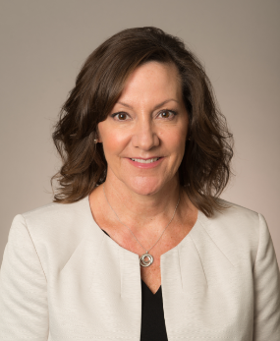
Jerri Sites, MA, is a Regional Training Specialist for the Southern Regional Children’s Advocacy Center (SRCAC), a project of the National Children’s Advocacy Center, where she provides training and technical assistance to Children’s Advocacy Centers (CACs) and Multidisciplinary Teams (MDTs) throughout 16 states in the southeast region of the US. Jerri has 27 years of experience working in the field of child abuse investigations, 21 of those working within the CAC movement in the state of Missouri. She has conducted over 2100 Forensic Interviews and has testified numerous times as an expert witness. Jerri co-authored “The Child Abuse Investigative Field Guide” published in 2015 and writes “Research to Practice” publications for SRCAC. She specializes in “MDT Response” presentations on specific topics to include: Recantation, Youth with Problem Sexual Behaviors, and Identifying Corroborative Evidence in the Forensic Interview.

Julia Knach, Mental Health Director, Baltimore Child Abuse Center
Julia Knach is currently the Mental Health Program Supervisor at Baltimore Child Abuse Center (BCAC). She recently accepted this position in order to undertake the creation of a mental health program at the BCAC. Previously, Julia Knach was the Clinical Supervisor with Family and Children’s Services (FCS), supervising both Baltimore City and County. She was with FCS for 1.5 years. She works with all populations dealing with trauma and abuse. Prior to joining FCS, she worked at Hope Health Systems satellite office. Here she worked with families throughout Baltimore City that were dealing with both trauma and addictions. The families had been separated due to addiction and she provided both mental health and addictions counseling. Before Hope Health Systems, she worked at Harbel Prevention and Recovery as the adolescent team leader. She received her BA from Arcadia University in 2002, where she received her BA in Art’s for psychology. During her time in undergraduate, she spent a year in Australia studying abroad. She attended University of Baltimore and received her Master’s degree in Applied Psychology with a minor in Forensic. She grew up in Baltimore, Maryland and has spent most of her adult life in Maryland.

Abigail Miller, Missing Youth Therapist, Baltimore Child Abuse Center
Abigail Miller attended Maryland Institute College of Art to obtain her undergraduate degree in fine arts and Morgan State University for her Masters of Social Work concentrating on At-Risk Children, Youth and Families. While at MSW, Abigail graduated Magna Cum Laude and was inducted into Phi Alpha Social Work National Honors Society. While participating in her Master’s program, Abigail interned with the Baltimore Country Department of Social Services where she worked directly with the Continuing Child Protective Services Department and at the Juvenile Circuit Court of Baltimore City. During Abigail’s professional career she spent four years at Kennedy Krieger Institute working with at-risk youth with cognitive disabilities. After graduate school, Abigail worked at Henderson Behavioral Health as a Mental Health Therapist. During her time at the organization, Abigail worked in-home with youth who were at risk of requiring residential treatment. Abigail currently works at Baltimore Child Abuse Center as the primary therapist in their Missing Youth Program.

Roger Canaff, Consultant/Speaker, Justice 3D
Roger began his years as a prosecutor with the Alexandria, Virginia Office of the Commonwealth’s Attorney in 1997. During his time there he prosecuted many different types of crimes, with a specialty in child abuse, child sexual assault, and juvenile crime. In 2003 he joined the staff of the National Center for the Prosecution of Child Abuse at the American Prosecutors Research Institute in Alexandria, Virginia as a Senior Attorney. In 2005 he returned to active prosecution in Bronx County, New York in that office’s Child Abuse and Sex Unit prosecuting both adult and child sexual assault crimes. In June 2007, he was hired by the New York State Office of the Attorney General as the Deputy Chief of the newly formed Sex Offender Management Unit.
After serving for two years in this position, he was hired by the United States Army in June of 2009 as a Highly Qualified Expert with the Trial Counsel Assistance Program, US Army Legal Services Agency. As an Army civilian, he trained and consulted with military prosecutors specializing in Special Victims issues worldwide. He left federal service in February 2012. He re-joined the National District Attorney’s Association as a Fellow in October of 2012 within the National Center for Prosecution of Child Abuse where he served until early 2015.
In 2017, he partnered officially and is currently associated with the law enforcement training group, Justice3D.
An experienced child, adolescent, adult, and disabled victims’ legal expert, he has lectured to prosecutors, law enforcement, medical experts, advocates and other allied professionals as well as the public. He continues to train and consult internationally, comments on cases for various media outlets, and lives and works in New York City.

Wade Stomer, Law Enforcement Liaison-U.S. Northeast Coast, Uber Technologies
Wade comes to Uber by way of the Air Force Office of Special Investigations. Wade was a civilian Special Agent for 12 years. During his first three years he worked in the major crimes unit mainly focused on sex crimes investigations. For the next 9 years, he conducted counterintelligence and counter-terrorism investigations and operations both domestic and abroad. In this capacity, Wade deployed to Iraq on three separate occasions and twice to Afghanistan. Before his civil service career, Wade attended the University of Cincinnati where he received a BA in economics and a BA international relations. Prior to attending college, Wade served in the United States Marine Corps infantry for four years.

Corine (CT) Moulton, Consultant/Speaker, Justice 3D
C.T. Moulton recently retired as a Special Victims Detective from Henrico Police in Richmond, Virginia. She was a law enforcement officer for over twenty years, and during that time did many trainings internally in her department, throughout Virginia and nationally. She currently serves on Virginia’s Child First faculty, providing training on child forensic interviewing and investigation of child sexual assault.

She was recognized for her work as a team member twice receiving the Henrico County Police Division Meritorious Award. C.T. was also a key member of the Henrico County Child Advocacy Center Multidisciplinary Team which was recognized as the best in the state in 2015.

In 2017, C.T. joined the team of Justice 3D, a company which provides cutting edge training and consulting nationally in the areas of child abuse, sexual assault and domestic violence.

C.T. is married and has two step-daughters.

Stacey T. Davenport, Assistant Commonwealth’s Attorney, Henrico County Commonwealth’s Attorney’s Office
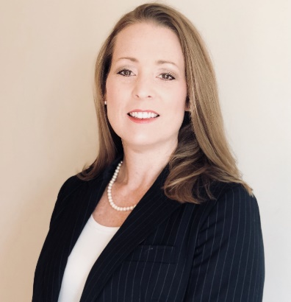
Stacey T. Davenport is an Assistant Commonwealth’s Attorney in Henrico County where she currently serves as the Domestic Violence Prosecutor. She received her BA from Wake Forest University and her JD from The University of Richmond. After being admitted to the Virginia Bar, Mrs. Davenport practiced criminal defense for over 10 years, focusing her practice on violent crimes, such as Domestic Violence and Child Sexual Assault, in the Juvenile and Domestic Relations Courts in the Richmond metro area. In 2014, she began her career as a prosecutor, serving as the Assistant Commonwealth’s Attorney in Essex County where she worked in a position funded by a Domestic Violence and Sexual Assault grant before moving to the Henrico County Commonwealth Attorney’s Office in January of 2016. Mrs. Davenport has several specialized trainings on Domestic Violence and violence against women, to include training on strangulation provided by the Strangulation Training Institute. She currently trains Henrico County Police Officers and Henrico County Firefighters serving as EMTs on the specialized legal and evidentiary issues of domestic violence and strangulation cases. In addition to training Henrico County’s first responders, she has also been privileged to speak on issues related to domestic violence at the Regional Law Enforcement Chaplains Conference and the Central Virginia EMS Expo.

Mariya Taher, Co-founder & U.S. Executive Director, Sahiyo
Named one of the six experts on female genital cutting (FGC) to watch by NewsDeeply.com , Mariya has worked in the anti-gender violence field for over a decade in research, policy, program development, and direct service. She received her Master of Social Work from San Francisco State University in 2010 where she pursued a qualitative study titled, “Understanding Female Genital Cutting in the United States.” Since then, she has worked on the issue of domestic violence at W.O.M.A.N., Inc., Asian Women’s Shelter, and Saheli, Support and Friendship for South Asian Women and Families, and was part of the Women’s Foundation of California Women's Policy Institute. In 2015, she cofounded Sahiyo, an internationally recognized, award-winning organization to empower Asian communities to end female genital cutting. Mariya also sits on the inaugural steering committee for the US End FGM/C Network. In Massachusetts, Mariya works with the Women’s Bar Association to pass state legislation that would ban FGC and create education and outreach programs for survivors. The Manhattan Young Democrats named her a 2017 Engendering Progress honoree and ABC news did a special feature on her, entitled: Underground: American Woman Underwent Female Genital Mutilation Comes Forward. She is also a prolific writer in fiction and nonfiction with essays and short stories appearing on NPR, Ms. Magazine, HuffPost, The Fair Observer, Brown Girl Magazine, Solstice Literary Magazine, The San Francisco Examiner, The Flexible Persona, Cecile’s Writer’s Magazine, and more. Follow her on Twitter @mariyataher83.

Cory Gerwe, Clinical Director, LGBT Life Center

Cory Gerwe graduated from Old Dominion University with a Bachelor’s in psychology, his Master’s degree in mental health counseling, and is currently finishing his PhD in Counseling. His research interest center on LGBT affirming counseling, intersectionality and transgender experiences, and inter-professional collaborative care. Cory’s research interest are echoed through his leadership endeavors, teaching activities, and clinical work.

He held multiple leadership positions including being president of a local Chapter of Chi Sigma Iota (Counseling Honor Society), associate director of graduate counseling admissions, and is currently president elect for the Virginia Association of Counselor Education and Supervision (VACES). Cory has presented at 4 national presentations and over 25 local and regional presentations that focus on counseling, intersectional experiences, and cultural awareness.

Cory has also and has also taught over 12 undergraduate courses at Old Dominion University. Cory's past clinical experiences include internships at a correctional facility and EVMS, as well as being an in-home counselor. For the past 3 years, Cory has worked as the clinical coordinator and is currently the clinical director at the LGBT Life Center in Norfolk Virginia. Cory is currently a Licensed Professional Counselor in the state of Virginia along with a Nationally Board Certified Counselor.

Elvira De La Cruz Macedo, CEO/ SENIOR ADVOCATE, Latinos in Virginia Empowerment Center

Mrs. De la Cruz has participated in countless hours of training and is well-respected in the community as an expert in the field. She is a bilingual and bicultural advocate with vast experience working with and implementing programs for victims of crime from Underserved Populations. She has worked for nine years in a local DV/SV Program, where she supervised and provided direct services. She was instrumental in the implementation of programs that served immigrant victims of domestic violence, sexual violence, and stalking. She is a member of the VDSS –DV Underserved Population Committee and has served as a consultant for the VDSS Underserved Populations Outreach Project that in 2016 worked with local Virginia crisis centers and community base organization’s to improve outreach and increase access to services for unserved, underserved and inadequately served populations utilizing Woman of Color Network’s 3-Tier system. Mrs. De la Cruz is an appointed member of the VDH Advisory Council on Health Disparity and Health Equity; she has served in the Action Alliance DV/SV accreditation committee, VAData Committee, and the Virginia Sexual and Domestic Violence Program Professional Standards Committee. According to the Office of the Attorney General, she was key in the implementation of Lethally Assessment Protocols (LAP) in six Virginia jurisdictions. Mrs. De la Cruz received the 2018 Unsung Heroes award granted by the office of Attorney General for her work implementing programs that target underserved victims of crimes.

Manuela Vazquez, Community Outreach Coordinator, First Step: A Response to Domestic Violence
Manuela S. Vazquez is the Community Outreach Coordinator at First Step: A Response to Domestic Violence, an agency serving survivors of domestic violence in the Harrisonburg City and Rockingham County area. She regularly meets with community members and organizations to talk about the needs of domestic violence survivors. Through presentations, trainings, and community events, she is able to teach the community about the negative effects of domestic violence and the positive impact First Step makes. One of her favorite activities is forming community partnerships to provide services that are more comprehensive to clients. During the week, Manuela can be found collaborating with First Step’s Board of Directors, updating First Step social media accounts, meeting with local supporters, or at the office trying to find innovative ways to connect with the community.

The Reverend Gloria R. Newsome-Brickhouse,, National Council of Negro Women-Norfolk
Reverend Newsome-Brickhouse is the eldest child of the late Lila and Clarence Ruffin. She was born and reared in Norfolk, Virginia where she attend Norfolk Public Schools; graduating with honors. She has earned a Bachelor’s Degree in Religious Studies from Hampton University and a Master of Divinity Degree from the Samuel DeWitt Proctor School of Theology, Maga Cum Laude.
Rev. Newsome-Brickhouse is the Associate Minister of Evangelism/Missions and Outreach and the Assistant to the Pastor; Dr. Robert G. Murray, at the Historic First Baptist Church Norfolk.

Pyowook Han, Director of Programs, Korean Community Service Center of Greater Washington
Pyowook Han has served the Director of Programs at the Korean Community Service Center of Greater Washington since Feb 2015. He is primarily responsible for overseeing KCSC’s programs and services, including the Social & Immigration Program, Health Promotion Program, Family Enrichment Program, Senior Empowerment Program, and Educational Program. Mr. Han received his Master of Social Work from Ohio State University and served Asian immigrants in Columbus OH from March 2009 to January 2015.

Jane Straub, Victim Assistance Specialist, Jacob Wetterling Resource Center and Zero Abuse Project
Jane Straub is the Victim Assistance Specialist for the Jacob Wetterling Resource Center (JWRC), a program of Zero Abuse Project. In this role, she trains and educates on topics related to violence and prevention, supports families who have a missing loved one and advocates for victims and families struggling with the effects of abuse or neglect.
Jane has been working in the violence prevention and intervention field for over 20 years and has worked with youth and families for more than 25 years. In addition to providing advocacy and support, Jane is a national trainer on topics such as missing persons, domestic abuse, sexual violence, stalking, trafficking, bullying/cyberbullying, reproductive coercion, healthy relationships, consent and impact of trauma (Ace Study). She was instrumental in creating the curriculum and is the principal trainer for “From Trauma to Resilience: Fostering Hope through Trauma Informed Care”. Her training audience ranges from pre-school to college-age students, victim/survivors to offenders, parents, teachers, community leaders and all professionals working with youth. One of Jane’s goals is to work collaboratively with fields such as law enforcement, all components of health, education, social services and business to collectively connect the dots of risk and prevention, to provide coordinated services and create hope and health for all of our children and families.
Jane provides direct case management in cases of family and nonfamily abduction, lost, injured or otherwise missing children, runaway youth and adults missing under suspicious circumstances. Assistance includes reunification assistance, emotional support, reporting procedures, posters, flyers and social media campaigns, working with law enforcement and media and referrals for search and rescue. Connecting families with appropriate support and resources is vital when a person is missing. Advocacy continues for as long as a loved one may be missing including resources for reunification, services needed upon recovery as well as support for cases where the loved one is recovered deceased.
She provides advocacy and support to victims, families and allies of those experiencing any type of child maltreatment, exploitation, stalking, sexual assault and domestic violence. Assistance includes emotional support, aid in navigating the justice system such as court advocacy, victim impact statements, notification procedures and compensation, traditional and non-traditional support groups incorporating trauma informed yoga, writing and the arts.

Sarah Yanosy, LCSW , Director, Creating PRESENCE
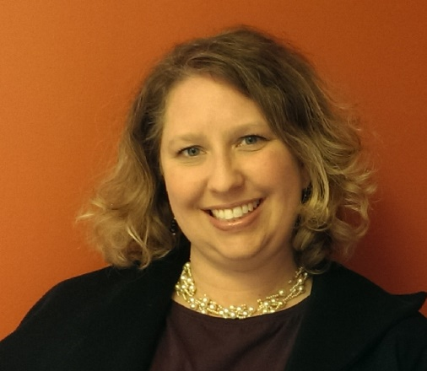
Sarah Yanosy, LCSW has been a keynote and featured speaker on trauma and organizational culture at both national and international conferences and has published extensively on the implementation and impact of trauma responsive practice.
Ms. Yanosy’s career has integrated clinical work, education and administration, which developed her expertise in trauma treatment in individual and family therapy, program and curriculum development as well as program evaluation and replication. She currently teaches at the Fordham University Graduate School of Social Service, consults with nonprofit human service organizations and sees clients in a group practice in her home state of NY. She has developed nationally available collegiate leadership programming, and previously served as the founding Director of the Sanctuary Institute. In her role as Director, Ms. Yanosy oversaw the development, training and implementation of the Sanctuary Model, a system-wide holistic organizational intervention. The resulting social movement built around practice of this model grew to over 350 organizations, including residential care, D&A treatment, domestic violence, juvenile justice programs, hospital, community based and school settings across the United States and seven other countries. Ms. Yanosy received her undergraduate and graduate degrees at Cornell University and Smith College respectively, and has completed post graduate programs at New York University, Fordham University and Columbia Business School.

Nancy Oglesby Domestic and Sexual Violence Resource Prosecutor, Commonwealth’s Attorney’s Services Council
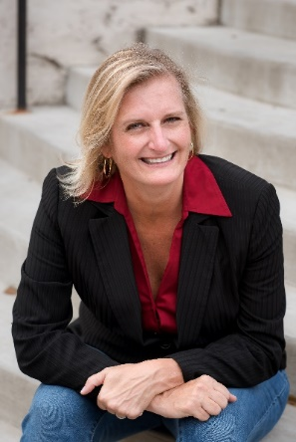
Nancy has been a career prosecutor in the Commonwealth of Virginia for over 20 years. She is currently Virginia’s Domestic and Sexual Violence Resource Prosecutor.
Nancy has handled thousands of domestic violence, child abuse and sexual assault cases. In addition, she has provided training on these issues to many professionals including prosecutors, law enforcement officers, advocates, medical professionals and forensic interviewers. She has been appointed by four Virginia Governors to statewide advisory boards, commissions and task forces devoted to combatting domestic and sexual violence. Nancy also served a key role in the development of Virginia’s model law enforcement policies related to domestic and sexual violence.
In 2011, Nancy was chosen by the Virginia Association of Commonwealth’s Attorneys to receive the Virginia S. Duvall Distinguished Juvenile and Domestic Court Prosecutor Award. She also was recognized in 2012 as the Outstanding Woman of the Year in the area of Law and Government by the Richmond YWCA. In 2017, she received the Lecturer of Merit Award in recognition of her exceptional leadership and commitment to the training of Virginia Prosecutors. Most recently, in 2019, she was recognized by the National Organization for Victim Assistance for her dedication to empowering victims and survivors of crimes.
Nancy is a co-founder of Justice 3D, a company that offers training and consulting to allied professionals nationally on issues of child abuse, domestic violence and sexual assault.
Nancy is married and has two daughters, Mackenzie and Berkeley.
Chief Mike Milnor (ret.), Consultant/Speaker, Justice 3D
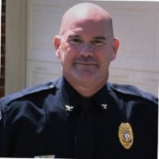

Mike has been involved in law enforcement for over 36 years and recently retired as Chief of Police for Alta Vista, Virginia. Over the years he has worked in various positions which include Interim Sheriff, Director of Public Safety, Coordinator of an FBI/Virginia State Police multi-jurisdictional task force, Senior Supervisory Investigator, uniformed Deputy Sheriff and Polygraph Examiner.
In addition to being involved in thousands of investigations, Mike has also done an extensive amount of teaching in criminal justice with an emphasis in the areas of sexual assault, child abuse, elder abuse and domestic violence as well as being a Professor of Criminal Justice at Liberty University. Mike also contributed to the development of Virginia’s Model Law Enforcement Policy on Sexual Assault Investigation. In 2016, Mike was selected to the core faculty of the National Center for Campus Public Safety which allowed him the opportunity to instruct at colleges and universities across the country in the areas of sexual assault investigation, Title IX compliance, and campus violence.
In 2016, Mike cofounded Justice 3D, a company that offers training and consulting to allied professionals nationally on issues of child abuse, domestic violence and sexual assault.
Mike is married and has two grown children and two grandbabies, Cadie and Grayson.

Renee Roman, LMSW, Executive Director, START Children’s Center, Inc.
Renee Roman holds a MSW degree in Social Work from SUNY Albany and BA degree in Psychology from Alfred University. Ms. Roman is the Executive Director of START Children’s Center, Inc.; a Child Advocacy Center in Rensselaer County, NY. She has been in this role for over 20 years. In the role as Executive Director she has conducted over one thousand Forensic Interviews of abused children. As part of her responsibilities, she participates in pre-interview meetings, conducts interviews, writes grant reports, coordinates training opportunities, participates in case reviews, supervises staff and administers the programs and grants at the CAC.
Ms. Roman is a frequent educator and trainer for a wide range of groups. Ms. Roman has taught social work classes at both The College of St. Rose and SUNY Albany and is a trainer with the Fordham University Sexual Abuse Dynamics and Intervention Training. She was an original writer of New York State Forensic Interviewing Best Practices; co-author of the update for the same and one of the writers of New York State Advanced Forensic Interviewing Best Practices. She was instrumental in the certification of New York State Forensic Interviewing Best Practices on the national level. She has trained hundreds of CPS workers, attorneys and law enforcement investigators.
Ms. Roman has participated in many learning collaborations across the State. She has co-facilitated the Youth with Problematic Sexual Behavior Collaborative. She has been trained in the adolescent model and co-facilitates a group for adolescent males and their caregivers. Ms. Roman has been working on the State level to increase the access to evidence-based services for these youth and families across New York.

Anton A. Bell, Commonwealth’s Attorney, Hampton Commonwealth’s Attorney’s Office
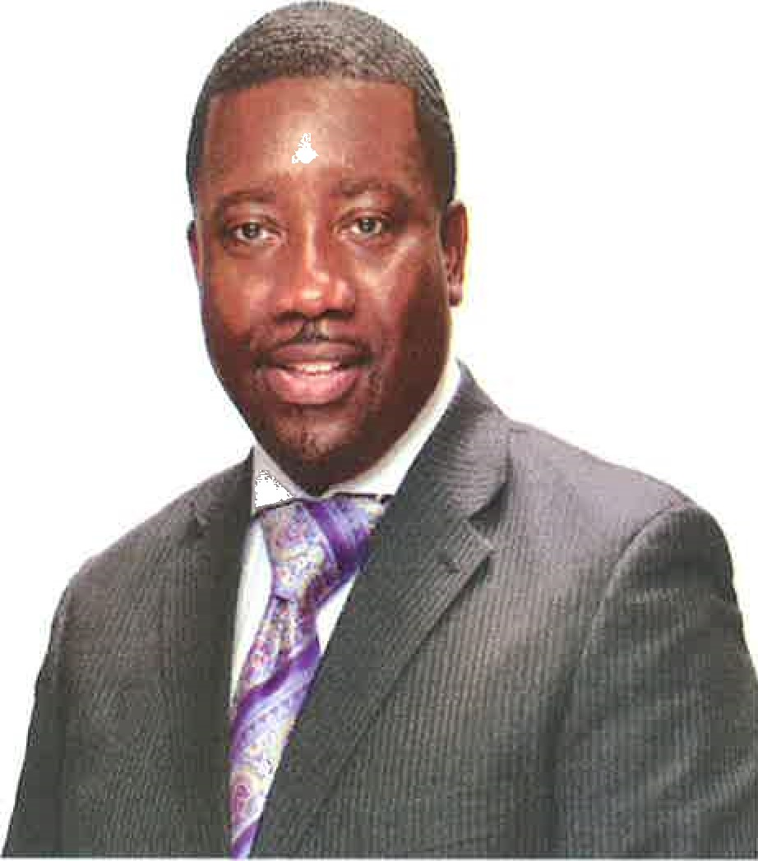
Anton A. Bell is a career prosecutor who has devoted his legal career to public safety throughout the Hampton Roads area. As a native and lifelong resident of Hampton Roads, Bell was reared by a single mother in the urban settings of Norfolk. Overcoming many challenges, Bell went on to graduate from Norfolk Catholic High School (now Bishop Sullivan Catholic High School). Following high school, Bell attended Norfolk State University and North Carolina Central University School of Law, where he graduated with Honors.
Once admitted to the Virginia State Bar, Bell soon began his public service as a prosecutor, starting in the City of Portsmouth. This service would later extend to the City of Hampton, where Bell has served in various positions in the Commonwealth's Attorney's Office for more than a decade.
Bell began his service in Hampton in 2000, specializing in the prosecution of child molestation cases. Bell soon broadened his sphere of prosecutions to all violent crimes, in particular — murders. During this time, Bell was cross designated as a Special Assistant United States Attorney for the Eastern District of Virginia. As a Special Assistant, Bell was assigned to the Peninsula Drug Task Force, where he tenaciously combated drug trafficking in both federal and state courts.
In 2012, Anton Bell was elected as Commonwealth's Attorney for the City of Hampton. During his short tenure, Bell has aggressively embraced the role as the Chief Law Enforcement Officer through both tough prosecution and prevention mechanisms. Armed with such tools as the Multijurisdictional Grand Jury, Bell created a new seven (7) attorneys Gang/Drug Prosecutorial Team within the Commonwealth's Attorney's Office to combat the recent spike in violent crimes. Moreover, Bell secured a new prosecutor under a grant through the Department of Criminal Justice Services (DCJS) to combat violent crimes committed primarily against women.
In his preventative role, Bell has served as a mentor to youths throughout
Hampton Roads, speaking to "at risk" youth in Hampton Public Schools (all high school and most middle schools), churches and civic organizations. Through such initiatives as the Anti-Gang and Anti-Bullying collaborations, Bell has encouraged youth citywide to end gun violence and eliminate bullying in our schools. Above all, Bell has stressed to our youth the need to make positive choices in their lives, inspiring them to dream big and remain focused on their goals.
Anton Bell is married to the former Dr. Dawn Yvette Bishop. They have one son, Anton Bell, Jr. Bell is also an ordained and licensed minister at Calvary Revival Church, where he and his wife are active in youth ministries.

Stephanie Edwards, Coordinator, Peninsula Elder Abuse Forensic Center/York-Poquoson Social Services
Stephanie Edwards, BSW, MSG serves as Coordinator of the Peninsula Elder Abuse Forensic Center. She is also employed as an Adult Protective Services worker at York-Poquoson Social Services. Stephanie has 20 years’ experience in the elder abuse field with 17 years in APS at various local departments of social services. Stephanie was employed as an elder abuse investigator for 3 years at the Virginia Attorney General's Office. Stephanie holds a Bachelor's degree in Social Work from Christopher Newport University and a Master's degree in Gerontology from Virginia Commonwealth University.

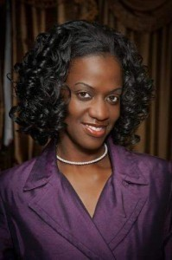
Arlene Vassell, Vice President of Programs, Prevention and Social Change, National Resource Center on Domestic Violence
Arlene Vassell supervises NRCDV’s Programs & Prevention and Communications Teams and oversees several key initiatives, including the Domestic Violence Awareness Project and PreventIPV. Joining NRCDV in 2015, Arlene brings over 20 years of multi-faceted experience within the movement to end domestic and other forms of gender-based violence. From 2011 to 2015, Arlene served as the Vice-Chair of NRCDV’s Board of Directors prior to joining the staff. She previously worked for the Florida Coalition Against Domestic Violence, Virginia Sexual and Domestic Violence Action Alliance and the YWCA Women’s Advocacy Program in Chesterfield, Virginia. Her areas of expertise include leadership development, community organizing, developing community and state-level collaborations, children and youth exposed to domestic violence, and creating promising practices when working with traditionally underserved and marginalized populations. In 2016, Arlene was selected as part of the United States Delegation that traveled to China for an exchange of domestic violence information with the All China Women’s Federation. She has received many awards and recognitions for her advocacy work.

Kermit A. Crawford, Ph.D, Associate Professor, Chair of Psychology, Hampton University, Emeritus Associate Professor of Psychiatry, Boston University School of Medicine
Dr. Kermit A. Crawford, currently Associate Professor and Chair of the Department of Psychology at Hampton University, and Associate Professor Emeritus from the Boston University School of Medicine, is a licensed Psychologist, designated Forensic Psychologist, teach and researcher. Dr. Crawford is the former Director of the Center for Multicultural Mental Health (CMMH) at Boston University School of Medicine and Boston Medical Center and former Executive Director of the Massachusetts Marathon Bombing Victims/Survivors Resiliency Center. He has done extensive work in multicultural behavioral health disaster response, trauma, addictions and culturally-informed practices across the nation. He is a member of the American Psychological Association’s (APA) Presidential Initiative on Citizen Psychologist Working Group, The National Center for Injury Prevention and Control’s Board of Scientific Counselors for the Centers for Disease Control and Prevention (CDC), and the Disaster Behavioral Health Response Cadre of the Substance Abuse and Mental Health Services Administration (SAMHSA). He is a former member of the Committee on Developing Evidence-Based Standards for Psychosocial Interventions for Mental Disorders (Institute of Medicine) and the APA Clinical Guidelines Steering Committee. In addition to his earned doctorate from Boston College, he is recipient of an honorary doctorate from William James College. Dr. Crawford is the recipient of the w0qw Excellence in Diversity Training Award from the Association of Post-doctoral and Psychology Internship Centers (APPIC), the Dr. James Jones Lifetime Achievement Award (2102-APA Minority Fellowship Program) and a number of other national, state and local awards and recognitions. He is a former psychologist with the National Football League assigned to the New England Patriots.

Joshua Safran, Author, Attorney, Advocate, Rudder Law Group, Author, “Free Spirit: Growing Up On the Road and Off the Grid”, and subject of film, “Crime After Crime”

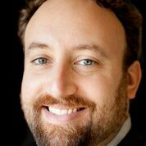

Joshua Safran is an attorney whose life was transformed through advocacy on behalf of an incarcerated survivor of domestic violence. Fresh out of UC Berkeley Law and in his first year as a corporate attorney at a top twenty law firm, Joshua Safran began work on a pro bono case to free Deborah Peagler, an imprisoned woman survivor of domestic violence who had been wrongfully convicted of killing her batterer. Peagler’s case became a grueling and highly-publicized seven-year legal odyssey to change California law for battered women, an endeavor which was captured in the award-winning film Crime After Crime which premiered at the Sundance Film Festival and debuted on the Oprah Winfrey Network.
Joshua Safran is also a childhood survivor. While working with Deborah to gather vital evidence for her case, he was unexpectedly forced to confront his own long-suppressed memories of his childhood journey through domestic violence. Safran’s interactions with his client while in prison instilled in him an urgency to share his own story and pen his critically acclaimed memoir, Free Spirit: Growing Up On the Road and Off the Grid, chronicling his unconventional 1980’s childhood of neglect and abuse in the wilds of rural northern Washington State. Living with his mother on welfare and a violent alcoholic Marxist guerilla commander stepfather in a variety of substandard “shelters” without electricity or running water (ramshackle shacks, lean-tos, school buses, an ice cream truck, and even on a tree stump in the forest), Joshua grew up living by his wits and a will to survive.
A master storyteller and nationally-known inspirational speaker, Safran will take you on a journey through a childhood unlike any other, dispel certain mythologies surrounding domestic violence, highlight problems with our current legal system in domestic violence cases, and show how healing can arise in surprising ways through advocacy work.

Louise Stanger EdD, LCSW, CDWF, CIP , Founder, All About Interventions
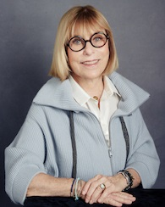
Dr. Louise Stanger is a preeminent interventionist and thought leader in the behavioral health and addiction treatments industry. She has performed thousands of family interventions in the US and abroad, gives presentations around the country on various topics related to mental health and addiction, process disorders and chronic pain, and has received prestigious awards from her fellow industry colleagues for her dedication to intervention and recovery. In addition to her work with clients and families, she is former University faculty at San Diego State University and University of San Diego, where she brought in over 4 million in grants for substance abuse and alcohol training and education.

