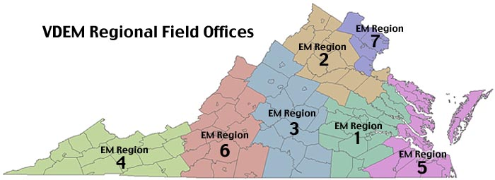

Region 1 – Richmond | Region 2 – Culpeper
Amelia County | Caroline County
Brunswick County | Clarke County
Charles City County | Culpeper County
Chesterfield County | Fauquier County
City of Colonial Heights | Frederick County
Dinwiddie County | City of Fredericksburg
City of Emporia | Greene County
Essex County | King George County
Goochland County | Louisa County
Greensville County | ﻿Madison County﻿
Hanover County | ﻿Orange County﻿
Henrico County | ﻿Page County﻿
City of Hopewell | ﻿Rappahannock County﻿
King & Queen County | ﻿Shenandoah County﻿
King William County | ﻿Spotsylvania County﻿
New Kent County | ﻿Warren County﻿
Nottoway County | ﻿City of Winchester﻿
City of Petersburg
Powhatan County
Prince George County
City of Richmond
Sussex County
Region 3 – Central Virginia | Region 4 – Southwest
Albemarle County | Bland County
Amherst County | City of Bristol
Appomattox County | Buchanan County
Augusta County | Carroll County
Buckingham County | Dickenson County
Campbell County | City of Galax
Charlotte County | Grayson County
City of Charlottesville | Lee County
Cumberland County | City of Norton
Town of Farmville | Pulaski County
Fluvanna County | City of Radford
Halifax County | Russell County
City of Harrisonburg | Scott County
Lunenburg County | Smyth County
City of Lynchburg | Tazwell County
Mecklenburg County | Washington County
Nelson County | Wise County
Prince Edward County | Wythe County
Rockingham County
Town of South Boston
City of Staunton
City of Waynesboro
Region 5 – Tidewater | Region 6 – Roanoke Area
Accomack County | Alleghany County
City of Chesapeake | Bath County
Town of Chincoteague | City of Bedford
City of Franklin | Bedford County
Gloucester County | Botetourt County
City of Hampton | City of Buena Vista
Isle of Wight County | Town of Christiansburg
James City County | Town of Clifton Forge
Lancaster County | City of Covington
Mathews County | Craig County
Middlesex County | City of Danville
City of Newport News | Floyd County
City of Norfolk | Franklin County
Northampton County | Henry County
Northumberland County | Highland County
City of Poquoson | City of Lexington
City of Portsmouth | City of Martinsville
Richmond County | Montgomery County
Southampton County | Patrick County
City of Suffolk | Pittsylvania County
Surry County | City of Roanoke
City of Virginia Beach | Roanoke County
Westmoreland County | Rockbridge County
City of Williamsburg | City of Salem
York County | Town of Vinton
Region 7 – Northern Virginia
City of Alexandria
Arlington County
City of Fairfax
Fairfax County
City of Falls Church
Loudoun County
City of Manassas
City of Manassas Park
Prince William County
Stafford County

