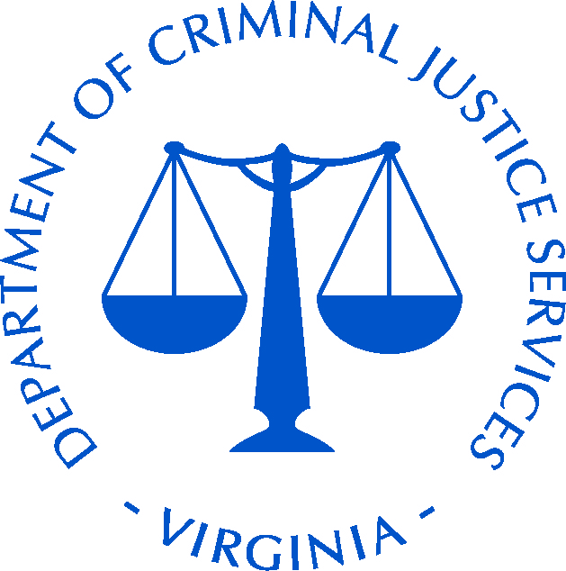
Virginia Department of Criminal Justice Services

2017 Strengthening Connections Climate Forum

November 27-28, 2017

DoubleTree by Hilton Hotel Richmond - Midlothian

REGISTRATION SCHOLARSHIP APPLICATION
Thank you for your interest in attending the Strengthening Connections Climate Forum. Please fill out the following form for consideration of a registration scholarship. If applying for a scholarship, please do not register yourself for the forum. DCJS will register you and waive the registration fee if the application is approved, and will notify you in the event it is not approved.

SECTION A: Applicant Information
This section will provide additional information about you, the applicant.
1. Name of Applicant:
2. Applicant’s Position:
3. Applicant’s Organization:
4. Address:
City: |  |  |  |  |  |  |  |  |  | State: |  |  | Zip Code:
5. Phone:
Email:
6. Type of Organization:
 | School or Campus Law Enforcement |  |  |  |  |  |  |  | School or Campus/School Security Department
 | Municipal Law Enforcement |  |  |  |  |  |  |  | School Division or College/University Administrator
 | Mental Health Professional |  |  |  |  |  |  |  | School or Campus Administrator
 | Other (Please Insert Type):
Please list any special dietary or ADA requirements: _____________________________________________________________________

SECTION B: Supervisor/Agency Head Attestation
This section ensures that your supervisor or organization head supports your attendance at the training event.
I agree to support the attendance of my employee to attend this training. I acknowledge that should a scholarship be awarded, the employee will be permitted to attend.

_________________________________________ ________________________________
Signature of Supervisor Date
_______________________________________________________________________________
Printed Name of Supervisor
_______________________________________________________________________________
Title of Supervisor
_______________________________________________________________________________
Name of Agency or Organization
_______________________ ___________________________________________________
Phone Number Email Address

Please return the completed form by November 11, 2017 to Kristina Fawcett:

Email: kristina.fawcett@dcjs.virginia.gov • Phone: (804) 225-3948 • Fax: (804) 786-0410

