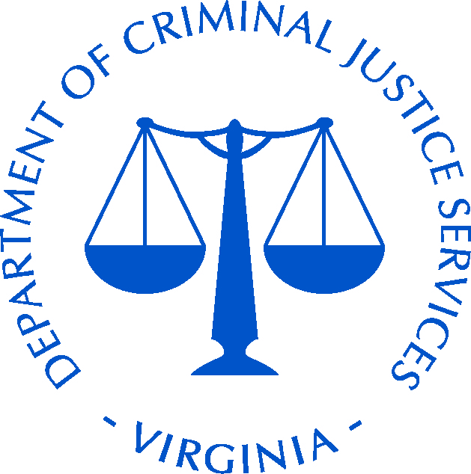
Virginia Department of Criminal Justice Services
CERTIFICATION OF COMPLIANCE WITH REGULATIONS
OFFICE FOR CIVIL RIGHTS, DEPARTMENT OF JUSTICE
INSTRUCTIONS: Please read this form completely, identify the person responsible for reporting civil rights findings, certify that the required Civil Rights training has been completed by the Project Director, and check only one certification under “II” that applies to your agency. Your Project Administrator must sign at the bottom of page 2, forward a copy to the person identified as being responsible for reporting civil rights findings, and return the original to grantsmgmt@dcjs.virginia.gov within 45 days of the grant award beginning date.

GRANTEE NAME & ADDRESS: |  |  |  |  | GRANT NUMBER:
Name: |  |  |  |  | PROJECT TITLE:
Street:
City/State/Zip Code:
AWARD ($): |  |  |  |  | PROJECT DURATION:
 |  |  |  |  | FROM: |  |  |  |  | TO:
PROJECT DIRECTOR: |  |  |  |  | PHONE:
PERSON RESPONSIBLE FOR REPORTING CIVIL RIGHTS FINDINGS OF DISCRIMINATION:
Name:
Street:
City/State/Zip Code:
Email:

I acknowledge that I viewed the training on Civil Rights available on the DCJS website (Victims Services page) or at https://ojp.gov/about/ocr/ocr-training-videos/video-ocr-training.htm. I accept responsibility for ensuring that project staff understands their responsibilities as outlined in the presentations. I understand that if I have any questions about the material presented and my responsibilities as a grantee that I will contact my grant monitor.
PROJECT DIRECTOR SIGNATURE |  | DATE
SIGNATURE AUTHORITY’S CERTIFICATION: As the Project Administrator for the above Grantee, I certify, by my signature on page two (2), that I have read and am fully cognizant of our duties and responsibilities under this Certification.
- REQUIREMENTS OF GRANT RECIPIENTS: All grant recipients (regardless of the type of entity or the amount awarded) are subject to prohibitions against discrimination in any program or activity, and must take reasonable steps to provide meaningful access for persons with limited English proficiency.
- I certify that this agency will maintain data (and submit when required) to ensure that: our services are delivered in an equitable manner to all segments of the service population; our employment practices comply with Equal Opportunity Requirements, 28 CFR 42.207 and 42.301 et seq.; our projects and activities provide meaningful access for people with limited English proficiency as required by Title VI of the Civil Rights Act, (See also, 2000 Executive Order #13166).
- I also certify that the person in this agency or unit of government who is responsible for reporting civil rights findings of discrimination will submit these findings, if any, to the DCJS within 45 days of the finding, and/or if the finding occurred prior to the grant award beginning date, within 45 days of the grant award beginning date.

CERTIFICATION OF COMPLIANCE WITH REGULATIONS
OFFICE FOR CIVIL RIGHTS, DEPARTMENT OF JUSTICE (Continued)

- EQUAL EMPLOYMENT OPPORTUNITY PLAN (EEOP) CERTIFICATIONS: Check the box before ONLY ONE APPROPRIATE CERTIFICATION (A, B, or C below) that applies to this grantee agency during the period of the grant duration noted on page one (1).
CERTIFICATION “A” [Applicable, if (1), (2) or (3) apply.] This is the Certification that most non-profits and small agencies will use. Check all that apply to your entity.
This funded entity:
(1) is an educational, medical or non-profit organization or an Indian Tribe;
(2) has less than 50 employees;
(3) was awarded through this single grant award from the Virginia Department of Criminal Justice Services less than $25,000 in federal U.S. Department of Justice funds.
Therefore, I hereby certify that this funded entity is not required to maintain an EEOP, pursuant to
28 CFR §42.302, but is required to submit a Certification (https://ojp.gov/about/ocr/eeop.htm).
CERTIFICATION “B” (Applicable to all entities that do not qualify for Certification “A” above)
This funded entity, as a for-profit entity or a state or local government having 50 or more employees (counting both full- and part-time employees but excluding political appointees) and is receiving, through this single grant award from the Virginia Department of Criminal Justice Services, more than $25,000, in federal U.S. Department of Justice funds.
Therefore, I hereby certify that the funded entity will prepare and submit an EEOP and Certification at https://ojp.gov/about/ocr/eeop.htm, within 60 days of the award. The EEOP shall be submitted in accordance with 28 CFR §42, subpart E, to Office for Civil Rights, Office of Justice Programs, U.S. Department of Justice that will include a section specifically analyzing the grantee (implementing) agency. (If you have already submitted an EEOP applicable to this time period, send a copy of the letter received from the Office for Civil Rights showing that your EEOP is acceptable.)

As the Project Administrator for the above grantee, I certify, by my signature below, that I have read and am fully cognizant of our duties and responsibilities under this Certification. I, hereby, also certify that the content of this form, other than the data entry required, has not been altered.
PROJECT ADMINISTRATOR SIGNATURE |  | DATE
TYPED NAME |  | TITLE
This signed form must be returned to grantsmgmt@dcjs.virginia.gov at the Virginia Department of Criminal Justice Services, 1100 Bank Street, Richmond, VA 23219, within 45 days of the grant award beginning date. You must also forward a signed copy to the person identified in the box above.

