2022 Virginia School Survey of Climate & Working Conditions

Survey Administration Instructions

Safety

Engagement and Relationships

Teaching and Learning Environment

School Supports

Version 2
Updated parental notification procedures per Code of Virginia §22.1-79.3., parents must be notified 30 days prior to the administration of this survey and provided the opportunity to exempt their students from participation.

2022 Virginia School Survey of Climate and Working Conditions
Table of Contents
Overview of the Survey 3
Instructions for the Student Administration 6
Template for the Parent/Guardian Information Letter 7
Student Survey Administration Manual 8
Instructions for the Classroom Instructors and Staff Administration 12
Template for the Classroom Instructors and Staff Information Letter 13
Frequently Asked Questions 14

Overview of the Survey
The Virginia School Survey of Climate and Working Conditions is being conducted through a partnership between the Virginia Center for School and Campus Safety at the Virginia Department of Criminal Justice Services and the Virginia Department of Education. Participating in this survey fulfills one component of your school’s safety audit requirements. This survey assesses school safety conditions and student safety concerns, and also meets the requirements to measure the working conditions of all licensed personnel in schools.
This instruction packet provides more detail on the three-step process for administering the 2022 Virgina School Survey and summarized in Figure 1.
Step 1
Provide information to classroom instructors, staff, parents, and guardians.
- Use the information letter templates provided here to notify classroom instructors, staff, parents, and guardians about the survey at least 30 days prior to the start of your administration window.
- Communicate the value of the survey and encourage classroom instructors, staff, and students to participate.
Step 2
Administer the online Virginia School Survey of Climate and Working Conditions to classroom instructors, staff, and students.
- Provide Administration Manuals to those administering the survey to students.
- Provide classroom instructors, staff, and students with the access codes for accessing the survey. Access codes will be emailed directly to the school point-of-contact.
- The goal is an 80% response rate. Send periodic reminders during the administration period encouraging your classroom instructors and staff to complete the survey.
Step 3
Look for emails with information on how to access the results from your school.
- A School Participation Snapshot will be available within 2 weeks of your survey administration window closing, if your school met the required response rate thresholds.
- A School Survey Summary Report will be available in May 2022.

Figure 1. Survey administration process for the 2021 Virginia School Survey

In 2022, students in grades 9-12 as well as licensed classroom instructors and any other individual holding a state professional license (such as those with a Collegiate Professional License, Postgraduate License, Provisional License, or Pupil Personnel Services License) in your school, regardless of grades served, must be invited to take the survey. You may invite other non-licensed staff members to complete the survey, if you so desire. All 9th through 12th grade students should be provided an opportunity to complete the survey, so that your school will have information about the school’s climate from as many students as possible. When reasonable accommodations are needed for students to take the survey, they should be provided. A read-aloud administration manual can be found on the DCJS and VDOE websites. Students have the option to take the survey in English or Spanish, so students identified as having Limited English Proficiency but who speak Spanish should not be excluded from taking the survey.
All surveys will be completed online through a secure website and can be completed while in the school building or at home with any internet-connected device (e.g., computer, cell phone, tablet, etc.). You will provide each student, classroom instructor, and staff member with a school-specific access code to begin the survey. The access codes will be emailed to the school point-of-contact one week prior to your window opening as well as on the day your window opens. The access codes do not identify individuals but will identify the school. We expect the student survey for grades 9 through 12 will require 25-30 minutes to complete and the classroom instructors and staff surveys will require 20-25 minutes to complete.
Parents or guardians may decline permission for their student to complete the survey. Provide all parents and guardians of students in grades 9 through 12 with the information contained in the letter template found on page 7, informing them that their child will be asked to participate in the survey. A Spanish version of the template can be found on the DCJS and VDOE websites. Due to the inclusion of student mental health-related questions, schools are required, at a minimum, to notify parents or guardians of this survey and provide a process for opting their students out of the survey at least 30 days in advance to the administration. This notification is required by the Code of Virginia §22.1-79.3. Please also include your school or division’s standard opt out procedure in the information letter, so that parents have the opportunity to exempt their child from participating in the survey. Students may decline to take the survey.
Students should take the survey in a quiet space. It is important for a classroom instructor or staff member to monitor students while they are taking the survey to ensure students do not confer with one another and to answer any questions that may arise. The adult administering the survey to students should review the Student Survey Administration Manual found on page 8 about the survey process prior to providing students the link and access code for the survey.
Classroom instructors and staff may decline to take the survey. Provide classroom instructors and staff members the information found in the letter template, inviting them to participate in the survey. The template for the Classroom Instructors and Staff Information Letter is provided on page 13 of this instruction packet. When your survey window opens, provide classroom instructors and staff the survey link and your school’s access code. Classroom instructors and staff members can take the survey in small group setting or individually but should be advised not to confer with one another. Send reminders to your classroom instructors and staff members about the survey throughout the survey window to encourage participation.
The higher your school’s response rate, the more likely the results of the survey will reflect the opinions of all students, classroom instructors, and staff in your school. An 80% response rate is the goal for each group participating. School Participation Snapshots and School Survey Summary Reports will not be generated for survey groups with response rates less than 50% and fewer than 10 respondents. Your division and school point-of-contact will have access to real-time response rates for your school.
Each school will receive a School Participation Snapshot and a School Survey Summary Report, if their response rates meet the indicated threshold. The School Participation Snapshot provides item-level responses aggregated across all individuals (e.g., the percent selecting “Strongly Disagree”, the percent selecting “Disagree”, etc.). These will be available within two weeks of the division’s survey administration window closing, provided the school achieved a response rate of at least 50% per survey group and the number of responses is 10 or greater. In May, each school meeting that same response rate threshold per survey group will receive a School Survey Summary Report that presents the school’s scores on the surveys’ measures of climate and working conditions. The Report will facilitate comparisons to other schools in the division, region, and state. Your division point-of-contact will need to download these reports and share them with you.

Instructions for the Student Administration

- Provide information to the parents and guardians of each student in grades 9-12 informing them that students in their child’s grade are participating in the survey. We recommend you use the Template for the Parent/Guardian Information Letter provided on page 7 (Spanish version can be found on the DCJS and VDOE websites. Please ensure that parents or guardians have been notified and provided instructions for opting their students out of the survey at least 30 days in advance of your planned administration timeframe. Provide reasonable accommodations as needed for students to take the survey.

- Aim for a successful completion of the Virginia School Survey with at least 80% of students completing the survey. All students should be given equal opportunity to participate in the survey. Students should not be excluded on any systematic basis, such as excluding those students with low grades.

- Provide the Student Administration Manual provided on page 8 of this document to all individuals administering the survey to students. A read-aloud administration manual can be found on the DCJS and VDOE websites.

- Provide the link and your school’s access code to all 9th through 12th grade students once your window has opened.

- Questions or concerns regarding the Virginia School Survey of Climate and Working Conditions should be directed to Dr. Nikki Wilcox at nikki.wilcox@dcjs.virginia.gov or (804) 786-3923. You may also contact Dr. Jess Marcon Zabecki at jessica.marconzabecki@doe.virginia.gov or (804) 225-2963.

Template for the Parent/Guardian Information Letter
Principals: Provide the information below to the parents and guardians of all students at your school in grades 9 through 12, at least 30 days prior to the survey administration. When you prepare these letters, be sure to specify the date by which parents and guardians must decline to have their child participate, if they choose to opt their child out of the survey.

Dear Parent or Guardian,
This spring our school, in cooperation with the Virginia Department of Criminal Justice Services and the Virginia Department of Education, is conducting the Virginia School Survey of Climate and Working Conditions of students, classroom instructors, and staff. The purpose of this survey is to measure student support, student engagement, school discipline, and safety conditions in each school. This information will be used to guide educational practices that produce a safe and supportive school environment.
I am writing to provide you with information on the student survey. The survey will be completed online between DATE and DATE. The survey does not ask for your child’s name and all answers are anonymous (no one will know how your child answered the survey). Parents and guardians will not have access to their child’s survey answers. You may review the student survey at this website: https://tinyurl.com/VaSchoolSurvey.
The survey will ask questions such as how students feel about their school, how students get along with one another and their teachers, how students feel about school rules, and their perceptions of their teachers’ willingness to help them. Students will also be asked what kinds of bullying they may have observed during school and whether they have been bullied themselves.
All students in your child’s grade level will be eligible to participate in the survey. Students participating in remote instruction and in-person instruction are both eligible to participate. The survey is voluntary and your child can decide not to participate. No action will be taken against you, your child, or the school if your child does not participate. If you do not wish for your child to participate, please notify the school office by telephone or letter by DATE.
Your child will not receive any immediate benefit from participating in the survey, but the survey will help us to maintain a safe, inviting, and supportive learning environment for your child.
Thank you for your cooperation in this important study of Virginia’s schools.
{Signed by principal}

Student Survey Administration Manual
Principals/Points-of-contact: Provide this manual to all individuals administering the survey to students. A read-aloud administration manual can be found on the DCJS and VDOE websites.

Thank you for assisting in the administration of the Virginia School Survey of Climate and Working Conditions to your students. It is intended to give schools information that can help maintain a safe, inviting, and supportive learning environment.
The administration of the survey is important to engaging students and obtaining valid results. Please communicate to students that this survey is an effort to include their views and opinions to improve their school.
What is the procedure for students to complete the survey? The survey should be administered in a quiet space where students can be monitored – remotely or in person.
In-person: The survey should be administered in a quiet space where students can be monitored and have access to an individual computer or device. The staff member administering the survey should encourage students to complete the survey to the best of their ability and inform students that they should not discuss or talk with one another while taking the survey. The staff member should inform the students the survey takes 25-30 minutes to complete.
Remotely: Students taking the survey remotely are encouraged to find a quiet space where they can complete the survey free from distractions and have access to an individual computer or device. The staff member administering the survey should encourage students to complete the survey to the best of their ability and inform students that they should not discuss or talk with one another while taking the survey. The staff member should inform the students the survey takes 25-30 minutes to complete.
How do I administer the survey with a read-aloud accommodation? A read-aloud administration manual can be DCJS and VDOE websites.
How do I prepare for and administer the survey? We recommend that you prepare the information that students need ahead of time, including the survey link, the school’s access code, and the school and division information.
Your school’s survey link and access code will be emailed to the school point-of-contact one week prior to the survey window opening. Students must enter this access code to complete the survey. All students in your school will use the same access code. Students will be asked to confirm the name of their school and division, to verify their responses are collected correctly.
Be sure to review the following instructions with all students. These instructions also appear on the welcome page of the survey. Below the text in bold and italics is the narrative you should read aloud as students begin the survey.

SAY: “This survey is being given to Virginia public school students in grades 9-12. The survey asks how you feel about your school and how students get along with one another and their teachers. We want to know your opinion in order to learn ways to improve your school.
Your individual answers to the survey are anonymous, which means that no one will know how you answered them. Student answers will be summarized in a report to the school that does not include anyone's name.
There are several screens of questions and it should take about 25-30 minutes to complete the survey.
Use the Next and Previous buttons at the bottom of the screen to go to the next or previous page.
Be careful! Do not use the back button of your browser to go back to the previous page. If you use the browser button, your results may be lost and you will need to start the survey again.
Please proceed to the link provided.”
Students should see the following screen.
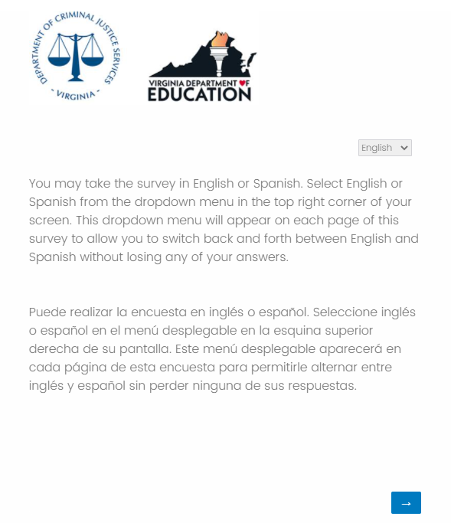
SAY: “You may take the survey in English or Spanish. Select English or Spanish from the dropdown menu in the top right corner of your screen. This dropdown menu will appear on each page of this survey to allow you to switch back and forth between English and Spanish without losing any of your answers. (Pause) Now select the blue arrow in the bottom right corner. Take a moment to read the information on the screen. Once you finished reading please select the blue arrow in the bottom right corner to move forward.” Students should see the following screen.
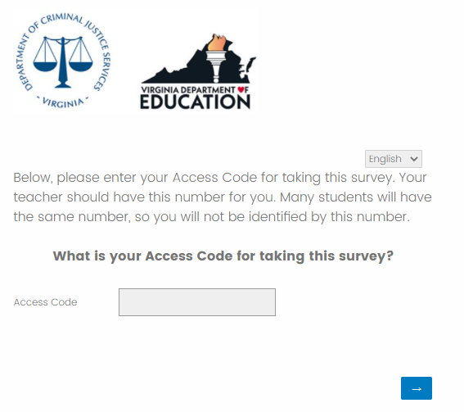
SAY: “The access code is _ _ _ _ _S then select the blue forward arrow.”
Please write the access code given to you somewhere the students can easily see it. Students should see the following screen.

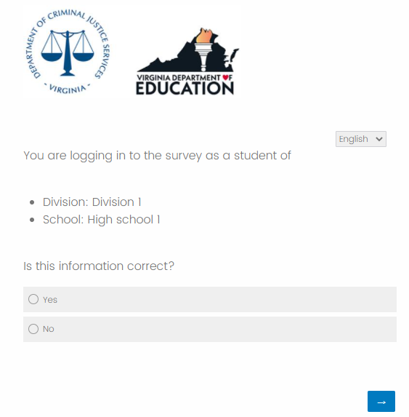
SAY: “You should see our division and school name. If the division and school name are not correct please raise your hand.” (pause) “If this information is correct please select ‘Yes’ and then the forward arrow and begin the survey. Remember to answer each question to the best of your ability.”
If the division and/or school name are not correct have the student select ‘No,’ and assist them with selecting the correct information.

What kind of help can I give to students in taking the survey? You are free to help students who do not understand survey instructions or who need clarification of a term or phrase used in the survey. Encourage students to express their own views and to answer all of the questions. If students attempt to skip a question, the survey will not permit them to continue to the next page. They will remain on the same page until they have answered each question, students should be instructed to answer to their best ability.
Is the survey the same for all students? Almost all of the questions are the same for all students in the same grade. In a few cases, a student who answers one question in a certain way will be asked a follow-up question that will not be asked if a student gives a different answer.
What if students ask about the race and ethnicity questions? Following standard practice, there is a question asking students whether they are of Hispanic or Latino ethnic background (Hispanic and Latino are intended to be interchangeable terms). Some students are unfamiliar with this distinction, and may be concerned that there is a separate question about being Hispanic. It is appropriate to explain to students that these questions are following federal guidelines to recognize that people of different races can be Hispanic. Subsequently, they will be asked a question that allows them to report their race.
What if students ask about the gender question? The question that asks students to report their gender provides students with more flexibility in their response to this question. Encourage the students to select the option that best describes their gender.

Questions or concerns regarding the Virginia School Survey of Climate and Working Conditions should be directed to Dr. Nikki Wilcox at nikki.wilcox@dcjs.virginia.gov (804) 786-3923. You may also contact Jess Marcon Zabecki at jessica.marconzabecki@doe.virginia.gov or (804) 225-2963.

Instructions for the Classroom Instructors and Staff Administration

- You must invite all licensed classroom instructors to complete the survey as well as any other individuals holding a state professional license, such as those with a Collegiate Professional License, Postgraduate Professional License, Provisional License, or Pupil Personnel Services License. You may invite other non-licensed staff members to complete the survey, if you so desire. Use the Template for the Classroom Instructors and Staff Information Letter on page 13 to inform staff of the upcoming survey, at least two weeks prior to your administration window.

- During your school’s survey administration window, send regular reminders to your classroom instructors and staff members asking them to please consider completing the survey if they have not done so already. Be sure to include in these reminders the survey link and the access code they need to complete the survey. We recommend dedicating time for classroom instructors and staff members to take the survey, such as the beginning of a staff meeting, but please consider your building’s bandwidth capabilities.

- Questions or concerns regarding the Virginia School Survey of Climate and Working Conditions should be directed to Dr. Nikki Wilcox at nikki.wilcox@dcjs.virginia.gov (804) 786-3923. You may also contact Dr. Jess Marcon Zabecki at jessica.marconzabecki@doe.virginia.gov or (804) 225-2963.

Template for the Classroom Instructors and Staff Information Letter
Principals: Please provide the following information to all licensed classroom instructors as well as any other individuals holding a state professional license, such as those with a Collegiate Professional License, Postgraduate Professional License, or Pupil Personnel Services License. You may send it to other non-licensed staff members, if you wish for them to complete the survey. Be sure to specify the survey window dates. Please remind your classroom instructors and staff members periodically about the survey to encourage a high response rate.

Dear ,
This spring our school, in cooperation with the Virginia Department of Criminal Justice Services and Virginia Department of Education, is conducting the Virginia School Survey of Climate and Working Conditions of students, classroom instructors, and staff. The purpose of the survey is to measure school-level working conditions which have shown to impact classroom instructor and staff retention as well as student educational outcomes.
All classroom instructors and staff members are asked to participate in the Virginia School Survey. The survey can be completed on any internet-connected device (e.g., computer, cell phone, tablet, etc.) between DATE and DATE.
The survey asks questions about staff collegiality, work environment, teaching and instruction, student supports, professional development, relationships with parents/guardians, teacher autonomy, school leadership, and safety. Classroom instructors and staff members will not give their names on the survey and all answers are anonymous. While you will be asked to identify your role in the school, however data will not be reported by role within school or division results.
Participants will not receive any immediate benefit from completing the survey, but the survey will help us ensure all students, classroom instructors, and staff have access to a safe, healthy and positive environment in which to learn, work, interact, and grow. The survey is voluntary and you are free to decline. No action will be taken against you or the school if you do not participate.
Thank you for your cooperation in this important study of Virginia’s schools.

{Signed by principal}

Frequently Asked Questions
1. Who should complete the Virginia School Survey? In 2022, all students in grades 9-12 as well as licensed classroom instructors and any other individual holding a state professional license (such as those with a Collegiate Professional License, Postgraduate License, Provisional License, or Pupil Personnel Services License) in your school, regardless of grades served, must be invited to take the survey. You may invite other non-licensed staff members to complete the survey, if you so desire.
2. How will the survey be administered? All surveys will be completed online through a secure website. You will provide each student, classroom instructor, and staff member with a school-specific access code to begin the survey. The access codes will be emailed to the school point-of-contact one week prior to your window opening as well as on the day your window opens. The access codes do not identify individuals but will identify the school.
3. How long will the survey take? We expect the student survey for grades 9 through 12 will require 25-30 minutes to complete and the classroom instructors and staff surveys will require 20-25 minutes to complete.
4. How do I contact students and parents/guardians about the survey? Provide all parents and guardians of students in grades 9 through 12 with the information contained in the letter template found on page 7, informing them that their child will be asked to participate in the survey. Please ensure that parents or guardians have been notified and provided instructions for opting their students out of the survey at least 30 days in advance of your planned administration timeframe. A Spanish version of the template can be found on the DCJS and VDOE websites. Please include your school or division’s standard opt out procedure in the information letter.
5. How do I contact classroom instructors and staff members to invite their participation? Provide classroom instructors and staff members the information found in the letter template, inviting them to participate in the survey. The template for the Classroom Instructors and Staff Information Letter is provided on page 13 of this instruction packet.
6. How do students, staff and classroom instructors access the survey? You will provide each student, classroom instructor, and staff member with a school-specific access code to begin the survey. The access codes for your school will be provided via email to the school point-of-contact. Do not use the access code for a different school. The adult administering the survey to students should utilize the Student Survey Administration Manual found on page 8.
7. What if a student is absent on the day the survey is administered? Students who are absent can take the survey if they return to school before the survey window closes. Providing an additional opportunity for absent students to take the survey is encouraged so that your school’s survey results reflect the experiences of as many students as possible.
8. What can I do to encourage classroom instructors and staff members to respond to the survey? The greater the response rate among classroom instructors and staff members at your school, the more complete your results will be. Communicate the value of survey results to classroom instructors and staff. Also, dedicate time for classroom instructors and staff members to take the survey during the workday, such as at the beginning of a staff meeting. It is essential, throughout your school’s survey window, to regularly remind and encourage your classroom instructors and staff members to complete the survey so that you can achieve a high response rate.
9. What response rate should I achieve on the Student, Classroom Instructors, and Staff surveys? An 80% response rate is the goal for each group participating. School Participation Snapshots and School Survey Summary Reports will not be generated for survey groups with response rates less than 50% and fewer than 10 respondents. Your division and school point-of-contact will have access to real-time response rates for your school.
10. What results will I receive? Each school will receive a School Participation Snapshot and a School Survey Summary Report, if their response rates meet the indicated threshold. The School Participation Snapshot provides item-level responses aggregated across all individuals (e.g., the percent selecting “Strongly Disagree”, the percent selecting “Disagree”, etc.). School Survey Summary Report that presents the school’s scores on the surveys’ measures of climate and working conditions.
11. When will I receive results of the survey? Within two weeks of the division’s survey administration window closing each school will receive a School Participation Snapshot, provided the school achieved a response rate of at least 50% per survey group and the number of responses is 10 or greater. In May, each school meeting that same response rate threshold per survey group will receive a and a School Survey Summary Report, if their response rates meet the indicated threshold.
12. How will I receive the results of the survey? Your division point-of-contact will need to download these reports and share them with you.
13. What if I have other questions? Questions or concerns regarding the Virginia School Survey of Climate and Working Conditions should be directed to Dr. Nikki Wilcox at nikki.wilcox@dcjs.virginia.gov (804) 786-3923. You may also contact Dr. Jess Marcon Zabecki at jessica.marconzabecki@doe.virginia.gov or (804) 225-2963.

