SCHOOL-LAW ENFORCEMENT PARTNERSHIP: LEGAL ISSUES

Overview

SLEP Training Module II Goal

The goal of SLEP Module II is to acquaint SROs and school administrator participants with fundamental legal issues associated with school-law enforcement partnerships including clarifying the disciplinary and legal implications of student misconduct, use of discretion and supportive approaches to discipline, information sharing, questioning, searches, detention and arrest, use of physical intervention, and student victims’ rights.

Module II Learning Objectives

Upon completion of Module II, participants will be able to

- Compare and contrast the roles of school administrators and SROs in response to school-related criminal conduct.
- Compare and contrast the roles of school administrators and SROs in response to school-related non-criminal misconduct.
- Describe key elements of supportive responses to student misconduct involving use of discretion and balancing interests of the student with welfare of the school community.
- Identify opportunities and resources for diversion from juvenile justice involvement of students.
- Describe legal parameters and related practices for information sharing in SLEPs.
- Compare and contrast criteria for and questioning of students.
- Compare and contrast criteria for school searches by administrators and by law enforcement.
- Compare and contrast legal basis for detention by school officials and arrest by law enforcement.
- Compare and contrast legal basis for restraint by school officials and physical intervention by law enforcement.
- Identify key sources for learning more about issues and practices taught in Module II.

Module II. Overview with Crosswalk to SLEP Guide

Module II. Topics | Related SLEP Guide
A. Overview of Module II. Legal Issues in School-Law Enforcement Partnerships
B. Student Discipline Policies and Practices | Chapter III, Section A
C. Student Misconduct: Clarifying Disciplinary and Law Enforcement Responses | Chapter III, Section B
C. Use of Discretion | Chapter III, Section C
1. “Pipeline to Prison” Concerns | Chapter III, Section C
2. Supportive Practices | Chapter III, Section C
3. Diversion from Justice Involvement | Chapter III, Section C
4. Restorative Justice | Chapter III, Section D
D. Information Sharing | Chapter III, Section E
- FERPA | Chapter III, Section E
- HIPAA | Chapter III, Section E
E. Questioning | Chapter III, Section F
- Law Enforcement Questioning | Chapter III, Section F
- School Administrator Questioning | Chapter III, Section F
F. School Searches | Chapter III, Section G
- Balancing Competing Interests | Chapter III, Section G
- Reasonable Suspicion and Probable Cause | Chapter III, Section G
- Importance of School Policy | Chapter III, Section G
G. Detention and Arrest | Chapter III, Section H
- Physical Intervention | Chapter III, Section I
- By Administrator/Other School Personnel | Chapter III, Section I
- Law Enforcement Standards | Chapter III, Section I
- Corporal Punishment | Chapter III, Section I
J. Student Victims’ Rights | Chapter III, Section J
K. Review of Module II

Training Content

Module II. SLEP Legal Issues
Slides | Instructor Script
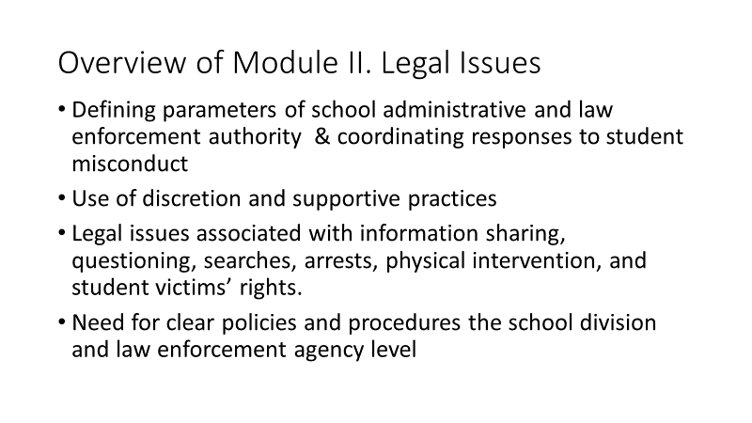 | A. Overview of Module II. Legal Issues in School-Law Enforcement Partnerships  Guide, beginning p. 35  Key Learning Points:  - This module focuses legal issues in SLEPs.  - We begin by examining disciplinary and law enforcement responses to student misconduct and defining proper parameters of school administrative and law enforcement authority.  - We’ll then discuss “pipeline to prison” concerns that have been expressed and supportive responses to misconduct that address these concerns.  - We then look at legal issues associated with information sharing, questioning, searches, arrests, physical intervention, and student victims’ rights.  - For each of these issues, having clear policies and procedures, established at the school division and law enforcement agency level is critical to the success of SLEPs.
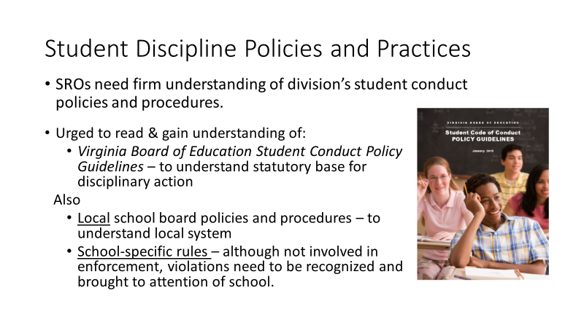 | Understanding Student Discipline Policies and Practices  Guide, p. 35  Key Learning Points:  - SROs need to have a firm understanding of their school division’s student conduct policies and procedures  - Strongly urged to read both the Virginia Board of Education Student Conduct Policy Guidelines (to understand statutory base for disciplinary actions) and the local school board student conduct policies (to understand division-wide policies and procedures).  - In addition, SROs should become familiar with school-specific rules. Although SROs should have no role in the enforcement of school rules, violations need to be recognized and brought to the attention of school personnel for appropriate administrative action.
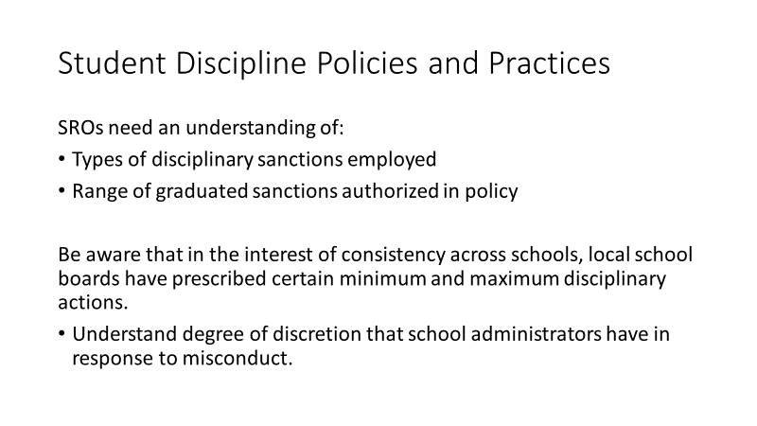 | Student Discipline Policies and Practices  Guide, p. 35  Key Learning Points:  - It is also important for SROs to acquire an understanding of the types of disciplinary sanctions that are employed and the range of sanctions authorized in policy.  - School boards have a legitimate interest in the consistency and fairness of policy implementation across schools in the same school division and, in an effort to have that consistency, some boards have prescribed minimum and maximum disciplinary actions for certain types of offenses.  - This affects the degree of discretion that school administrators have in responding to misconduct and SROs need to understand administrators’ parameters of authority.
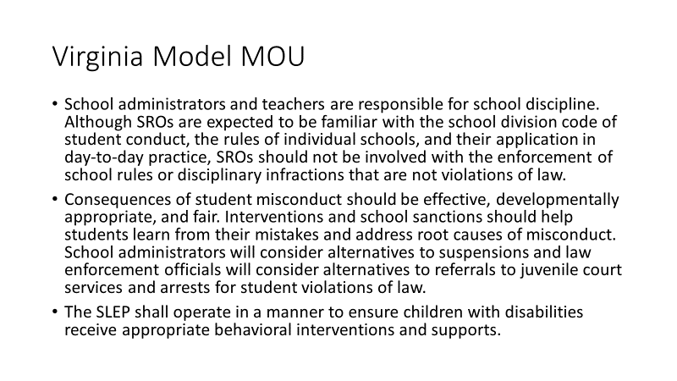 | Student Misconduct: Differentiating Disciplinary and Law Enforcement Responses  Guide, p. 36  Virginia’s Model MOU requires differentiation of misconduct requiring disciplinary responses and criminal offenses requiring a law enforcement response and includes the provisions you see here.  Quickly reviewing:  - School administrators and teachers are responsible for school discipline. Although SROs are expected to be familiar with the school division code of student conduct, the rules of individual schools, and their application in day-to-day practice, SROs should not be involved with the enforcement of school rules or disciplinary infractions that are not violations of law.  - Consequences of student misconduct should be effective, developmentally appropriate, and fair. Interventions and school sanctions should help students learn from their mistakes and address root causes of misconduct. School administrators will consider alternatives to suspensions and law enforcement officials will consider alternatives to referrals to juvenile court services and arrests for student violations of law.  - The SLEP shall operate in a manner to ensure children with disabilities receive appropriate behavioral interventions and supports.
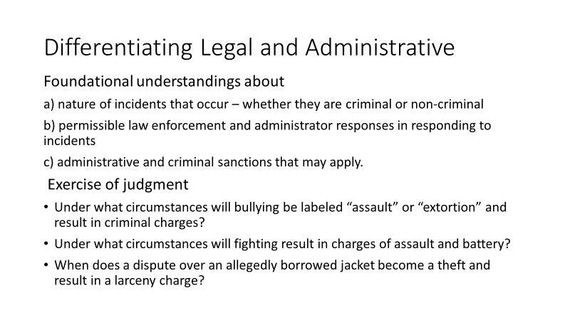 | Differentiating Legal and Administrative Responses  Guide, p. 36  Key Learning Points:  An effective SLEP is characterized by foundational understandings about:  a) nature of incidents that occur – whether they are criminal or non-criminal),  b) permissible law enforcement and administrator responses in responding to incidents, and  c) administrative and criminal sanctions that may apply.  In determining the nature of the incident, relevant questions include:  - Is it a conduct code violation? Does it conform by the DCV definitions?  - Is it also a violation of law? Does it meet criteria set forth in Code?  Discussing questions such as these will raise important issues involving exercise of judgement:  - Under what circumstances will bullying be labeled “assault” or “extortion” and result in criminal charges?  - Under what circumstances will fighting result in charges of assault and battery?  - When does a dispute over an allegedly borrowed jacket become a theft and result in a larceny charge?  SLEPs that achieve common understandings are most effective.
Instructor Note: Ask participants:

- Can anyone offer some examples of cases where there might have been different opinions about what offense a student’s misconduct should be labeled?
- How was the difference in opinion resolved?
- What that a good outcome or one you didn’t think went well?
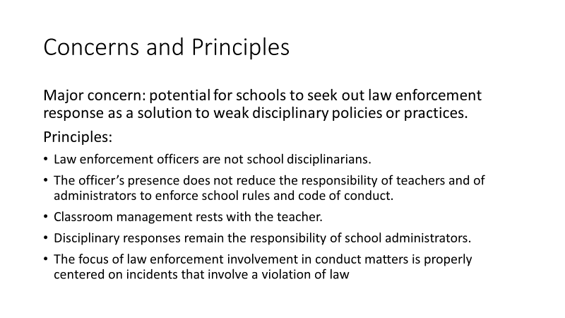 | Concerns and Principles  Guide, p. 37  Key Learning Points:  - A major concern in SLEPs is the potential for schools to seek out law enforcement response as a solution to weak disciplinary policies and practices.  - Experience with SLEPs has taught:  - Law enforcement officers are not school disciplinarians.  - The officer’s presence does not reduce the responsibility of teachers and of administrators to enforce school rules and the school division’s student code of conduct.  - Classroom management rests with the teacher.  - Disciplinary responses remain the responsibility of school administrators.  - The focus of law enforcement involvement in conduct matters is properly centered on incidents that involve a violation of law.
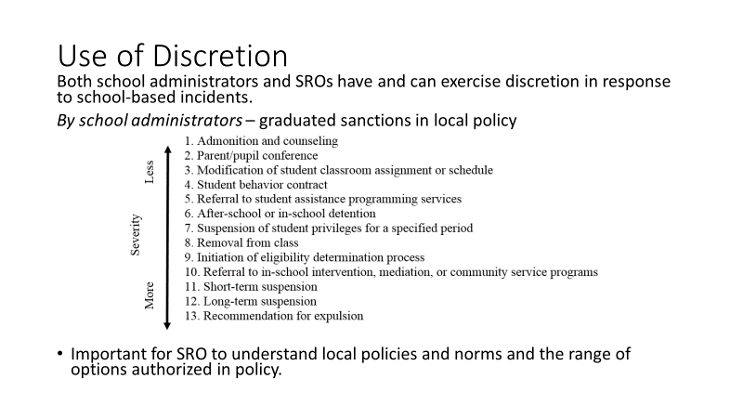 | Use of Discretion  Guide, p. 37  Key Learning Points:  - Both school administrators and SROs have and can exercise discretion and judgment in response to school-based incidents. Criminalizing misconduct that arises from youthful poor judgment should be avoided if at all possible.  - School administrators exercise discretion in accordance with local school board policy.  - The graphic you see is from the Virginia Board of Education Student Conduct Policy Guidelines citing a range of option from admonition to expulsion.  - Quickly reviewing,  Severity More Less 1. Admonition and counseling 2. Parent/pupil conference 3. Modification of student classroom assignment or schedule 4. Student behavior contract 5. Referral to student assistance programming services 6. After-school or in-school detention 7. Suspension of student privileges for a specified period 8. Removal from class 9. Initiation of eligibility determination process 10. Referral to in-school intervention, mediation, or community service programs 11. Short-term suspension 12. Long-term suspension 13. Recommendation for expulsion  - SROs must become familiar with local school division disciplinary policies, the range of disciplinary options authorized and available, and the enforcement norms at the assigned school.
Instructor Note: Ask participants:

- Many school division policies require that administrators recommend expulsion for weapons and drug offenses. Some prescribe at least some period of out of school suspension for fights. Can anyone offer an example from their local school division?
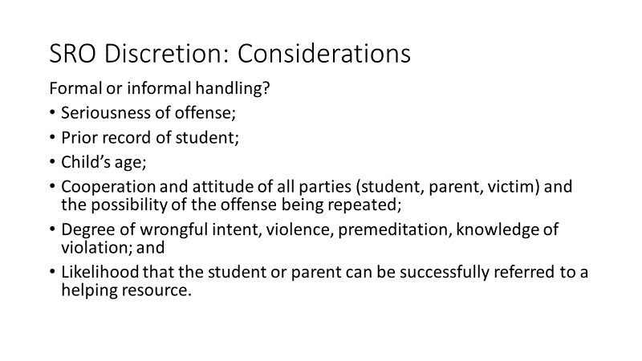 | SRO Discretion: Considerations  Guide, p. 38  Key Learning Points:  In deciding whether to handle an incident formally or informally, SROs and their law enforcement agency policies should consider:  - Seriousness of offense;  - Prior record of student;  - Child’s age;  - Cooperation and attitude of all parties (student, parent, victim) and the possibility of the offense being repeated;  - Degree of wrongful intent, violence, premeditation, knowledge of violation; and  - Likelihood that the student or parent can be successfully referred to a helping resource.
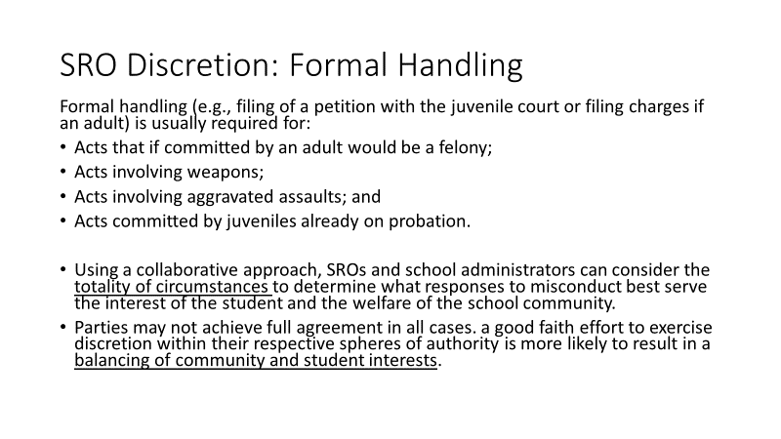 | SRO Discretion: Formal Handling  Guide, p. 38  Key Learning Points:  - Formal handling (e.g., filing of a petition with the juvenile court or filing charges if an adult) is usually required for:  - Acts that if committed by an adult would be a felony;  - Acts involving weapons;  - Acts involving aggravated assaults; and  - Acts committed by juveniles already on probation.  - Using a collaborative approach, SROs and school administrators can consider the totality of circumstances to determine what responses to misconduct best serve the interest of the student and the welfare of the school community.  - Although parties may not achieve full agreement in all cases. a good faith effort to exercise discretion within their respective spheres of authority is more likely to result in a balancing of community and student interests.
Instructor Note: Acknowledge that participants, as law enforcement officers, frequently exercise discretion. Ask:
- Based on your experience in exercising discretion, do these considerations seem reasonable and appropriate?
(Allow a few representative comments)

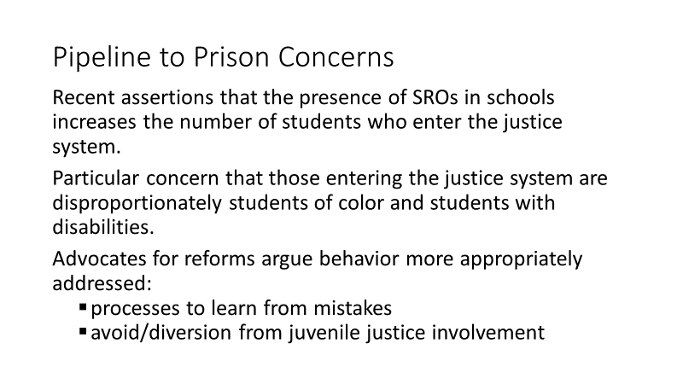 | Instructor Notes:  Acknowledge that concerns and supportive responses to student misconduct were discussed in Module I but we are briefly revisiting the concerns and supportive practices to address concerns to reinforce it as a key learning point.  Very quickly review the next 3 slides (“Pipeline to Prison” concerns, Virginia Studies, and Supportive Practices)  “Pipeline to Prison” Concerns  Guide, p. 38  Key Learning Points:  - Establishing clear understandings about responses to student misconduct has become even more critical in light of recent assertions that the presence of SROs in schools increases the number of students who enter the justice system, contributing to the “pipeline to prison.”  - There is concerns that those entering the justice system are disproportionately students of color and students with disabilities.  - Advocates for reforms argue that minor, adolescent behavior would be more appropriately addressed by education through disciplinary processes that allow students to learn from their mistakes and avoid unintended negative consequences of involvement with the justice system.  - Current school law enforcement reforms emphasize diversion from the justice system of students who commit minor criminal offenses and strengthening rehabilitative alternatives.
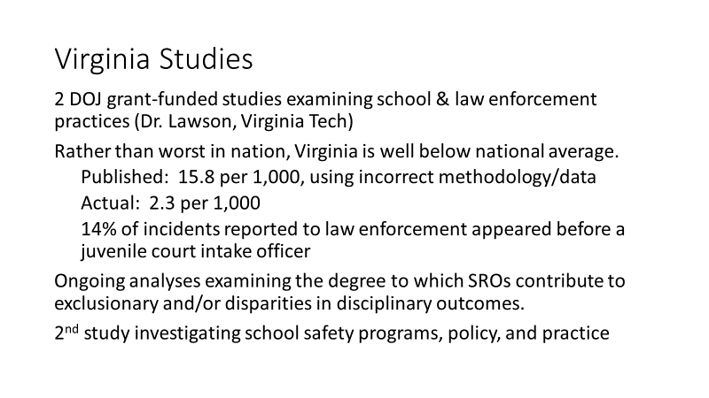 | Virginia Studies  Guide, p. 38  Key Learning Points:  - In Virginia, the “pipeline to prison” issue is being rigorously studied as part of two National Institute of Justice grant-funded studies.  - Last year, a highly publicized study from an advocacy organization declared Virginia “worst in nation” in the rate of children referred to juvenile justice.  - The first Virginia study identified errors in the earlier study and preliminary findings are that rather than a rate of referral to juvenile justice of 15.8 per 1,000, the actual rate is 2.3 per 1,000, placing Virginia well below the national rate.  - The second study is investigating school resource and school safety programs, policy, and practice in Virginia and is likely to greatly improve understanding of current practices in Virginia.
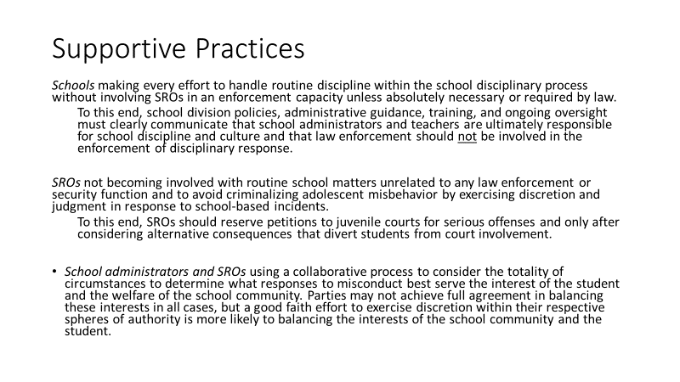 | Supportive Responses to Student Misconduct  Guide, p. 39  Key Learning Points:  Within the context of current concerns, experiences of SRO programs suggest the need for supportive responses to student misconduct that involve:  - Schools making every effort to handle routine discipline within the school disciplinary process without involving SROs in an enforcement capacity unless absolutely necessary or required by law.  - To this end, school division policies, administrative guidance, training, and ongoing oversight must clearly communicate that school administrators and teachers are ultimately responsible for school discipline and culture and that law enforcement should not be involved in the enforcement of disciplinary response.  - SROs not becoming involved with routine school matters unrelated to any law enforcement or security function and to avoid criminalizing adolescent misbehavior by exercising discretion and judgment in response to school-based incidents.  - To this end, SROs should reserve petitions to juvenile courts for serious offenses and only after considering alternative consequences that divert students from court involvement.  - School administrators and SROs using a collaborative process to consider the totality of circumstances to determine what responses to misconduct best serve the interest of the student and the welfare of the school community. Parties may not achieve full agreement in balancing these interests in all cases, but a good faith effort to exercise discretion within their respective spheres of authority is more likely to balancing the interests of the school community and the student.  Instructor Notes:  Conclude by reinforcing these understandings:  - Although the advocacy report was found to be flawed in its methodology and the data it relied on, there do remain concerns about:  - The criminalization of relative minor misconduct and  - Inappropriate involvement of SROs in matters that should be school personnel should manage.  - This training is designed to support partnerships that avoid these pitfalls and to highlight practices in which SROs and school administrators work together to make schools both safe and supportive.
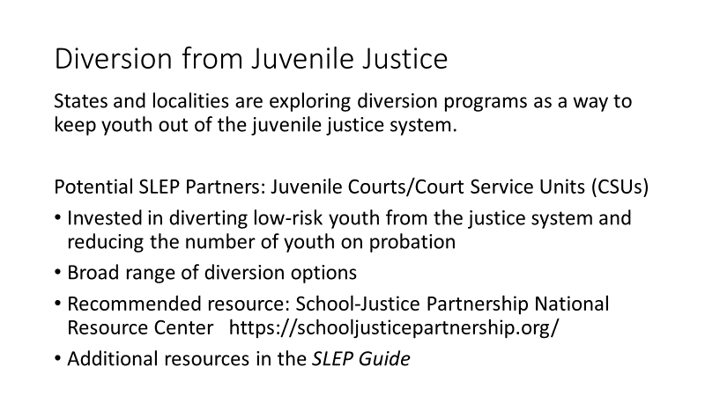 | Diversion from Juvenile Justice Involvement  Guide, p. 40  Key Learning Points:  - Many states and localities are exploring diversion programs as a way to keep youth out of the juvenile justice system.  - In Virginia, juvenile courts are an often overlooked resource for SLEPs.  - Court Services Units in their intake capacity are heavily invested in diverting low-risk youth from the justice system and reducing the number of youth on probation.  - A broad range of diversion options have been employed by juvenile courts and a key resource for learning about work with juvenile courts is the School-Justice Partnership National Resource Center.  - There are numerous other resources for developing diversion options listed in the SLEP Guide.
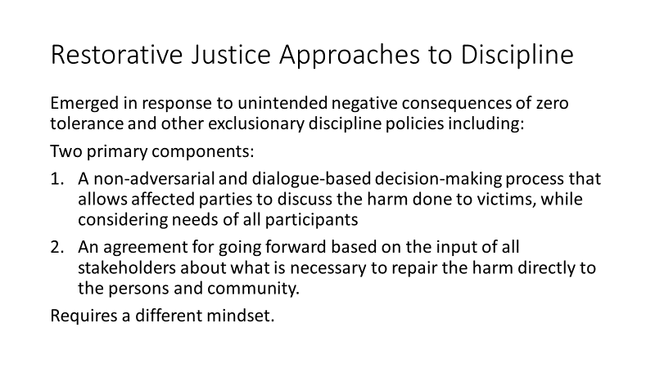 | Restorative Justice Approaches to Discipline  Guide, p. 41  Key Learning Points:  - Restorative justice approaches to discipline have emerged in response to unintended negative consequences of zero tolerance and other exclusionary discipline policies.  - A restorative response includes two primary components:  - A non-adversarial and dialogue-based decision-making process that allows affected parties to discuss the harm done to victims, while considering needs of all participants  - An agreement for going forward based on the input of all stakeholders about what is necessary to repair the harm directly to the persons and community.  A restorative response requires a different mindset.
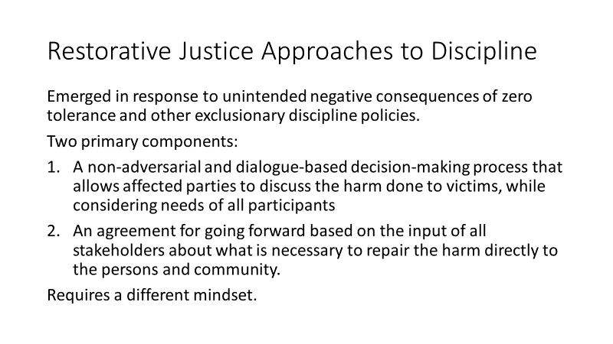 | Restorative Justice: Comparison & Goals  Guide, p. 42  Key Learning Points:  The table you see shows a comparison of traditional and restorative systems:  Briefly reviewing,  Traditional Systems Restorative Systems  What law was broken? Who has been harmed and what harm was done?  Whose fault is it? (Who did it and who do we blame? What are their needs?  What do they deserve? (What should the punishment be? How should we punish them?) Whose obligation is this? (What repair is needed and who is responsible?)
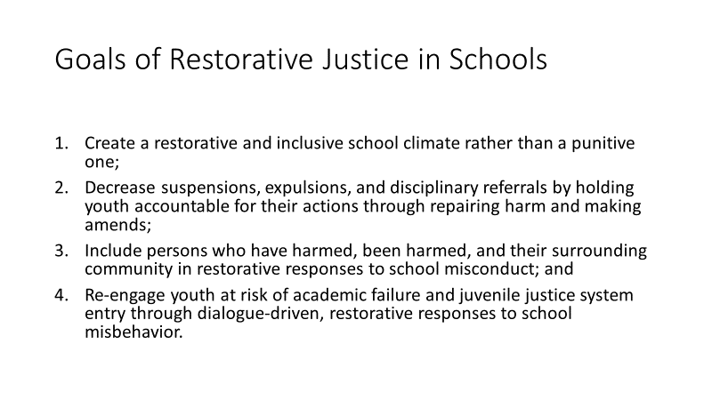 | Goals of Restorative Justice in Schools  Guide, p. 42  Key Learning Points:  You will see how restorative justice fits with supportive responses to student misconduct when you examine its goals:  - Create a restorative and inclusive school climate rather than a punitive one;  - Decrease suspensions, expulsions, and disciplinary referrals by holding youth accountable for their actions through repairing harm and making amends;  - Include persons who have harmed, been harmed, and their surrounding community in restorative responses to school misconduct; and  - Re-engage youth at risk of academic failure and juvenile justice system entry through dialogue-driven, restorative responses to school misbehavior.
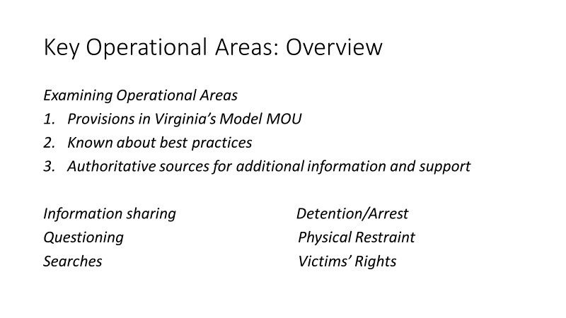 | Instructor Notes:  Transition participants by explaining that remainder of this Module will focus on legal issues associated with key operational areas. For each area, we’ll look at  - provisions in Virginia’s Model MOU,  - review what is known about best practices, and  - identify authoritative sources for additional information and support.  The operational areas we’ll review are  Informational sharing  - Questioning  - Searches  - Detention/Arrest  - Physical Restraint  - Victims’ Rights
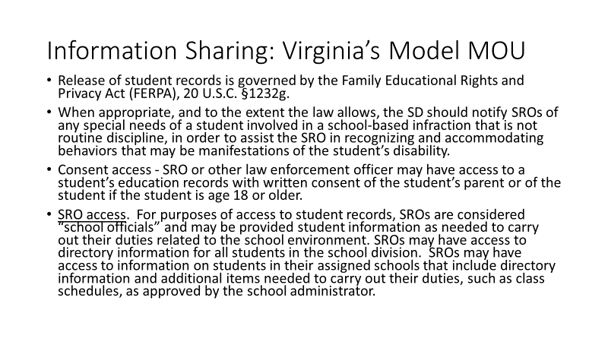  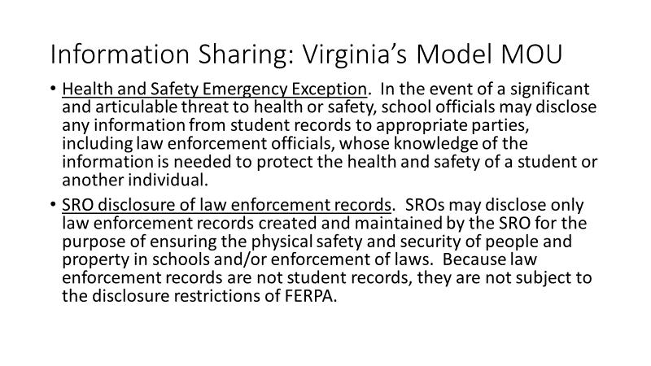 | Information Sharing  Guide, p. 42  Virginia Model MOU  - Turning now to the issue of information sharing, Virginia’s Model MOU includes the following provisions:  Quickly review each item:  - Release of student records is governed by the Family Educational Rights and Privacy Act (FERPA), 20 U.S.C. §1232g.  - When appropriate, and to the extent the law allows, the SD should notify SROs of any special needs of a student involved in a school-based infraction that is not routine discipline, in order to assist the SRO in recognizing and accommodating behaviors that may be manifestations of the student’s disability.  - Consent access - SRO or other law enforcement officer may have access to a student’s education records with written consent of the student’s parent or of the student if the student is age 18 or older.  - SRO access. For purposes of access to student records, SROs are considered “school officials” and may be provided student information as needed to carry out their duties related to the school environment. SROs may have access to directory information for all students in the school division. SROs may have access to information on students in their assigned schools that include directory information and additional items needed to carry out their duties, such as class schedules, as approved by the school administrator.  - Health and Safety Emergency Exception. In the event of a significant and articulable threat to health or safety, school officials may disclose any information from student records to appropriate parties, including law enforcement officials, whose knowledge of the information is needed to protect the health and safety of a student or another individual.  - SRO disclosure of law enforcement records. SROs may disclose only law enforcement records created and maintained by the SRO for the purpose of ensuring the physical safety and security of people and property in schools and/or enforcement of laws. Because law enforcement records are not student records, they are not subject to the disclosure restrictions of FERPA.
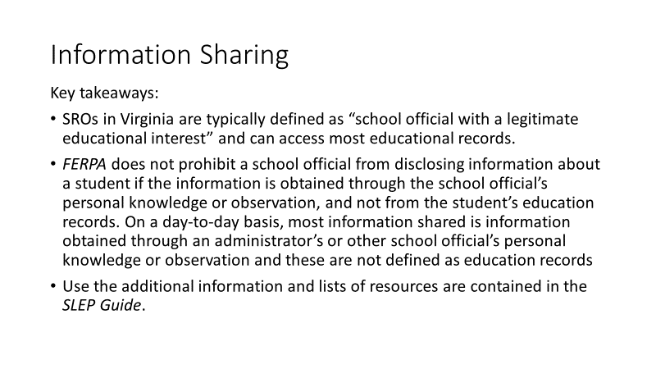 | Key Learning Points:  - Important takeaways for information sharing are:  - SROs in Virginia are typically defined as “school official with a legitimate educational interest” and can access most educational records.  - FERPA does not prohibit a school official from disclosing information about a student if the information is obtained through the school official’s personal knowledge or observation, and not from the student’s education records. On a day-to-day basis, most information shared is information obtained through an administrator’s or other school official’s personal knowledge or observation and these are not defined as education records.  - Use the additional information and lists of resources are contained in the SLEP Guide.
Instructor Notes: Ask participants if policies and procedures in their schools are clear and operate well?
(Allow a few comments)

Conclude discussion by reinforcing the need for everyone to be on the same page and encourage their getting any unclear areas clarified.
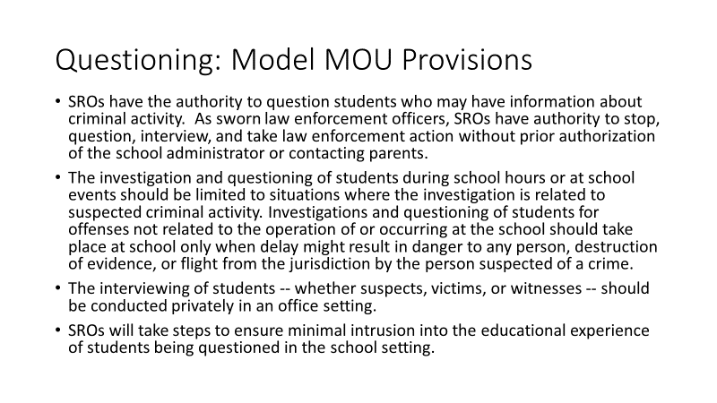  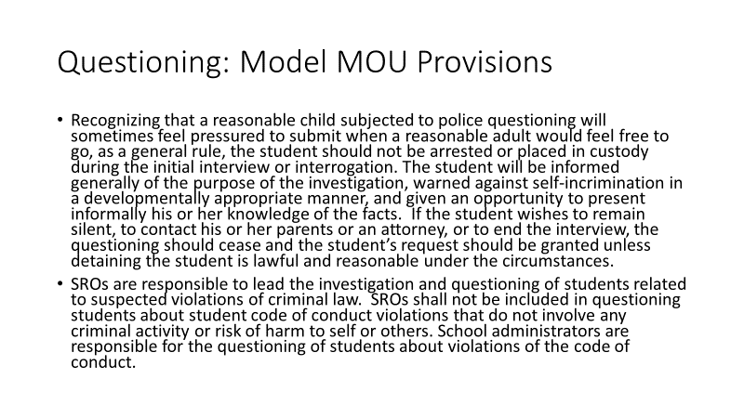 | Questioning  Guide, p.46  Reviewing provisions in Virginia’s Model MOU:  - SROs have the authority to question students who may have information about criminal activity. As sworn law enforcement officers, SROs have authority to stop, question, interview, and take law enforcement action without prior authorization of the school administrator or contacting parents.  - The investigation and questioning of students during school hours or at school events should be limited to situations where the investigation is related to suspected criminal activity. Investigations and questioning of students for offenses not related to the operation of or occurring at the school should take place at school only when delay might result in danger to any person, destruction of evidence, or flight from the jurisdiction by the person suspected of a crime.  - The interviewing of students -- whether suspects, victims, or witnesses -- should be conducted privately in an office setting.  - SROs will take steps to ensure minimal intrusion into the educational experience of students being questioned in the school setting.  - Recognizing that a reasonable child subjected to police questioning will sometimes feel pressured to submit when a reasonable adult would feel free to go, as a general rule, the student should not be arrested or placed in custody during the initial interview or interrogation. The student will be informed generally of the purpose of the investigation, warned against self-incrimination in a developmentally appropriate manner, and given an opportunity to present informally his or her knowledge of the facts. If the student wishes to remain silent, to contact his or her parents or an attorney, or to end the interview, the questioning should cease and the student’s request should be granted unless detaining the student is lawful and reasonable under the circumstances.  - SROs are responsible to lead the investigation and questioning of students related to suspected violations of criminal law. SROs shall not be included in questioning students about student code of conduct violations that do not involve any criminal activity or risk of harm to self or others. School administrators are responsible for the questioning of students about violations of the code of conduct.
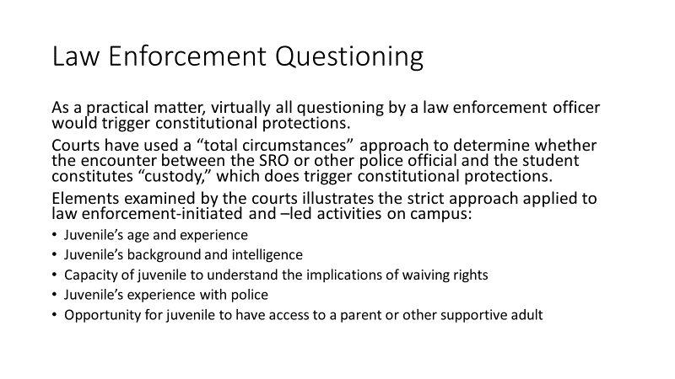 | Law Enforcement Questioning  Guide, p. 46  Key Learning Points:  - As a practical matter, virtually all questioning by a law enforcement officer would trigger constitutional protections.  - Courts have used a “total circumstances” approach to determine whether the encounter between the SRO or other police official and the student constitutes “custody,” which does trigger constitutional protections.  - The elements of the case examined by the courts illustrates the strict approach applied to law enforcement-initiated and –led activities on campus:  - Juvenile’s age and experience  - Juvenile’s background and intelligence  - Capacity of juvenile to understand the implications of waiving rights  - Juvenile’s experience with police  - Opportunity for juvenile to have access to a parent or other supportive adult  - Interviews of students -- whether suspects, victims, or witnesses -- should be conducted privately in an office setting.
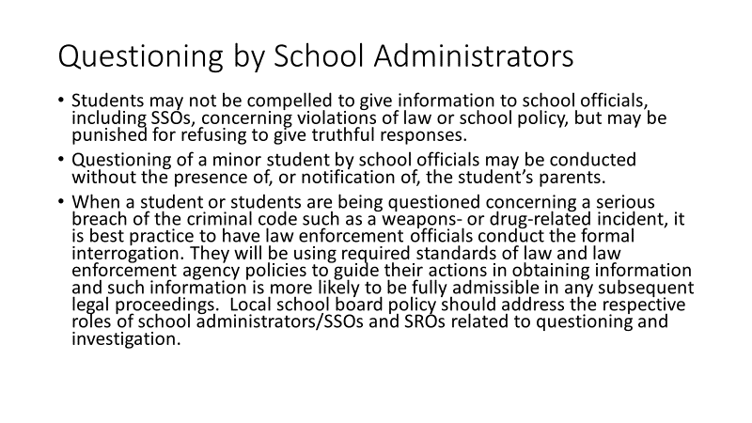  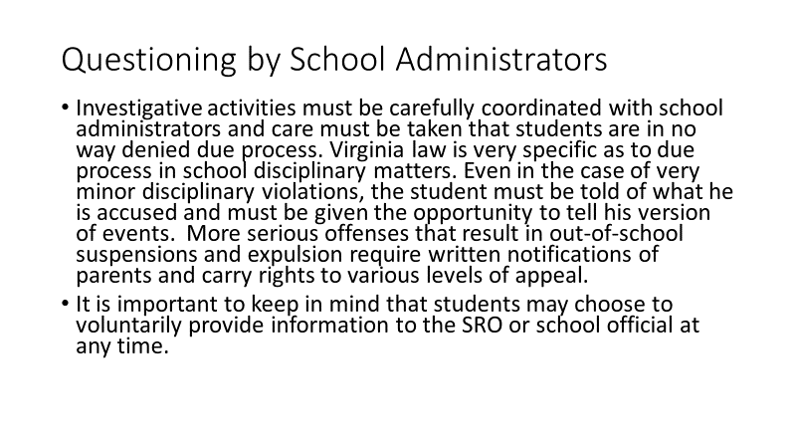 | School Administrator Questioning  Guide, p. 47  Key Learning Points:  - Students may not be compelled to give information to school officials concerning violations of law or school policy; however, they may be punished for refusing to give truthful responses.  - Questioning of a minor student by school officials may be conducted without the presence of, or notification of, the student’s parents.  - When a student or students are being questioned concerning a serious breach of the criminal code such as a weapons- or drug-related incident, it is best practice to have law enforcement officials conduct the formal interrogation. They will be using required standards of law and law enforcement agency policies to guide their actions in obtaining information and such information is more likely to be fully admissible in any subsequent legal proceedings.  - Local school board policy should address the respective roles of school administrators/SSOs and SROs related to questioning and investigation.  - Investigative activities must be carefully coordinated with school administrators and care must be taken that students are in no way denied due process.  - Virginia law is very specific as to due process in school disciplinary matters. Even in the case of very minor disciplinary violations, the student must be told of what he is accused and must be given the opportunity to tell his version of events. More serious offenses that result in out-of-school suspensions and expulsion require written notifications of parents and carry rights to various levels of appeal.  - It is important to keep in mind that students may choose to voluntarily provide information to the SRO, school official, or SSO at any time.  For additional tips, see “Talking with Teens: Basic Strategies for Interviewing” in Supplement 1. Partnership Toolkit section of this Guide.
Instructor Notes: Ask participants if policies and procedures in their schools are clear and operate well?
(Allow a few comments)

Conclude discussion by reinforcing the need for everyone to be on the same page and encourage their getting any unclear areas clarified.
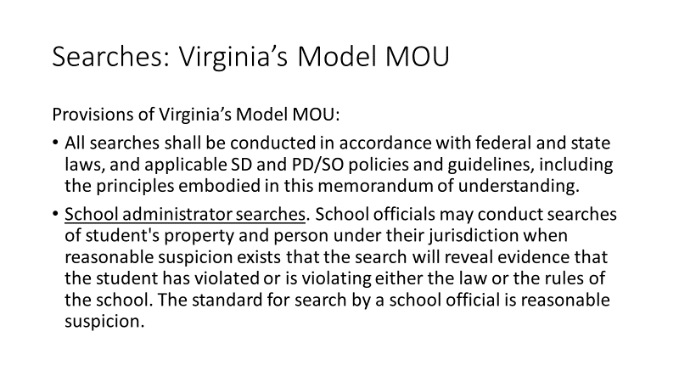  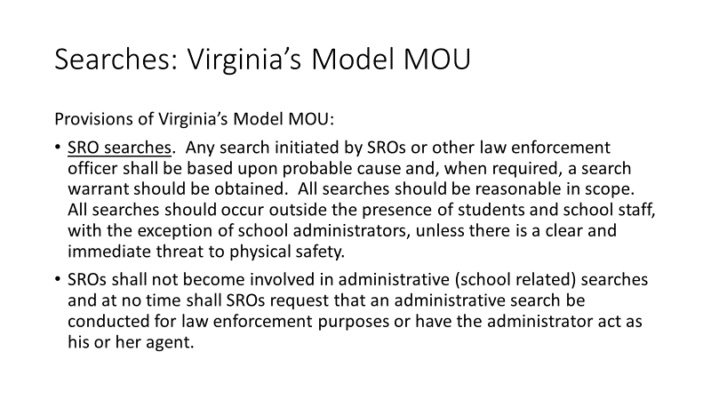 | School Searches  Guide, p. 47  Provisions of Virginia’s Model MOU:  - All searches shall be conducted in accordance with federal and state laws, and applicable SD and PD/SO policies and guidelines, including the principles embodied in this memorandum of understanding.  - School administrator searches. School officials may conduct searches of student's property and person under their jurisdiction when reasonable suspicion exists that the search will reveal evidence that the student has violated or is violating either the law or the rules of the school. The standard for search by a school official is reasonable suspicion.  - SRO searches. Any search initiated by SROs or other law enforcement officer shall be based upon probable cause and, when required, a search warrant should be obtained. All searches should be reasonable in scope. All searches should occur outside the presence of students and school staff, with the exception of school administrators, unless there is a clear and immediate threat to physical safety.  - SROs shall not become involved in administrative (school related) searches and at no time shall SROs request that an administrative search be conducted for law enforcement purposes or have the administrator act as his or her agent.
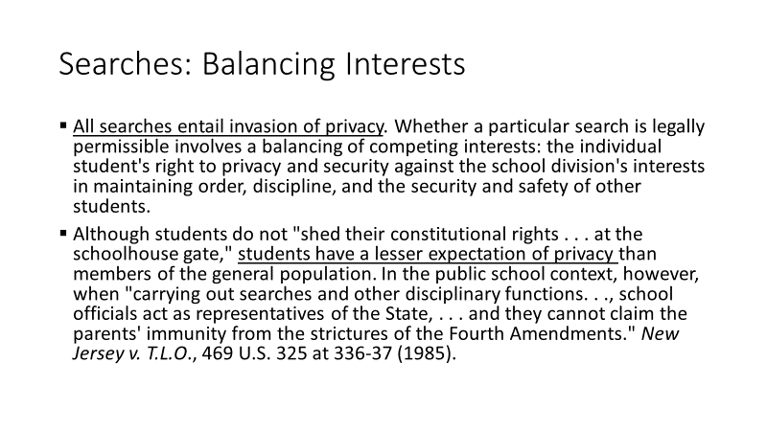 | School Searches: Balancing Competing Interests  Guide, p. 47-48  Key Learning Points:  - Important points to keep in mind are:  - All searches entail invasion of privacy. Whether a particular search is legally permissible involves a balancing of competing interests: the individual student's right to privacy and security against the school division's interests in maintaining order, discipline, and the security and safety of other students.  - Although students do not "shed their constitutional rights . . . at the schoolhouse gate," students have a lesser expectation of privacy than members of the general population. In the public school context, however, when "carrying out searches and other disciplinary functions. . ., school officials act as representatives of the State, . . . and they cannot claim the parents' immunity from the strictures of the Fourth Amendments." New Jersey v. T.L.O., 469 U.S. 325 at 336-37 (1985).
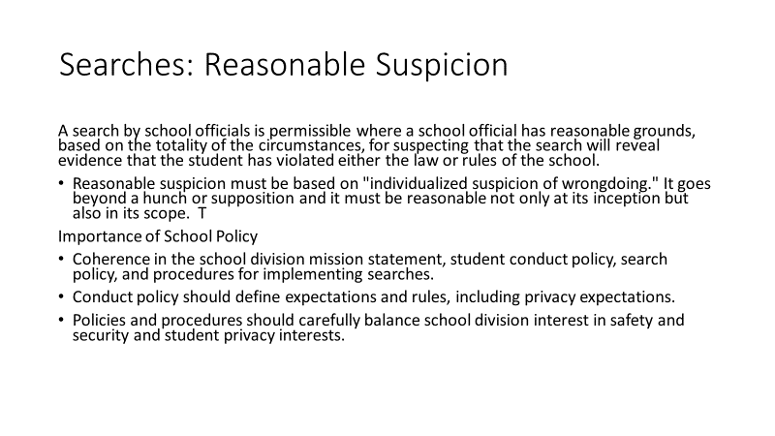 | Reasonable Suspension  Guide, p. 48  Key Learning Points:  - In the school environment (and at school-sponsored activities), a search is permissible where a school official has reasonable grounds, based on the totality of the circumstances, for suspecting that the search will reveal evidence that the student has violated either the law or rules of the school.  - Reasonable suspicion must be based on "individualized suspicion of wrongdoing." It goes beyond a hunch or supposition and it must be reasonable not only at its inception but also in its scope.  - School policy is extremely important and should carefully balance school division interest in safety and security and student privacy interests.
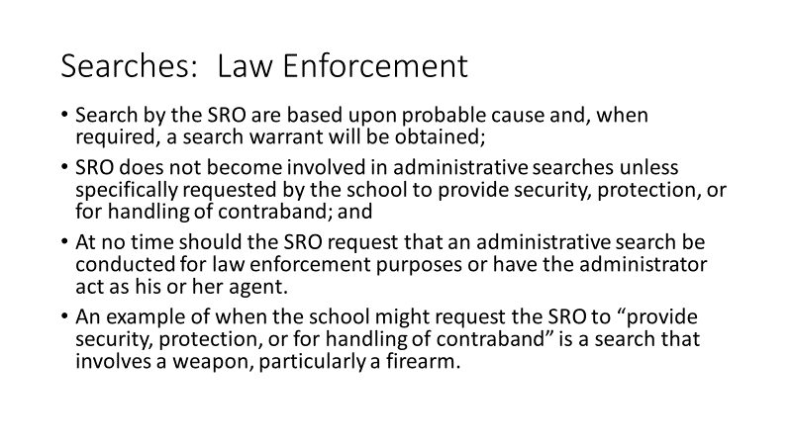 | Searches Involving Law Enforcement Officers (Including SROs)  Guide, p. 48  Key Learning Points:  - Searches by SROs must be based on probable cause and, when required, a search warrant should be obtained.  - SROs do not become involved in administrative searches  unless specifically requested by the school to provide security, protection, or for handling of contraband.  - At no time should the SRO request that an administrative search be conducted for law enforcement purposes or have the administrator act as his or her agent.  - An example of when the school might request the SRO to “provide security, protection, or for handling of contraband” is a search that involves a weapon, particularly a firearm.
Instructor Notes: Ask participants

- The idea of “balancing the interests of privacy and security” is central to school searches. Can anyone give an example of how that balancing occurs in actual practice?
(Allow a few brief examples)

Conclude discussion by reinforcing the need for everyone to be on the same page and encourage their getting any unclear areas clarified.
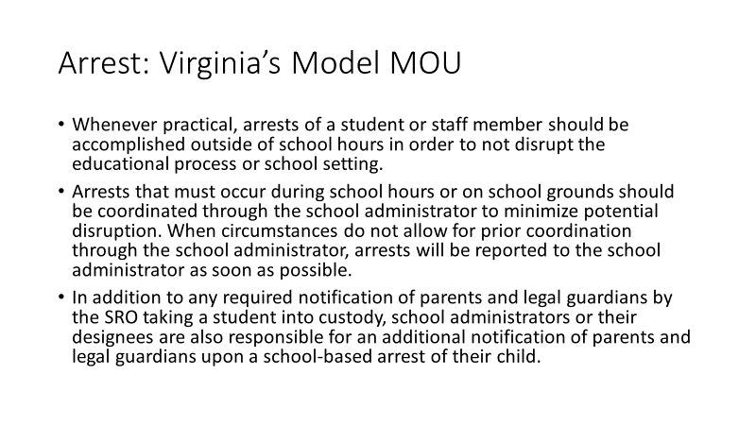 | Detention and Arrest  Guide, p. 49  Virginia’s Model MOU  Model MOU provisions are:  - Whenever practical, arrests of a student or staff member should be accomplished outside of school hours in order to not disrupt the educational process or school setting.  - Arrests that must occur during school hours or on school grounds should be coordinated through the school administrator to minimize potential disruption. When circumstances do not allow for prior coordination through the school administrator, arrests will be reported to the school administrator as soon as possible.  - In addition to any required notification of parents and legal guardians by the SRO taking a student into custody, school administrators or their designees are also responsible for an additional notification of parents and legal guardians upon a school-based arrest of their child.
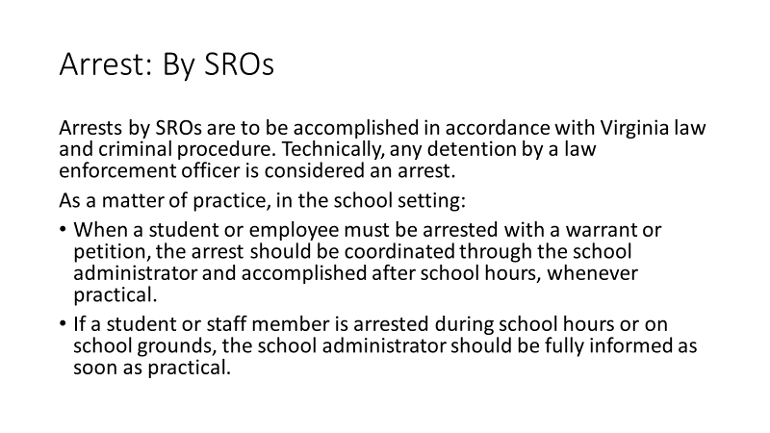 | Arrests by SROs  Guide, p. 49  Key Learning Points:  Arrests by SROs are to be accomplished in accordance with Virginia law and criminal procedure. Technically, any detention by a law enforcement officer is considered an arrest.  As a matter of practice, in the school setting:  - When a student or employee must be arrested with a warrant or petition, the arrest should be coordinated through the school administrator and accomplished after school hours, whenever practical.  - If a student or staff member is arrested during school hours or on school grounds, the school administrator should be fully informed as soon as practical.
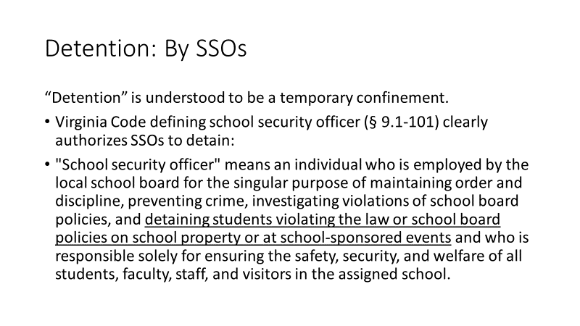 | Detention by SSO  Guide, p. 49  Key Learning Points:  To further clarify, let’s look at what the Code of Virginia says about detention by school security officers.  “Detention” is understood to be a temporary confinement. SSOs are clearly authorized by Virginia Code to detain students who violate the law or school board policy.  Virginia Code defining school security officer (§ 9.1-101) clearly authorizes SSOs to detain:  "School security officer" means an individual who is employed by the local school board for the singular purpose of maintaining order and discipline, preventing crime, investigating violations of school board policies, and detaining students violating the law or school board policies on school property or at school-sponsored events and who is responsible solely for ensuring the safety, security, and welfare of all students, faculty, staff, and visitors in the assigned school.
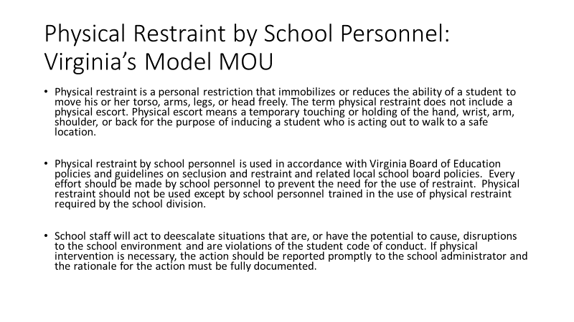 | Physical Intervention: Virginia’s Model MOU  Guide, pp. 49-50  Key Learning Points:  Virginia’s Model MOU addresses physical restraint by school personnel and physical intervention by SROs.  - Physical restraint is a personal restriction that immobilizes or reduces the ability of a student to move his or her torso, arms, legs, or head freely. The term physical restraint does not include a physical escort. Physical escort means a temporary touching or holding of the hand, wrist, arm, shoulder, or back for the purpose of inducing a student who is acting out to walk to a safe location.  - Physical restraint by school personnel is used in accordance with Virginia Board of Education policies and guidelines on seclusion and restraint and related local school board policies. Every effort should be made by school personnel to prevent the need for the use of restraint. Physical restraint should not be used except by school personnel trained in the use of physical restraint required by the school division.  - School staff will act to deescalate situations that are, or have the potential to cause, disruptions to the school environment and are violations of the student code of conduct. If physical intervention is necessary, the action should be reported promptly to the school administrator and the rationale for the action must be fully documented.
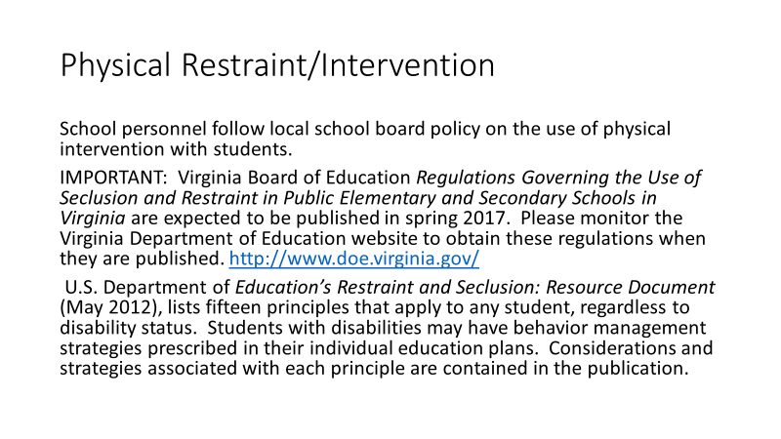 | Physical Restraint Resources  Guide, p. 50-51  School personnel follow local school board policy on the use of physical intervention with students.  IMPORTANT: Virginia Board of Education Regulations Governing the Use of Seclusion and Restraint in Public Elementary and Secondary Schools in Virginia are expected to be published in spring 2017. Please monitor the Virginia Department of Education website to obtain these regulations when they are published. http://www.doe.virginia.gov/  U.S. Department of Education’s Restraint and Seclusion: Resource Document (May 2012), lists fifteen principles that apply to any student, regardless to disability status. Students with disabilities may have behavior management strategies prescribed in their individual education plans. Considerations and strategies associated with each principle are contained in the publication.
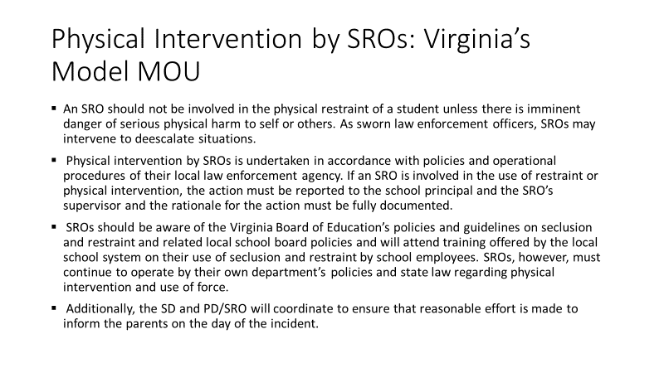 | Physical Intervention by SROs: Virginia’s Model MOU  - An SRO should not be involved in the physical restraint of a student unless there is imminent danger of serious physical harm to self or others. As sworn law enforcement officers, SROs may intervene to deescalate situations.  - Physical intervention by SROs is undertaken in accordance with policies and operational procedures of their local law enforcement agency. If an SRO is involved in the use of restraint or physical intervention, the action must be reported to the school principal and the SRO’s supervisor and the rationale for the action must be fully documented.  - SROs should be aware of the Virginia Board of Education’s policies and guidelines on seclusion and restraint and related local school board policies and will attend training offered by the local school system on their use of seclusion and restraint by school employees. SROs, however, must continue to operate by their own department’s policies and state law regarding physical intervention and use of force.  - Additionally, the SD and PD/SRO will coordinate to ensure that reasonable effort is made to inform the parents on the day of the incident.
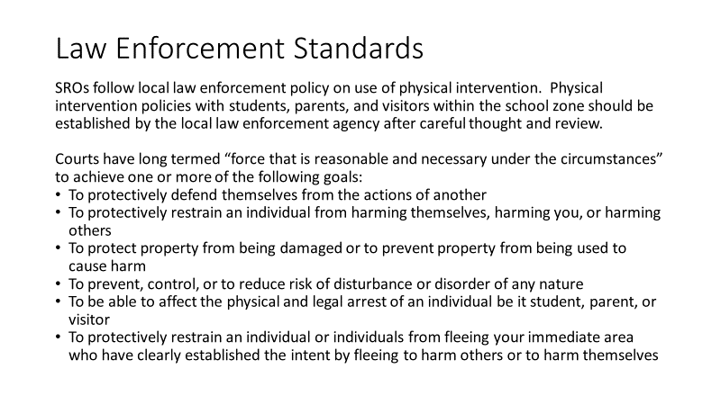 | Law Enforcement Standards for Physical Intervention  Guide, pp. 51-52  Key Learning Points:  - SROs follow local law enforcement policy on use of physical intervention. Physical intervention policies with students, parents, and visitors within the school zone should be established by the local law enforcement agency after careful thought and review.  - Courts have long termed “force that is reasonable and necessary under the circumstances” to achieve one or more of the following goals:  - To protectively defend themselves from the actions of another  - To protectively restrain an individual from harming themselves, harming you, or harming others  - To protect property from being damaged or to prevent property from being used to cause harm  - To prevent, control, or to reduce risk of disturbance or disorder of any nature  - To be able to affect the physical and legal arrest of an individual be it student, parent, or visitor  - To protectively restrain an individual or individuals from fleeing your immediate area who have clearly established the intent by fleeing to harm others or to harm themselves
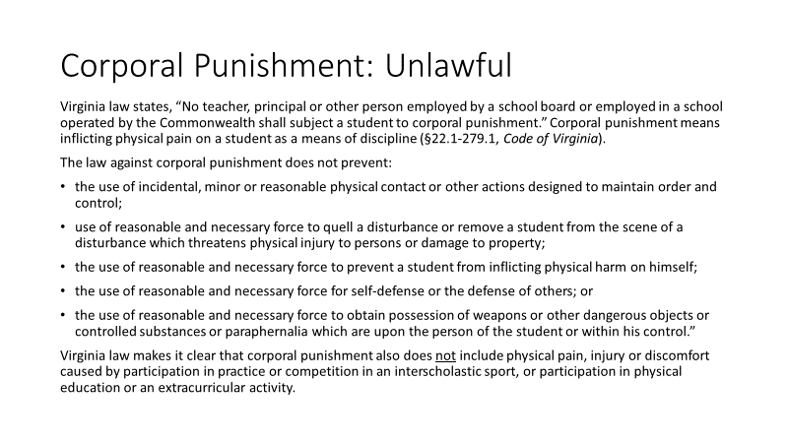 | Corporal Punishment Unlawful  Guide, pp. 49-50  Key Learning Points:  - Relevant to discussion of physical restraint or intervention is an awareness of laws about corporal punishment.  - Virginia law states, “No teacher, principal or other person employed by a school board or employed in a school operated by the Commonwealth shall subject a student to corporal punishment.” Corporal punishment means inflicting physical pain on a student as a means of discipline (§22.1-279.1, Code of Virginia).  - The law against corporal punishment does not prevent:  - the use of incidental, minor or reasonable physical contact or other actions designed to maintain order and control;  - use of reasonable and necessary force to quell a disturbance or remove a student from the scene of a disturbance which threatens physical injury to persons or damage to property;  - the use of reasonable and necessary force to prevent a student from inflicting physical harm on himself;  - the use of reasonable and necessary force for self-defense or the defense of others; or  - the use of reasonable and necessary force to obtain possession of weapons or other dangerous objects or controlled substances or paraphernalia which are upon the person of the student or within his control.”  - Virginia law makes it clear that corporal punishment also does not include physical pain, injury or discomfort caused by participation in practice or competition in an interscholastic sport, or participation in physical education or an extracurricular activity.
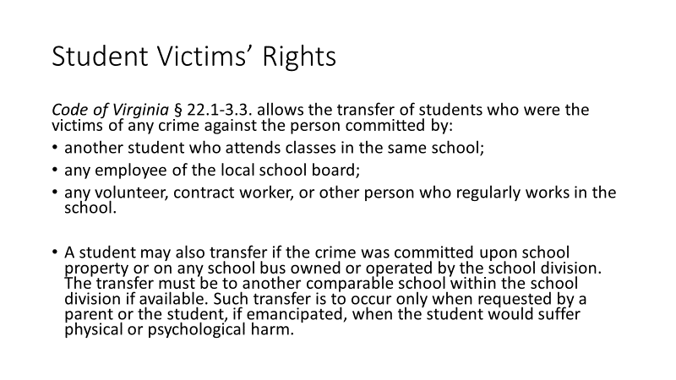 | Student Victims’ Rights  Guide, p. 51  Key Learning Points:  Code of Virginia § 22.1-3.3. allows the transfer of students who were the victims of any crime against the person committed by:  - another student who attends classes in the same school;  - any employee of the local school board;  - any volunteer, contract worker, or other person who regularly works in the school.  - A student may also transfer if the crime was committed upon school property or on any school bus owned or operated by the school division.  - The transfer must be to another comparable school within the school division if available. Such transfer is to occur only when requested by a parent or the student, if emancipated, when the student would suffer physical or psychological harm.
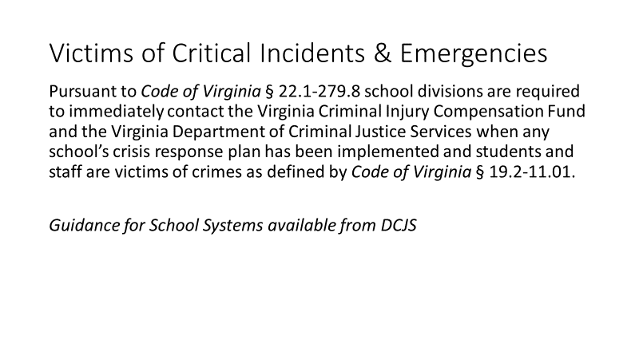 | Victims of Critical Incidents and Emergencies  Guide, p. 52  Key Learning Points:  Pursuant to Code of Virginia § 22.1-279.8 school divisions are required to immediately contact the Virginia Criminal Injury Compensation Fund and the Virginia Department of Criminal Justice Services when any school’s crisis response plan has been implemented and students and staff are victims of crimes as defined by Code of Virginia § 19.2-11.01.  The Department of Criminal Justice Services, Victims Services has guidance and related resources.
Instructor Notes: Ask participants

- The idea of “balancing the interests of privacy and security” is central to school searches. Let’s hear some examples of how that balancing occurs in actual practice?

(Allow a few brief examples, reinforcing key understandings)

Conclude discussion by reinforcing the need for everyone to be on the same page and encourage their getting any unclear areas clarified.
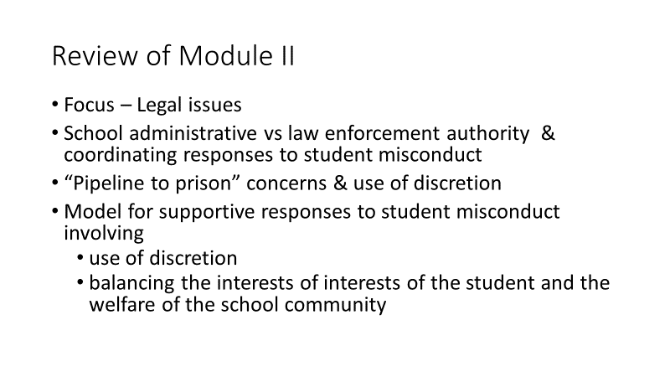  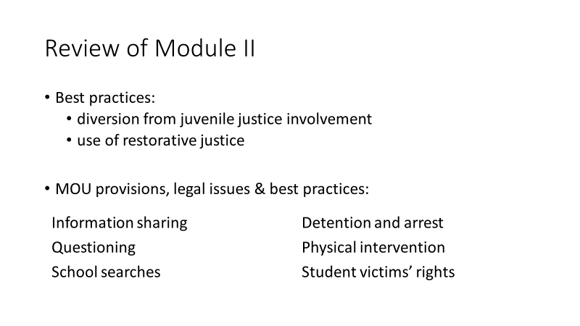 | Review of Module II  Key Review Points:  - Module II has focused on legal issues in school-law enforcement partnerships.  - A critical area is defining the parameters of school administrative and law enforcement authority and coordinating responses to student misconduct.  - Related to this we reviewed “pipeline to prison” concerns, discussed the use of discretion by both school administrators and law enforcement.  - Importantly, we introduced a model for supportive responses to student misconduct involving use of discretion and balancing the interests of interests of the student and the welfare of the school community.  - Diversion from juvenile justice involvement and use of restorative justice were both discussed.  - We then focused on specific legal issues, examining provisions of Virginia’s Model MOU, legal issues and best practices related to information sharing, questioning, school searches, detention and arrest, physical intervention, and student victims’ rights.

