- SCHOOL-LAW ENFORCEMENT PARTNERSHIP: UNDERSTANDING AND WORKING EFFECTIVELY WITH STUDENTS

Overview

SLEP Training Module III Goal

The goal of SLEP Module III is to orient SROs to work with adolescents in a school setting by identifying law enforcement implications of adolescent brain development and common challenges of students and offering specific strategies for SRO effectiveness and then examining the relationship of school climate and student behavior, tiered supports for students, and the contributions of SROs to positive school climate in their roles as informal mentor and positive role model and law-related educator role.

Module III Learning Objectives

Upon completion of Module II, participants will be able to

- Describe key features of adolescent development and implications for school disciplinary practices and law enforcement.
- Identify key SRO strategies to work effectively with students who face challenges including child abuse, trauma, mental health issues, alcohol and other drugs, gangs, homelessness, and juvenile justice involvement.
- Describe SRO strategies for working effectively with students with disabilities.
- Describe the relationship of school climate and student behavior.
- Describe types and uses of tiered supports for students and positive behavioral supports.
- Identify contributions to safe and supportive schools of SROs in their role as mentor and positive role model.
- Describe strategies and resources for SROs in their law-related educator role.
- Identify key sources for learning more about issues and practices taught in Module III.

Module III. Overview with Crosswalk to SLEP Guide

Module III. Topics | Related SLEP Guide
A. Overview of Module III. Understanding and Working Effectively with Students
B. Adolescent Development | Chapter V, Section A
- Teen Brain
- Implications for School Discipline, Law Enforcement, and Juvenile Justice | Chapter V, Section A
- Talking with Teens | Supplement 1
C. Challenges Students Experience & SRO Strategies | Chapter V, Section B
- Child Abuse | Chapter V, Section B
- Students Who Have Experienced Trauma | Chapter V, Section B
- Mental Health Issues | Chapter V, Section B
- Alcohol and Other Drug Abuse | Chapter V, Section B
- Gangs | Chapter V, Section B
- Homeless Students | Chapter V, Section B
- Juvenile Justice Involved Youth | Chapter V, Section B
D. Students with Disabilities | Chapter V, Section C
E. School Climate, Student Behavior, and Supportive Schools | Supplement 2
F. Tiered Support for Students | Supplement 2
G. SRO Role as Mentor and Positive Role Model | Chapter II, Section A
H. SRO as Law-Related Educator | Chapter II, Section A &  Supplement 1
Review of Module III

Training Content
Module III. Understanding and Working Effectively with Students
Slides | Instructor Script
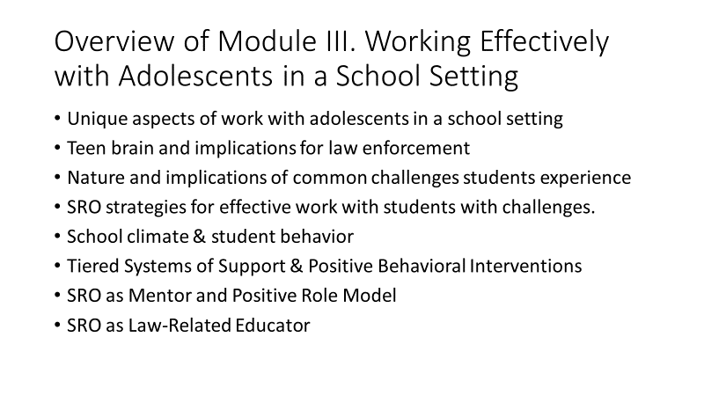 | - Overview of Module III. Working Effectively with Adolescents in a School Setting  Key Learning Points:  - This module focuses on working effectively with adolescents in a setting.  - We first look at the ways adolescents are different – in how they think, solve problems, and make decisions – and the implications for law enforcement.  - Next, we look at some of the challenges that students we work with have experienced and what we need to know and learn about these experiences.  - The challenges we’ll discuss include child abuse, trauma, mental health issues, alcohol and other drugs, gangs, homelessness, justice-involved youth, and disabilities.  - You’ll see that for each of these challenges, we’ll identify specifically the implications for law enforcement and then offer strategies for SRO effectiveness with these students.  - Then, we’ll look at the connections between school climate and how students behave and how SROs can contribute to improving school climate.  - Next, we’ll look at tiered supports for students and Virginia’s model for intervening and supporting students.  - The module concludes with a closer look at SRO roles as Mentor and Positive Role Model and Law-Related Educator  Refer participants to appropriate pages in the SLEP Guide, Chapter V, beginning on page 67.
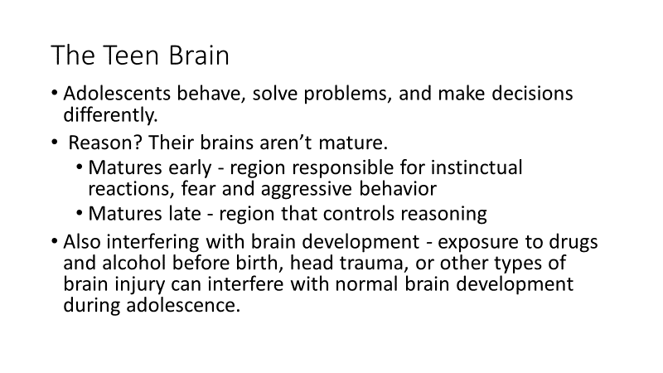 | Adolescent Development  The Teen Brain: Behavior, Problem Solving, and Decision Making  Guide, p. 67  Ask, by a show of hands, how many participants either work regularly with adolescents or have an adolescent or two at home?  Then, ask if anyone would like to comment on how they think and act, solve problems, or make decisions.  After comments, reinforce key point: they are different – not yet mature adults.  Key Learning Points:  The brain  - Recognizing that adolescents differ from adults in the way they behave, solve problems, and make decisions, the American Academy of Child and Adolescent Psychiatry reports there is a biological explanation for this difference – their brains aren’t mature.  - Scientists have specific regions of the brain and found that although the region responsible for instinctual reactions including fear and aggressive behavior matures early, the region that controls reasoning and helps us think before we act, develops later. This part of the brain is still changing and maturing well into adulthood.  - In addition, exposure to drugs and alcohol before birth, head trauma, or other types of brain injury can interfere with normal brain development during adolescence.  The behavior  Adolescents are more likely to:  - act on impulse  - misread or misinterpret social cues and emotions  - get into accidents of all kinds  - get involved in fights  - engage in dangerous or risky behavior  They are less likely to:  - think before they act  - pause to consider the potential consequences of their actions  - modify their dangerous or inappropriate behaviors  - These brain differences don’t mean that young people can’t make good decisions or tell the difference between right and wrong. It also doesn’t mean that they shouldn’t be held responsible for their actions.  - An awareness of these differences can help parents, teachers, advocates, and policy makers understand, anticipate, and manage the behavior of adolescents.  To Learn More about Policing the Teen Brain  Policing the Teen Brain (2014) by Bostic, J. Q., Thurau, L., Potter, M., & Drury, S. S. Journal of the American Academy of Child and Adolescent Psychiatry, 53(2), 127–129.  http://www.ncbi.nlm.nih.gov/pmc/articles/PMC4336465/pdf/nihms663374.pdf
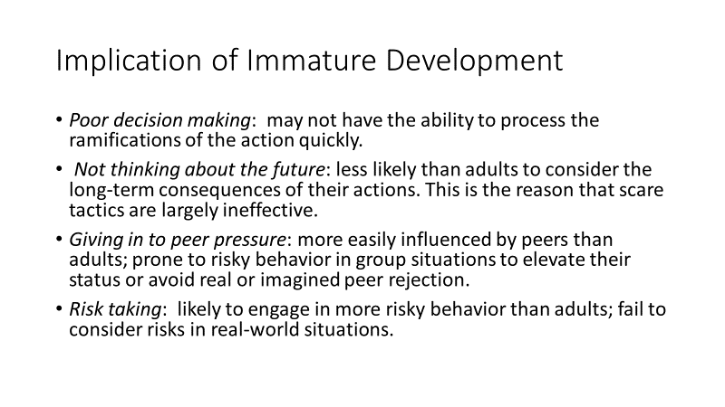  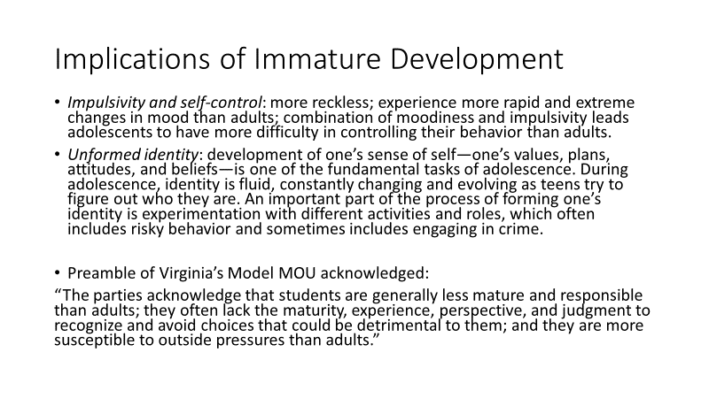 | Implications for School Discipline, Law Enforcement, and Juvenile Justice  Guide, p. 68  Key Learning Points:  Adolescents’ relative developmental immaturity contributes to immature judgment and criminal behavior in the following ways:  - Poor decision making: Teens are less able to process information quickly and thoughtfully in real-world situations. Their ability to make good decisions in situations that require a fast and well-thought out response is sometimes flawed— such as whether or not to go along with a friend to steal a car for a joyride— because they may not have the ability to process the ramifications of the action quickly.  - Not thinking about the future: Teens are less likely than adults to consider the long-term consequences of their actions, termed “future orientation.” This reduces their fear of punishment in the future—such as the possibility of going to jail— and leads them to choose the fun of the present over the pain of the future. This is the reason that scare tactics are largely ineffective.  - Giving in to peer pressure: Adolescents are more easily influenced by, pay more attention to, spend more time with, and are more responsive to their peers than adults are with friends. Teens are more likely to change their decisions or alter their behavior in response to peer pressure—to use drugs or initiate risky behavior in group situations in order to elevate their status or avoid real or imagined peer rejection.  - Risk taking: Teenagers engage in more risky behavior than adults. There are two “blind spots” that adolescents have when it comes to assessing risk that work together to increase their risk-taking behavior: 1) While teens demonstrate that they understand the level of risk associated with a given behavior under ideal (and simulated) conditions, they fail to consider these same risks in real-world situations; and 2) adolescents are more “reward sensitive” (the rush of driving fast) and less “risk averse” (getting a ticket or being in an accident) than adults.  - Impulsivity and self-control: Adolescents are more reckless than adults because they are still developing the ability to control impulses. In addition, adolescents experience more rapid and extreme changes in mood than adults do. High levels of emotional arousal, whether anger or elation, have been connected to difficulties with self-control. The combination of moodiness and impulsivity leads adolescents to have more difficulty in controlling their behavior than adults.  - Unformed identity: The development of one’s sense of self—one’s values, plans, attitudes, and beliefs—is one of the fundamental tasks of adolescence. During adolescence, identity is fluid, constantly changing and evolving as teens try to figure out who they are. An important part of the process of forming one’s identity is experimentation with different activities and roles, which often includes risky behavior and sometimes includes engaging in crime.  - Thinking back to the preamble of Virginia’s Model MOU, you see these factors clearly acknowledged:  “The parties acknowledge that students are generally less mature and responsible than adults; they often lack the maturity, experience, perspective, and judgment to recognize and avoid choices that could be detrimental to them; and they are more susceptible to outside pressures than adults.”  - So, we see that the SLEP is predicated on some assumptions about the main population with whom SROs work.
Ask: Who can give a really strong example of adolescent thinking gone wrong? Some example of one of the behaviors we’ve just discussed?

Allow a few examples and point out/reinforce the most relevant characteristic/behavior reflected in the example.
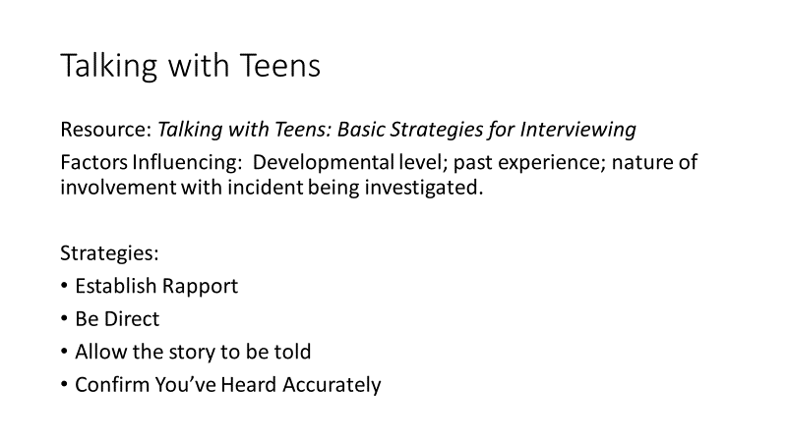 | Talking with Teens: Basic Strategies for Interviewing  Guide, Supplement 1, pp. 88-89  Key Learning Points:  - Included in Supplement 1 of your Guide, the SLEP Toolkit, is a brief piece on basic strategies for Interviewing teens.  - You can review this on your own, but the strategies listed reflect an understanding of where teens are developmentally and most effective approaches to talking with them.  - Three key points made:  - Developmental level determines ability to reason and express thoughts in a clear and understandable way and the presence of a disability can affect the level.  - Past experiences with law enforcement may influence willingness to talk.  - Nature of and role in an incident being investigated influences what is reported.  Quickly review strategies recommended:  Establish Rapport  Starting the conversation with non-threatening, less serious topics can help reduce the student’s anxiety. If you know the student is involved with a sport, you might comment on how the team is doing and ask about the next game or what position he/she plays.  Be Direct  Be direct in introducing the reason for the interview. Don’t start by asking, “Do you know why you are here?” Simply state the basics – “on Tuesday, a fight broke out in the cafeteria” – and explain that you need to hear from the student, in their own words, what occurred.  Allow the story to be told  Encourage the student to tell his or her own story. Avoid interrupting or placing the student on the spot by focusing prematurely on incriminating information. Be patient and attentive; use neutral comments such as “tell me more.” Be aware of your body language; conveying calm and openness will help the student to relax and tell his/her story. Do not correct grammar or vocabulary.  Ask simple, open-ended questions such as “tell me more about. . .” or “help me better understand. . .” Avoid long, complicated questions with a great deal of information in them or containing multiple options – they can be confusing.  Confirm You’ve Heard Accurately  Before ending the interview, confirm that you have heard correctly the information given. Briefly sum up, “What you’ve told me is that . . . Is that correct?” This gives the student an opportunity to clarify or add to what he or she has said and confirms that the information given has been accurately understood.
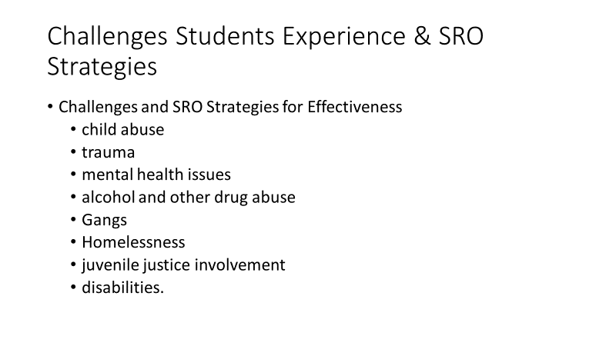 | Challenges Students Experience  Guide, p. 69 – 75  Explain that now we will look at some challenges that students face that are too commonly seen in the school setting and that for each of these challenges we will identify some SRO strategies for becoming more knowledgeable about the challenge and more effective in collaborating with school personnel to help students overcome these challenges.  Challenges we’ll review are child abuse, trauma, mental health issues, alcohol and other drug abuse, gangs, homelessness, juvenile justice involvement, and disabilities.
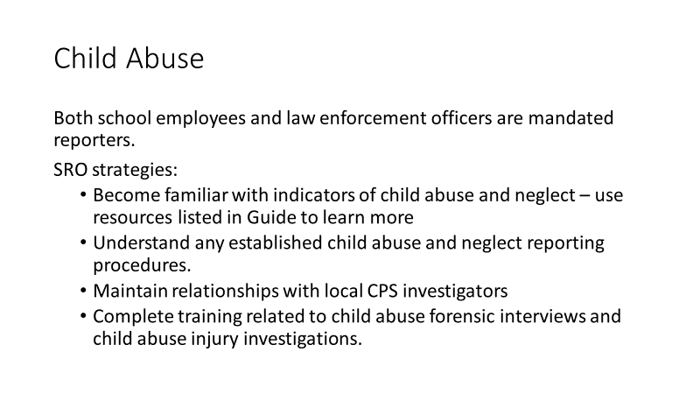 | Child Abuse  Guide, p. 69  Key Learning Points:  - Code of Virginia § 63.2-1509 requires certain professionals to report suspected child abuse or neglect to the local department of social services of the county or city where the child resides or to the state’s toll-free child abuse and neglect hotline.  - Both school employees and law enforcement officers are mandated reporters.  - Civil Immunity - Code of Virginia § 63.1-1512. states that any person making such a report shall be immune from any civil or criminal liability in connection with the reporting unless it can be proven that the person acted in bad faith or with malicious intent.  - SRO strategies:  - Become familiar with indicators of child abuse and neglect – the resources listed below contain a great deal of very helpful information.  - Clearly understand any established child abuse and neglect reporting procedures.  - Maintain close relationships with child protective services investigators from local departments of social services.  - Consider completing training related to child abuse forensic interviews and child abuse injury investigations.
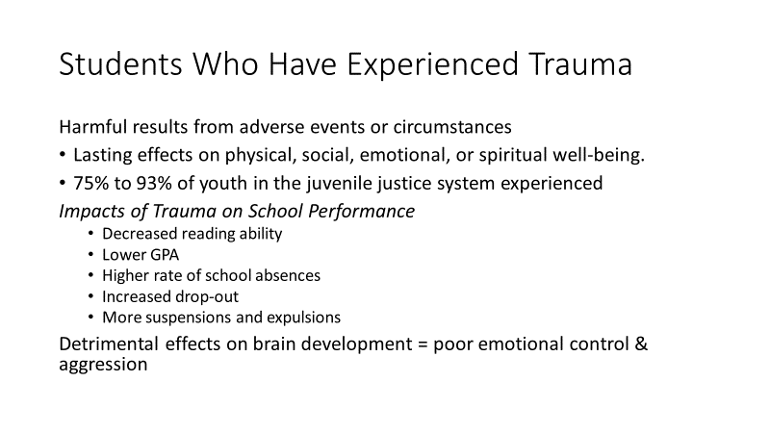  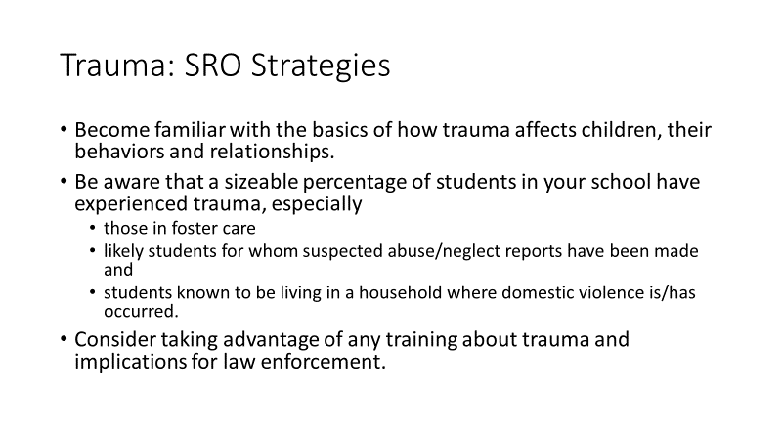 | Students Who Have Experienced Trauma  Guide, p. 69  Key Learning Points:  - Trauma results from a harmful event, series of events, or set of circumstances that is experienced that has lasting adverse effects on the individual’s physical, social, emotional, or spiritual well-being.  Research suggests  - approximately 75% to 93% of youth in the juvenile justice system are estimated to have experienced some type of trauma.  Trauma can result from:  - Natural disasters  - Forced displacement  - War / terrorism  - Emotional, physical, or sexual abuse or assault  - Serious accident or illness /medical procedure  - Victim / witnessing domestic, community, school, or interpersonal violence  Trauma can impact school performance in multiple ways:  - Decreased reading ability  - Lower GPA  - Higher rate of school absences  - Increased drop-out  - More suspensions and expulsions  Trauma in early childhood can have a detrimental effect on brain development. Brain structures associated with regulating emotion, memory, and behavior can be smaller in size, contributing to poor emotional control and aggression.  SRO Strategies:  - Become familiar with the basics of how trauma affects children and how it affects their behaviors and relationships.  - Be aware that a sizeable percentage of students in your school have experienced trauma, including those in foster care and likely students for whom suspected abuse/neglect reports have been made and students known to be living in a household where domestic violence is/has occurred.  - Consider taking advantage of any training about trauma and implications for law enforcement.
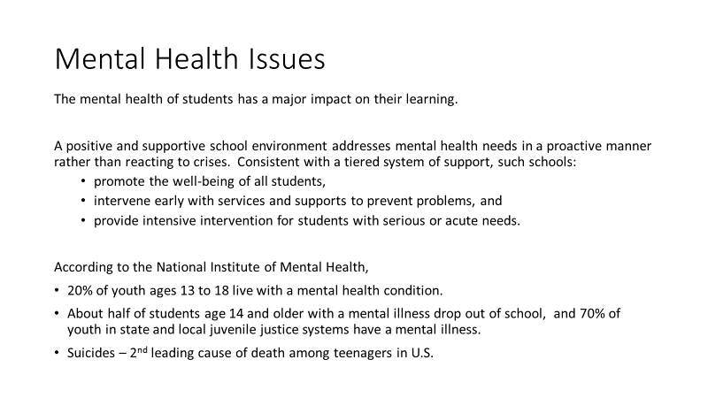  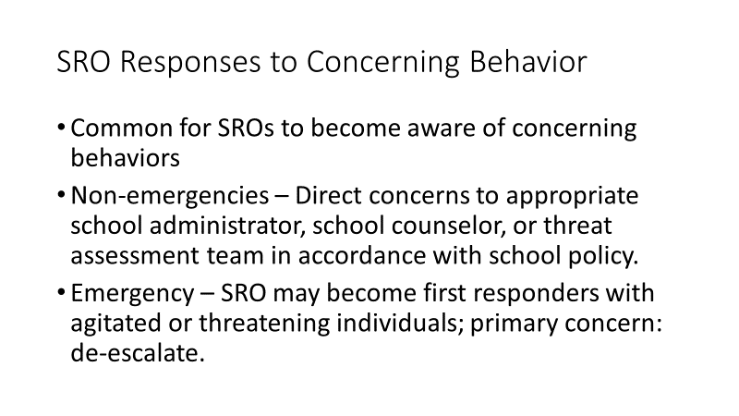  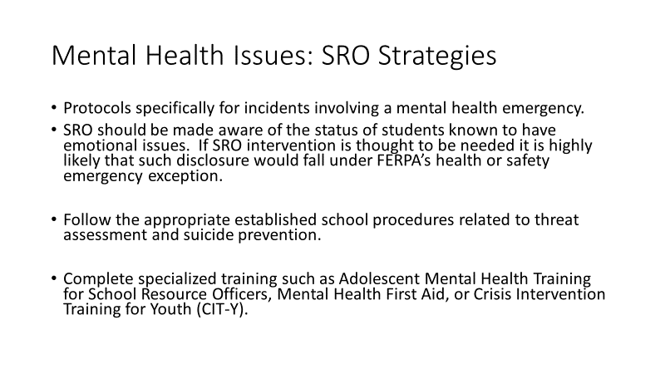 | Mental Health Issues  Guide, p. 70  Key Learning Points:  - The mental health of students has a major impact on their learning.  - A positive and supportive school environment addresses mental health needs in a proactive manner rather than reacting to crises. Consistent with a tiered system of support, such schools:  - promote the well-being of all students,  - intervene early with services and supports to prevent problems, and  - provide intensive intervention for students with serious or acute needs.  - According to the National Institute of Mental Health,  - 20% of youth ages 13 to 18 live with a mental health condition.  - About half of students age 14 and older with a mental illness drop out of school, and 70% of youth in state and local juvenile justice systems have a mental illness.  - In June 2016 the Population Reference Bureau (http://www.prb.org/) announced that suicides had become the second-leading cause of death among teenagers in the United States, surpassing homicide deaths.  Non-emergencies - It is common for SROs to become aware of problem behaviors through direct contact with a student or very commonly through reports of peers who are concerned. Concerning patterns of behavior may not involve violations of school conduct policy or law, but do require further investigation. Concerns should be directed to appropriate school administrators, guidance specialist, or threat assessment team.  Mental health emergencies - In cases of mental health emergencies, SROs may become first responders. A primary concern is how to effectively de-escalate mental health incidents involving agitated or threatening individuals.  SRO Strategies:  - Work with school administrators to develop protocols specifically for incidents involving a mental health emergency. In the case of a student known to have emotional issues, the SRO should be made aware of the student’s status. If SRO intervention is thought to be needed it is highly likely that such disclosure would fall under FERPA’s health or safety emergency exception.  - Follow the appropriate established school procedures related to threat assessment and suicide prevention. Legal requirements for threat assessment and suicides prevention is included in chapter III.  - Consider completing specialized training such as Adolescent Mental Health Training for School Resource Officers, Mental Health First Aid, or Crisis Intervention Training for Youth (CIT-Y).
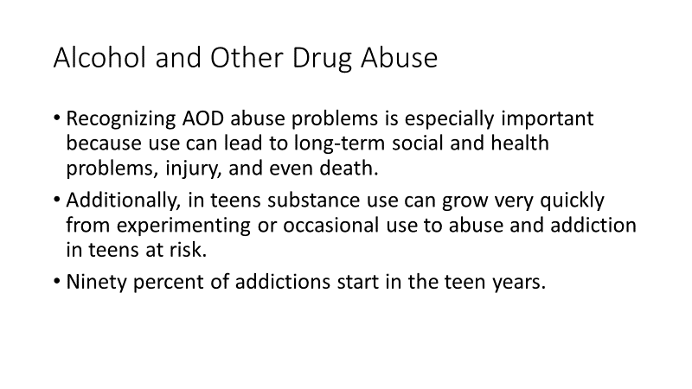  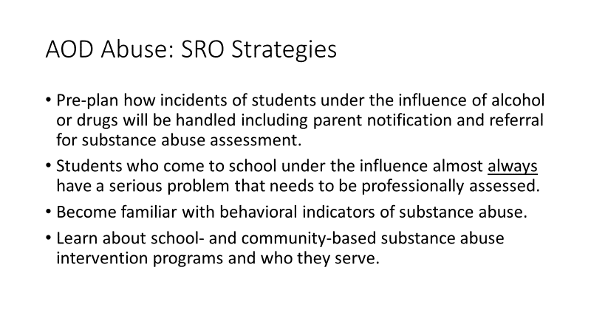 | Alcohol and Other Drug Abuse  Guide, p. 72  Key Learning Points:  - Recognizing alcohol and other drug abuse problems in students is especially important because use can lead to long-term social and health problems, injury, and even death.  - Additionally, in teens substance use can grow very quickly from experimenting or occasional use to abuse and addiction in teens at risk.  - Ninety percent of addictions start in the teen years.  SRO strategies:  - Pre-plan how incidents of students under the influence of alcohol or drugs will be handled including parent notification and referral for substance abuse assessment. Students who come to school under the influence almost always have a serious problem that needs to be professionally assessed.  - Become familiar with behavioral indicators of substance abuse.  - Learn about school- and community-based substance abuse intervention programs and who they serve.
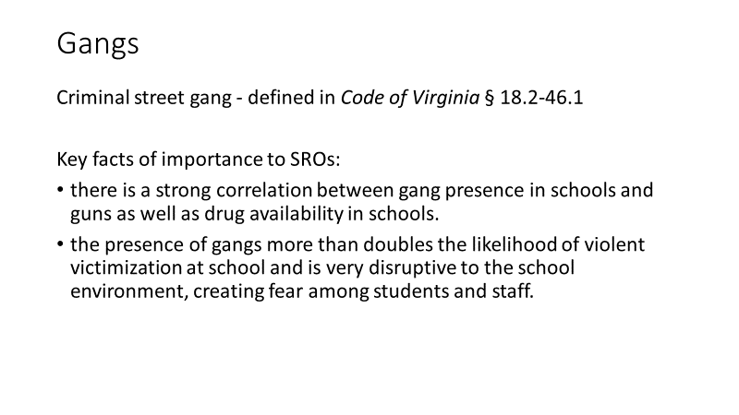  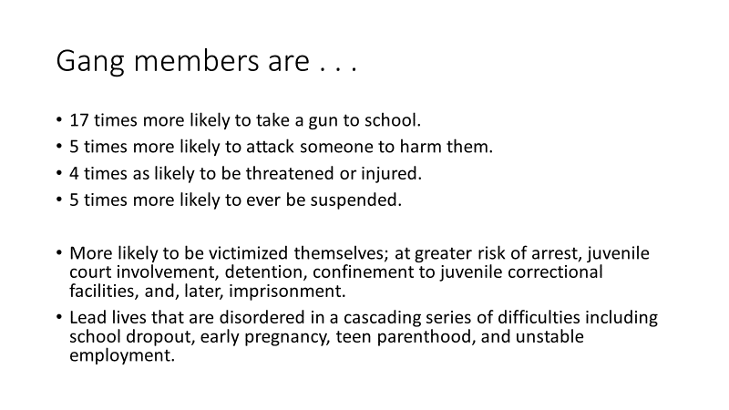  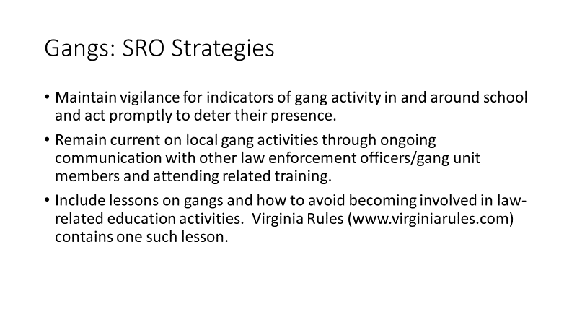 | Gangs  Guide, p. 73  Key Learning Points:  Virginia law (Code of Virginia § 18.2-46.1) defines a “criminal street gang” as  - any group, organization or association of three or more persons, whether formal or informal, which has as one of its primary objectives or activities the commission of one or more criminal acts,  - which has an identifiable name or identifying sign or symbol, and  - whose members individually or collectively have engaged in the commission of, attempt to commit, conspiracy to commit, or solicitation of two or more predicate criminal acts, at least one of which is an act of violence.  Facts of importance to SROs:  - there is a strong correlation between gang presence in schools and guns as well as drug availability in schools.  - the presence of gangs more than doubles the likelihood of violent victimization at school and is very disruptive to the school environment, creating fear among students and staff.  Juvenile gang members are responsible for far more than their share of all self-reported criminal activity, and are also far more likely to be the victims of such acts. In Virginia, studies show that students involved in gang activity are:  - 17 times more likely (31.6 percent) than all respondents (3.9 percent) to take a gun to school, and five times more likely (11.9 percent) to attack someone to harm them.  - Over four times as likely (36.7 percent) than all respondents (8.6 percent) to be threatened or injured.  - Five times more likely (31.3 percent) than all respondents (6.4 percent) to ever be suspended.  Sadly, gang membership has very negative impacts on gang members’ lives:  - Gang members are more likely to be victimized themselves. They are also at greater risk of arrest, juvenile court involvement, detention, confinement to juvenile correctional facilities, and, later, imprisonment.  - Gang involvement dramatically alters young peoples’ life changes. The gang acts as “a powerful social network” constraining and limiting members so they are cut off from conventional pursuits such as education and employment. Rather than making successful transitions to adulthood, their lives are disordered in a cascading series of difficulties including school dropout, early pregnancy, teen parenthood, and unstable employment.  SRO Strategies:  - Maintain vigilance for indicators of gang activity in and around school and act promptly to deter their presence.  - Remain current on local gang activities through ongoing communication with other law enforcement officers/gang unit members and attending related training.  - Include lessons on gangs and how to avoid becoming involved in law-related education activities. Virginia Rules (www.virginiarules.com) contains one such lesson.
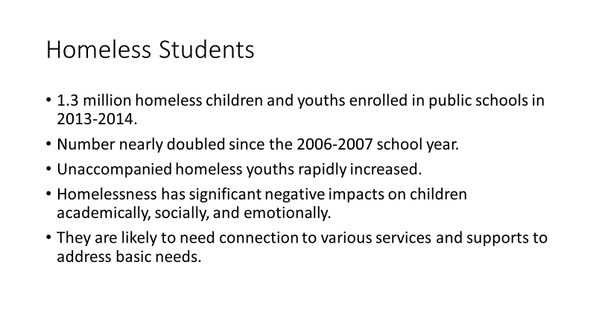  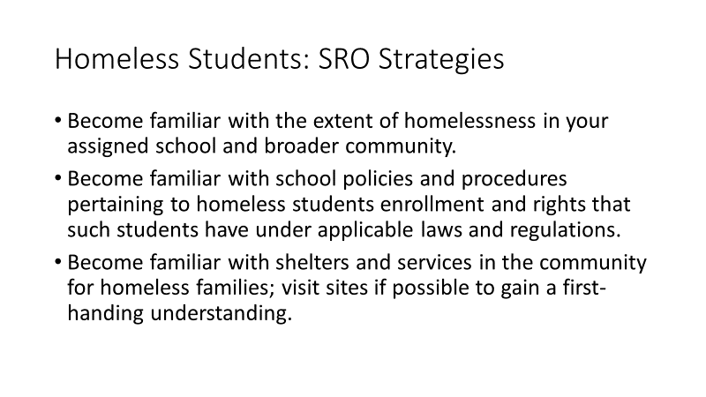 | Homeless Students  Guide, p. 74  Key Learning Points:  - During the 2013-2014 school year, more than 1.3 million homeless children and youths were enrolled in public schools in 2013-2014.  - The number of homeless children and youths enrolled in public schools has nearly doubled since the 2006-2007 school year.  - Further, the number of unaccompanied homeless youths (not in the physical custody of a parent or guardian) identified by schools has more than doubled to nearly 100,000.  - Homelessness has significant negative impacts on children academically, socially, and emotionally.  - They are likely to need connection to various services and supports to address basic needs.  SRO Strategies:  - Become familiar with the extent of homelessness in your assigned school and broader community.  - Become familiar with school policies and procedures pertaining to homeless students enrollment and rights that such students have under applicable laws and regulations.  - Become familiar with shelters and services in the community for homeless families; visit sites if possible to gain a first-handing understanding.  To Learn More about Homelessness  Supporting the Success of Homeless Children and Youth - A factsheet and tips for teachers, principals, school leaders, and other school staff. Available at:  http://www2.ed.gov/policy/elsec/leg/essa/160315ehcyfactsheet072716.pdf
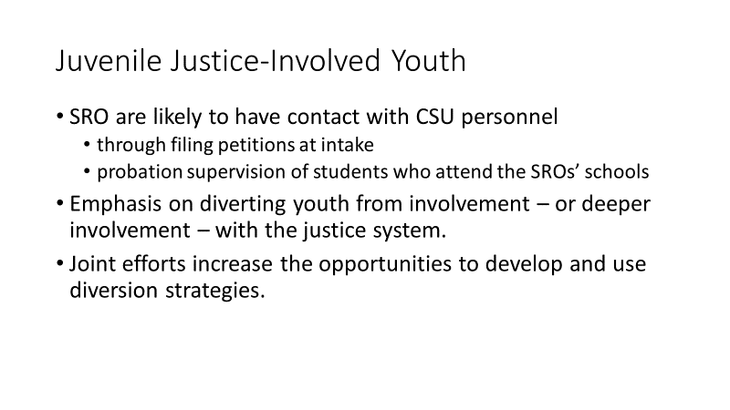 | Juvenile Justice-Involved Youth  Guide, p. 74  Key Learning Points:  - SROs in Virginia are likely to have regular contact with Court Service Unit (CSU) personnel, either related to filing petitions at intake or the probation supervision of students who attend the SROs’ schools.  - Recent juvenile justice reforms have placed great emphasis on diverting youth from involvement – or deeper involvement – with the justice system.  - Joint efforts involving SROs and CSU staff increase the opportunities to develop and use diversion strategies.  SRO Strategies:  - Develop relationships with Court Services Unit personnel who handle intake and provide probation supervision of students in your assigned school.  - Learn about any diversion efforts at the juvenile court. There may be opportunities for additional collaboration to address minor offenses through mediation, restitution, completion of brief interventions that avoid filing a formal petition or appearance before a judge.  - Consider involving CSU personnel in law-related education activities; they would be expert presenters on the juvenile justice process.  To Learn More about Court Service Units and Juvenile Justice in Virginia  Information about Virginia’s 34 court service units (CSUs) is available at http://www.djj.virginia.gov/pages/community/court-service-units.htm
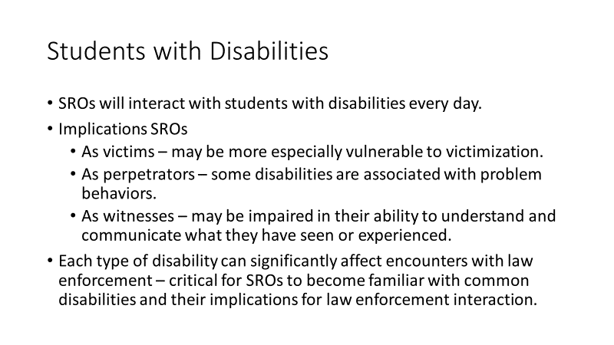  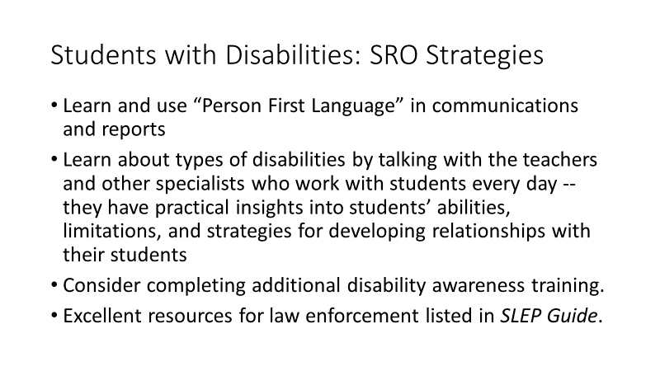 | Students with Disabilities  Guide, p. 74-75  - SROs interact with students with disabilities on a daily basis. Some disabilities are visible while others are invisible, not signaling to the SRO or other law enforcement officer that they are dealing with a student with a disability.  - Implications SROs  - As victims – students with cognitive disabilities are especially vulnerable to victimization; persons with disabilities are 4 to 10 times more likely to be victims.  - As perpetrators – some disabilities are associated with problem behaviors.  - As witnesses – some students who witness an incident may be impaired in their ability to understand and communicate what they have seen or experienced.  - Each type of disability can significantly affect encounters with law enforcement. Some persons with autism, for example, are known to wander or run away, are attracted to water (a hazard!), react to overstimulation such as sirens, to repeat what is said to them (called echolalia), avoid touch, lack a fear of dangers, and resist restraint – sometimes violently.  - It is critical for SROs to become familiar with common disabilities and their implications for law enforcement interaction.  SRO Strategies:  - Begin by learning and using “Person First Language” and using the language in communications with others and in official reports.  Examples of Person First Language  Rather than this. . . Say this. . .  The disabled, handicapped Person with a disability  Retarded, slow, simple-minded, moronic Person with an intellectual, cognitive, developmental disability  Confined to a wheelchair, wheelchair bound Person who uses a wheelchair  Insane, crazy, nuts, psycho Person with an emotional or behavioral disability  Learn more: Communicating With and About People with Disabilities – Available at:  http://www.cdc.gov/ncbddd/disabilityandhealth/pdf/DisabilityPoster_Photos.pdf  - Learn about types of disabilities by talking with the teachers and other specialists who work with students every day; they will have practical insights into their students’ abilities, limitations, and strategies for developing relationships with their students  - Consider completing additional disability awareness training.  - Use resources listed to learn more about disabilities and implications for school-law enforcement partnerships
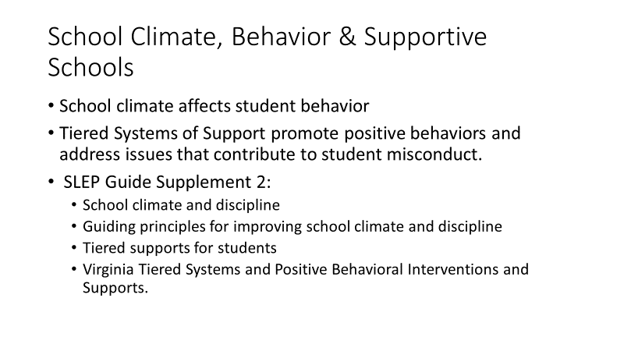 | School Climate, Student Behavior, and Supportive Schools  Explain that now we look at strategies for safe and supportive schools.  It is important for SRO effectiveness to understand the importance of school climate, how it affects student conduct, and the systems of support that are in schools to address issues that contribute to student misconduct.  Refer participants to the SLEP Guide, Supplement 2, beginning on p. 94.  Explain: We’ll first look at how school climate affects student behavior, then guiding principles for improving school climate, then tiered supports for students that operate in Virginia schools.
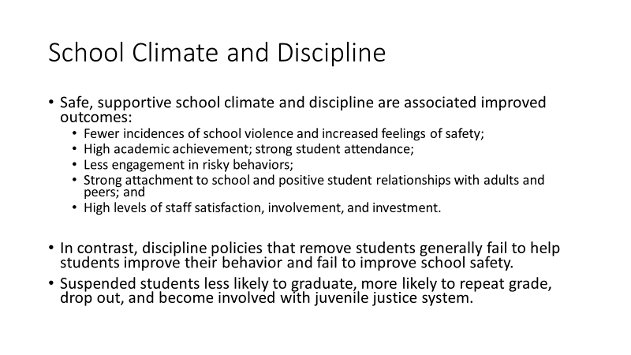 | Background on School Climate and Discipline  Guide, Supplement 2, pp. 94-97  Key Learning Points:  - According to the U.S. Department of Education, safe, supportive school climate and discipline are associated a number of improved outcomes, including:  - Fewer incidences of school violence and increased feelings of safety;  - High academic achievement;  - Strong student attendance;  - Minimal engagement in risky behaviors;  - Strong attachment to school and positive student relationships with adults and peers; and  - High levels of staff satisfaction, involvement, and investment.  - In contrast, discipline policies and practices that remove students from engaging instruction — such as suspensions, expulsions, and inappropriate referrals to law enforcement — generally fail to help students improve their behavior and fail to improve school safety.  - Suspended students are less likely to graduate on time and more likely to repeat a grade, drop out of school, and become involved in the juvenile justice system
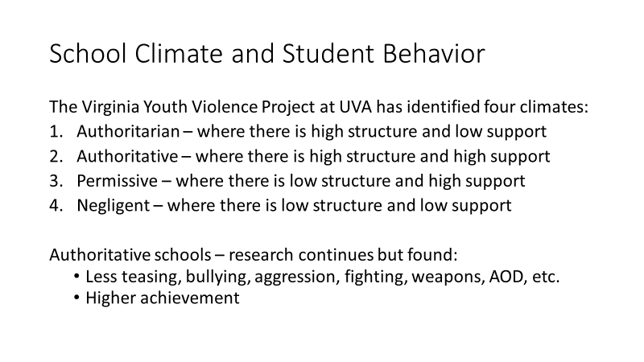 | School Climate and Student Behavior  Guide, p. 94  Key Learning Points:  - The Virginia Youth Violence Project at UVA have conducted extensive research on school climate.  - Applying research in developmental psychology and findings from Virginia school climate surveys, they have identified four climates:  - Authoritarian – where there is high structure and low support  - Authoritative – where there is high structure and high support  - Permissive – where there is low structure and high support  - Negligent – where there is low structure and low support  - The research is continuing but findings to date demonstrate that authoritative schools, compared to schools with other climates, have:  - less teasing and bullying;  - less student aggression towards teachers;  - fewer disciplinary infractions for aggressive behavior;  - high achievement test passing rates;  - less fighting and weapon carrying at school;  - less alcohol and marijuana use; and  - lower suspension rates for black and white students.
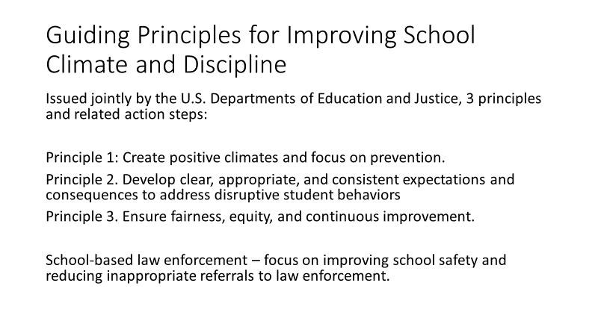 | Guiding Principles for Improving School Climate and Discipline  Guide, pp. 95-96  Key Learning Points:  U.S. Departments of Education and of Justice have issued guiding principles for improving school climate and discipline identifying three principles and action steps associated with each principle.  Principle 1. Create positive climates and focus on prevention  Principle 2. Develop clear, appropriate, and consistent expectations and consequences to address disruptive student behaviors  Principle 3. Ensure fairness, equity, and continuous improvement  The action steps associated with each Principle are detailed in the SLEP Guide. Of particular importance to SROs as the recommended action step:  - Ensure that any school-based law enforcement officers’ roles focus on improving school safety and reducing inappropriate referrals to law enforcement.
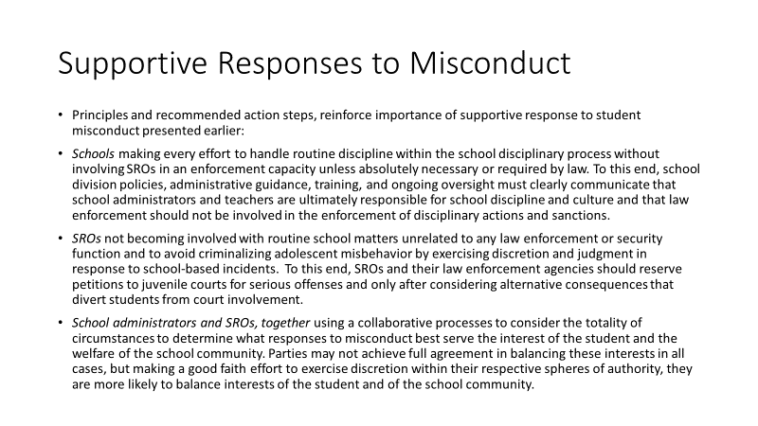 | Supportive Responses to Student Misconduct:  Key Learning Points:  - These principles and recommended action steps are consistent with and even reinforce the supportive responses to student misconduct presented earlier:  - Schools making every effort to handle routine discipline within the school disciplinary process without involving SROs in an enforcement capacity unless absolutely necessary or required by law.  - To this end, school division policies, administrative guidance, training, and ongoing oversight must clearly communicate that school administrators and teachers are ultimately responsible for school discipline and culture and that law enforcement should not be involved in the enforcement of disciplinary actions and sanctions.  - SROs not becoming involved with routine school matters unrelated to any law enforcement or security function and to avoid criminalizing adolescent misbehavior by exercising discretion and judgment in response to school-based incidents.  - To this end, SROs and their law enforcement agencies should reserve petitions to juvenile courts for serious offenses and only after considering alternative consequences that divert students from court involvement.  - School administrators and SROs, together using a collaborative processes to consider the totality of circumstances to determine what responses to misconduct best serve the interest of the student and the welfare of the school community. Parties may not achieve full agreement in balancing these interests in all cases, but making a good faith effort to exercise discretion within their respective spheres of authority, they are more likely to balance interests of the student and of the school community.
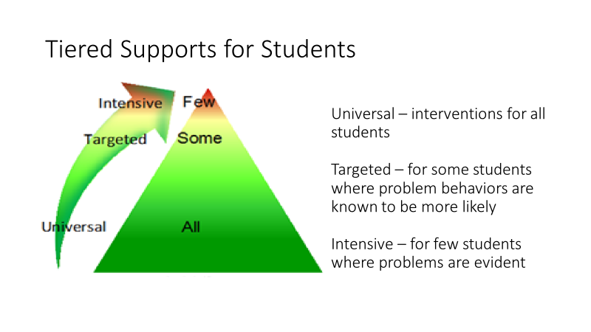  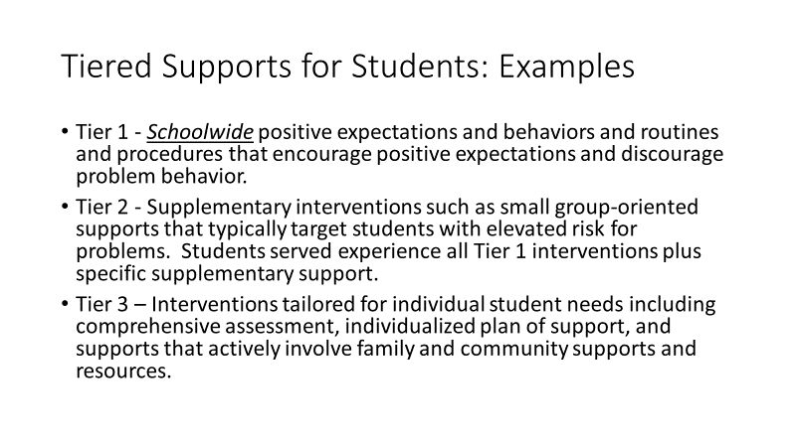 | F. Tiered Supports for Students  Guide, p. 97  Key Learning Points:  Looking at the “multi-tiered behavioral framework” that reflects the logic of the tiered system of supports, there are three levels of supports:  Universal – resources and interventions for all students  Targeted – serving some students who are at risk; problem behaviors are known to be more likely  Intensive – serving a few students where problems are evident  Examples for each tier:  Tier 1 - Schoolwide positive expectations and behaviors and routines and procedures that encourage positive expectations and discourage problem behavior.  Tier 2 - Supplementary interventions such as small group-oriented supports that typically target students with elevated risk for problems. Students served experience all Tier 1 interventions plus specific supplementary support.  Tier 3 – Interventions tailored for individual student needs including comprehensive assessment, individualized plan of support, and supports that actively involve family and community supports and resources.
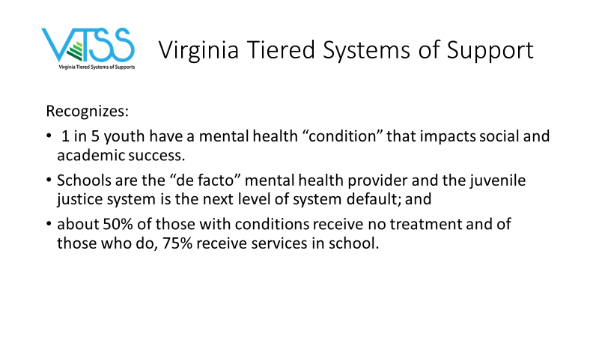 | Virginia Tiered Systems of Support  Guide, p. 98  Key Learning Points:  Virginia’s Tiered Systems of Support recognizes that --  - 1 in 5 youth have a mental health “condition” that impacts social and academic success.  - Schools are the “de facto” mental health provider and the juvenile justice system is the next level of system default; and  - about 50% of those with conditions receive no treatment and of those who do, 75% receive services in school.
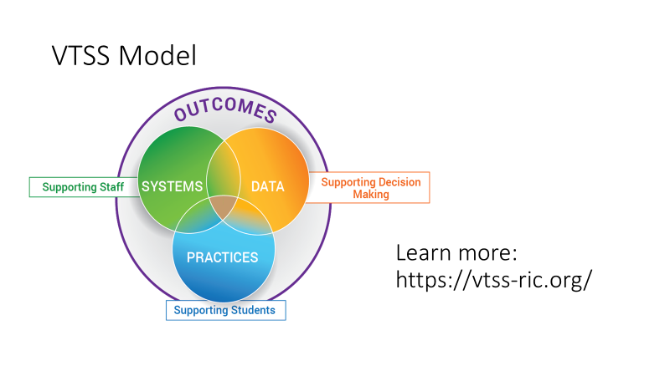 | VTSS Model  Guide, p. 98  Key Learning Points:  The VTSS Model uses practices supporting students within systems supporting staff and data used to inform decision making to achieve more positive outcomes for youth.  You can learn more about VTSS at  https://vtss-ric.org/about-us/
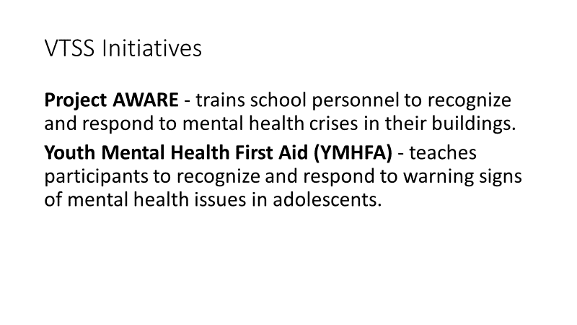 | VTSS Initiatives  Two initiatives of VTSS are:  - Project AWARE - trains school personnel to recognize and respond to mental health crises in their buildings. Registered participants have access to workgroup materials.  - Youth Mental Health First Aid (YMHFA) - a training program that teaches participants to recognize and respond to warning signs of mental health issues in adolescents.
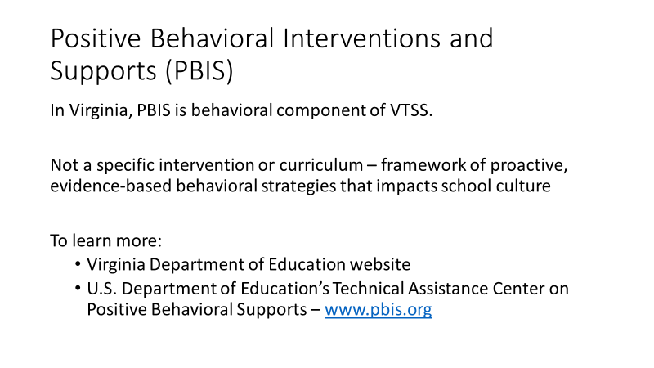 | Positive Behavioral Interventions and Supports (PBIS)  Guide, p. 99  Key Learning Points:  In Virginia schools, PBIS is the behavioral component of the Virginia Tiered Systems of Supports (VTSS).  PBIS is not a specific intervention or curriculum, but provides a framework of proactive, evidence-based behavioral strategies that impacts school culture, shifting attention to positive behavior and successful learning systems.  To learn more, see the Virginia Department of Education website and the U.S. Department of Education’s technical assistance center on positive behavioral supports – www.pbis.org
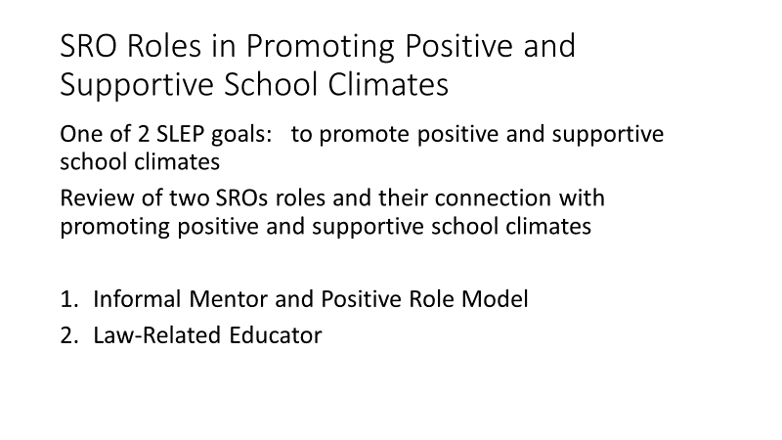 | SRO Roles in Promoting Positive and Supportive School Climates  Explain: If you recall from Module I one of the two goals of school-law enforcement partnerships was:  1) to promote positive and supportive school climates  This module will conclude with a review of two SROs roles, connecting the dots with positive and supportive school climates.  - Informal Mentor and Positive Role Model  - Law-Related Educator  Refer participants to Chapter II, Section A, beginning on p. 28
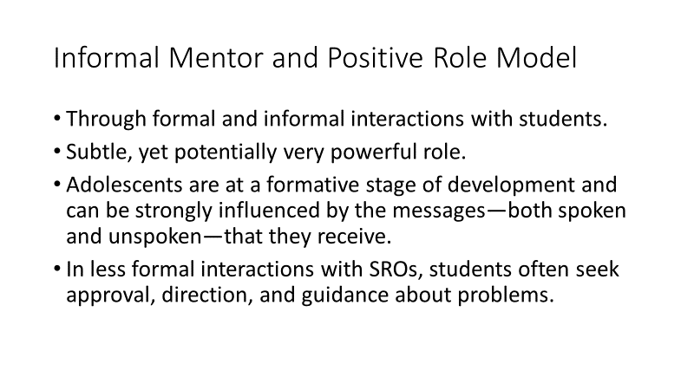  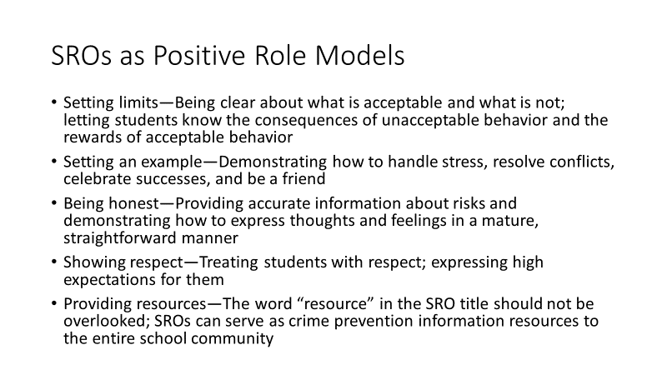 | G. Informal Mentor and Positive Role Model  Guide, p. 28  Key Learning Points:  - SROs serve as informal mentor and positive role model through formal and informal interactions with students that increase the visibility and accessibility of police to the school community.  - This is a subtle, yet potentially very powerful role  - Adolescents are at a formative stage of development and can be strongly influenced by the messages—both spoken and unspoken—that they receive.  - In the less formal interactions with SROs, students often seek approval, direction, and guidance about problems.  SROs serve as positive role models by:  - Setting limits—Being clear about what is acceptable and what is not; letting students know the consequences of unacceptable behavior and the rewards of acceptable behavior  - Setting an example—Demonstrating how to handle stress, resolve conflicts, celebrate successes, and be a friend  - Being honest—Providing accurate information about risks and demonstrating how to express thoughts and feelings in a mature, straightforward manner  - Showing respect—Treating students with respect; expressing high expectations for them  - Providing resources—The word “resource” in the SRO title should not be overlooked; SROs can serve as crime prevention information resources to the entire school community
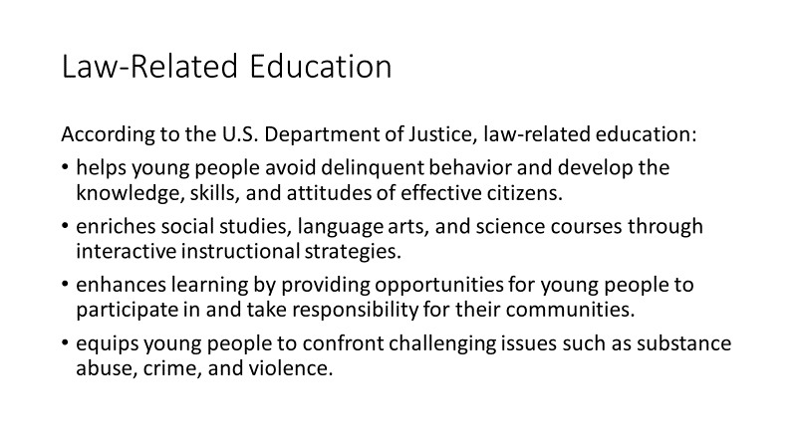 | H. SRO Law-Related Educator Role  Guide, p. 27 and Supplement 1, pp. 89-91  Refer participants to Supplement 1, p. 89 - items related to law-related education.  Key Learning Points:  - We looked at the law-related educator role briefly in Module I and we identified important resources for law related education. We’re going to briefly look at the law related education resources that are in the SLEP Guide, Supplement 1 Toolkit.  According to the U.S. Department of Justice, law-related education:  - helps young people avoid delinquent behavior and develop the knowledge, skills, and attitudes of effective citizens.  - enriches social studies, language arts, and science courses through interactive instructional strategies.  - enhances learning by providing opportunities for young people to participate in and take responsibility for their communities.  - equips young people to confront challenging issues such as substance abuse, crime, and violence.
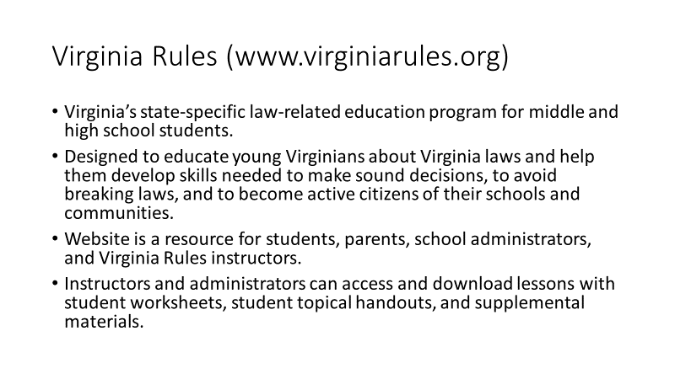 | Virginia Rules  Key Learning Points:  - Virginia Rules (www.virginiarules.org) is Virginia’s state-specific law-related education program for middle and high school students.  - It is designed to educate young Virginians about Virginia laws and help them develop skills needed to make sound decisions, to avoid breaking laws, and to become active citizens of their schools and communities.  - The website is designed as a resource for students, parents, school administrators, and Virginia Rules instructors.  - Instructors and administrators can access and download lessons with student worksheets, student topical handouts, and supplemental materials.
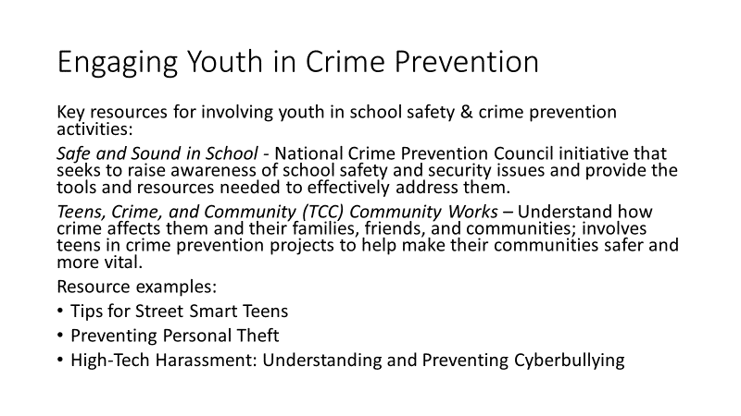 | Engaging Youth in School Safety and Other Crime Prevention Activities  Guide, p. 90  Key Learning Points:  - SROs who conduct law-related education often engage youth in school safety and crime prevention activities.  - Key resources include:  Safe and Sound in School (B3S)  http://www.ncpc.org/topics/programs/be-safe-and-sound-campaign  This is an initiative of the National Crime Prevention Council that seeks to raise awareness of school safety and security issues and provide the tools and resources needed to effectively address them.  Teens, Crime, and Community (TCC) Community Works  http://www.ncpc.org/topics/programs/teens-crime-and-the-community  TCC's Community Works program helps teens understand how crime affects them and their families, friends, and communities, and it involves them in crime prevention projects to help make their communities safer and more vital.  Resource examples:  - Tips for Street Smart Teens  - Preventing Personal Theft  - High-Tech Harassment: Understanding and Preventing Cyberbullying
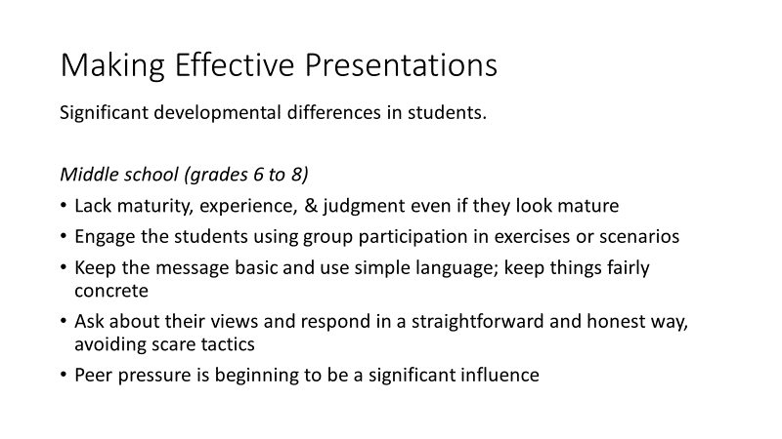  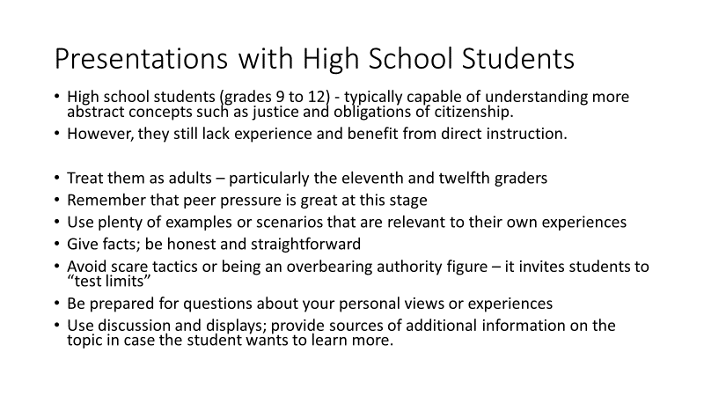 | Making Effective Presentations  Guide, p. 92 - 93  Key Learning Points:  - Some SROs have served as DARE officers and are comfortable with making presentations to both student and adult audiences. However, many officers assigned to schools don’t have that level of training and experience in making presentation.  - Two resources in the SLEP Guide are designed to help.  Very briefly review “Tips” from the two resources being presented.  - First is Tips for Effective Presentation with Students at Different Grade Levels  - When working with students, there are some significant developmental differences to keep in mind when selecting the topics and how you present them.  - Briefly, with middle school students (6-8)  There is a great deal of variation in the developmental stages of students in middle school; it is a transition period from childhood to early adolescence. Many sixth graders will appear quite childlike; by eighth grade most girls and some boys will appear quite mature. Despite the appearance of physical maturity, these students lack the maturity, experience, and judgment of older adolescents.  - Engage the students using group participation in exercises or scenarios  - Keep the message basic and use simple language; keep things fairly concrete  - Ask about their views and respond in a straightforward and honest way, avoiding scare tactics  - Peer pressure is beginning to be a significant influence  With high school students (9-12)  High school students are typically capable of understanding more abstract concepts such as justice and obligations of citizenship; however, they still lack experience and benefit from direct instruction.  - Treat them as adults – particularly the eleventh and twelfth graders  - Remember that peer pressure is great at this stage  - Use plenty of examples or scenarios that are relevant to their own experiences  - Give facts; be honest and straightforward  - Avoid scare tactics or being an overbearing authority figure – it invites students to “test limits”  - Be prepared for questions about your personal views or experiences  - Use discussion and displays; provide sources of additional information on the topic in case the student wants to learn more.
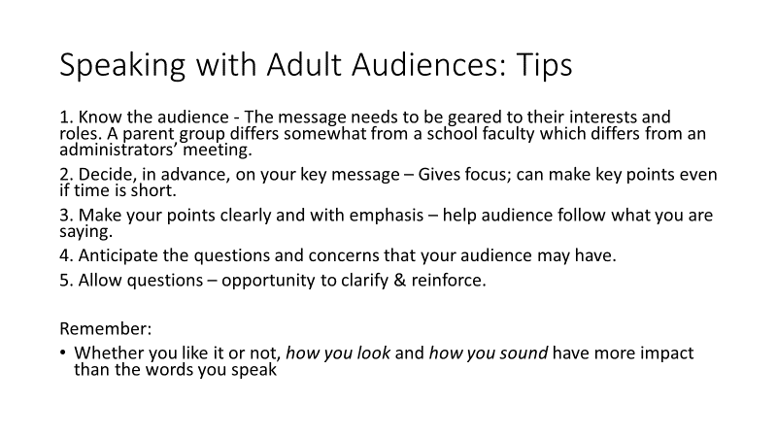 | Public Speaking Tips with Adult Audiences  Guide, p. 93  Key Learning Points:  - SROs have many opportunities to speak publicly – at faculty meetings, PTA, and community advisory councils, and civic organizations.  The essentials of public speaking are:  1. Know the audience  The message needs to be geared to their interests and roles. A parent group differs somewhat from a school faculty which differs from an administrators’ meeting.  2. Decide, in advance, on your key message  This not only helps give your message focus, but can be critical when a meeting runs longer than expected and you do not have as much time as you thought you would. By knowing the key message, you can effectively abbreviate your remarks and not lose the key point(s).  3. Make your points clearly and with emphasis  Use phrases such as “my second point is. . .” to help the audience follow what you are saying.  4. Anticipate the questions and concerns that your audience may have  Try to answer these within the presentation. Say, “A concern that parents often have is . . .” or “Teachers have often asked me. . .”  5. Allow questions  This gives you an opportunity to clarify any points which might have been misinterpreted and to make your points again.  Remember:  Whether you like it or not, how you look and how you sound have more impact than the words you speak
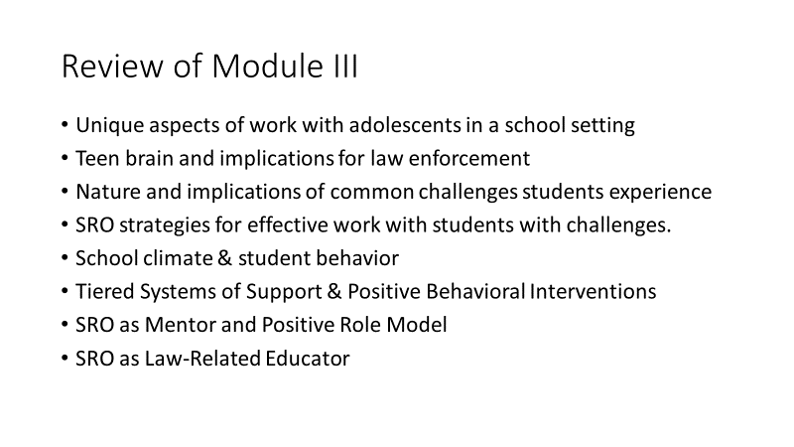 | Review of Module III  Key Review Points:  - In this module we have focused on working effectively with adolescents in a school setting.  - We first looked at the ways adolescents are different, brain development and the many implications for law enforcement.  - Next, we looked at a series of challenges that students experience – and, for each of these challenges, we identified the implications for law enforcement and offered some very specific strategies for SRO effectiveness with these populations.  - Then, we looked at the connections between school climate and how students behave and specifically how SROs can contribute to improving school climate.  - Then, we looked at tiered supports for students and Virginia’s model for intervening and supporting students.  - We then concluded with closer looks at the roles of SROs Mentor and Positive Role Model and as Law-Related Educator

