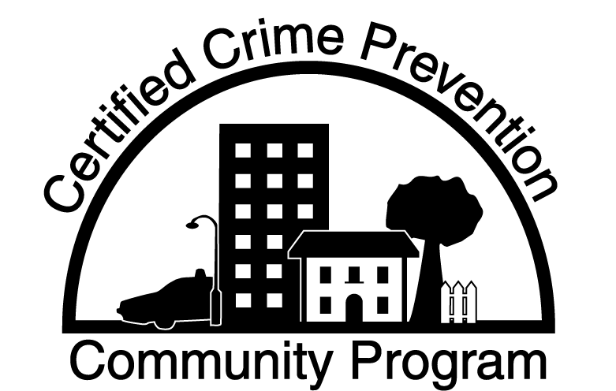

RESOLUTION OF PARTICIPATION

WHEREAS, The governing body of __________________________ is interested in the safety and security of its citizenry and the community at large; and,

WHEREAS, The governing body is prepared to support appropriate efforts within the community to become totally prepared to promote crime prevention and community safety; and,

WHEREAS, The Department of Criminal Justice Services offers a program which is specifically designed to recognize Virginia communities committed to crime prevention and community safety while providing a framework for those communities to institutionalize crime prevention at the local level; and,

WHEREAS, This program is entitled the Certified Crime Prevention Community Program,

NOW ThErEFOrE, BE IT RESOLVED by the ____________________ That our community, ______________________________________ wishes to participate in the Certified Crime Prevention Community Program, and that the leadership of this community fully supports all reasonable efforts to meet the DCJS requirements to become designated as a Certified Crime Prevention Community; and

BE IT FURTHER RESOLVED, that the program requires the existence or formation of a local community crime prevention/community safety council or coalition, and this governing body designates the _____________________________ as representing our community for the purpose or participating in this program.

This resolution is in full effect upon its adoption this ____day of ___________, 20__

__________________________________
SEAL: Official

__________________________________
Title

__________________________________
Attest

__________________________________
Title

STATEMENT OF INTENT

Our community, ________________________________________ wishes to participate in the Certified Crime Prevention Community Certification Program. The leadership of this community fully realizes this program requires dedicated effort. By making entry into this program, we are pledging our honest efforts to become designated as a "Certified Crime Prevention Community".

The program requires the existence of formation of a local community crime prevention/community safety council or coalition. The name of this council/coalition is___________________________________.

we understand that the goal of our community is to complete successfully this program within six (6) months of the day of the official start date, to be recorded when the program manual is delivered.

__________________________ _______________________
Designated Official Program Coordinator

__________________________ _______________________
Title Title

__________________________ _______________________
Date Date

Address for Contact: Address for Contact:
___________________________ ___________________________
___________________________ ___________________________
___________________________ ___________________________
___________________________ ___________________________

Telephone: Telephone:

Office ______________ Office ______________

Home ______________ Home ______________

