De-escalation / Crisis Intervention for Law Enforcement During the Pandemic Crisis
By
James L. Greenstone, Ed.D., J.D., DABECI
Deputy Sheriff, Tarrant County Sheriff’s Office
Professor, Disaster and Emergency Management, Nova Southeastern University, College of Osteopathic Medicine
Dr.james.greenstone@gmail.com

And

Sharon C. Leviton, Ph.D., DABECI
drleviton@juno.com

“Police In US Say Arrests Are Last Resort To Enforce Coronavirus Distancing”
ABC News
What should be the first resort? Crisis Intervention or De-escalation.
When a crisis situation occurs in a person’s life it usually occurs suddenly, unexpectedly, and arbitrarily. Such an occurrence tends to raise experienced stress to levels that exceed those in normal, non-crisis times in their life. When this happens, the individual may have difficulty leading their life and making decisions in the way that they normally do. This individual is not as much out-of-control as they are out-of-structure. And, they are not mentally ill. All of us rely on structure in our lives. When that structure is significantly changed, that individual will experience a crisis in their life that will not be reconciled until the experienced structure is regained. Since they will have some difficulty in regaining this structure by themselves, the immediate and skillful intervention of a law enforcement officer could mean the difference between that person being able to get on with their life constructively as they usually would rather than continuing to deteriorate further into their crisis scenario. The results of their continued deterioration can be psychologically debilitating or even deadly. A crisis is time sensitive and self-limiting. Do nothing and the crisis will eventually end. Where it will end poses the real problem in terms of regaining effective functioning. The Crisis Cube below may help to explain this crisis phenomenon. A detailed explanation of the Cube is contained in the references listed below. (Greenstone, 2008 and 2015, and Greenstone and Leviton, 2011).
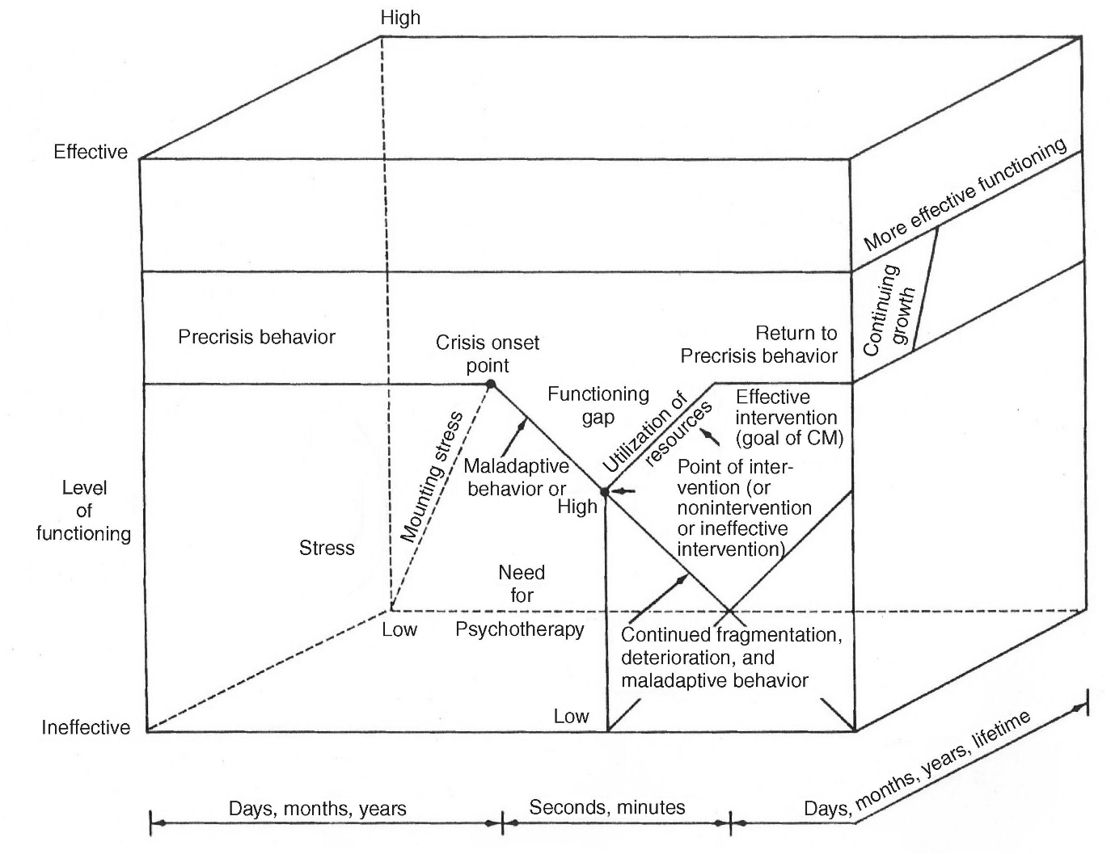
The Crisis Cube (Copyright 2019. Dr. James L. Greenstone)

Whatever needs to be done by the law enforcement officer present during such a situation, they must act immediately, quickly and decisively. They must seek to control the situation as much as possible until the crisis victim is able to assume that control as they usually would. No more, no less. Control can be exhibited by
the officer’s willingness to listen to the victim, by helping the individual to move to a safer place as needed, getting the victim to medical assistance if needed, by showing personal confidence that the officer can and will assist the victim to regain structure in their life, and by a willingness to provide thoughtful alternatives to the current behavior of the victim. The officer is actually acting to some degree in the stead of the crisis victim but only until that victim can regain self-control. It is important that control of their life be returned to the victim as soon as possible and be done sensitively and consistently. Sometimes questions, requesting permissions, acknowledging strengths, and using good listening skills can bridge this structure-gap in the victim’s life.
It is important for the law enforcement officer to attempt to find out what is the source of the crisis that the person is experiencing. Sometimes the source will be more obvious to the observant officer, sometimes not. Observation and a few well-constructed questions combined with a willingness to listen to the responses will often go a long way in this encounter. It is important to understand that the more severe the perceived threat and the greater the danger to the person themselves, the greater the risk of crisis. The Pandemic - Crisis Continuum below demonstrates how this might occur. It is explained in detail in the references listed below. (Greenstone, 2008 and 2015, and Greenstone and Leviton, 2011).

The Pandemic – Crisis Continuum ©Copyright 2019. Dr. James L. Greenstone
Self Self Envelope Envelope Envelope Envelope
Offended Insecure Threatened Injured Entered Destroyed
NB. The “envelope” refers to the crisis victim’s body.

Less invasion of self Greater invasion of self
Crisis Potential
Less direct contact with the pandemic Direct contact with pandemic

Experience Pandemic Fear of Actual Life - Possibility
Pandemic Personalized Immediate Injury/illness Threatening of Death
Injury/illness Sustained Injury/illness

Increased direct contact with the pandemic and the likelihood of personal crisis
NB. This may be experienced by the victim or by significant others of the victim.
Once some calm and structure has been established or returned to the victim, realistic problem solving can take place. Attempting to reason with a person who is experiencing a crisis may yield little, if any, positive results. If the above noted steps are followed initially, the likelihood that reasoning and planning will work at this stage will improve dramatically. The officer has acted immediately, taken control as necessary, been willing to listen without judgement, and has progressively returned control to the victim. Now, it may be possible to get the person additional help as needed, and to include that person in the decision-making process. Always remember, and never forget, that communications between people involves at least two important components. The first component is what the crisis intervener says to the crisis victim. The second is how what was said is understood by the listener. Every attempt should be made to ensure that the message sent is actually the message received. Do not assume anything. Clarify what you said by asking the victim to tell you what was received. Include the crisis victim in the decision-making process as much as possible considering how they are faring at that time. Keep them involved. Not keeping them involved and part of the recovery process tends to enhance their victimhood.
If additional psychological help or psychotherapy is needed and desired by the victim, referrals should be carefully made. The officer may want to research such sources before suggesting them to the victim. A botched referral can cost both the victim and the officer an otherwise successful intervention.
Remember the model described above: Immediacy, Control, Assessment, Disposition, Referral and Follow-up as needed and as possible. The intervener’s concern is with crisis management rather than crisis resolution. They are assisting the sufferer to return to their own level of pre-crisis functioning.
As may be obvious, utilization of the same model when attempting to assist fellow law enforcement officers who are in crisis, this model will work as well. The willingness to help another officer is important. It is also important to allow another skilled officer to help you if you may be overwhelmed by your personal or professional situation and are approaching crisis. Think about it. Help each other and help those you serve. It may be that you are the vital link that is needed.
End Notes
Asking Good and Helpful Questions
Asking questions
Avoid asking “why” questions.
Keep your questions present-oriented. “Who,” “What,” “Where,” “When,” “How.”
Keep your questions simple.
Confirm that the sufferer understands your question.
Avoid complex or multi-part questions.
Ask permission if your actions involve them.
Don’t ask more questions than are necessary.
Do not assume that silence by the victim means nothing.
Allow sufficient time for the sufferer to answer the questions asked.
Ask open-ended questions to gain more information.
What happened?
Can I talk with you?
Will you tell me what is going on?
Is there something that I can do to help?
How can I assist you?
Who can I call to be with you at this time?
Where would you like to go?
When did this happen to you?
Can you tell me a little more?
RESPONDING TO THE VICTIM IN AN EFFECTIVE WAY
Responding to another person’s feelings is a delicate process. In gathering information from victims, interveners must handle feelings with care and concern. If the intervener wants the victim to continue to talk about facts pertinent to the problem, the intervener cannot judge, use logic, or attempt to give advice. The individual’s feelings must be legitimized. The goal is to increase communication rather than shut it down.

CRISIS INTERVENTION PROCEDURE
What is most often needed in the early stages of the pandemic crisis is crisis management. Not crisis treatment or crisis resolution, but crisis management. This involves such things as, but are not limited to, structure, answers, honesty, direction, and guidance. The model may vary according to style and training, but the goal is the same.
- Understand and respond to the timeliness of a crisis.
- Remember that crises are self-limiting.
- Remember that crises are time limited.
- Understand that most reactions to a crisis or disaster situation are normal, to be expected, and usual under the circumstances.
- Know the threats presented by your particular situation.
- Adjust to the reality that you cannot attend to or preserve every victim.
- Learn to accept that some victims will die.
- Encourage self-reliance among victims.
- Follow the model for crisis intervention of
Immediacy,
Control,
Assessment,
Disposition,
Referral, and
Follow-up.
- Remember that different people may respond differently to the same situation.
- Accept your duty to normalize.
- Educate others so that panic will not ensue.
- Exude confidence even though you might be scared yourself.
- Although you will be involved with victims, acknowledge problem ownership of the victim.
- Avoid overidentification with victims. They need your help, not your pity.
- Recognize symptoms of psychological stress such as anger, self-blame, isolation, withdrawal, blaming, fear, feeling stunned, variations in mood, feelings of helplessness, the tendency to deny, memory problems, family discord, sadness, and grief.
- Recognize the physiological symptoms such as limited or no appetite, chest pains, body aches, headaches, gastrointestinal problems, hyperactivity, drug and/or alcohol abuse or misuse, trouble getting to sleep or staying asleep, troubled dreams and nightmares, and low energy levels and fatigue even after rest or sleep.
- Emphasize the team approach.
- Force fluids for interveners.
- Use fluids as indicated for victims.
- Remember that responses of victims may be mediated by cognitive functioning, physical health, personal relationships, duration and intensity of normal life disruption, personal meaning attached to the disaster or related events, the usual psychological well-being of the victim pre-crisis, and by elapsed time since the disaster occurred.
- Always perform an immediate assessment of victims or sufferers when encountered.
- Enlist assistance of those able to be of help.
- Support those who need support.
- Listen. Listen carefully.
- Help victims to reconnect with usual and normal support systems.
- Expect that victims may need help accessing support systems.
- Be cautious in offering advice to sufferers.
- Provide the needed psychological structure for a victim.
- Provide the needed physical structure for a victim.
- Be reliable in what you say you will do.
- Return control of the victim’s life to the victim as quickly as they are able to exercise the control.
- Do not say that you understand exactly how the victim feels.
- Remember that your credibility as an intervener is continually being evaluated by the victim.
- Do not tell victims to stop feeling what they feel.
- Do not tell victims that they should not feel the way that they feel.
- Do not tell a victim not to cry. Do not challenge perceptions of the victims. Crisis is always in the eye of the beholder.
- Never say that you don’t think that things are really as bad as the victim says they are.
- Be careful that your responses to victims do not elicit negative responses or reactions to your intervention. Credibility is at issue.
- Be respectful of a victim and his or her needs.
- Intervene within the scope of your competency and resources.
- Identify those at high risk for immediate referral and treatment.
- Normalize responses.
- Empathize with victims.
- Reduce psychological arousal.
- Access support for the most distressed victims.
- Screen for depression and suicide.
- Ask if the victim has felt depressed: have they lost interest in things they would normally have interest in; have they had thoughts that their life was not worth living; and have they had recent thoughts about killing themselves.
- Assess suicidal possibilities by focusing on the lethality of the means and the specificity of the plan.
- Assess for stress disorders by assessing startle responses, emotional numbing, emotional arousal or emotional avoidance, and the persistence of the symptoms.
- Assess victims for possibilities of alcohol or substance abuse by asking if they felt that they should cut down; have others annoyed them by telling them to cut down on drinking; have they felt guilty about their own drinking; and do they routinely need a drink to start the day in order to overcome a hangover.
- Those involved may present with many symptoms.
- Symptoms presented may not be expected.
- Watch your sufferers for signs of agents to include nausea, muscle aches, respiratory problems, unusual fatigue, and dizziness.
- Expect many questions about certainty of exposure or degree of exposure.
- Try to respond to questions about long-term effects in a realistic manner based on what you actually know rather than on unsubstantiated or rumor information.
- Expect confusion, bewilderment, and the inability to care for self.
- Expect confusion, anxiety, emotional flailing, and trial-and-error problem-solving behavior.
- Enlist the aid of victims who you want to help. Not everyone will react to the situation in the same way. Some will want and need to do something helpful. Accept their help as appropriate.

Additional Resources
Greenstone, J.L.(2008). The Elements of disaster Psychology: Managing psychosocial trauma – An integrated approach to force protection and acute care. Charles C. Thomas, Publishers.
Greenstone, J.L. & Leviton, Sharon.(2011). Elements of crisis intervention: Crises and how to respond to them (3rd ed.). Brooks/Cole Publishing Company, Thomson Learning.
Greenstone, J.L. (2015). Emotional first aid: Field guide to crisis intervention and psychological survival. Whole Person Associates.
Greenstone JL (2019) Crisis management: Responding effectively to traumatic crises. International Journal of Psychology and Behavioral Analysis, 5(1),159-161. doi: https://doi. org/10.15344/2455-3867/2019/159.

©Copyright 2020. Dr. James L. Greenstone.

National Sheriffs’ Association
Psychological Services Board

