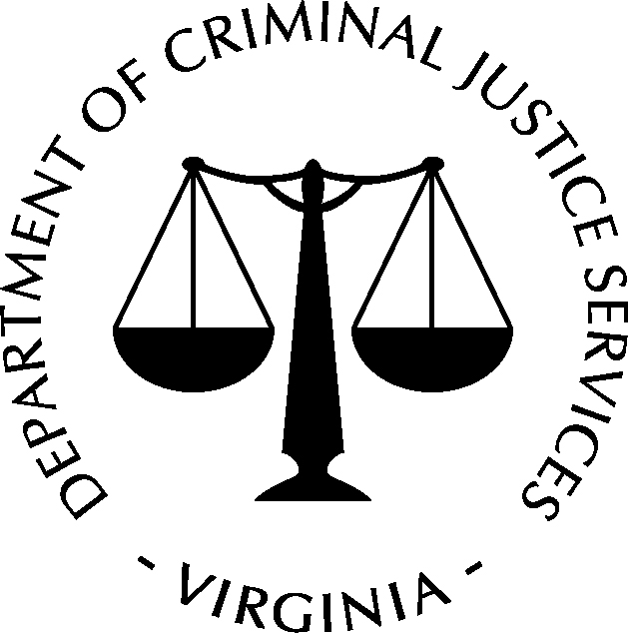
COMMONWEALTH OF VIRGINIA
Department of Criminal Justice Services
P.O. Box 1300 • Richmond, VA 23218
Phone: (804) 786-4700 • Fax: (804) 786-6344 www.dcjs.virginia.gov

Private Security Services – COMPLIANCE INSPECTION
Information
DCJS ID Number: | Business Name:
Audit Number: | DBA/Trade As Name:
Mailing Address (Street/Apt.#): |  |  | City, State, Zip:
Business Physical Address (if different than mailing address): |  |  | City, State, Zip:
Business Phone: ( ) |  | Fax: ( )
Email Address:

PART I: General Provisions
Comp. Non/Comp. N/A
- Maintain current business address with DCJS, 6 VAC 20-172-70.1
- Notify DCJS of change in operating or fictitious names, 6 VAC 20-172-70.2
- Report changes in ownership or principals to DCJS, 6 VAC 20-172-70.3
- Report change in entity to DCJS, 6 VAC 20-172-70.4
- Maintain current liability insurance, 6 VAC 20-172-70.5
- File Irrevocable consent for service, if applicable, 6 VAC 20-172-70.6
- Employ a valid designated compliance agent, 6 VAC 20-172-70.7
- Maintain required files (DOH, FP, I9, Reg., Tr., etc), 6 VAC 20-172-70.8
- Notify DCJS of termination of compliance agent, 6 VAC 20-172-70.9
- Timely submittal of replacement compliance agent, 6 VAC 20-172-70.10
- Display business license, 6 VAC 20-172-70.11
- Fingerprints submitted as required by Code, 6 VAC 20-172-70.12
- Timely report guilty pleas, convictions, found guilty, 6 VAC 20-172-70.13
- Report firearm discharges, 6 VAC 20-172-70.15
- Documentary evidence of terms of agreement, 6 VAC 20-172-70.16
- Maintain written use of force policy if applicable, 6 VAC 20-172-70.21
- Maintain permitted intermediate weapons records, 6 VAC 20-172-70.22
- Maintain detector canine handler team records, 6 VAC 20-172-70.23
- Employees properly reg. or certified, 6 VAC 20-172-80.4
- Ensure contractors or subcontractors are licensed, 6 VAC 20-172-80.5
- Ensure independent contractors have required insurance 6 VAC 20-172-80.6
- License number on business advertising materials, 6 VAC 20-172-80.12
- Only utilize vehicles with authorized flashing lights, 6 VAC 20-172-80.18
- Not use or display state seal of Virginia or DCJS seal, 6 VAC 20-172-80.19
- Uniforms worn in accordance with, 6VAC20-174-150.17

Comments (attach additional pages if needed)
Acknowledgement
The results of this inspection have been fully explained to me by the Virginia Department of Criminal Justice Services Investigator. If there are issues of non-compliance, I understand that I must submit an “Action Plan” that as a minimum outlines how I have addressed the non-compliance issues and what steps I have implemented to eliminate or minimize repeat occurrences. The Action Plan must be submitted to the Investigator listed below by no later than __________________. I also realize that administrative action may occur as a result of the non-compliance issues identified during this compliance inspection.

Investigator’s Signature Date Compliance Agent’s Signature Date

Print Name Print Name

