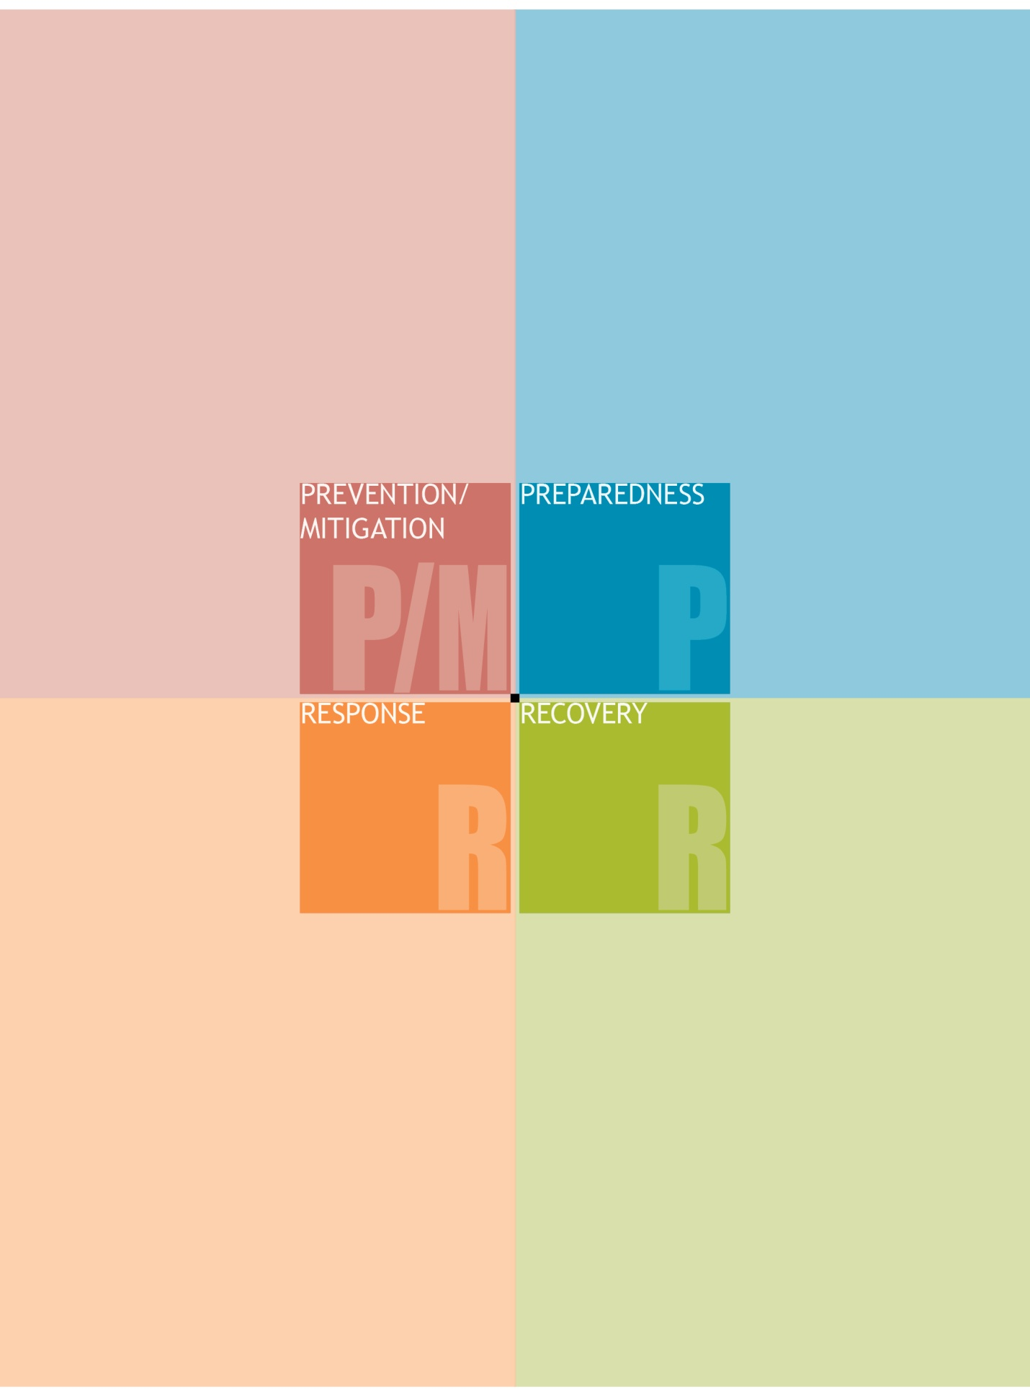

Model Crisis, Emergency Management and Medical Response Plan

QUICK GUIDE

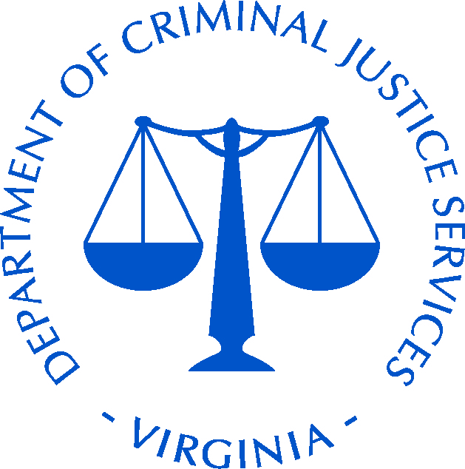
Virginia Department of Criminal Justice Services
www.dcjs.virginia.gov

Introduction

School personnel in Virginia have two primary responsibilities—educate students and keep them safe. Both responsibilities are tremendously complicated, are predicated on planning and implementation, and require regular assessment and refinement of plans. This Quick Guide is designed to assist school and school division personnel, administrators, and decision makers in the pursuit of safety preparedness.
This Quick Guide connects decision makers to several key documents and resources. The presentation of these materials is organized around the four phase logic of emergency management: Prevention/Mitigation, Preparedness, Response and Recovery. This four phase approach facilitates planning for (or even avoiding), reacting to, and recovering from crisis situations. A crisis situation could be a natural disaster (like an earthquake, hurricane, or tornado), a manmade situation (like an active shooter, an explosive device, or violent event), or a health crisis (such as an outbreak or pandemic).

Four Phases of Emergency Preparedness
Prevention/Mitigation refers to assessments which address the safety, security, and integrity of facilities, students, and personnel. Prevention means the capabilities necessary to avoid, deter, or prevent a threatened or actual incident from occurring. Mitigation means the capabilities necessary to eliminate or reduce the loss of life and property damage by lessening the impact of an event or emergency. Enhancing security, building communication pathways, and collaborating with first responders are examples of Prevention/Mitigation.
Preparedness means readying the school to respond in a rapid, coordinated and effective manner due to a crisis situation. Assembling effective plans, connecting resources, maintaining go-kits, and conducting training exercises and drills are elements of preparedness.
Response means the capabilities necessary to stabilize an emergency once it has already happened or is certain to happen in an unpreventable way; establish a safe and secure environment; save lives and property; and facilitate the transition to recovery. Effective responses often involve local and state first responders, including law enforcement, emergency managers, fire and EMS, and other government officials.
Recovery refers to the capabilities necessary to assist schools affected by an event or emergency in restoring the learning environment. Recovery usually involves joint efforts by local and state education, public health, emergency management, and related agencies.

Key Resources Connected to each Phase
The following section links key resources to each of the four phases (Prevention/Mitigation, Preparedness, Response, and Recovery). These resources are available at the website of the Virginia Center for School and Campus Safety (VCSCS) located within the Department of Criminal Justice Services (www.dcjs.virginia.gov/vcscs). Many of these resources were produced by DCJS, the Department of Education, other state and federal agencies, or subject matter experts. Some of these resources may encompass or address multiple phases—they have been categorized for the purposes of this Quick Guide. Please note that complete legislative requirements are provided in the specific resources—this Quick Guide does not represent a comprehensive review of legislative mandates.

I. Prevention/Mitigation

School Safety Inspection Checklist
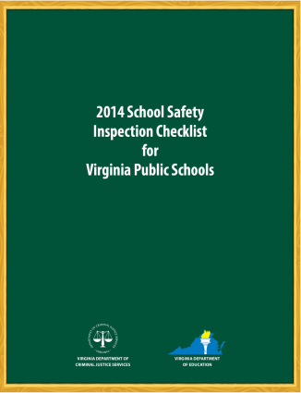
The School Safety Inspection Checklist provides guidelines for schools and school divisions to facilitate fulfillment of legislatively mandated planning exercises (please see the Checklist for full descriptions of the legislation and requirements). Based on the idea that crime can be deterred or prevented through environmental changes, school safety audit committees are expected to regularly review the school environment and identify nodes of vulnerability. Points such as areas of population concentration (like bus loading areas and cafeterias), classrooms, ingress and egress sites, communication systems, etc.) should be assessed periodically and deficits should be addressed when possible. These prevention steps may obviate future problems and decrease the need for first responder action.

Threat Assessment
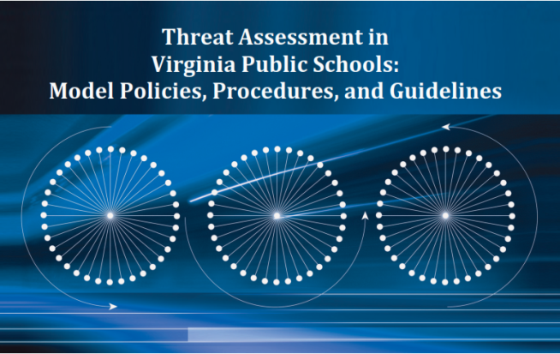
The Threat Asssessment in Virginia Public Schools: Model Policies, Procedures, and Guidelines document presents guidance for school and school division personnel on identifying and addressing potential threats. Threat assessment team composition and practice, key legislation, model policies and procedures are presented. Information is presented on issues of both student and workplace/employee threat assessment. Additionally, resources and contacts are provided.

Climate Survey
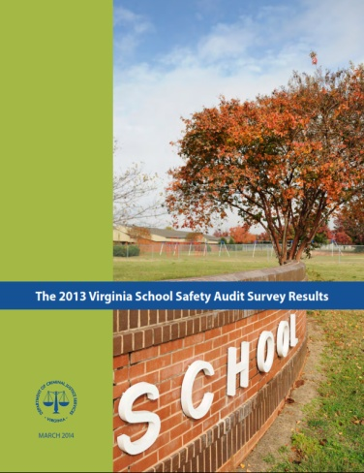
Each year the Virginia Center for School and Campus Safety conducts a safety survey of all Virginia public schools, as mandated by legislation. The 2013 Virginia School Safety Audit Survey Results represents 100% participation by nearly 2,000 public schools in Virginia, as well as a number of participating alternative schools. This report, published annually, provides a benchmark of safety practices in schools and can guide decision makers as they consider safety improvements. If a school is below average in safety practices, funding sources may be solicited for improvements and additional measures.

II. Preparedness

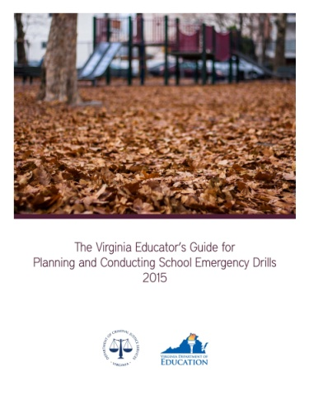
Virginia Educator’s Guide for Planning and Conducting School Emergency Drills
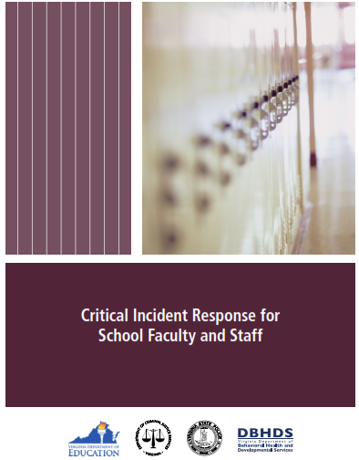
The Virginia Educator’s Guide for Planning and Conducting School Emergency Drills (hereafter, Drill Guide) assists school and school division administrators in planning, conducting, and assessing a variety of emergency drills. These drills are legislatively mandated (please see the Drill Guide for full descriptions of the legislation and requirements) and impact staff, teachers, and students. Drills prepare a school population for natural disasters (like tornadoes or earthquakes), crisis situations such as an active shooter, and other scenarios. The Drill Guide has decision matrices, draft plans and exercises, and related resources.

Critical Incident Response Manual
The Critical Incident Response Manual, and the accompanying training video, is designed to train school and school division personnel to respond appropriately during emergency situations and critical incidents. The training addresses three key response approaches: lockdown, evacuate, and shelter-in-place. Further, training is provided on active shooter responses which may require additional actions (such as run, hide, or fight).

III. Response

School Crisis, Emergency Management, and Medical Emergency Response Plan
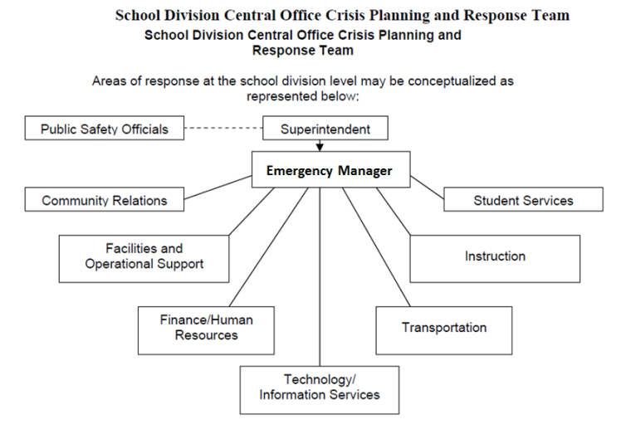
The School Crisis, Emergency Management, and Medical Emergency Response Plan, (hereafter School Crisis Response Plan) is an extensive document which reviews and addresses all four phases of emergency preparedness. It is principally designed to help school and school division personnel in the planning phase and in the response phase. The School Crisis Response Plan describes the phases of emergency management, provides examples and models of response protocols to a variety of incidents, and has information and tools that will facilitate effective responses.

Virginia School Search Resource Guide
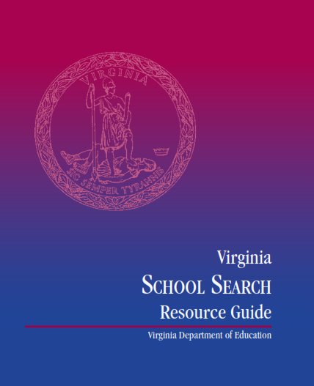
The Virginia School Search Resource Guide provides specific information on the complex issue of school search. Through an interpretation of federal and Virginia law, school administrators are given direction on their responsibilities and discretion, the role of law enforcement and their range of action, and how schools and law enforcement can work together. When a critical incident (such as an act of violence) occurs at a school, or involves students enrolled at a school, administration may consider conducting searches of that student’s possessions to ensure the safety of students and school personnel. There are, however, policies and laws which guide school searches. The Virginia Search Resource Guide should be reviewed by school administrators and the school division should, in consultation with local law enforcement, develop a policy on searches.

IV. Recovery

The Code of Virginia requires that the Virginia Department of Criminal Justice Services (DCJS) and Criminal Injuries Compensation Fund (CICF) shall be contacted immediately to deploy assistance in the event of an emergency as defined in the emergency response plan when there are victims as defined in §19.2-11.01. DCJS coordinates and deploys Virginia’s Crisis Response Team, which consists of crime victim advocates trained to provide crisis response to victims and their families, first responders, law enforcement and others impacted by the event. CICF maintains a fund that provides financial assistance to victims and families for medical bills, counseling, funeral expenses, etc. CICF also coordinates with other funding agencies to ensure resources are maximized. To report a school or campus emergency, please visit the DCJS website at www.dcjs.virginia.gov/research/reportemergency

Conclusion

The four phases of emergency management exist to assist decision makers as they prepare for events that we hope will never occur. Benjamin Franklin wrote “If you fail to plan, you are planning to fail.” The first of the two phases, Prevention/Mitigation and Preparedness, are predicated on thoughtful assessment and planning. The resources in this Quick Guide, and the numerous resources available from DCJS and other sources can facilitate prevention of problems, mitigation of their potential severity, and responsiveness through readiness. It is far better to preclude an event through security measures, or minimize the consequences through preparedness, than to exacerbate a crisis situation through a lack of readiness.
The third phase, Response, is oriented around implementation of plans and utilization of existing agencies, such as public safety and emergency managers. The final phase, Recovery, can be achieved through a concerted effort of local and state agencies, volunteers, and health professionals, contributing to the work of school and school division personnel.
This Quick Guide introduces decision makers to some of the key resources dedicated to helping schools and school divisions work towards preparedness. Please contact the DCJS Virginia Center for School and Campus Safety for additional assistance or guidance.

Recently the Federal Emergency Management Agency (FEMA) shifted from a four phase approach to a five phase approach. The traditional four phase approach (Prevention/Mitigation, Preparedness, Response, and Recovery) was replaced with a five phase approach (Prevention, Protection, Response, Recovery, and Mitigation). The new phase, Protection, refers to actions taken which safeguard assets and critical infrastructure elements. See for example the FEMA document Developing and Maintaining Emergency Operations Plans. This Quick Guide, and related DCJS materials, follows the traditional approach as many institutions have existing emergency operations plans aligned with the four phase model and the revised five phase model has not been fully implemented at this time. Schools and School Divisions should adopt the approach that best fits their needs and available resources.

