Table of Contents
Preface 1
Acknowledgements 2
Our Risk Management Strategy 3
Information Security 3
Vehicle Checking 4
Communication Protocols 5
Emergency Communications Plan 5
Emergency Communications 6
Reporting Suspicious People and Vehicles 6
Reporting Suspicious People 6
Identifying and Reporting Suspicious Vehicles 7
The Decision Point 8
Recognition of Threats or an Attack in Progress 8
Warning Indicators 9
Bus Evacuation Protocols 9
Responses to Threats 10
Safe Houses and Knowing your routes 14
Knowing Your Routes 15
Conducting Drills 15
Students with Special Needs and Disabilities 15
Keep Calm and Carry On 16
Summary 16

Preface
Public transportation plays an important role in the educational process, transporting children to and from school each day. The role requires maturity, diligence, professionalism, determination, stamina, good physical health, and skill. In the wake of community tragedies that can occur, either from natural disasters, accidents or through criminal or terrorist targeting, Virginia School bus drivers and bus monitors are increasingly part of the front line team who protect our children from a range of risks on a day to day basis.
Bus drivers and bus monitors should understand that the lives of the children under their care depend on their knowledge, skill, alertness and judgement. Although unlikely, bus drivers and bus monitors may need to deal with critical incidents, these being situations which present a physical threat to students and requires an immediate response.
School Bus Drivers and Monitors play an important role in protecting our students
Knowledge and preparation is the foundation for effective safety, security and emergency management. By understanding the many threats we face within todays dynamic world, and by identifying our responses to such threats, we will be better placed to avoid, identify and respond to manmade and natural threats, managing the ALL HAZARDS approach to student safety and security, effectively, and with confidence.
While these threats are very unlikely to occur, our role as a bus driver or bus monitor is not only a function of moving students from the place of embarkation to a drop off point, but also to ensure the protection of their physical and psychological wellbeing at all times. Where bus monitors are not present, then the driver will have additional responsibilities in identifying and responding to threats.
Threats may include natural hazards ort manmade threats such as:
- Flooding
- Storms
- Earthquakes
- Crime
- Civil disorder
- Lone or active shooters
- Terrorism
The objective of this manual is to raise the awareness and competency of bus drivers and monitors by:
- Developing an understanding the principles of risk management;
- Gaining an appreciation of information security;
- Developing strong and effective communications strategy;
- Being able to identify, and report, suspicious people and vehicles;
- Recognizing and responding to an attack in progress;
- Being able to quickly and safely evacuate the bus;
- Having the knowledge and skills to respond to manmade and natural threats;
- Understanding what a safe house is, and how to use it; and
- Assisting students with special needs.

Acknowledgements

Virginia Department of Criminal Justice Services
Virginia Center for School and Campus Safety
1100 Bank Street
Richmond, VA 23219

Risk and Strategic Management, Corp (RSM) of Herndon, Virginia, graciously donated the production of the video, School Bus Driver and Monitor Security Manual, which is an essential component of this training.

Please direct any questions about this manual to:
• Donna Michaelis, Manager, Virginia Center for School and Campus Safety at 804-371-6506, donna.michaelis@dcjs.virginia.gov
• Shellie MacKenzie, School and Campus Safety Program and Training Coordinator, Virginia Center for School and Campus Safety at 804-678-8993 or shellie.mackenzie@dcjs.virginia.gov
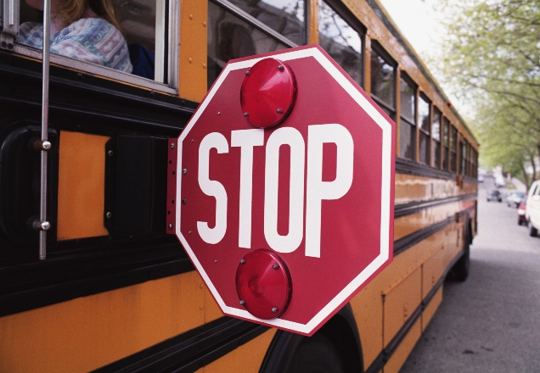

Our Risk Management Strategy
Our strategy to manage the risks faced by students during bus movements include the following principles:
- Prevention: Having the capability to avoid, deter, or stop an incident. Prevention is the action schools, bus drivers and bus monitors take to prevent a threatened or actual incident from occurring, including through sound planning and education or awareness;

- Protection: Being able to protect students against acts of violence and manmade or natural disasters. Protection focuses on ongoing actions that protect students, teachers, staff, visitors, networks, and property from a threat or hazard;

- Mitigation: Are the actions taken which are necessary to eliminate or reduce the loss of life and property damage by lessening the impact of an event or emergency. Mitigation also means reducing the likelihood of threats and hazards occurring;

- Response: Is the process by which we stabilize an emergency once it has already happened, or is certain to happen in an unpreventable way, and so establishes a safe and secure environment, saves lives and property; and facilitates the transition to recovery; and

- Recovery: Focuses on the actions necessary to restore normal bus operations following an incident.
Training and conducting drills play a key role in operationalizing and sustaining our ability to manage risks, and so protect the students under our care.

Information Security
Bus drivers and bus monitors are responsible for protecting information relating to these safety, security measures and response protocols, as well as any bus routes or planned field trips. Often hostile persons or groups will seek to gather information as part of their strategy for identifying soft or easy targets, and then plan an attack based on this information.
It is often discovered after a crisis event that these individuals or groups were able to access information which helped them to plan an attack more effectively, frequently assisted by people innocently sharing sensitive information with them. As such, you should adopt the following information security measures:

- Do not share information related to this training with others outside of the school
- No not discuss your role, or activities relating to your role, in public places
- Do not post information on social media relating to your role
- Do not post information on social media relating to bus routes or planned field trips
- If you are asked unusual or probing questions by others – report it!
- Remember… “when in doubt – call it out!”
Remember, the lives of those students under your charge rests in our ability to protect them. This includes making the targeting of schools and school transport difficult, or impossible, through information security.

Vehicle Checking
Bus drivers should inspect their vehicles as a standard safety and maintenance procedure; however, in situations where bomb threats may exist, this check can also address the need to identify potential explosive devices.
The bus driver should check from the front of the vehicle, looking underneath the bumper, down the sides of the vehicle and in the wheel arches, and around the rear bumper area and back to the front of the bus, looking for objects which are not part of the vehicle, but which may be painted and disguised in nature, or which may have been have been placed inside the vehicle when not in use. If an unusual or suspicious object is identified, this should be considered a suspect device. It should not be touched or moved, and the area where identified should be evacuated immediately, with the bus driver contacting police immediately.
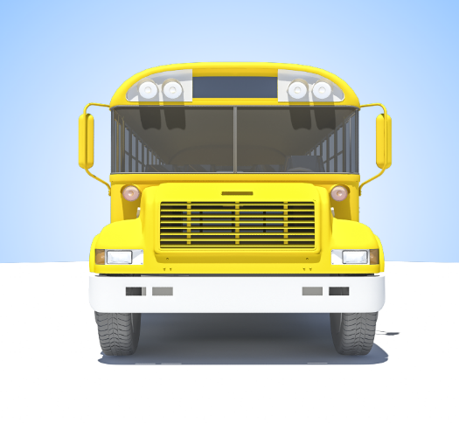 | 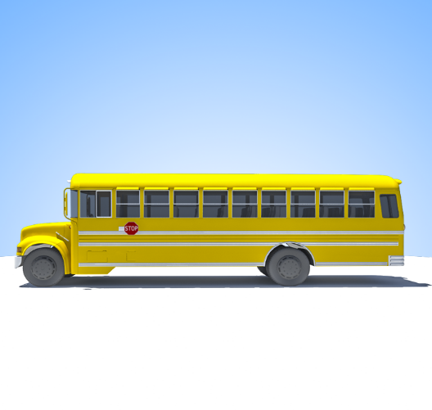
 | 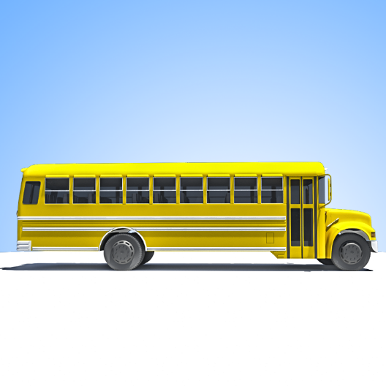
 | 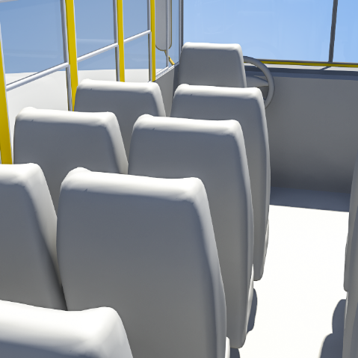

If a suspicious object is identified, then this should be considered a suspect device and it should not be touched or moved, and the area should be evacuated, with the bus driver contacting the police immediately.

Communication Protocols
The ability to communicate is a critical part of receiving information which may alert you to safety and security threats, but importantly, for you to also pass on information relating to potential or occurring threat to others. This passage of information must be fast and accurate, allowing those supporting you to provide quick and effective instructions, or to mobilize practical help effectively. It is important that your communications are:
- Accurate: Do not embellish, exaggerate or assume, rather report what you see, hear and know; and

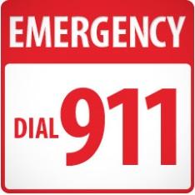
- Detailed: Provide full details of what is occurring, what you are doing, and what help you need.

Emergency Communications Plan
Bus drivers and bus monitors should ensure that they have preset phone numbers loaded on their mobile phones, which are clearly marked for ease of access during an emergency situation.
These should include local police authorities and medical emergency responders, key managers within the school, and other bus driver and bus monitor numbers.
A paper copy should also be carried within a wallet or purse should the bus driver or bus monitor need to leave the bus, and if their mobile phones are lost or damaged in the process, allowing them to use landlines or other mobile phones to pass on time sensitive information, and importantly, so that others may contact them during an emergency.

Emergency Communications
In the event that emergency communication protocols are initiated it will be important for information to be shared quickly and accurately with the appropriate points of contact. You may be under pressure, in a high stress and confusing situation, and as such it can be difficult to pass on full and accurate information easily. As such, having a reporting protocol can help you cover all of the essential points more easily. The information you need to pass on will include:
- What is happening: Be very specific about what is happening, providing facts, not assumptions

- Where it is happening: Be very specific as to where you are, use landmarks and signs as needed

- When did it happen: Is it happening now, or when did it happen if the event is over

- Why is it happening: If possible, explain the context of the problem or event

- Who is involved: Explain who is involved in the event and their physical status

- What help do you need: Explain what type of help you need and why

- What are you doing: Explain what you are doing about it, or where you are going
While operating a bus, drivers should have the bus monitor or student helper report this information. If someone is about to board a bus and might prevent you from communicating, then you should place your phone on the floor, or edge the phone in a seat so as to allow 911 or the person you contact to hear what is going on. If the bus driver or bus monitor has a radio with a panic alarm, then this should be used.

Reporting Suspicious People and Vehicles
Part of the bus driver and bus monitor responsibilities includes being observant for suspicious people and vehicles, whether at the school, at bus stops, or along the route itself. While most suspicious people and vehicles will be harmless and innocent, some may not be, and it is better to be cautious and report a concern, than ignore what could be a serious warning indicator.

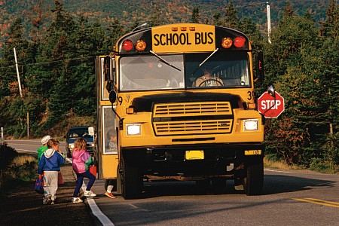
Reporting Suspicious People
Suspicious people might include seeing the same person in different places repeatedly, a person loitering in a place for an unusual period of time, or people watching or acting in an unusual manner.
People asking probing and unusual questions should also be considered suspicious and these people should be immediately reported.
When seeking to describe a suspicious person, whose identity is not known, then the following A to H system can be used:
A | The A stands for their approximate AGE. Where needed bracketing can also be used: for example stating that the person is between 25 to 30 years of age.
B | The B stands for their BUILD, such as skinny, obese, stocky or muscular.
C | The C stands for their CLOTHING, including what the person was wearing; was it stylish, casual or scruffy. Describe the colors, brands and any styles or emblems. Also, describe any bags, suitcases or backpacks the person was carrying.
D | The D stands for DISTINGUISHING MARKS, including any noticeable marks such as scars, tattoos, or injuries.
E | The E stands for their ETHNICITY, are they noticeably Caucasian, Arabic, Asian, Spanish, or Black.
F | The F stands for their FACE, is it round, long, thin or chubby? Was the person wearing glasses, did the person have a beard or moustache, or were they clean shaven?
G2 | The G stands for their GAIT, and GENDER. How was the person walking, was the person upright or slouched over, did the person walk with a limp? And, was the person a man or a woman?
H2 | The H stands for their HAIR and HEIGHT. Was the hair long, short, thick or thin, were they wearing a wig, and what is the hair color of the person? For height you can use other objects, such as cars or lampposts, to gauge their height from a distance.

Identifying and Reporting Suspicious Vehicles
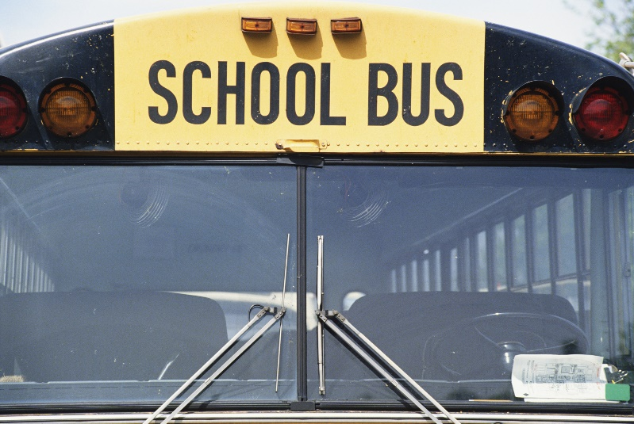
Suspicious vehicles might include vehicles which seem to be parked for excessive periods, where a group of men are sat in the vehicle for no apparent reason, especially with bulky clothing, where vehicles are sat low on their suspension which suggests a heavy load, or where tires have been slashed and bags or parcels are evident in the vehicle. Suspicious vehicles can also include vehicles which may seem to be following your route, despite multiple turns being made, or who brake or speed erratically in an effort to catch up to, or stay with, the bus.
When reporting a suspicious vehicle the acronym SCRIM can be used, this includes:

S | The S is for SHAPE, this means what shape type of vehicle was spotted – was it a car, van, truck or motorcycle?
C | The C is for COLOR, if you are unable to remember the color, then at least try and think if it was it light, dark or perhaps metallic in coloring.
R | The R is for REGISTRATION, try and remember as many numbers and letters as possible – write these down quickly.
I | The I is for IDENTIFYING MARKS, did you see any dents or damage? Did the vehicle have 2 or 4 doors? Were there any antennae attachments, markings or a roof rack?
M | The M is for MODEL, what was the make and model of the vehicle?

The Decision Point
During an emergency situation you may be required to make an on-the-spot decision, often before any emergency response support is able to deploy and assist you, or indeed before anyone can give you advice or instructions. This includes the decision to remain where you are, or move away from a potential or known threat. As such, you may be required to quickly, and decisively, decide whether to:
- Stay: Is safer to remain where you are, staying at the location or within the bus; or
- Go: Is it safer to move the bus from the area, or to exit the bus and move away on foot.
Each situation will be different, and only you can make the call based on your evaluation of the situation. Whatever you choose to do, you must base it on understanding the risks and implementing the options addressed in this training, communicating your decision to your emergency point of contact so that they are aware of your intended actions, and so that they can mobilize help quickly and effectively for you.

Recognition of Threats or an Attack in Progress
- Suspicious people
- Suspicious vehicles
- Crowds gathering
- Unusual numbers of police
- Deployed military forces
- Serious weather reports
It is important for school bus drivers and bus monitors to have the knowledge and skills needed to understand, identify and respond to manmade and nature threats which may be presented to the children and young adults under their care. The signs of a threat may be obvious – or they may be subtle.
Within todays increasing unstable world where crime, terrorism and natural disasters present a growing threat to the United States, this awareness and competence will play a critical part in keeping our children safe as they travel to and from school, during field trips, or going to or from sporting events.
Bus drivers and bus monitors must view risks from a 360 degree perspective, not only looking ahead of them physically for threats, whether natural or manmade, but also behind and the sides of the bus. This includes identifying suspicious people and vehicles at bus stops, or vehicles which may be following the bus. Often warning indicators may exist which could alert the bus driver to a potential threat before it happens – an alert and observant bus driver and bus monitor will be better placed to spot these warning signs and respond to them.

Warning Indicators
Warning indicators are situations or activities which will alert you to a potential or actual threat. These can include identifying suspicious people and vehicles watching or following you which might indicate a potential criminal or terrorist attack, the gathering of crowds which might suggest a potential demonstration and loss of law and order, unusual numbers of police or military forces which might indicate an operation is underway, or strong winds and serious weather reports which could suggest a potential natural disaster.
You should never be embarrassed to report these warning indicators, no matter whether or not a real threat was found to exist – it is always better to be safe than sorry. When you identify a warning indicator, you should immediately start to consider your emergency response options, notifying the appropriate emergency points of contact of your intentions and plans, and what help you need, so that a wider response can be implemented.

Bus Evacuation Protocols
A bus evacuation drill is typically in response to the bus, or the area where the bus is located, becoming unsafe. Typically, if the bus breaks down, the bus is a safe place for students to remain until a repair is implemented, or an alternative vehicle is dispatched.
However, if the bus is stranded in a dangerous location, has been involved in an accident, is experiencing a mechanical problem which might cause a fire or explosion, or is directly threatened by hostile persons, or by natural hazards, then the students will need to be moved from the bus, along a safe route, and to a safe location until help arrives.
All students should know where the emergency exits are in order to evacuate from the bus in a controlled and safe manner, and emergency drills should reinforce this understanding and the process for disembarking and evacuating with confidence and safety in mind.
The response actions during a bus evacuation include:
- The bus driver and bus monitor should identify the threat and determine the appropriate responses required;
  - A safe route and muster area should be identified before the students depart the bus;
  - The bus driver and bus monitor should identify the safest exit point, including:
- All passengers leaving the bus through the passenger entry;
- All passengers leaving through the rear passenger door;
- The bus driver taking the front half of the bus through the front exit door, with the bus monitor taking the rear half of the bus through the rear exit door;
- The passengers exiting alone and without assistance; and
- Passengers exiting through the roof emergency exit, if this is the only option available.
Some buses are equipped with emergency exit windows and emergency roof hatches; if these are present all passengers should be briefed as to their location and how they open. The actions taken during an evacuation of the bus includes:
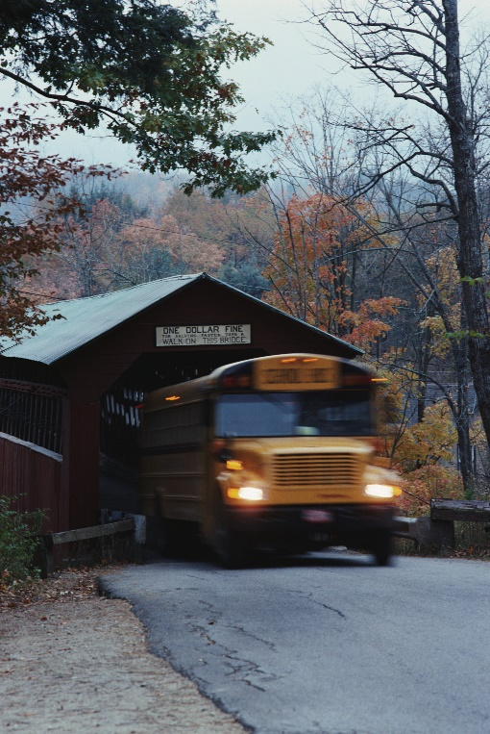
- The driver will secure the bus, turning off the ignition, setting the parking brake, and activating the 4 way flashers;
- The driver opens the front passenger entry door and confirms a safe route out and away from the bus and to a safe muster point, telling the students of the route and muster point;
- The driver gives the command “emergency drills, remain seated” and indicates the exit point to be used, giving the command “front or rear evacuation”;
- The driver should stand by the front door and will instruct students to walk, not run, on a seat by seat basis, with the bus monitor moving to the rear of the bus to ensure all students have departed, and to assist those with disabilities;
- Student helpers, or buddies, should be instructed to assist those with special needs;
- The students will be directed along a safe route to a safe muster point where a head count will be conducted by the driver;
- The bus monitor will confirm that the bus has been cleared; and
- The driver will immediately report the incident to the emergency point of contact with the student’s names, status, ages and home addresses or parents contact details.
If any injuries have occurred during the incident, the bus driver and bus monitor must alert the emergency services, seeking to stabilize the casualty until help arrives, but also critically, ensuring that all of the other students remain safe until help arrives.

Responses to Threats
For any threat, whether manmade or natural, your first action is to ensure the safety and security of the students, determine the immediate actions you need to take, and to communicate the situation to the police, emergency services, or your emergency point of contact. Remember, stay calm and ensure that the students remain calm. You must quickly and calmly determine:
    - What are the threats? You will need to quickly establish the nature of the threat and whether it is directed at you and the bus, or whether you are just in the wrong place at the wrong time;

    - Where are the threats? You will need to place the threat in the context of proximity, how close is the threat now, which way is it travelling, and will you then be affected;

    - When will the threat happen? You will need to establish how long before a threat impacts you, and so how long you have to make a decision and take action

    - What are my immediate actions? You will need to establish the immediate things you need to do to protect the students within the first seconds and minutes of an incident;

- What are my secondary actions? Once the immediate risks are addressed, you will need to determine your next set of actions, to ensure the continued safety and security of the students; and

    - Who do I need to tell? You should quickly determine who you need to tell, and what type of assistance you might need.

Manmade Threats
During travel, or when entering the school grounds you may be faced with a range of potential manmade threats. Your priority is to identify the risks, take immediate action to protect the students, and to report the situation. Some of the following threats and immediate response drills are offered as part of this training:

Toxic spill and fires
If a toxic spill of facility fire occurs along the route, you should identify the area of contamination and any downwind hazard areas and avoid these. If you are within an effected area you should immediately close all windows, and turn off all air-conditioning, closing all vehicle vents in order to reduce the inflow of air into the bus.

Being followed
If you believe you are being followed, then you should not seek to stop and confront the person as you may trigger a hostile situation, nor should you seek to try and outrun them as you could cause a road traffic accident. You should immediately report your concern and drive directly to a safe House which affords physical security, such as a police station or military base.

Bus stop threats
If you approach a bus stop and see a suspicious person or vehicle at or near the bus stop, then you should continue past the bus stop without slowing or stopping, and report your concerns immediately.

Aggressive unarmed person
If an unauthorized person who appears unarmed pushes or forces their way onto the bus and begins to threaten the welfare of the students, the driver should remain stopped with the 4 way flashers on and immediately notify the police and the emergency point of contact, providing the location of the bus and a description of the aggressor. The bus driver and bus monitor should remain calm and should not threaten or attack the aggressor.
Aggressive persons may also include a student who is normally permitted on the bus. Whether the aggressor is an unauthorized person or student, the bus driver or bus monitor should seek to place themselves between the aggressor and students, seeking to defuse the situation, and following, where it is safe to do so, the directions of the aggressor so as to provide time for the police to respond. The bus driver or bus monitor should, if necessary, evacuate the students through the rear emergency exit.

Bomb threat | Suspicious items
If the bus driver or bus monitor identifies a suspicious object on, or near, the bus then they should NOT touch, open or move the object, nor should they make a phone call within 50 feet of the object as the call may initiate an explosive device. The bus driver should pull over to a safe location, turn on the emergency 4 way flashers, evacuate the students in a safe manner and to a point behind hard cover, such as a brick or concrete wall at least 100 feet from the bus, and notify the police.

Bomb threats on routes
If a bomb threat has been identified along a route due to the presence of police bomb squad officers then the driver should follow emergency responder instructions, or, in the absence of any direction, should seek to stop, turn off, reverse, or do a U-turn so as to move the bus away from the potential explosive device.

Armed Aggressor on the bus
In the event that an armed aggressor is on the bus, whether a student or unauthorized person, then the bus driver and bus monitor should not confront the aggressor and should seek to defuse the situation, following the instructions of the aggressor, if it is safe to do so. If the bus is in motion then the driver, if they feel that there is an immediate risk to life, should brake sharply, repeatedly, or swerve the bus in order to destabilize the aggressor, and should seek to evacuate the bus once the bus is brought to a safe stop.
Once stopped, the bus driver should activate the stop arm and emergency 4 way flashers to draw attention to the incident, if it is safe to do so, immediately contacting 911.

Threat at the school
If a threat to the school is reported then the bus driver should follow any instructions provided, or, in the absence of any instructions, the bus driver should move immediately to the nearest Safe House or sister school, or a school that has been designed a Safe House, alerting the appropriate authorities of their actions.

Demonstrations and civil disorder
If the bus driver identifies a rally, demonstration or civil disorder along the route they should seek to turn off from the route, reverse, do a U-turn, or stop the vehicle and let the crowd pass. The doors should be locked, the emergency point of contact should be notified, and the students should be instructed to get onto the floor of the vehicle. If the situation is violent, and only as a last resort, the driver may proceed slowly through a crowd in order to evacuate the vehicle from a rioting mob.
If a direct threat to life exists, and if the bus needs to be evacuated, then the evacuation protocol should be established, with the students being told to hold on firmly to the person in front of them to avoid losing anyone in the evacuation, with the bus driver taking the front of the line and the bus monitor the rear. Once at a safe location, a head count should be conducted and the status of the students reported.

Response to gun fire | The bus is moving
If the bus is subject to gun fire then the bus driver should identify the source of the gunfire, determine whether it is directed at the bus, or whether the vehicle is in proximity to another person or location being attacked, and either turn off onto a side road, reverse away from the gunfire, or in the worst case scenario, and no other alternatives are available, the bus driver may decide to drive through the area being attacked. The bus driver should get low behind the wheel and the students should be instructed to lay on the floor.
If the vehicle is moving and a vehicle pulls alongside the bus and a gunman is identified, or starts shooting, then the bus driver should NOT seek to outrun the vehicle, but should brake and allow the vehicle to move past.

Response to gun fire | The bus is immobilized
If the bus is trapped or immobilized and you need to evacuate from the vehicle then students should gather behind the engine block of the vehicle, which affords the greatest protection from bullets. The bus driver and bus monitor should identify the safest route from the shooter, including a destination point, ideally a hard structure with stone walls, or earth ditches or banks, and instruct the students to run directly to that point.

Illegal Road Blocks
If a bus driver spots an illegal road block, this being vehicles parked in a manner to slow or stop the bus which is not manned by the police or emergency services, and the situation appears potentially life threatening, then the driver should decide whether to turn off onto a side street, do a U-turn, or reverse back and away from the road block, reporting the situation immediately.

Responses to Natural Disasters
During travel or when entering the school grounds you may be faced with a range of potential natural hazards. Your priority is to identify the risks, take immediate action to protect the students, and to report the situation. Some of the following threats and immediate response drills are offered as part of this training:

Wind storms
If a serious wind storm, notably a tornado, hurricane or tropical cyclone, is reported then the bus driver should following any instructions given, or should move the bus back to the school, or to a Safe House, depending upon the time available before the storm hits, or whether the storm is already present.
If the bus is caught in a serious wind storm then the bus driver should, only if it is safe to do so, move the bus slowly to the nearest place of refuge and move the students into a solid building and away from any windows until the storm has passed.
During travel through a storm the students should be instructed to get low and below the window line in case of debris breaking glass. The bus driver should report their location and intentions to the emergency point of contact. Secondary hazards including fallen power and telephone lines, flooding, and electrical hazards may be present.

Earthquakes
If an earthquake occurs during travel then the bus driver should slow and stop the vehicle. The bus driver should establish whether the bus is at risk from any debris falling from buildings, and only if an immediate risk exists, should drive slowly to an open area.
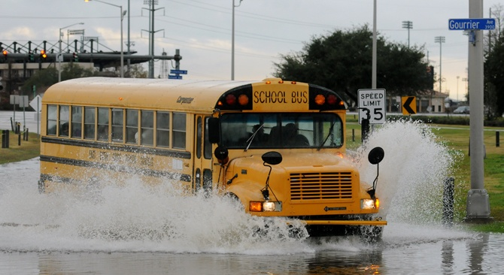
The students should remain inside the bus as this will likely afford them the greatest level of protection. Following an earthquake bridges and tunnels should not be used as these may have been damaged. Secondary hazards such as flooding, landslides and rock falls, and structural and electrical hazards may be present.

Flooding
During periods of flooding the bus driver should follow any instructions regarding routes to avoid and continue on their route, only if it is safe to do so. If caught in a flooded area the driver should seek to move the bus to high ground, and if necessary evacuate the bus and move the students into tall structures, and to the upper floors to avoid the flooding.
If the bus comes to flooded roads the bus driver should understand that vehicles can be swept downstream in fast moving flood waters in less than 4 inches of water, and should avoid seeking to cross roads with fast moving water and where the depth of flooding is not known.

Snow and Blizzards
If the bus is caught in a snow storm then the bus driver should slow the bus to a safe speed. If visibility is limited then the driver should move the bus back to the school, or to a Safe House or place of refuge during serious blizzards. If it is too dangerous to move the bus then the driver should find a safe location to stop the bus, with all lights and the emergency 4 way flashers on. If possible, the bus driver should move the students into a building for protection from cold weather injuries, or from potential road traffic accidents.
If students cannot depart the bus and the vehicle is stranded, then they should be instructed to put on all jackets and extra clothing, especially hats and gloves, and the bus heating should be turned up to a comfortable level. If the gas tanks run dry then students should form groups and should share body heat to reduce the chances of hypothermia.

Safe Houses and Knowing your routes
A Safe House is a predefined location which provides safety and security for the students during an emergency situation. These locations will be identified along the standard bus routes as fixed Safe Houses, or along routes for field trips for event driven Safe Houses. You should know where these locations are, and how to get to them by the shortest and most direct route.
These locations can include government facilities, such as police stations, fire stations, and military bases, a sister or other designated school, or they can be public areas such as hospitals, large hotels, churches or other appropriate religious locations. The selection of a Safe House is based on meeting two criteria, firstly it provides a place of physical protection for the children, and secondly, it has the capacity to offer a place of temporary refuge until help is mobilized, or the situation has resolved.
Upon arrival at a Safe House students should be quickly moved inside the structure and to a point away from the front entrance and windows, and should be instructed to remain quiet, and of the necessity for good behavior and in following instructions so that they do not increase the volatility of a crisis situation. The bus driver and bus monitor should immediately notify the police, or their emergency point of contact, as to the situation and their location.

Knowing Your Routes
It will be important to know NOT only your primary routes, but also alternative routes should a threat prevent your main route from being used, or should you need to move quickly and directly to a Safe House. Familiarity with these primary and alternative routes, and routes to the pre-identified Safe Houses should include not only reviewing street maps, but also ideally driving these routes.
Where field trips are planned, a map study should be conducted and primary and secondary routes, and event driven Safe House options should be marked on a road map.

Conducting Drills
Evacuation and emergency response drills should be practiced by all students. Where a student is unable to participate due to physical limitations, then they should watch the drill being practiced so that they understand what would happen, and how they should respond to an emergency situation.
Where roles are assigned to students, including using the “buddy team system”, then these should be explained to the buddy, as well as those they are assisting, and to the remainder of the bus. The drills should be sensible, safe and should not cause anxiety or alarm within the students, rather it should reinforce confidence of how they should respond to any form of threat.
You must seek permission before conducting any drills with the Principle or their delegates, and confirm the location of the drills to ensure it is safe and appropriate.
It is also important for the bus monitor to ensure that they have a nominal of those students on the bus, including knowing who may be absent, or who may have already disembarked during the trip.

Students with Special Needs and Disabilities
When transporting students you should identify those with special needs or disabilities, whether physical, emotional or psychological, and determine how you would manage these students during an emergency situation. This includes how you would rapidly exit the bus during an evacuation, or calm them during stressful situations. It may be that you will need to leverage other older and mature students to assist you with this process as part of a “buddy team system”.

Keep Calm and Carry On
Under high stress situations it is normal to feel anxiety and fear, and indeed this can be useful in terms of providing you with the energy and focus needed to best respond to a threat. However, you must retain an outward composure in order to inspire calm and confidence in your charges, as they will respond to your mood, whether positive or negative, and if the students are frightened then they will be harder to manage as you seek to respond to an emergency situation. As such you must seek to:
- Take a deep breath and take control of your emotions;
- Understand that panicking will not help you, or those you are protecting;
- Smile and look confident; and
- Speak in a calm and confident manner.

Summary
This training is designed to provide you with the knowledge and skills necessary to understand, identify and best manage a manmade or natural crisis situation. All situations will be different, and as such you will need to apply this training in the context of where you are and what is happening. Your role as a bus driver or bus monitor is critical in protecting the students under your care, ensuring that during day-2-day activities, and especially during a crisis, that their physical and psychological welfare is protected.
If you have any questions you should raise these directly to your school.

