Victim Services
Victim/Witness Grant Program

Client Information Management System (CIMS)
Installation Guide

Client Information Management System (CIMS)

About CIMS

There are 2 components to CIMS. The front end “Application” and the back-end “Database”. Each component is a separate installation.

The CIMS Application is a Microsoft Access Database saved as CIMS2004.mdb. It requires installation of Microsoft Access 32-bit version 2007 or higher. The Application (CIMS2004.mdb) must be installed on each individual users C:\ drive in a CIMS2004 folder and can be installed for multiple users.

If Office 2013 or higher is installed CIMS requires the installation and use of the Microsoft Access 2010 Runtime software package. After installing the 2010 Runtime you will need to create a new shortcut which instructions the CIMS application to open using the Runtime software.

The CIMS Database is a Microsoft Access Database saved as CIMSdata2001.mdb.
The database can be installed on a network or shared location and accessed by multiple users. IMPORTANT: There should only be ONE database for your program.

You should note that in a shared environment the reliability and availability of the system can experience issues if there are multiple simultaneous users changing data.

CIMS Installation

The CIMS Application is distributed by DCJS. When installing the CIMS2004.mdb you should always download from the DCJS website to ensure you are using the current version of the application. There is no need to make backup copies of the application. It is strongly recommended that you DO NOT store copies of the application files not in use to avoid the risk of installing an outdated copy of the application.

The CIMS Database is your individual program data. DCJS provides each program with a blank database at start up. Once a program begins using the CIMS application it is the responsibility of each location to back up their CIMS database on a regular basis. DCJS does NOT have copies of local databases nor does DCJS have the ability to restore any data should a problem occur.

If you need assistance creating a backup of your existing back-end database instructions can be found on the CIMS Website or click here to open the pdf file.

Downloading the CIMS Application (CIMS2004.mdb)

- Note the location of your back-end database. You will need to reattach after

- Download CIMS from the Client Information Management System (CIMS) web site.

- Go to the For Current CIMS Users section and select Download the CIMS system self-extractor file to begin the download.

- Enter C:\CIMS2004 in the Destination folder and select Extract
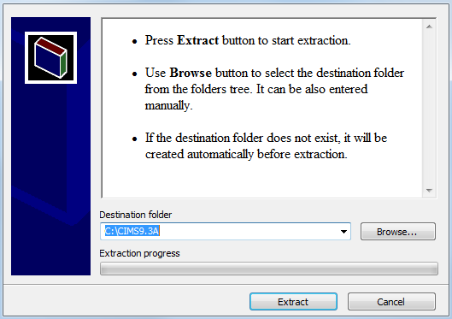

-OR-

Select Browse to use Windows Explorer to navigate to the C:\CIMS2004 folder.

- If you receive a message Confirm file replace select Yes to All. If you do not receive this message proceed to the next step.

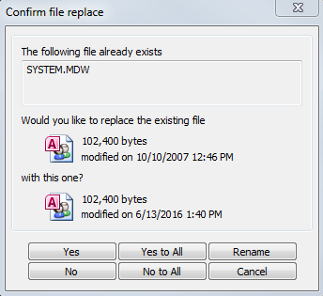

Connect the Application to the Database

- From the CIMS Main Switchboard screen select Reattach Data Base.

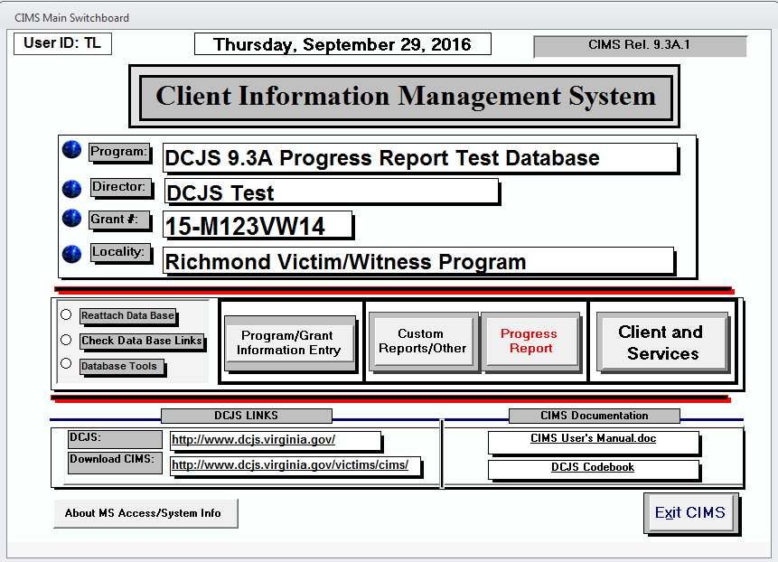

- The following message is displayed. Select OK
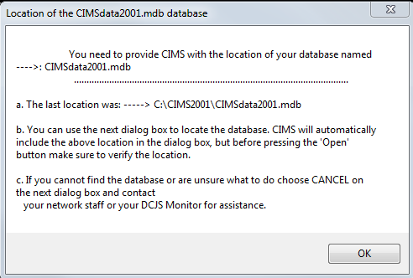

- Select your production CIMSdata2001.mdb and select Open
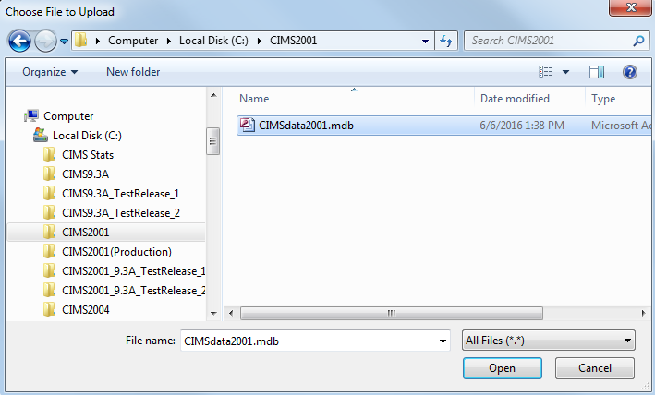

- To verify the attachment select Check Data Base Links from the CIMS Main Switchboard screen.
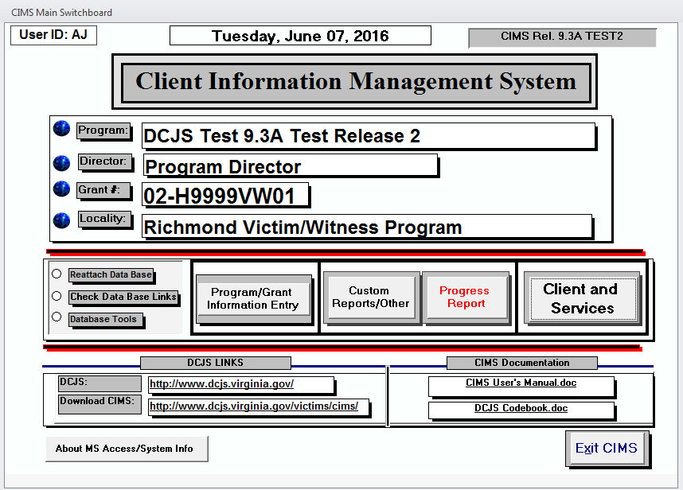

- The Location of your CIMSdata2001.mdb database link will display.

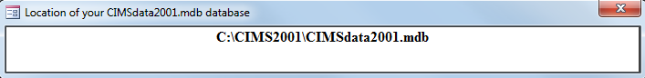

Troubleshooting

- For assistance navigate to the Client Information Management System (CIMS) web site Help And Assistance section and go to the Microsoft Access CIMS Troubleshooting Guide

- For additional support with your installation contact Lisa Self in Computer Services at (804) 786-8475.

Downloading the CIMS Database (CIMSdata2001.mdb)

- The CIMS Database is available to download from the Client Information Management System (CIMS) web site.

- Go to the For New CIMS Users section and select Download the CIMS Back-end Database Template self-extracting file to begin the download.

- Enter the location you wish to save your back-end database in the Destination folder and select Extract

-OR-

Select Browse to use Windows Explorer to navigate to the location you wish to save your database.

- If you receive a message Confirm file replace you should cancel the process and do some research. Only locations that have never used CIMS should be installing an empty back-end database. Continuing by answering Yes or Yes to All will replace the existing file with an empty database.

- Once you have installed the back-end database follow the instructions in the Connect the Application to the Database of this document to complete the installation.

