The Parkland Massacre Through a Police Chief’s Eyes

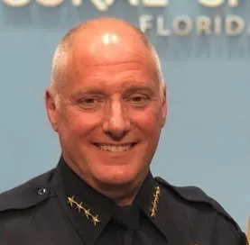
Presented by

Tony Pustizzi
Chief of Police, Retired
Coral Springs Police Department

On February 14, 2018, a former student entered Marjory Stoneman Douglas High School in Parkland Florida, killed 17 individuals, and wounded another 17. Retired Chief Tony Pustizzi, a 30-year veteran with the Coral Springs Police Department, along with members of his agency, arrived at the school within minutes. A multidisciplinary approach, including law enforcement, first responders, emergency managers and school administrators and staff, was initiated. This session includes a deep dive into the events that unfolded that day. Chief Pustizzi will also discuss many of the issues that ensued with regard to leadership and the unique challenges he experienced as an on-scene commander. He will review the response to the shooting and provide an analysis of the lessons learned. Attendees will leave with an understanding of the circumstances that contributed to the overall response to this tragedy as well as measures that must be taken to help prevent these types of incidents moving forward.

Highlights:

- Why leadership matters
- Multijurisdictional issues (federal, state, local)
- Facilities management and access issues
- Active killer training
- Rescue Task Force training
- Tactical operations
- Coordination with family members
- Media relations
- Political trap doors
- Relationship between first responders and school districts
- The use of code red and safer corners

Designed for:

- Law enforcement personnel
- Fire and EMS personnel
- First responders
- School resource officers and deputies
- Emergency managers
- SWAT members
- School superintendents, administrators and staff
- School security directors and officers
- University and college administrators
- Facilities managers and personnel
- Victim advocates and counselors

For more information about this program and others, please contact:
954-868-4894 tonyp@fourstarstrategies.com www.fourstarstrategies.com

