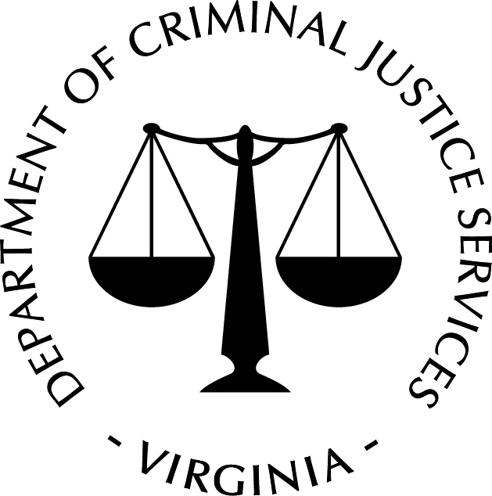
Commonwealth of Virginia

Virginia Department of Criminal Justice Services
Certification of De Minimis Indirect Cost Rate

An award recipient that proposes to use federal grant funds to pay for indirect costs but has never received a federally negotiated indirect cost rate may elect to charge a de minimis rate of up to 10% of its modified total direct costs (MTDC), which may be used indefinitely (2 CFR § 200.414). In order to charge a de minimis rate of up to 10% of its MTDC, the award recipient must submit this certification form to the Virginia Department of Criminal Justice Services.

I certify that (name of award recipient) meets the following eligibility criteria to use a de minimis indirect cost rate of %.
- The award recipient has never received a Federally-negotiated indirect cost rate for any federal awards.
- The award recipient has received less than $35 million in direct federal funding for the fiscal year requested.
- The de minimis rate approved will be applied to the MTDC. This base includes all direct salaries and wages, applicable fringe benefits, materials and supplies, services, travel, and up to the first $25,000 of each subaward (subgrants and subcontracts).
- The MTDC will exclude equipment, capital expenditures, and the portion of each subaward in excess of $25,000. Other items will only be excluded when necessary to avoid a serious inequity in the distribution of indirect costs, and with the approval of the cognizant federal agency for indirect costs.
- The project costs will be consistently charged as either indirect or direct and will not be double charged or inconsistently charged as both.
- The proper use and application of the de minimis rate is the responsibility of the award recipient. The Office of Justice Programs and/or the Virginia Department of Criminal Justice Services may perform a financial monitoring review to ensure compliance with 2 CFR Part 200.

Name of Project Administrator: Title:

Signature of Project Administrator: Date:

